0-9
erm | Info | Notes
.NET |  | .NET Framework (pronounced dot net) is a software framework developed by Microsoft that runs primarily on Microsoft Windows. It includes a large class library named Framework Class Library (FCL) and provides language interoperability (each language can use code written in other languages) across several programming languages. Programs written for .NET Framework execute in a software environment (in contrast to a hardware environment) named Common Language Runtime (CLR), an application virtual machine that provides services such as security, memory management, and exception handling. (As such, computer code written using .NET Framework is called "managed code".) FCL and CLR together constitute .NET Framework.  FCL provides user interface, data access, database connectivity, cryptography, web application development, numeric algorithms, and network communications. Programmers produce software by combining their source code with .NET Framework and other libraries. The framework is intended to be used by most new applications created for the Windows platform. Microsoft also produces an integrated development environment largely for .NET software called Visual Studio.  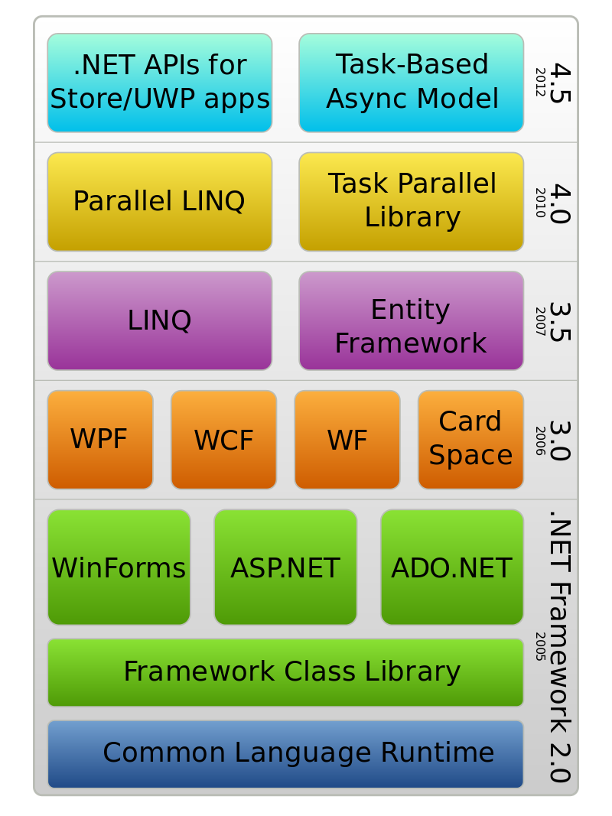
100 Mbps—Fast Ethernet |  | In computer networking, Fast Ethernet physical layers carry traffic at the nominal rate of 100 Mbit/s. The prior Ethernet speed was 10 Mbit/s. Of the Fast Ethernet physical layers, 100BASE-TX is by far the most common.  Fast Ethernet was introduced in 1995 as the IEEE 802.3u standard[1] and remained the fastest version of Ethernet for three years before the introduction of Gigabit Ethernet. The acronym GE/FE is sometimes used for devices supporting both standards
5ESS | 5ESS Switching System | The 5ESS Switching System is a telephone electronic switching system developed by Western Electric for the American Telephone and Telegraph Company (AT&T) and the Bell System in the United States.  The 5ESS came to market as the Western Electric No. 5 ESS. It first commenced service in Seneca, Illinois on 25 March 1982, and was destined to replace the Number One Electronic Switching System (1ESS and 1AESS) and other electromechanical systems in the 1980s and 1990s. The 5ESS was also used as a Class 4 telephone switch or as a hybrid Class 4/Class 5 switch in markets too small for the 4ESS. Approximately half of all US central offices are served by 5ESS switches. The 5ESS is also exported internationally, and manufactured outside the US under license.  The 5ESS technology was transferred to the AT&T Network Systems division upon the breakup of the Bell System. The division was divested by AT&T as Lucent Technologies, and after becoming Alcatel-Lucent, it was acquired by Nokia.  The 5ESS switch has three main types of modules: the Administrative Module (AM) contains the central computers; the Communications Module (CM) is the central time-divided switch of the system; and the Switching Module (SM) makes up the majority of the equipment in most exchanges. The SM performs multiplexing, analog and digital coding, and other work to interface with external equipment. Each has a controller, a small computer with duplicated CPUs and memories, like most common equipment of the exchange, for redundancy. Distributed systems lessen the load on the Central Administrative Module (AM) or main computer.
5G |  | 5G is a marketing term for some new mobile technologies. Definitions differ and confusion is common. The ITU IMT-2020 standard provides for speeds up to 20 gigabits per second and has only been demonstrated with millimeter waves of 15 gigahertz and higher frequency. The more recent 3GPP standard includes any network using the NR New Radio software. 5G New Radio can include lower frequencies, from 600 MHz to 6 GHz. However, the speeds in these lower frequencies are only modestly higher than new 4G systems, estimated at 15% to 50% faster. At least at the lower frequencies, "5G is evolutionary."
802.3 Physical Layer |  | EEE 802.3 is a working group and a collection of Institute of Electrical and Electronics Engineers (IEEE) standards produced by the working group defining the physical layer and data link layer's media access control (MAC) of wired Ethernet. This is generally a local area network (LAN) technology with some wide area network (WAN) applications. Physical connections are made between nodes and/or infrastructure devices (hubs, switches, routers) by various types of copper or fiber cable.  802.3 is a technology that supports the IEEE 802.1 network architecture.  802.3 also defines LAN access method using CSMA/CD.

A
AA | Authoritative Answer | Specifies that the responding name server is an authority for the domain name in question section. Note that the contents of the answer section may have multiple owner names because of aliases. This bit corresponds to the name which matches the query name, or the first owner name in the answer section.
AAC | Advanced Audio Coding | Advanced Audio Coding (AAC) is a proprietary audio coding standard for lossy digital audio compression. Designed to be the successor of the MP3 format, AAC generally achieves better sound quality than MP3 at the same bit rate. The confusingly named AAC+ (HE-AAC) does so only at low bit rates and less so at high ones.  AAC has been standardized by ISO and IEC, as part of the MPEG-2 and MPEG-4 specifications. Part of AAC, HE-AAC (AAC+), is part of MPEG-4 Audio and also adopted into digital radio standards DAB+ and Digital Radio Mondiale, as well as mobile television standards DVB-H and ATSC-M/H.  AAC supports inclusion of 48 full-bandwidth (up to 96 kHz) audio channels in one stream plus 16 low frequency effects (LFE, limited to 120 Hz) channels, up to 16 "coupling" or dialog channels, and up to 16 data streams. The quality for stereo is satisfactory to modest requirements at 96 kbit/s in joint stereo mode; however, hi-fi transparency demands data rates of at least 128 kbit/s (VBR). Tests of MPEG-4 audio have shown that AAC meets the requirements referred to as "transparent" for the ITU at 128 kbit/s for stereo, and 320 kbit/s for 5.1 audio.
AAL1 |  | An ATM Adaptation layer 1 or AAL1 is used for transmitting Class A network traffic, that is, real-time, constant bit rate, connection oriented traffic (example- uncompressed audio and video). Bits are fed in by the application at constant rate and must be delivered to other end with minimum delay, jitter or overhead. The input is stream of bits without message boundaries. For this traffic, error detection protocols cannot be used since timeouts and retransmission causes delay but the missing cells are reported to the application, that must take its own action to recover from them.
AAL2 | ATM Adaptation Layer 2 | ATM Adaptation Layer 2 (AAL2) is an ATM adaptation layer for Asynchronous Transfer Mode (ATM), used primarily in telecommunications; for example, it is used for the Iu interfaces in the Universal Mobile Telecommunications System, and is also used for transporting digital voice. The standard specifications related to AAL2 are ITU standards I.363.2 and I366.1.  What is AAL2?  AAL2 is a variable bitrate, connection-oriented, low latency service originally intended to adapt voice for transmission over ATM. Like other ATM adaptation layers, AAL2 defines segmentation and reassembly of higher-layer packets into ATM cells, in this case packets of data containing voice and control information. AAL2 is further separated into two sub-layers that help with the mapping from upper layer services to ATM cells. These are named Service Specific Convergence Sub-layer (SSCS) and Common Part Sub-layer (CPS).
AAL5 | ATM Adaptation Layer 5 | ATM Adaptation Layer 5 (AAL5) is an ATM adaptation layer used to send variable-length packets up to 65,535 octets in size across an Asynchronous Transfer Mode (ATM) network.  Unlike most network frames, which place control information in the header, AAL5 places control information in an 8-octet trailer at the end of the packet. The AAL5 trailer contains a 16-bit length field, a 32-bit cyclic redundancy check (CRC) and two 8-bit fields labeled UU and CPI that are currently unused.  Each AAL5 packet is divided into an integral number of ATM cells and reassembled into a packet before delivery to the receiving host. This process is known as Segmentation and Reassembly (see below). The last cell contains padding to ensure that the entire packet is a multiple of 48 octets long. The final cell contains up to 40 octets of data, followed by padding bytes and the 8-octet trailer. In other words, AAL5 places the trailer in the last 8 octets of the final cell where it can be found without knowing the length of the packet; the final cell is identified by a bit in the ATM header (see below), and the trailer is always in the last 8 octets of that cell.
Acceptance Test |  | Formal test defining acceptance criteria for a release.
Acceptance Testing |  | An acceptance test is a formal description of the behavior of a software product, generally expressed as an example or a usage scenario. A number of different notations and approaches have been proposed for such examples or scenarios. In many cases the aim is that it should be possible to automate the execution of such tests by a software tool, either ad-hoc to the development team or off the shelf.
Activity |  | An element of work performed during a project, normally associated with an expected resource usage. The terms activities and tasks are somewhat interchangeable, although the PMBOK defines tasks as resulting from the breakdown of activities.
Activity Model |  | Specifies work or workflow by showing and describing the states and flow of control of the system or process.
AD | Active Directory | Active Directory (AD) is a directory service that Microsoft developed for the Windows domain networks. It is included in most Windows Server operating systems as a set of processes and services. Initially, Active Directory was only in charge of centralized domain management. Starting with Windows Server 2008, however, Active Directory became an umbrella title for a broad range of directory-based identity-related services.  A server running Active Directory Domain Services (AD DS) is called a domain controller. It authenticates and authorizes all users and computers in a Windows domain type network—assigning and enforcing security policies for all computers and installing or updating software. For example, when a user logs into a computer that is part of a Windows domain, Active Directory checks the submitted password and determines whether the user is a system administrator or normal user. Also, it allows management and storage of information, provides authentication and authorization mechanisms, and establishes a framework to deploy other related services: Certificate Services, Federated Services, Lightweight Directory Services and Rights Management Services.  Active Directory uses Lightweight Directory Access Protocol (LDAP) versions 2 and 3, Microsoft's version of Kerberos, and DNS.
Ad Hoc Testing |  | See informal testing.
Ada |  | Ada is a structured, statically typed, imperative, and object-oriented high-level computer programming language, extended from Pascal and other languages. It has built-in language support for design-by-contract, extremely strong typing, explicit concurrency, tasks, synchronous message passing, protected objects, and non-determinism. Ada improves code safety and maintainability by using the compiler to find errors in favor of runtime errors. Ada is an international standard; the current version (known as Ada 2012) is defined by ISO/IEC 8652:2012.
ADSL | Asymmetric Digital Subscriber Loop | Asymmetric digital subscriber line (ADSL) is a type of digital subscriber line (DSL) technology, a data communications technology that enables faster data transmission over copper telephone lines than a conventional voiceband modem can provide. ADSL differs from the less common symmetric digital subscriber line (SDSL). In ADSL, bandwidth and bit rate are said to be asymmetric, meaning greater toward the customer premises (downstream) than the reverse (upstream). Providers usually market ADSL as a service for consumers for Internet access for primarily downloading content from the Internet, but not serving content accessed by others.  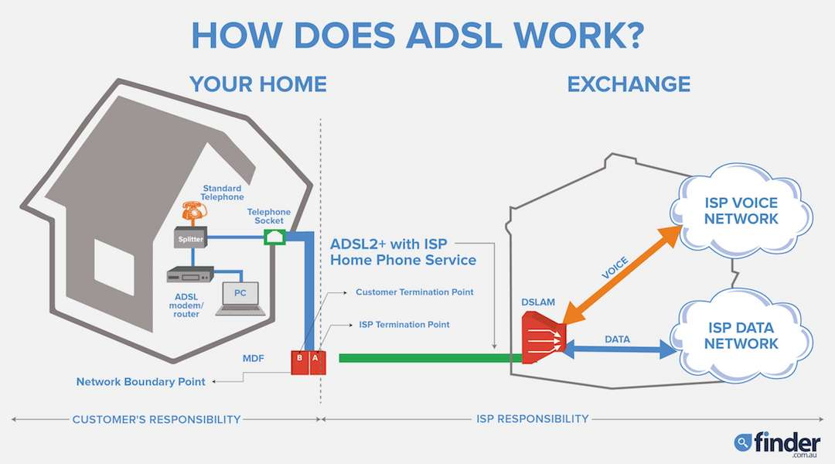
AES | Advanced Encryption Standard | The Advanced Encryption Standard (AES), also known by its original name Rijndael is a specification for the encryption of electronic data established by the U.S. National Institute of Standards and Technology (NIST) in 2001.  AES is a subset of the Rijndael block cipher developed by two Belgian cryptographers, Vincent Rijmen and Joan Daemen, who submitted a proposal[5] to NIST during the AES selection process.[6] Rijndael is a family of ciphers with different key and block sizes.  For AES, NIST selected three members of the Rijndael family, each with a block size of 128 bits, but three different key lengths: 128, 192 and 256 bits.  AES has been adopted by the U.S. government and is now used worldwide. It supersedes the Data Encryption Standard (DES), which was published in 1977. The algorithm described by AES is a symmetric-key algorithm, meaning the same key is used for both encrypting and decrypting the data.  In the United States, AES was announced by the NIST as U.S. FIPS PUB 197 (FIPS 197) on November 26, 2001. This announcement followed a five-year standardization process in which fifteen competing designs were presented and evaluated, before the Rijndael cipher was selected as the most suitable (see Advanced Encryption Standard process for more details).  AES became effective as a federal government standard on May 26, 2002, after approval by the Secretary of Commerce. AES is included in the ISO/IEC 18033-3 standard. AES is available in many different encryption packages, and is the first (and only) publicly accessible cipher approved by the National Security Agency (NSA) for top secret information when used in an NSA approved cryptographic module  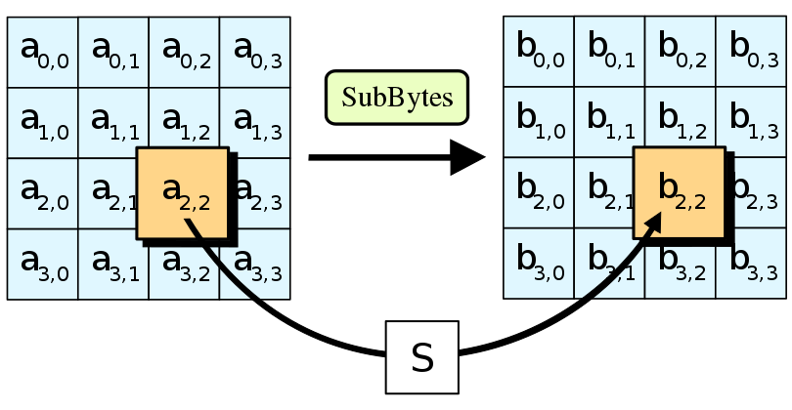
Agent |  | In a project charter, responsible for initiating, sponsoring, and supporting the project. Also see project sponsor.
Agile |  | a project management approach based on delivering requirements iteratively and incrementally throughout the life cycle.
Agile development |  | an umbrella term specifically for iterative software development methodologies. Popular methods include Scrum, Lean, DSDM and eXtreme Programming (XP).
Agile Manifesto |  | Describes the four principles of agile development:  - Individuals and interactions over processes and tools.  - Working software over comprehensive documentation.  - Customer collaboration over contract negotiation.  Responding to change over following a plan.
AIS | Alarm Indication Signaling | Alarm indication signal (AIS) (also called “all ones” because of the data and framing pattern) is a signal transmitted by an intermediate element of a multi-node transport circuit that is part of a concatenated telecommunications system to alert the receiving end of the circuit that a segment of the end-to-end link has failed at a logical or physical level, even if the system it is directly connected to is still working. The AIS replaces the failed data, allowing the higher order system in the concatenation to maintain its transmission framing integrity. Downstream intermediate elements of the transport circuit propagate the AIS onwards to the destination element.
A-law |  | An A-law algorithm is a standard companding algorithm, used in European 8-bit PCM digital communications systems to optimize, i.e. modify, the dynamic range of an analog signal for digitizing. It is one of two versions of the G.711 standard from ITU-T, the other version being the similar µ-law, used in North America and Japan.
ALCAP | Access Link Control Application Protocol | Control plane protocol for the transport layer in 3rd Generation UMTS networks is called ALCAP ("Access Link Control Application Part"). ALCAP is defined by 3GPP as equivalent of ITU recommendation Q.2630.2. Basic functionality of ALCAP is multiplexing of different users onto one AAL2 transmission path using channel IDs (CIDs). It is used in the UMTS access network UTRAN along with ATM, while IPBCP is use for IP links in the core of the network.  ALCAP makes it possible for up to 248 channels to be multiplexed onto one AAL2 bearer.  Protocol stack  +----------------+  | ALCAP |  +----------------+  | SAAL |  +----------------+  | AAL5 |  +----------------+  | ATM bø |  +----------------+  | Physical layer |  +----------------+
Algorithmic Estimation |  | See statistical estimation.
Amazon EC2 | Amazon Electric Compute Cloud | Amazon Elastic Compute Cloud (EC2) forms a central part of Amazon.com's cloud-computing platform, Amazon Web Services (AWS), by allowing users to rent virtual computers on which to run their own computer applications. EC2 encourages scalable deployment of applications by providing a web service through which a user can boot an Amazon Machine Image (AMI) to configure a virtual machine, which Amazon calls an "instance", containing any software desired. A user can create, launch, and terminate server-instances as needed, paying by the second for active servers – hence the term "elastic". EC2 provides users with control over the geographical location of instances that allows for latency optimization and high levels of redundancy.
AMP | Asymmetric Multiprocessing | In an asymmetric multiprocessing system (AMP), not all CPUs are treated equally; for example, a system might allow (either at the hardware or operating system level) only one CPU to execute operating system code or might allow only one CPU to perform I/O operations. Other AMP systems would allow any CPU to execute operating system code and perform I/O operations, so that they were symmetric with regard to processor roles, but attached some or all peripherals to particular CPUs, so that they were asymmetric with respect to the peripheral attachment. Asymmetric multiprocessing was the only method for handling multiple CPUs before symmetric multiprocessing (SMP) was available. It has also been used to provide less expensive options on systems where SMP was available. Additionally, AMP is used in applications that are dedicated, such as embedded systems, when individual processors can be dedicated to specific tasks at design time.  Multiprocessing is the use of more than one CPU in a computer system. The CPU is the arithmetic and logic engine that executes user applications. With multiple CPUs, more than one set of program instructions can be executed at the same time. All of the CPUs have the same user-mode instruction set, so a running job can be rescheduled from one CPU to another.  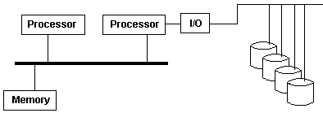
AMR-NB | Adaptive Multi-Rate Narrow band | The Adaptive Multi-Rate (AMR, AMR-NB or GSM-AMR) audio codec is an audio compression format optimized for speech coding. AMR speech codec consists of a multi-rate narrowband speech codec that encodes narrowband (200–3400 Hz) signals at variable bit rates ranging from 4.75 to 12.2 kbit/s with toll quality speech starting at 7.4 kbit/s.  AMR was adopted as the standard speech codec by 3GPP in October 1999 and is now widely used in GSM[4] and UMTS. It uses link adaptation to select from one of eight different bit rates based on link conditions.
AMR-WB | Adaptive Multi-Rate Wideband | Adaptive Multi-Rate Wideband (AMR-WB) is a patented wideband speech audio coding standard developed based on Adaptive Multi-Rate encoding, using similar methodology as algebraic code excited linear prediction (ACELP). AMR-WB provides improved speech quality due to a wider speech bandwidth of 50–7000 Hz compared to narrowband speech coders which in general are optimized for POTS wireline quality of 300–3400 Hz. AMR-WB was developed by Nokia and VoiceAge and it was first specified by 3GPP.  AMR-WB is codified as G.722.2, an ITU-T standard speech codec, formally known as Wideband coding of speech at around 16 kbit/s using Adaptive Multi-Rate Wideband (AMR-WB). G.722.2 AMR-WB is the same codec as the 3GPP AMR-WB. The corresponding 3GPP specifications are TS 26.190 for the speech codec and TS 26.194 for the Voice Activity Detector.  The AMR-WB format has the following parameters:  - Frequency bands processed: 50-6400 Hz (all modes) plus 6400-7000 Hz (23.85 kbit/s mode only)  - Delay frame size: 20 ms  - Look ahead: 5 ms  - AMR-WB codec employs a bandsplitting filter; the one-way delay of this filter is 0.9375 ms  - Complexity: 38 WMOPS, RAM 5.3KWords  - Voice activity detection, discontinuous transmission, comfort noise generator  - Fixed point: Bit-exact C  - Floating point: under work.
Analogy Estimation |  | Creating estimates by using expert judgment to compare proposed work to historical data for similar past work. Often coupled with fuzzy logic techniques.
Android |  | Android is a mobile operating system developed by Google, based on a modified version of the Linux kernel and other open source software and designed primarily for touchscreen mobile devices such as smartphones and tablets. In addition, Google has further developed Android TV for televisions, Android Auto for cars, and Wear OS for wrist watches, each with a specialized user interface. Variants of Android are also used on game consoles, digital cameras, PCs and other electronics.
ANDSF | Access Network Discovery and Selection Function | The ANDSF provides information to the UE about connectivity to 3GPP and non-3GPP access networks (such as Wi-Fi). The purpose of the ANDSF is to assist the UE to discover the access networks in their vicinity and to provide rules (policies) to prioritize and manage connections to these networks.  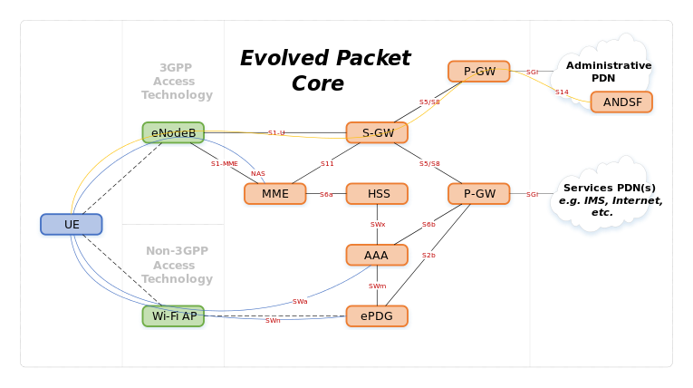
ANSI | American National Standards Institute | The American National Standards Institute is a private non-profit organization that oversees the development of voluntary consensus standards for products, services, processes, systems, and personnel in the United States. The organization also coordinates U.S. standards with international standards so that American products can be used worldwide.  ANSI accredits standards that are developed by representatives of other standards organizations, government agencies, consumer groups, companies, and others. These standards ensure that the characteristics and performance of products are consistent, that people use the same definitions and terms, and that products are tested the same way. ANSI also accredits organizations that carry out product or personnel certification in accordance with requirements defined in international standards
Antipattern |  | are common solutions to common problems where the solution is ineffective and may result in undesired consequences.
Anycast |  | Anycast is a network addressing and routing methodology in which a single destination address has multiple routing paths to two or more endpoint destinations. Routers will select the desired path on the basis of number of hops, distance, lowest cost, latency measurements or based on the least congested route. Anycast networks are widely used for CDN products to bring their content closer to the end user.  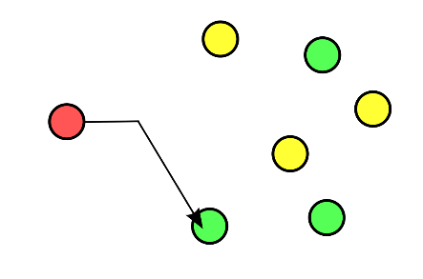
AOP | aspect-oriented programming | In computing, aspect-oriented programming (AOP) is a programming paradigm that aims to increase modularity by allowing the separation of cross-cutting concerns. It does so by adding additional behavior to existing code (an advice) without modifying the code itself, instead separately specifying which code is modified via a "pointcut" specification, such as "log all function calls when the function's name begins with 'set'". This allows behaviors that are not central to the business logic (such as logging) to be added to a program without cluttering the code, core to the functionality. AOP forms a basis for aspect-oriented software development.  AOP includes programming methods and tools that support the modularization of concerns at the level of the source code, while "aspect-oriented software development" refers to a whole engineering discipline.  Aspect-oriented programming entails breaking down program logic into distinct parts (so-called concerns, cohesive areas of functionality). Nearly all programming paradigms support some level of grouping and encapsulation of concerns into separate, independent entities by providing abstractions (e.g., functions, procedures, modules, classes, methods) that can be used for implementing, abstracting and composing these concerns. Some concerns "cut across" multiple abstractions in a program, and defy these forms of implementation. These concerns are called cross-cutting concerns or horizontal concerns.  Logging exemplifies a crosscutting concern because a logging strategy necessarily affects every logged part of the system. Logging thereby crosscuts all logged classes and methods.  All AOP implementations have some crosscutting expressions that encapsulate each concern in one place. The difference between implementations lies in the power, safety, and usability of the constructs provided. For example, interceptors that specify the methods to intercept express a limited form of crosscutting, without much support for type-safety or debugging. AspectJ has a number of such expressions and encapsulates them in a special class, an aspect. For example, an aspect can alter the behavior of the base code (the non-aspect part of a program) by applying advice (additional behavior) at various join points (points in a program) specified in a quantification or query called a pointcut (that detects whether a given join point matches). An aspect can also make binary-compatible structural changes to other classes, like adding members or parents.
API | application programming interface | a specific method prescribed by a computer operating system or by an application program by which a programmer writing an application program can make requests of the operating system or another application.
APN | Access Point Name | An Access Point Name (APN) is the name of a gateway between a GSM, GPRS, 3G or 4G mobile network and another computer network, frequently the public Internet.  A mobile device making a data connection must be configured with an APN to present to the carrier. The carrier will then examine this identifier to determine what type of network connection should be created, for example: which IP addresses should be assigned to the wireless device, which security methods should be used, and how or if, it should be connected to some private customer network.  More specifically, the APN identifies the packet data network (PDN) that a mobile data user wants to communicate with. In addition to identifying a PDN, an APN may also be used to define the type of service, (e.g. connection to Wireless Application Protocol (WAP) server, Multimedia Messaging Service (MMS)) that is provided by the PDN. APN is used in 3GPP data access networks, e.g. General Packet Radio Service (GPRS), evolved packet core (EPC).
Architecture |  | Top level overview and plan for a software system. See CxStand_Design for more information.
ARP spoofing |  | In computer networking, ARP spoofing, ARP cache poisoning, or ARP poison routing, is a technique by which an attacker sends (spoofed) Address Resolution Protocol (ARP) messages onto a local area network. Generally, the aim is to associate the attacker's MAC address with the IP address of another host, such as the default gateway, causing any traffic meant for that IP address to be sent to the attacker instead.  ARP spoofing may allow an attacker to intercept data frames on a network, modify the traffic, or stop all traffic. Often the attack is used as an opening for other attacks, such as denial of service, man in the middle, or session hijacking attacks.  The attack can only be used on networks that use ARP, and requires attacker have direct access to the local network segment to be attacked  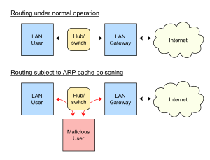
Artifact |  | The tangible result of work performed.  May be used at any level of detail, e.g., the artifact resulting from a task might be a document, while the artifact resulting from a project might be a software system.
ASCII |  | ASCII, abbreviated from American Standard Code for Information Interchange, is a character encoding standard for electronic communication. ASCII codes represent text in computers, telecommunications equipment, and other devices. Most modern character-encoding schemes are based on ASCII, although they support many additional characters.  ASCII is the traditional name for the encoding system; the Internet Assigned Numbers Authority (IANA) prefers the updated name US-ASCII, which clarifies that this system was developed in the US and based on the typographical symbols predominantly in use there.
ASN.1 |  | Abstract Syntax Notation One (ASN.1) is an interface description language for defining data structures that can be serialized and deserialized in a standard, cross-platform way. It is broadly used in telecommunications and computer networking, and especially in cryptography.  Protocol developers define data structures in ASN.1 modules, which are generally a section of a broader standards document written in the ASN.1 language. Because the language is both human-readable and machine-readable, modules can be automatically turned into libraries that process their data structures, using an ASN.1 compiler.  ASN.1 is similar in purpose and use to protocol buffers and Apache Thrift, which are also interface description languages for cross-platform data serialization. Like those languages, it has a schema (in ASN.1, called a "module"), and a set of encodings, typically type-length-value encodings. However, ASN.1, defined in 1984, predates them by many years. It also includes a wider variety of basic data types, some of which are obsolete, and has more options for extensibility. A single ASN.1 message can include data from multiple modules defined in multiple standards, even standards defined years apart.  FooProtocol DEFINITIONS ::= BEGIN  FooQuestion ::= SEQUENCE {  trackingNumber INTEGER(0..199),  question IA5String  }  FooAnswer ::= SEQUENCE {  questionNumber INTEGER(10..20),  answer BOOLEAN  }  FooHistory ::= SEQUENCE {  questions SEQUENCE(SIZE(0..10)) OF FooQuestion,  answers SEQUENCE(SIZE(1..10)) OF FooAnswer,  anArray SEQUENCE(SIZE(100)) OF INTEGER(0..1000),  ...  }  END
Assessment |  | A review of the state or practices of a project or organization, often performed by an independent entity.
ATDD | Acceptance Test Driven Development | involves team members with different perspectives (customer, development, testing) collaborating to write acceptance tests in advance of implementing the corresponding functionality.
ATM | Asynchronous Transfer Mode | Asynchronous transfer mode (ATM) is, according to the ATM Forum, "a telecommunications concept defined by ANSI and ITU (formerly CCITT) standards for carriage of a complete range of user traffic, including voice, data, and video signals".[1] ATM was developed to meet the needs of the Broadband Integrated Services Digital Network, as defined in the late 1980s,[2] and designed to integrate telecommunication networks. Additionally, It was designed for networks that must handle both traditional high-throughput data traffic (e.g., file transfers), and real-time, low-latency content such as voice and video. The reference model for ATM approximately maps to the three lowest layers of the ISO-OSI reference model: network layer, data link layer, and physical layer.[3] ATM is a core protocol used over the SONET/SDH backbone of the public switched telephone network (PSTN) and Integrated Services Digital Network (ISDN), but its use is declining in favour of all IP.  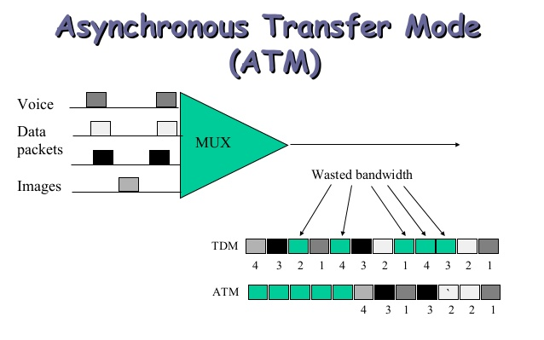
Audio Codecs |  | An audio coding format (or sometimes audio compression format) is a content representation format for storage or transmission of digital audio (such as in digital television, digital radio and in audio and video files). Examples of audio coding formats include MP3, AAC, Vorbis, FLAC, and Opus. A specific software or hardware implementation capable of audio compression and decompression to/from a specific audio coding format is called an audio codec; an example of an audio codec is LAME, which is one of several different codecs which implements encoding and decoding audio in the MP3 audio coding format in software.  Some audio coding formats are documented by a detailed technical specification document known as an audio coding specification. Some such specifications are written and approved by standardization organizations as technical standards, and are thus known as an audio coding standard. The term "standard" is also sometimes used for de facto standards as well as formal standards.  Audio content encoded in a particular audio coding format is normally encapsulated within a container format. As such, the user normally doesn't have a raw AAC file, but instead has a .m4a audio file, which is a MPEG-4 Part 14 container containing AAC-encoded audio. The container also contains metadata such as title and other tags, and perhaps an index for fast seeking. A notable exception is MP3 files, which are raw audio coding without a container format. De facto standards for adding metadata tags such as title and artist to MP3s, such as ID3, are hacks which work by appending the tags to the MP3, and then relying on the MP3 player to recognize the chunk as malformed audio coding and therefore skip it. In video files with audio, the encoded audio content is bundled with video (in a video coding format) inside a multimedia container format.  An audio coding format does not dictate all algorithms used by a codec implementing the format. An important part of how lossy audio compression works is by removing data in ways humans can't hear, according to a psychoacoustic model; the implementer of an encoder has some freedom of choice in which data to remove (according to their psychoacoustic model).  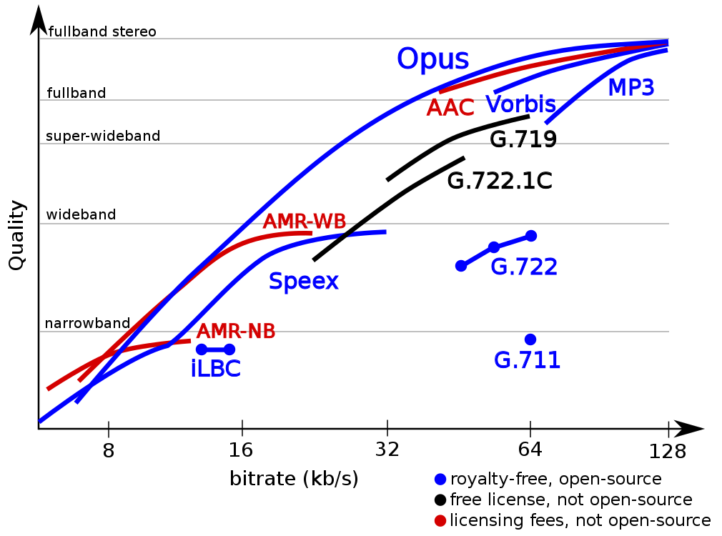
Audit |  | Sometimes used as a synonym for assessment, usually in a more formal and independent context.
Author |  | For a review, the person assigned to represent the author viewpoint for an artifact. The author is normally the primary contributor to the creation of the artifact.
Authority |  | Responsible for funding and championing a project, the project sponsor.
Automated Build |  | In the context of software development, build refers to the process that converts files and other assets under the developers' responsibility into a software product in its final or consumable form. The build is automated when these steps are repeatable, require no direct human intervention, and can be performed at any time with no information other than what is stored in the source code control repository.
Automated Testing |  | The use of tools and technology to encode, execute, and note results of test cases on a system without human intervention.
Awk |  | AWK is a programming language designed for text processing and typically used as a data extraction and reporting tool. It is a standard feature of most Unix-like operating systems.  The AWK language is a data-driven scripting language consisting of a set of actions to be taken against streams of textual data – either run directly on files or used as part of a pipeline – for purposes of extracting or transforming text, such as producing formatted reports. The language extensively uses the string datatype, associative arrays (that is, arrays indexed by key strings), and regular expressions. While AWK has a limited intended application domain and was especially designed to support one-liner programs, the language is Turing-complete, and even the early Bell Labs users of AWK often wrote well-structured large AWK programs.
AWS | Amazon Web Services | Amazon Web Services (AWS) is a subsidiary of Amazon.com that provides on-demand cloud computing platforms to individuals, companies and governments, on a paid subscription basis. The technology allows subscribers to have at their disposal a virtual cluster of computers, available all the time, through the Internet. AWS's version of virtual computers emulate most of the attributes of a real computer including hardware (CPU(s) & GPU(s) for processing, local/RAM memory, hard-disk/SSD storage); a choice of operating systems; networking; and pre-loaded application software such as web servers, databases, CRM, etc. Each AWS system also virtualizes its console I/O (keyboard, display, and mouse), allowing AWS subscribers to connect to their AWS system using a modern browser. The browser acts as a window into the virtual computer, letting subscribers log-in, configure and use their virtual systems just as they would a real physical computer. They can choose to deploy their AWS systems to provide internet-based services for themselves and their customers.  The AWS technology is implemented at server farms throughout the world, and maintained by the Amazon subsidiary. Fees are based on a combination of usage, the hardware/OS/software/networking features chosen by the subscriber, required availability, redundancy, security, and service options. Subscribers can pay for a single virtual AWS computer, a dedicated physical computer, or clusters of either. As part of the subscription agreement, Amazon provides security for subscribers' system. AWS operates from many global geographical regions including 6 in North America.
Azure |  | Microsoft Azure is a cloud computing service created by Microsoft for building, testing, deploying, and managing applications and services through a global network of Microsoft-managed data centers. It provides software as a service (SaaS), platform as a service (PaaS) and infrastructure as a service (IaaS) and supports many different programming languages, tools and frameworks, including both Microsoft-specific and third-party software and systems.

B
B2B | business-to-business | Business-to-business (B2B or, in some countries, BtoB) refers to a situation where one business makes a commercial transaction with another. This typically occurs when:  A business is sourcing materials for their production process (e.g. a food manufacturer purchasing salt).  A business needs the services of another for operational reasons (e.g. a food manufacturer employing an accountancy firm to audit their finances).  A business re-sells goods and services produced by others (e.g. a retailer buying the end product from the food manufacturer).  B2B is often contrasted with business-to-consumer (B2C). In B2B commerce, it is often the case that the parties to the relationship have comparable negotiating power, and even when they do not, each party typically involves professional staff and legal counsel in the negotiation of terms, whereas B2C is shaped to a far greater degree by economic implications of information asymmetry. However, within a B2B context, large companies may have many commercial, resource and information advantages over smaller businesses.
B2C | business-to-consumer | Business to consumer (B2C) refers to the transactions conducted directly between a company and consumers who are the end-users of its products or services. The business to consumer as a business model differs significantly from the business-to-business model, which refers to commerce between two or more businesses. While most companies that sell directly to consumers can be referred to as B2C companies, the term became immensely popular during the dotcom boom of the late 1990s, when it was used mainly to refer to online retailers, as well as other companies that sold products and services to consumers through the internet.  Read more: Business To Consumer (B To C) https://www.investopedia.com/terms/b/btoc.asp#ixzz5MjtnxcKz  Follow us: Investopedia on Facebook
Backhaul |  | In a hierarchical telecommunications network the backhaul portion of the network comprises the intermediate links between the core network, or backbone network, and the small subnetworks at the "edge" of the entire hierarchical network.  In contracts pertaining to such networks, backhaul is the obligation to carry packets to and from that global network. A non-technical business definition of backhaul is the commercial wholesale bandwidth provider who offers quality of service (QOS) guarantees to the retailer. It appears most often in telecommunications trade literature in this sense, whereby the backhaul connection is defined not technically but by who operates and manages it, and who takes legal responsibility for the connection or uptime to the Internet or 3G/4G network. See also hotspot contracts below.  In both the technical and commercial definitions, backhaul generally refers to the side of the network that communicates with the global Internet, paid for at wholesale commercial access rates to or at an Ethernet Exchange or other core network access location. Sometimes middle mile networks exist between the customer's own LAN and those exchanges. This can be a local WAN or WLAN connection, for instance Network New Hampshire Now and Maine Fiber Company run tariffed public dark fiber networks as a backhaul alternative to encourage local and national carriers to reach areas with broadband and cell phone that they otherwise would not be serving. These serve retail networks which in turn connect buildings and bill customers directly.
Backlog |  | A backlog is an ordered list of items representing everything that may be needed to deliver a specific outcome. There are different types of backlogs depending on the type of item they contain and the approach being used.
Backlog Grooming |  | Backlog grooming is when the product owner and some, or all, of the rest of the team refine the backlog on a regular basis to ensure the backlog contains the appropriate items, that they are prioritized, and that the items at the top of the backlog are ready for delivery.
Bandwidth |  | Bandwidth is the maximum rate of data transfer across a given path. Bandwidth may be characterized as network bandwidth, data bandwidth, or digital bandwidth.  This definition of bandwidth is in contrast to the field of signal processing, wireless communications, modem data transmission, digital communications, and electronics[citation needed], in which bandwidth is used to refer to analog signal bandwidth measured in hertz, meaning the frequency range between lowest and highest attainable frequency while meeting a well-defined impairment level in signal power.  However, the actual bit rate that can be achieved depends not only on the signal bandwidth, but also on the noise on the channel.
Baseline |  | The original version of an artifact that serves as the basis for all future development work. Baselined artifacts are normally placed under change control.
Bash |  | Bash is a Unix shell and command language written by Brian Fox for the GNU Project as a free software replacement for the Bourne shell. First released in 1989, it has been distributed widely as the default login shell for most Linux distributions and Apple's macOS (formerly OS X). A version is also available for Windows 10. It is also the default user shell in Solaris 11.  Bash is a command processor that typically runs in a text window where the user types commands that cause actions. Bash can also read and execute commands from a file, called a shell script. Like all Unix shells, it supports filename globbing (wildcard matching), piping, here documents, command substitution, variables, and control structures for condition-testing and iteration. The keywords, syntax and other basic features of the language are all copied from sh. Other features, e.g., history, are copied from csh and ksh. Bash is a POSIX-compliant shell, but with a number of extensions.  The shell's name is an acronym for Bourne-again shell, a pun on the name of the Bourne shell that it replaces.
BASIC |  | BASIC (an acronym for Beginner's All-purpose Symbolic Instruction Code) is a family of general-purpose, high-level programming languages whose design philosophy emphasizes ease of use. In 1964, John G. Kemeny, Thomas E. Kurtz and Sr. Mary Kenneth Keller designed the original BASIC language at Dartmouth College. They wanted to enable students in fields other than science and mathematics to use computers. At the time, nearly all use of computers required writing custom software, which was something only scientists and mathematicians tended to learn.
BAU | Business as Usual | Business as usual (BAU) - the normal execution of standard functional operations within an organization - forms a possible contrast to projects or programmes which might introduce change.[citation needed] BAU may also stand in contradistinction to external events which may have the effect of unsettling or distracting those inside an organisation
BDD | Behavior Driven Development (BDD) | BDD is a practice where members of the team discuss the expected behavior of a system in order to build a shared understanding of expected functionality.
Bench Test |  | A test that is performed in the development environment and focuses on the part of the system being worked on.
BER | Bit Error Rate | In digital transmission, the number of bit errors is the number of received bits of a data stream over a communication channel that have been altered due to noise, interference, distortion or bit synchronization errors.  The bit error rate (BER) is the number of bit errors per unit time. The bit error ratio (also BER) is the number of bit errors divided by the total number of transferred bits during a studied time interval. Bit error ratio is a unitless performance measure, often expressed as a percentage.
BER | Basic Encoding Rules | The format for Basic Encoding Rules specifies a self-describing and self-delimiting format for encoding ASN.1 data structures. Each data element is encoded as a type identifier, a length description, the actual data elements, and, where necessary, an end-of-content marker. These types of encodings are commonly called type-length-value or TLV encodings. This format allows a receiver to decode the ASN.1 information from an incomplete stream, without requiring any pre-knowledge of the size, content, or semantic meaning of the data.
Best Practice |  | A practice, technique, process, or idiom that has been proven effective and/or efficient for completing a goal or addressing common risks. See CxOne Best Practice material type.
Best Practice Description | CxBest | CxOne best practice material type, see CxOneOverview for description.
BGCF | Breakout Gateway Control Function | A Breakout Gateway Control Function (BGCF) is a SIP proxy which processes requests for routing from an S-CSCF when the S-CSCF has determined that the session cannot be routed using DNS or ENUM/DNS. It includes routing functionality based on telephone numbers.  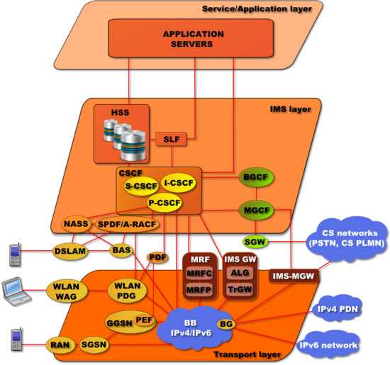
BGP | Border Gateway Protocol | Border Gateway Protocol (BGP) is a standardized exterior gateway protocol designed to exchange routing and reachability information among autonomous systems (AS) on the Internet. The protocol is classified as a path vector protocol. The Border Gateway Protocol makes routing decisions based on paths, network policies, or rule-sets configured by a network administrator and is involved in making core routing decisions.
Bjarne Stroustrup |  | Bjarne Stroustrup is a Danish computer scientist, who is most notable for the creation and development of the widely used C++ programming language.
Black-Box Testing |  | Synonym for functional testing.
Bluetooth |  | Bluetooth is a wireless technology standard for exchanging data over short distances (using short-wavelength UHF radio waves in the ISM band from 2.4 to 2.485 GHz) from fixed and mobile devices, and building personal area networks (PANs). Invented by Dutch electrical engineer Jaap Haartsen, working for telecom vendor Ericsson in 1994, it was originally conceived as a wireless alternative to RS-232 data cables.  Bluetooth is managed by the Bluetooth Special Interest Group (SIG), which has more than 30,000 member companies in the areas of telecommunication, computing, networking, and consumer electronics. The IEEE standardized Bluetooth as IEEE 802.15.1, but no longer maintains the standard.
BNG | Broadband Network Gateway | The Broadband Network Gateway (BNG) allows subscribers to connect to a broadband network through an access portal. It creates and manages subscriber sessions, aggregating traffic from various subscriber sessions from an access network, and routing it to the network of the Internet Service Provider (ISP) or Network Service Provider (NSP).
BOOTP | Dynamic IP Address Allocation – Bootstrap protocol | The Bootstrap Protocol (BOOTP) is a computer networking protocol used in Internet Protocol networks to automatically assign an IP address to network devices from a configuration server. The BOOTP was originally defined in RFC 951.  When a computer that is connected to a network is powered up and boots its operating system, the system software broadcasts BOOTP messages onto the network to request an IP address assignment. A BOOTP configuration server assigns an IP address based on the request from a pool of addresses configured by an administrator.  BOOTP is implemented using the User Datagram Protocol (UDP) as transport protocol, port number 67 is used by the (DHCP) server to receive client requests and port number 68 is used by the client to receive (DHCP) server responses. BOOTP operates only on IPv4 networks.  Historically, BOOTP has also been used for Unix-like diskless workstations to obtain the network location of their boot image, in addition to the IP address assignment. Enterprises used it to roll out a pre-configured client (e.g., Windows) installation to newly installed PCs.
Boston Matrix |  | The growth–share matrix (aka the product portfolio matrix,[ Boston Box, BCG-matrix, Boston matrix, Boston Consulting Group analysis, portfolio diagram) is a chart that to help corporations to analyze their business units, that is, their product lines. This helps the company allocate resources and is used as an analytical tool in brand marketing, product management, strategic management, and portfolio analysis. Some analysis of market performance by firms using its principles has called its usefulness into question.
Bottom-Up Estimation |  | Estimating a system by decomposing it and then estimating each decomposed piece individually, rolling up the total to get an entire system estimate.
BPEL | Business Process Execution Language | BPEL (Business Process Execution Language) is an XML-based language that allows Web services in a service-oriented architecture (SOA) to interconnect and share data.  Programmers use BPEL to define how a business process that involves web services will be executed. BPEL messages are typically used to invoke remote services, orchestrate process execution and manage events and exceptions.  BPEL is often associated with Business Process Management Notation (BPMN), a standard for representing business processes graphically. In many organizations, analysts use BPMN to visualize business processes and developers transform the visualizations to BPEL for execution.  BPEL was standardized by OASIS in 2004 after collaborative efforts to create the language by Microsoft, IBM and other companies.
BPMN | Business Process Model and Notation | Business Process Model and Notation (BPMN) is a graphical representation for specifying business processes in a business process model.  Business Process Management Initiative (BPMI) developed BPMN, which has been maintained by the Object Management Group since the two organizations merged in 2005. Version 2.0 of BPMN was released in January 2011,[1] at which point the name was adapted to Business Process Model and Notation as execution semantics were also introduced alongside the notational and diagramming elements.  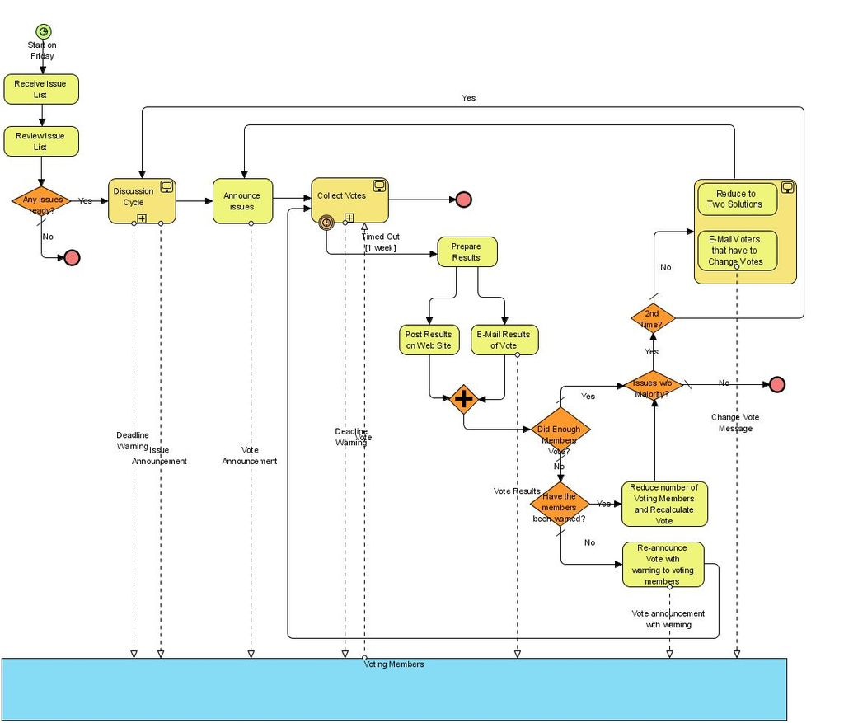
BRAS | Broadband Remote Access Server | A broadband remote access server (BRAS, B-RAS or BBRAS) routes traffic to and from broadband remote access devices such as digital subscriber line access multiplexers (DSLAM) on an Internet service provider's (ISP) network  BRAS can also be referred to as a Broadband Network Gateway (BNG)  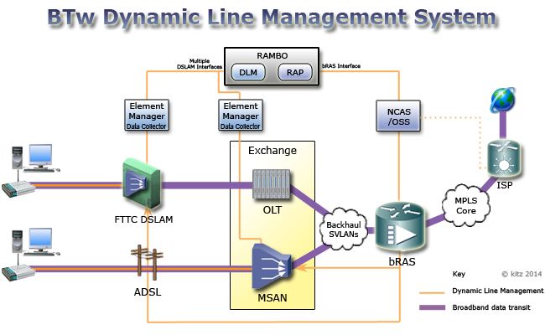  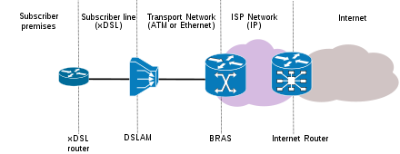
Broadcast |  | In computer networking, telecommunication and information theory, broadcasting is a method of transferring a message to all recipients simultaneously. Broadcasting can be performed as a high level operation in a program, for example broadcasting Message Passing Interface, or it may be a low level networking operation, for example broadcasting on Ethernet.  All-to-all communication is a computer communication method in which each sender transmits messages to all receivers within a group. This contrasts with the point-to-point method in which each sender communicates with one receiver.  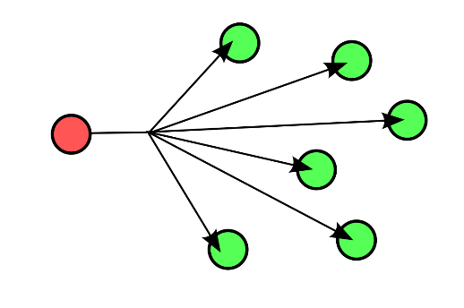
BSC |  | The base station controller (BSC) provides, classically, the intelligence behind the BTSs. Typically a BSC has tens or even hundreds of BTSs under its control. The BSC handles allocation of radio channels, receives measurements from the mobile phones, and controls handovers from BTS to BTS (except in the case of an inter-BSC handover in which case control is in part the responsibility of the anchor MSC). A key function of the BSC is to act as a concentrator where many different low capacity connections to BTSs (with relatively low utilisation) become reduced to a smaller number of connections towards the mobile switching center (MSC) (with a high level of utilisation). Overall, this means that networks are often structured to have many BSCs distributed into regions near their BTSs which are then connected to large centralised MSC sites.  The BSC is undoubtedly the most robust element in the BSS as it is not only a BTS controller but, for some vendors, a full switching center, as well as an SS7 node with connections to the MSC and serving GPRS support node (SGSN) (when using GPRS). It also provides all the required data to the operation support subsystem (OSS) as well as to the performance measuring centers.  A BSC is often based on a distributed computing architecture, with redundancy applied to critical functional units to ensure availability in the event of fault conditions. Redundancy often extends beyond the BSC equipment itself and is commonly used in the power supplies and in the transmission equipment providing the A-ter interface to PCU.  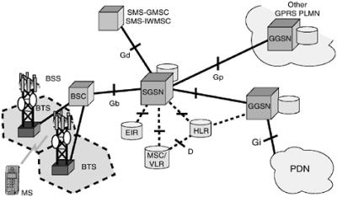
BSS | Base station subsystem | The base station subsystem (BSS) is the section of a traditional cellular telephone network which is responsible for handling traffic and signaling between a mobile phone and the network switching subsystem. The BSS carries out transcoding of speech channels, allocation of radio channels to mobile phones, paging, transmission and reception over the air interface and many other tasks related to the radio network.  BSS interfaces  - Um  - The air interface between the mobile station (MS) and the BTS. This interface uses LAPDm protocol for signaling, to conduct call control, measurement reporting, handover, power control, authentication, authorization, location update and so on. Traffic and signaling are sent in bursts of 0.577 ms at intervals of 4.615 ms, to form data blocks each 20 ms.  - Abis  - The interface between the BTS and BSC. Generally carried by a DS-1, ES-1, or E1 TDM circuit. Uses TDM subchannels for traffic (TCH), LAPD protocol for BTS supervision and telecom signaling, and carries synchronization from the BSC to the BTS and MS.  - A  - The interface between the BSC and MSC. It is used for carrying traffic channels and the BSSAP user part of the SS7 stack. Although there are usually transcoding units between BSC and MSC, the signaling communication takes place between these two ending points and the transcoder unit doesn't touch the SS7 information, only the voice or CS data are transcoded or rate adapted.  - Ater  - The interface between the BSC and transcoder. It is a proprietary interface whose name depends on the vendor (for example Ater by Nokia), it carries the A interface information from the BSC leaving it untouched.  - Gb  - Connects the BSS to the SGSN in the GPRS core network.  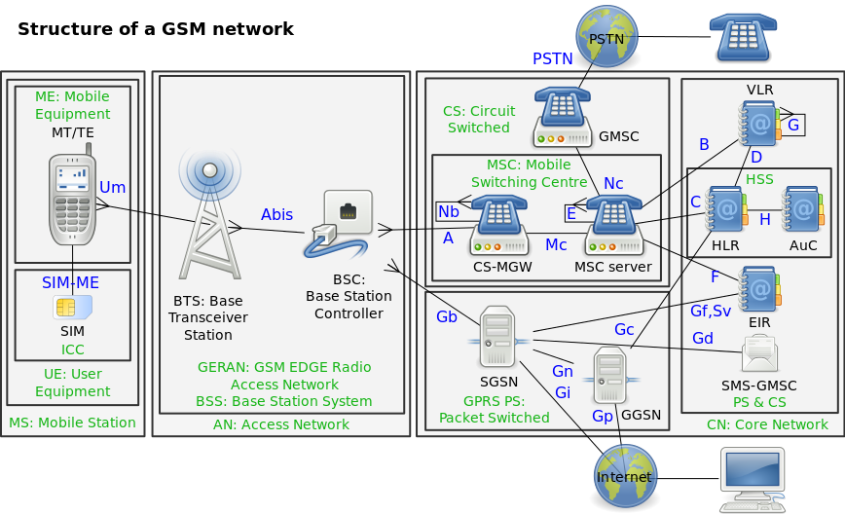
BSS | Business support systems | Business support systems (BSS) are the components that a telecommunications service provider (or telco) uses to run its business operations towards customers.  Together with operations support systems (OSS), they are used to support various end-to-end telecommunication services (e.g., telephone services). BSS and OSS have their own data and service responsibilities. The two systems together are often abbreviated OSS/BSS, BSS/OSS or simply B/OSS.  The acronym BSS is also used in a singular form to refer to all the business support systems viewed as a whole system.
BT 21CN | BT 21st Century Network | 21CN involves a huge overhaul of the existing 20CN network. Over the next few years BT will gradually be updating the existing equipment and replacing it with a new multi-service network.  The PSTN (telephone) services will be provided over the same IP network as broadband. This will involve replacing telephone switching equipment and the adsl broadband DSLAMs with MSANs (Multi-Service Access Nodes) which will terminate telephone and broadband connections.  Note: Plans to also move the telephone network over to IP has been temporary been abandoned by BT.  As well as faster speeds the new equipment will also allow BT more configuration options and allow them to offer products with QoS (Quality of Service) availability.  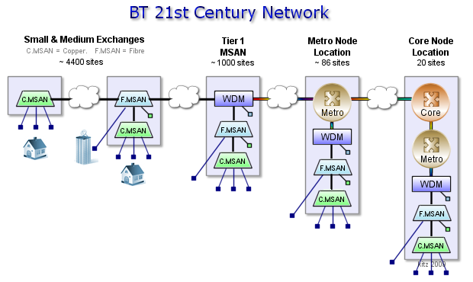  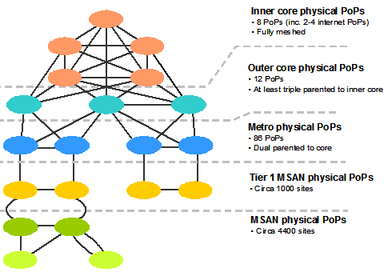
BTNUP | See IUP
BTS | Base Transceiver Station | A base transceiver station (BTS) is a piece of equipment that facilitates wireless communication between user equipment (UE) and a network. UEs are devices like mobile phones (handsets), WLL phones, computers with wireless Internet connectivity. The network can be that of any of the wireless communication technologies like GSM, CDMA, wireless local loop, Wi-Fi, WiMAX or other wide area network (WAN) technology.  BTS is also referred to as the node B (in 3G Networks) or, simply, the Base Station (BS). For discussion of the LTE standard the abbreviation eNB for evolved node B is widely used
bug |  | a coding error in a computer program.
build |  | a version of a program, usually pre-release, and identified by a build number, rather than by a release number. As a verb, to build can mean either to write code or to put individual coded components of a program together.
Build |  | The process of executing a software build, which is normally largely automated. Also refers to the resulting output, which is a built version of a system, ready for testing.
Build Environment |  | A development environment that is isolated and dedicated to the create of builds. Normally one or more dedicate build machines.
Build Machine |  | A computer dedicated to the create of software builds.
build tool |  | a programming utility that is used when building a new version of a program.
Burndown Chart |  | Burndown charts and burnup charts track the amount of output (in terms of hours, story points, or backlog items) a team has completed across an iteration or a project.  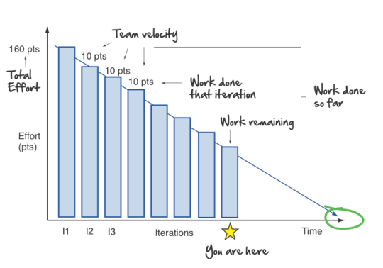
Burst |  | In telecommunication, a burst transmission or data burst is the broadcast of a relatively high-bandwidth transmission over a short period.
Business Agility Ownership |  | Business agility is the ability of an organization to sense changes internally or externally and respond accordingly in order to deliver value to its customers.
Business Requirement |  | High level objectives of the organization or customer requesting a system or product. Also known as the Why Requirements.
Business Schedule |  | High level project schedule containing top level milestones and their associated business goals for the entire project. A business schedule often defines a set of top-down schedule constraints that will be managed to. Compare to detailed schedule.
BYOD | Bring your own device | Bring your own device (BYOD)—also called bring your own technology (BYOT), bring your own phone (BYOP), and bring your own personal computer (BYOPC)—refers to the policy of permitting employees to bring personally owned devices (laptops, tablets, and smart phones) to their workplace, and to use those devices to access privileged company information and applications. The phenomenon is commonly referred to as IT consumerization.  BYOD is making significant inroads in the business world, with about 75% of employees in high growth markets such as Brazil and Russia and 44% in developed markets already using their own technology at work. Surveys have indicated that businesses are unable to stop employees from bringing personal devices into the workplace. Research is divided on benefits. One survey shows around 95% of employees stating they use at least one personal device for work.

C
C |  | C is a general-purpose, imperative computer programming language, supporting structured programming, lexical variable scope and recursion, while a static type system prevents many unintended operations. By design, C provides constructs that map efficiently to typical machine instructions, and therefore it has found lasting use in applications that had formerly been coded in assembly language, including operating systems, as well as various application software for computers ranging from supercomputers to embedded systems.  C was originally developed by Dennis Ritchie between 1969 and 1973 at Bell Labs, and used to re-implement the Unix operating system. It has since become one of the most widely used programming languages of all time,[8][9] with C compilers from various vendors available for the majority of existing computer architectures and operating systems. C has been standardized by the American National Standards Institute (ANSI) since 1989 (see ANSI C) and subsequently by the International Organization for Standardization (ISO).  C is an imperative procedural language. It was designed to be compiled using a relatively straightforward compiler, to provide low-level access to memory, to provide language constructs that map efficiently to machine instructions, and to require minimal run-time support. Despite its low-level capabilities, the language was designed to encourage cross-platform programming. A standards-compliant and portably written C program can be compiled for a very wide variety of computer platforms and operating systems with few changes to its source code. The language has become available on a very wide range of platforms, from embedded microcontrollers to supercomputers.
C# |  | C# is a multi-paradigm programming language encompassing strong typing, imperative, declarative, functional, generic, object-oriented (class-based), and component-oriented programming disciplines. It was developed around 2000 by Microsoft within its .NET initiative and later approved as a standard by Ecma (ECMA-334) and ISO (ISO/IEC 23270:2006). C# is one of the programming languages designed for the Common Language Infrastructure.  C# is a general-purpose, object-oriented programming language.
C++ |  | C++ is a general-purpose programming language. It has imperative, object-oriented and generic programming features, while also providing facilities for low-level memory manipulation.  It was designed with a bias toward system programming and embedded, resource-constrained and large systems, with performance, efficiency and flexibility of use as its design highlights. C++ has also been found useful in many other contexts, with key strengths being software infrastructure and resource-constrained applications, including desktop applications, servers (e.g. e-commerce, Web search or SQL servers), and performance-critical applications (e.g. telephone switches or space probes). C++ is a compiled language, with implementations of it available on many platforms. Many vendors provide C++ compilers, including the Free Software Foundation, Microsoft, Intel, and IBM.  C++ is standardized by the International Organization for Standardization (ISO), with the latest standard version ratified and published by ISO in December 2017 as ISO/IEC 14882:2017 (informally known as C++17). The C++ programming language was initially standardized in 1998 as ISO/IEC 14882:1998, which was then amended by the C++03, C++11 and C++14 standards. The current C++17 standard supersedes these with new features and an enlarged standard library. Before the initial standardization in 1998, C++ was developed by Bjarne Stroustrup at Bell Labs since 1979, as an extension of the C language as he wanted an efficient and flexible language similar to C, which also provided high-level features for program organization. C++20 is the next planned standard thereafter.
CA | Certificate Authority | In cryptography, a certificate authority or certification authority (CA) is an entity that issues digital certificates. A digital certificate certifies the ownership of a public key by the named subject of the certificate. This allows others (relying parties) to rely upon signatures or on assertions made about the private key that corresponds to the certified public key. A CA acts as a trusted third party—trusted both by the subject (owner) of the certificate and by the party relying upon the certificate. The format of these certificates is specified by the X.509 standard.  One particularly common use for certificate authorities is to sign certificates used in HTTPS, the secure browsing protocol for the World Wide Web. Another common use is in issuing identity cards by national governments for use in electronically signing documents.  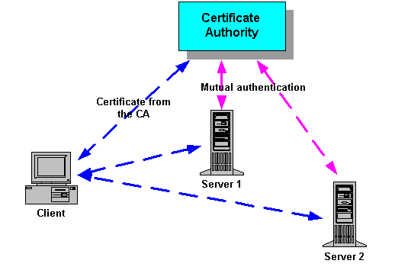
Cacti |  | Cacti is an open-source, web-based network monitoring and graphing tool designed as a front-end application for the open-source, industry-standard data logging tool RRDtool. Cacti allows a user to poll services at predetermined intervals and graph the resulting data. It is generally used to graph time-series data of metrics such as CPU load and network bandwidth utilization. A common usage is to monitor network traffic by polling a network switch or router interface via Simple Network Management Protocol (SNMP).
Cadence |  | the number of days or weeks in a Sprint or release; the length of the team’s development cycle.
Calendar Days |  | Time measure of the number of work days an activity takes.  The relationship between staff days and calendar days depends on how the work is scheduled.
CAM Item |  | Corrective activity management item. This is an abstract term referring to a change request, defect, risk, or issue that is being managed in a CAM process.
CAMEL | Customized Applications for Mobile networks Enhanced Logic | Customized Applications for Mobile networks Enhanced Logic (CAMEL) is a set of standards designed to work on either a GSM core network or the Universal Mobile Telecommunications System (UMTS) network. The framework provides tools for operators to define additional features for standard GSM services/UMTS services. The CAMEL architecture is based on the Intelligent Network (IN) standards, and uses the CAP protocol. The protocols are codified in a series of ETSI Technical Specifications.  Many services can be created using CAMEL, and it is particularly effective in allowing these services to be offered when a subscriber is roaming, like, for instance, no-prefix dialing (the number the user dials is the same no matter the country where the call is placed) or seamless MMS message access from abroad.
Camel Case |  | Camel case (stylized as camelCase or CamelCase; also known as camel caps or more formally as medial capitals) is the practice of writing compound words or phrases such that each word or abbreviation in the middle of the phrase begins with a capital letter, with no intervening spaces or punctuation. Common examples include "iPhone", "eBay", "FedEx", "DreamWorks", and "HarperCollins". It is also sometimes used in online usernames such as "JohnSmith", and to make multi-word domain names more legible, for example in advertisements.  Programming and coding  The use of medial caps for compound identifiers is recommended by the coding style guidelines of many organizations or software projects. For some languages (such as Mesa, Pascal, Modula, Java and Microsoft's .NET) this practice is recommended by the language developers or by authoritative manuals and has therefore become part of the language's "culture".  Style guidelines often distinguish between upper and lower camel case, typically specifying which variety should be used for specific kinds of entities: variables, record fields, methods, procedures, types, etc. These rules are sometimes supported by static analysis tools that check source code for adherence.  The original Hungarian notation for programming, for example, specifies that a lowercase abbreviation for the "usage type" (not data type) should prefix all variable names, with the remainder of the name in upper camel case; as such it is a form of lower camel case.  Programming identifiers often need to contain acronyms and initialisms that are already in uppercase, such as "old HTML file". By analogy with the title case rules, the natural camel case rendering would have the abbreviation all in uppercase, namely "oldHTMLFile". However, this approach is problematic when two acronyms occur together (e.g., "parse DBM XML" would become "parseDBMXML") or when the standard mandates lower camel case but the name begins with an abbreviation (e.g. "SQL server" would become "sQLServer"). For this reason, some programmers prefer to treat abbreviations as if they were lowercase words and write "oldHtmlFile", "parseDbmXml" or "sqlServer". However, this can make it harder to recognise that a given word is intended as an acronym.
CAP | CAMEL Application Part | The CAMEL Application Part (CAP) is a signalling protocol used in the Intelligent Network (IN) architecture. CAP is a Remote Operations Service Element (ROSE) user protocol, and as such is layered on top of the Transaction Capabilities Application Part (TCAP) of the SS#7 protocol suite. CAP is based on a subset of the ETSI Core and allows for the implementation of carrier-grade, value added services such as unified messaging, prepaid, fraud control and Freephone in both the GSM voice and GPRS data networks. CAMEL is a means of adding intelligent applications to mobile (rather than fixed) networks. It builds upon established practices in the fixed line telephony business that are generally classed under the heading of (Intelligent Network Application Part) or INAP CS-2 protocol
Capability Maturity Model |  | The Capability Maturity Model (CMM) is a development model created after a study of data collected from organizations that contracted with the U.S. Department of Defense, who funded the research. The term "maturity" relates to the degree of formality and optimization of processes, from ad hoc practices, to formally defined steps, to managed result metrics, to active optimization of the processes.  The model's aim is to improve existing software development processes, but it can also be applied to other processes.  Structure  The model involves five aspects:  - Maturity Levels: a 5-level process maturity continuum - where the uppermost (5th) level is a notional ideal state where processes would be systematically managed by a combination of process optimization and continuous process improvement.  - Key Process Areas: a Key Process Area identifies a cluster of related activities that, when performed together, achieve a set of goals considered important.  - Goals: the goals of a key process area summarize the states that must exist for that key process area to have been implemented in an effective and lasting way. The extent to which the goals have been accomplished is an indicator of how much capability the organization has established at that maturity level. The goals signify the scope, boundaries, and intent of each key process area.  - Common Features: common features include practices that implement and institutionalize a key process area. There are five types of common features: commitment to perform, ability to perform, activities performed, measurement and analysis, and verifying implementation.  - Key Practices: The key practices describe the elements of infrastructure and practice that contribute most effectively to the implementation and institutionalization of the area.  Levels  There are five levels defined along the continuum of the model and, according to the SEI: "Predictability, effectiveness, and control of an organization's software processes are believed to improve as the organization moves up these five levels. While not rigorous, the empirical evidence to date supports this belief".  - Initial (chaotic, ad hoc, individual heroics) - the starting point for use of a new or undocumented repeat process.  - Repeatable - the process is at least documented sufficiently such that repeating the same steps may be attempted.  - Defined - the process is defined/confirmed as a standard business process  - Capable - the process is quantitatively managed in accordance with agreed-upon metrics.  - Efficient - process management includes deliberate process optimization/improvement.  Within each of these maturity levels are Key Process Areas which characterise that level, and for each such area there are five factors: goals, commitment, ability, measurement, and verification. These are not necessarily unique to CMM, representing — as they do — the stages that organizations must go through on the way to becoming mature.  The model provides a theoretical continuum along which process maturity can be developed incrementally from one level to the next. Skipping levels is not allowed/feasible.
Cat 5 |  | Category 5 cable, commonly referred to as Cat 5, is a twisted pair cable for computer networks. The cable standard provides performance of up to 100 MHz and is suitable for most varieties of Ethernet over twisted pair. Cat 5 is also used to carry other signals such as telephony and video.  This cable is commonly connected using punch-down blocks and modular connectors. Most Category 5 cables are unshielded, relying on the balanced line twisted pair design and differential signaling for noise rejection.  The category 5 specification was deprecated in 2001 and is superseded by the category 5e specification.
Cat 5e |  | See cat 5
Cat 6 |  | Category 6 cable, commonly referred to as Cat 6, is a standardized twisted pair cable for Ethernet and other network physical layers that is backward compatible with the Category 5/5e and Category 3 cable standards.  Compared with Cat 5 and Cat 5e, Cat 6 features more stringent specifications for crosstalk and system noise. The cable standard also specifies performance of up to 250 MHz compared to 100 MHz for Cat 5 and Cat 5e.  Whereas Category 6 cable has a reduced maximum length of 55 meters when used for 10GBASE-T, Category 6A cable (or Augmented Category 6) is characterized to 500 MHz and has improved alien crosstalk characteristics, allowing 10GBASE-T to be run for the same 100 meter maximum distance as previous Ethernet variants.
CCITT | Comité Consultatif International Téléphonique et Télégraphique | See ITU-T
CCS | Common Channel Signalling | In telephony, common-channel signaling (CCS), in the US also common-channel interoffice signaling (CCIS), is the transmission of signaling information (control information) on a separate channel than the data, and, more specifically, where that signaling channel controls multiple data channels.  For example, in the public switched telephone network (PSTN) one channel of a communications link is typically used for the sole purpose of carrying signaling for establishment and tear down of telephone calls. The remaining channels are used entirely for the transmission of voice data. In most cases, a single 64kbit/s channel is sufficient to handle the call setup and call clear-down traffic for numerous voice and data channels.  The logical alternative to CCS is channel-associated signaling (CAS), in which each bearer channel has a signaling channel dedicated to it.  CCS offers the following advantages over CAS, in the context of the PSTN:  - Faster call set-up time  - Greater trunking efficiency due to the quicker set up and clearing, thereby reducing traffic on the network  - Can transfer additional information along with the signaling traffic, providing features such as caller ID  - Signaling can be performed mid-call  The most common CCS signaling methods in use today are Integrated Services Digital Network (ISDN) and Signalling System No. 7 (SS7).  ISDN signaling is used primarily on trunks connecting end-user private branch exchange (PBX) systems to a central office. SS7 is primarily used within the PSTN. The two signaling methods are very similar since they share a common heritage and in some cases, the same signaling messages are transmitted in both ISDN and SS7.
CCTA | Central Computer and Telecommunications Agency | The Central Computer and Telecommunications Agency (CCTA) was a UK government agency providing computer and telecoms support to government departments.
CDMA | Code-division multiple access | Code-division multiple access (CDMA) is a channel access method used by various radio communication technologies.  CDMA is an example of multiple access, where several transmitters can send information simultaneously over a single communication channel. This allows several users to share a band of frequencies . To permit this without undue interference between the users, CDMA employs spread spectrum technology and a special coding scheme (where each transmitter is assigned a code).  CDMA is used as the access method in many mobile phone standards. IS-95, also called "cdmaOne", and its 3G evolution CDMA2000, are often simply referred to as "CDMA", but UMTS, the 3G standard used by GSM carriers, also uses "wideband CDMA", or W-CDMA, as well as TD-CDMA and TD-SCDMA, as its radio technologies.
CDMA2000 | Code-division multiple access 2000 | CDMA2000 (also known as C2K or IMT Multi-Carrier (IMT-MC)) is a family of 3G mobile technology standards for sending voice, data, and signaling data between mobile phones and cell sites. It is developed by 3GPP2 as a backwards-compatible successor to second-generation cdmaOne (IS-95) set of standards and used especially in North America and South Korea.  CDMA2000 compares to UMTS, a competing set of 3G standards, which is developed by 3GPP and used in Europe, Japan, and China.
CDR | Call Detail Record | A call detail record (CDR) is a data record produced by a telephone exchange or other telecommunications equipment that documents the details of a telephone call or other telecommunications transaction (e.g., text message) that passes through that facility or device. The record contains various attributes of the call, such as time, duration, completion status, source number, and destination number.
CE | Customer Edge | The customer edge (CE) is the router at the customer premises that is connected to the provider edge of a service provider IP/MPLS network. CE peers with the Provider Edge (PE) and exchanges routes with the corresponding VRF inside the PE. The routing protocol used could be static or dynamic (an interior gateway protocol like OSPF or an exterior gateway protocol like BGP).  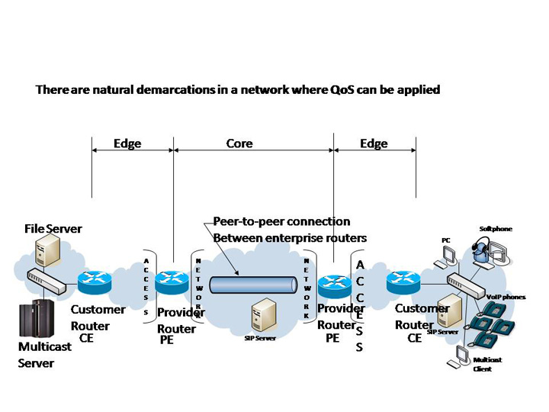
CER | Canonical Encoding Rules | CER (Canonical Encoding Rules) is a restricted variant of BER for producing unequivocal transfer syntax for data structures described by ASN.1. Whereas BER gives choices as to how data values may be encoded, CER (together with DER) selects just one encoding from those allowed by the basic encoding rules, eliminating rest of the options. CER is useful when the encodings must be preserved; e.g., in security exchanges.
Ceremonies |  | meetings, often a daily planning meeting, that identify what has been done, what is to be done and the barriers to success.
CESG | Communication-Electronics Security Group | CESG is the UK government's national technical authority for information assurance (IA). It protects the UK by providing policy and assistance on the security of communications and electronic data, in partnership with industry and academia.  The group is known as CESG. It dropped the expanded name of Communications-Electronics Security Group in 2002 because it no longer described the full extent of its work. CESG has existed since World War I when it advised on the security of British codes and ciphers. Since 1997, it has charged a fee for most of the information security services it offers rather than being funded by central government.  UK central government departments and agencies and the armed forces are CESG’s main customers. CESG also works with the wider public sector, including health service, law enforcement, local government and the utility companies that provide the services that form the UK's critical national infrastructure.  CESG provides information assurance products and services and accreditation for consultants in industry. It also produces policy and guidance on biometrics and runs GovCertUK, the Computer Emergency Response Team (CERT) for UK government, assisting public sector organizations in their response to computer security incidents and providing advice to reduce their exposure to security threats.  Other services provided by CESG include Information Assurance Maturity Model (IAMM) assessment services for organisations wishing to check their progress towards the National IA Strategy and security awareness training for government clients.
CFi | Canonical Format Indicator | A bit in an IEEE 802.1Q frame.  The Canonical Format Indicator (CFI) bit indicates whether the following 12 bits of VLAN identifier conform to Ethernet or not. For Ethernet frames, this bit is always set to 0. (The other possible value, CFI=1, is used for Token Ring LANs, and tagged frames should never be bridged between an Ethernet and Token Ring LAN regardless of the VLAN tag or MAC address.)
CGI | Common Gateway Interface | n computing, Common Gateway Interface (CGI) offers a standard protocol for web servers to execute programs that execute like console applications (also called command-line interface programs) running on a server that generates web pages dynamically. Such programs are known as CGI scripts or simply as CGIs. The specifics of how the script is executed by the server are determined by the server. In the common case, a CGI script executes at the time a request is made and generates HTML.
Change Control | CC | A subset of change management concerned with identifying artifacts that will be placed under the control of a change control board. Change control may refer to explicit change control or implicit change control.  Also a synonym for change management.
Change Control Board | CCB | The group of individuals responsible for processing and making final decisions on change requests to the artifacts under change control.
Change Control Plan | CCP | Documents the types and levels of change control used on project artifacts.
Change Management |  | Systematic management of feature, scope, or other requested changes to an artifact or project. Part of both configuration management and corrective activity management.
Change Request | CR | A request to change an item under change control.  Usually a request to add, modify, or remove a system requirement based on a business need. May also be a request to change project planning. Change requests are a type of corrective activity management item.
CHAP | Challenge Handshake Authentication Protocol | In computing, the Challenge-Handshake Authentication Protocol (CHAP) authenticates a user or network host to an authenticating entity. That entity may be, for example, an Internet service provider. CHAP is specified in RFC 1994.  CHAP provides protection against replay attacks by the peer through the use of an incrementally changing identifier and of a variable challenge-value. CHAP requires that both the client and server know the plaintext of the secret, although it is never sent over the network. Thus, CHAP provides better security as compared to Password Authentication Protocol (PAP) which is vulnerable for both these reasons. The MS-CHAP variant does not require either peer to know the plaintext and does not transmit it, but has been broken
Checklist | CxCheck | CxOne checklist material type. Short list of brief items that provide guidance when creating artifacts or performing actions. See CxOneOverview for description.
Chrome OS |  | Chrome OS is an operating system designed by Google that is based on the Linux kernel and uses the Google Chrome web browser as its principal user interface. As a result, Chrome OS primarily supports web applications.
Circuit Switched |  | Circuit switching is a method of implementing a telecommunications network in which two network nodes establish a dedicated communications channel (circuit) through the network before the nodes may communicate. The circuit guarantees the full bandwidth of the channel and remains connected for the duration of the communication session. The circuit functions as if the nodes were physically connected as with an electrical circuit.  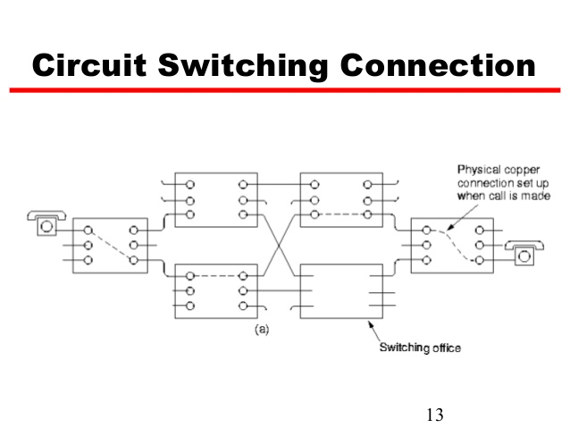
Class 4 Softswitch |  | Softswitches used for transit VoIP traffic between carriers are usually called class 4 softswitches. Analogous with other Class 4 telephone switches, the main function of the class 4 softswitch is the routing of large volumes of long distance VoIP calls. The most important characteristics of class 4 softswitch are protocol support and conversion, transcoding, calls per second rate, average time of one call routing, number of concurrent calls.
Class 5 Softswitch |  | Class 5 softswitches are intended for work with end-users. These softswitches are both for local and long distance telephony services. Class 5 softswitches are characterized by additional services for end-users and corporate clients such as IP PBX features, call center services, calling card platform, types of authorization, QoS, Business Groups and other features similar to other Class 5 telephone switches. Class 5 Softswitches may also provide analog twisted-pair POTS Access to subscribers homes using special Central Office hardware like ATA's, EMTA's, IAD's, And General-Purpose PBX's.
Class Model |  | An internal object oriented view of a system showing the static class structure.
CLF | Subscriber Location Function | A subscriber location function (SLF) is needed to map user addresses when multiple HSSs are used.
CMDB | Configuration Management Database | A Configuration Management Database (CMDB) is an ITIL database used by an organization to store information about hardware and software assets (commonly referred to as Configuration Items [CI]). This database acts as a data warehouse for the organization and also stores information regarding the relationship between its assets. The CMDB provides a means of understanding the organization's critical assets and their relationships, such as information systems, upstream sources or dependencies of assets, and the downstream targets of assets.
CMDB | configuration management database | A configuration management database (CMDB) is a data repository that acts as a data warehouse or inventory for information technology (IT) installations. It holds data relating to a collection of IT assets (commonly referred to as configuration items (CI)), as well as to descriptive relationships between such assets. The repository provides a means of understanding:  - the composition of critical assets such as information systems  - the upstream sources or dependencies of assets  the downstream targets of assets
CNG | Comfort Noise Generation | Comfort noise (or comfort tone) is synthetic background noise used in radio and wireless communications to fill the artificial silence in a transmission resulting from voice activity detection or from the audio clarity of modern digital lines.  Some modern telephone systems (such as wireless and VoIP) use voice activity detection (VAD), a form of squelching where low volume levels are ignored by the transmitting device. In digital audio transmissions, this saves bandwidth of the communications channel by transmitting nothing when the source volume is under a certain threshold, leaving only louder sounds (such as the speaker's voice) to be sent. However, improvements in background noise reduction technologies can occasionally result in the complete removal of all noise. Although maximizing call quality is of primary importance, exhaustive removal of noise may not properly simulate the typical behavior of terminals on the PSTN system.  The result of receiving total silence, especially for a prolonged period, has a number of unwanted effects on the listener, including the following:  the listener may believe that the transmission has been lost, and therefore hang up prematurely.  the speech may sound "choppy" (see noise gate) and difficult to understand.  the sudden change in sound level can be jarring to the listener.  To counteract these effects, comfort noise is added, usually on the receiving end in wireless or VoIP systems, to fill in the silent portions of transmissions with artificial noise. The noise generated is at a low but audible volume level, and can vary based on the average volume level of received signals to minimize jarring transitions.  In many VoIP products, users may control how VAD and comfort noise are configured, or disable the feature entirely.  As part of the RTP audio video profile, RFC 3389 defines a standard for distributing comfort noise information in VoIP systems.  A similar concept is that of sidetone, the effect of sound that is picked up by a telephone's mouthpiece and introduced (at low level) into the earpiece of the same handset, acting as feedback.
Cobol |  | COBOL is a compiled English-like computer programming language designed for business use. It is imperative, procedural and, since 2002, object-oriented. COBOL is primarily used in business, finance, and administrative systems for companies and governments. COBOL is still widely used in legacy applications deployed on mainframe computers, such as large-scale batch and transaction processing jobs. But due to its declining popularity and the retirement of experienced COBOL programmers, programs are being migrated to new platforms, rewritten in modern languages or replaced with software packages. Most programming in COBOL is now purely to maintain existing applications.  COBOL was designed in 1959 by CODASYL and was partly based on previous programming language design work by Grace Hopper, commonly referred to as "the (grand)mother of COBOL". It was created as part of a US Department of Defense effort to create a portable programming language for data processing. Intended as a stopgap, the Department of Defense promptly forced computer manufacturers to provide it, resulting in its widespread adoption. It was standardized in 1968 and has since been revised four times. Expansions include support for structured and object-oriented programming. The current standard is ISO/IEC 1989:2014.  COBOL statements have an English-like syntax, which were designed to be self-documenting and highly readable. However, it is verbose and uses over 300 reserved words. In contrast with modern, succinct syntax like y = x;, COBOL has a more English-like syntax (in this case, MOVE x TO y). COBOL code is split into four divisions (identification, environment, data and procedure) containing a rigid hierarchy of sections, paragraphs and sentences. Lacking a large standard library, the standard specifies 43 statements, 87 functions and just one class.
Code and Fix Lifecycle |  | The system is started from a general concept and evolved through some combination of informal design, code, debug, and test methodologies until it is ready to release
Codecs |  | A codec is a device or computer program for encoding or decoding a digital data stream or signal. Codec is a portmanteau of coder-decoder.  A codec encodes a data stream or a signal for transmission and storage, possibly in encrypted form, and the decoder function reverses the encoding for playback or editing. Codecs are used in videoconferencing, streaming media, and video editing applications.  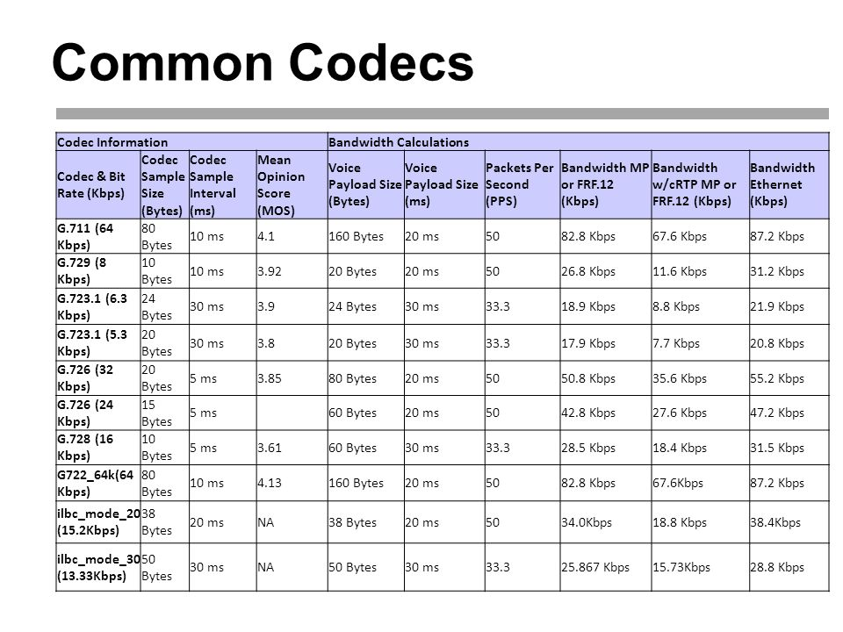
Coding |  | The core activity of construction; involves creating source code instructions and/or data that define the behavior of a software system.
Coding Standard |  | Synonym for Construction Standard.
CoE | Centre of Excellence | A center of excellence (COE) is a team, a shared facility or an entity that provides leadership, best practices, research, support and/or training for a focus area. The focus area might be a technology (e.g. Java), a business concept (e.g. BPM), a skill (e.g. negotiation) or a broad area of study (e.g. women's health). A center of excellence may also be aimed at revitalizing stalled initiatives.  Within an organization, a center of excellence may refer to a group of people, a department or a shared facility. It may also be known as a competency center or a capability center. The term may also refer to a network of institutions collaborating with each other to pursue excellence in a particular area.
COFDM | Coded orthogonal frequency-division multiplexing | In coded orthogonal frequency-division multiplexing (COFDM), forward error correction (convolutional coding) and time/frequency interleaving are applied to the signal being transmitted. This is done to overcome errors in mobile communication channels affected by multipath propagation and Doppler effects.
Collaboration Model |  | Specifies the set of object roles and their interactions by showing and describing the messages exchanged. The focus is on the relationship between roles.
Collaborative Construction | CCON  (see-kahn) | A technique used during construction where a small group of 2-6 engineers work together closely to incrementally construct system functionality. Marked by frequent, informal communication, iterative, code-oriented low level design techniques, and shared ownership of source code and test responsibilities.
Collective code ownership |  | Collective code ownership is the explicit convention that every team member can make changes to any code file as necessary: either to complete a development task, to repair a defect, or to improve the code's overall structure.
COLO | COlLOcated
Compatibility Test |  | See configuration test.
Compiled Language |  | A compiled language is a programming language whose implementations are typically compilers (translators that generate machine code from source code), and not interpreters (step-by-step executors of source code, where no pre-runtime translation takes place).  The term is somewhat vague. In principle, any language can be implemented with a compiler or with an interpreter. A combination of both solutions is also common: a compiler can translate the source code into some intermediate form (often called p-code or bytecode), which is then passed to an interpreter which executes it.
Compiler Back end |  | The back end takes the optimized IR from the middle end. It may perform more analysis, transformations and optimizations that are specific for the target CPU architecture. The back end generates the target-dependent assembly code, performing register allocation in the process. The back end performs instruction scheduling, which re-orders instructions to keep parallel execution units busy by filling delay slots. Although most algorithms for optimization are NP-hard, heuristic techniques are well-developed and currently implemented in production-quality compilers. Typically the output of a back end is machine code specialized for a particular processor and operating system.
Compiler Front end |  | The front end verifies syntax and semantics according to a specific source language. For statically typed languages it performs type checking by collecting type information. If the input program is syntactically incorrect or has a type error, it generates errors and warnings, highlighting[dubious – discuss] them on the source code. Aspects of the front end include lexical analysis, syntax analysis, and semantic analysis. The front end transforms the input program into an intermediate representation (IR) for further processing by the middle end. This IR is usually a lower-level representation of the program with respect to the source code
Compiler Middle end |  | The middle end performs optimizations on the IR that are independent of the CPU architecture being targeted. This source code/machine code independence is intended to enable generic optimizations to be shared between versions of the compiler supporting different languages and target processors. Examples of middle end optimizations are removal of useless (dead code elimination) or unreachable code (reachability analysis), discovery and propagation of constant values (constant propagation), relocation of computation to a less frequently executed place (e.g., out of a loop), or specialization of computation based on the context. Eventually producing the "optimized" IR that is used by the back end.
Compiler preprocessor |  | In computer science, a preprocessor is a program that processes its input data to produce output that is used as input to another program. The output is said to be a preprocessed form of the input data, which is often used by some subsequent programs like compilers. The amount and kind of processing done depends on the nature of the preprocessor; some preprocessors are only capable of performing relatively simple textual substitutions and macro expansions, while others have the power of full-fledged programming languages.  A common example from computer programming is the processing performed on source code before the next step of compilation. In some computer languages (e.g., C and PL/I) there is a phase of translation known as preprocessing. It can also include macro processing, file inclusion and language extensions.
Complier |  | A compiler is computer software that transforms computer code written in one programming language (the source language) into another programming language (the target language). Compilers are a type of translator that support digital devices, primarily computers. The name compiler is primarily used for programs that translate source code from a high-level programming language to a lower level language (e.g., assembly language, object code, or machine code) to create an executable program.  However, there are many different types of compilers. If the compiled program can run on a computer whose CPU or operating system is different from the one on which the compiler runs, the compiler is a cross-compiler. A bootstrap compiler is written in the language that it intends to compile. A program that translates from a low-level language to a higher level one is a decompiler. A program that translates between high-level languages is usually called a source-to-source compiler or transpiler. A language rewriter is usually a program that translates the form of expressions without a change of language. The term compiler-compiler refers to tools used to create parsers that perform syntax analysis.  A compiler is likely to perform many or all of the following operations: preprocessing, lexical analysis, parsing, semantic analysis (syntax-directed translation), conversion of input programs to an intermediate representation, code optimization and code generation. Compilers implement these operations in phases that promote efficient design and correct transformations of source input to target output. Program faults caused by incorrect compiler behavior can be very difficult to track down and work around; therefore, compiler implementers invest significant effort to ensure compiler correctness.  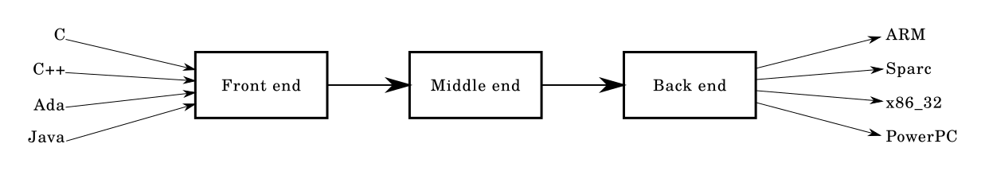
Component |  | Software component. An abstraction that refers to a part of a software system.
Component Test |  | Test of a software component in isolation from its system.
Cone of Uncertainty |  | Early in a project, specific details of the nature of the software to be built, details of specific requirements, details of the solution, project plan, staffing, and other project variables are unclear. The variability in these factors contributes variability to project estimates — an accurate estimate of a variable phenomenon must include the variability in the phenomenon itself. As these sources of variabiility are further investigated and pinned down, the variability in the project diminishes, and so the variability in the project estimatescan also diminish. This phenomenon is known as the “Cone of Uncertainty” which is illustrated in the following figure. As the figure suggests, significant narrowing of the Cone occur during the first 20-30% of the total calendar time for the project.  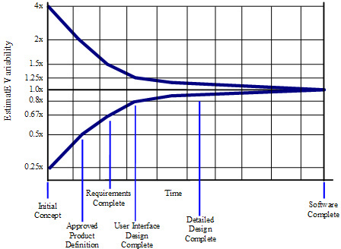
Cone of Uncertainty |  | The amount of possible error in a software project estimate, which is very large in the early stages of a project and shrinks dramatically as the project nears completion.
Configuration Item | CI | A description of an artifact or group of artifacts that is identified by the configuration management plan. Configuration items are used to apply CM policies and processes to organizational and project artifacts.
Configuration Management | CM | Activities and tasks related to defining, documenting, releasing, and maintaining the integrity of information in or about a system.
Configuration Test |  | Test of a software system to determine behavior with different configurations, platforms, environments, etc.
Construction |  | Software construction. Implementing a design to create a software system using technology. Also denotes the construction CKA. See CxStand_Construction for more information.
Construction Environment |  | See development environment.
Construction Lead |  | Responsible for construction, integration, product builds, technology issues, development environment, and deployment issues.
Construction Standard |  | A standard describing detailed conventions, and styles that developers should follow when creating a system's source code or related construction artifacts. Coding Standard is a common synonym.
Construction Test Environment |  | See local test environment.
Construction Testing |  | A best practice that calls for several types of testing to be performed during the construction of a component, by the engineer(s) creating it, to verify additions or modifications both at the component level and in the context of the system.
Construx Knowledge Area | CKA | The basis for organizing CxOne and other Construx software engineering resources. Based on the SWEBOK organization of software engineering.  Sometimes referred to as ‘CxOne Knowledge Areas’.
Continuous Deployment |  | Continuous deployment aims to reduce the time elapsed between writing a line of code and making that code available to users in production. To achieve continuous deployment, the team relies on infrastructure that automates and instruments the various steps leading up to deployment, so that after each integration successfully meeting these release criteria, the live application is updated with new code.
continuous integration |  | In software engineering, continuous integration (CI) is the practice of merging all developer working copies to a shared mainline several times a day. Grady Booch first named and proposed CI in his 1991 method, although he did not advocate integrating several times a day. Extreme programming (XP) adopted the concept of CI and did advocate integrating more than once per day – perhaps as many as tens of times per day.
Continuous Integration |  | Continuous Integration is the practice of merging code changes into a shared repository several times a day in order to release a product version at any moment. This requires an integration procedure which is reproducible and automated.
Control Plane |  | In routing, the control plane is the part of the router architecture that is concerned with drawing the network topology, or the information in a (possibly augmented) routing table that defines what to do with incoming packets. Control plane functions, such as participating in routing protocols, run in the architectural control element. In most cases, the routing table contains a list of destination addresses and the outgoing interface(s) associated with them. Control plane logic also can define certain packets to be discarded, as well as preferential treatment of certain packets for which a high quality of service is defined by such mechanisms as differentiated services.  Depending on the specific router implementation, there may be a separate forwarding information base that is populated (i.e., loaded) by the control plane, but used by the forwarding plane to look up packets, at very high speed, and decide how to handle them.  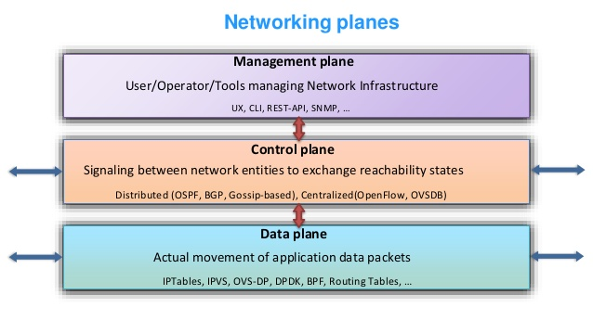
Copyleft |  | Copyleft (a play on the word copyright) is the practice of offering people the right to freely distribute copies and modified versions of a work with the stipulation that the same rights be preserved in derivative works down the line. Copyleft software licenses are considered protective or reciprocal, as contrasted with permissive free software licenses.  Copyleft is a form of licensing, and can be used to maintain copyright conditions for works ranging from computer software, to documents, to art, to scientific discoveries and instruments in medicine. In general, copyright law is used by an author to prohibit recipients from reproducing, adapting, or distributing copies of their work. In contrast, under copyleft, an author must give every person who receives a copy of the work permission to reproduce, adapt, or distribute it, with the accompanying requirement that any resulting copies or adaptations are also bound by the same licensing agreement.  Copyleft licenses for software require that information necessary for reproducing and modifying the work must be made available to recipients of the binaries. The source code files will usually contain a copy of the license terms and acknowledge the authors.  Copyleft type licenses are a novel use of existing copyright law to ensure a work remains freely available. The GNU General Public License (GPL), originally written by Richard Stallman, was the first software copyleft license to see extensive use, and continues to dominate in that area. Creative Commons, a non-profit organization founded by Lawrence Lessig, provides a similar license provision condition called share-alike.  
Corrective Activity Management | CAM | The management of identified change requests, defects, risks, and issues.  CAM is a CxOne abstraction allowing reuse of materials and processes for the management of project work not explicitly identified in the project plan.
CoS | Class of Service | Class of service is a parameter used in data and voice protocols to differentiate the types of payloads contained in the packet being transmitted. The objective of such differentiation is generally associated with assigning priorities to the data payload or access levels to the telephone call.
COTS | Commercial off-the-shelf | Commercial off-the-shelf or commercially available off-the-shelf (COTS) is a term used to describe the purchase of packaged solutions which are then adapted to satisfy the needs of the purchasing organization, rather than the commissioning of custom-made, or bespoke, solutions. A related term, Mil-COTS, refers to COTS products for use by the U.S. military.  In the context of the U.S. government, the Federal Acquisition Regulation (FAR) has defined "COTS" as a formal term for commercial items, including services, available in the commercial marketplace that can be bought and used under government contract. For example, Microsoft is a COTS software provider. Goods and construction materials may qualify as COTS but bulk cargo does not. Services associated with the commercial items may also qualify as COTS, including installation services, training services, and cloud services.  COTS purchases are alternatives to custom software or one-off developments – government-funded developments or otherwise.  Although COTS products can be used out of the box, in practice the COTS product must be configured to achieve the needs of the business and integrated to existing organizational systems. Extending the functionality of COTS products via custom development is also an option, however this decision should be carefully considered due to the long term support and maintenance implications. Such customized functionality is not supported by the COTS vendor, so brings its own sets of issues when upgrading the COTS product.
CPE | Customer Premise Equipment | Customer-premises equipment or customer-provided equipment (CPE) is any terminal and associated equipment located at a subscriber's premises and connected with a carrier's telecommunication circuit at the demarcation point  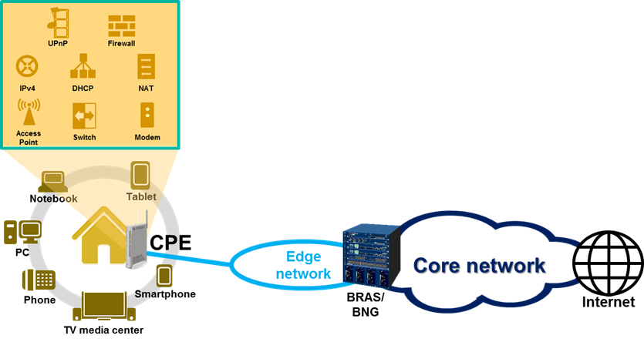
CPM | critical path method | The critical path method (CPM), or critical path analysis (CPA), is an algorithm for scheduling a set of project activities.[1] It is commonly used in conjunction with the program evaluation and review technique (PERT).
CPS | Carrier Pre-Select | Carrier preselect is a term relating to the telecommunications industry. It is a method of routing calls for least-cost routing (LCR) without the need for programming of PBX telephone system.  This is the process whereby a telephone subscriber whose telephone line is maintained by one company, usually a former monopoly provider (e.g. BT), can choose to have some of their calls automatically routed across a different telephone company's network (e.g. Talk Talk) without needing to enter a special code or special equipment.
CRC | cyclic redundancy check | A cyclic redundancy check (CRC) is an error-detecting code commonly used in digital networks and storage devices to detect accidental changes to raw data. Blocks of data entering these systems get a short check value attached, based on the remainder of a polynomial division of their contents. On retrieval, the calculation is repeated and, in the event the check values do not match, corrective action can be taken against data corruption. CRCs can be used for error correction (see bitfilters).  CRCs are so called because the check (data verification) value is a redundancy (it expands the message without adding information) and the algorithm is based on cyclic codes. CRCs are popular because they are simple to implement in binary hardware, easy to analyze mathematically, and particularly good at detecting common errors caused by noise in transmission channels. Because the check value has a fixed length, the function that generates it is occasionally used as a hash function.
CRC Cards | Class Responsibility Collaborator Cards | CRC Cards are an object oriented design technique teams can use to discuss what a class should know and do and what other classes it interacts with.  CRC cards are usually created from index cards. Members of a brainstorming session will write up one CRC card for each relevant class/object of their design. The card is partitioned into three areas:  - On top of the card, the class name  - On the left, the responsibilities of the class  On the right, collaborators (other classes) with which this class interacts to fulfill its responsibilities
CSCF | Call Session Control Function | Several roles of SIP servers or proxies, collectively called Call Session Control Function (CSCF), are used to process SIP signaling packets in the IMS.  - A Proxy-CSCF (P-CSCF) is a SIP proxy that is the first point of contact for the IMS terminal. It can be located either in the visited network (in full IMS networks) or in the home network (when the visited network is not IMS compliant yet). Some networks may use a Session Border Controller (SBC) for this function. The P-CSCF is at its core a specialized SBC for the User–network interface which not only protects the network, but also the IMS terminal. The use of an additional SBC between the IMS terminal and the P-CSCF is unnecessary and infeasible due to the signaling being encrypted on this leg. The terminal discovers its P-CSCF with either DHCP, or it may be configured (e.g. during initial provisioning or via a 3GPP IMS Management Object (MO)) or in the ISIM or assigned in the PDP Context (in General Packet Radio Service (GPRS)).  - An Interrogating-CSCF (I-CSCF) is another SIP function located at the edge of an administrative domain. Its IP address is published in the Domain Name System (DNS) of the domain (using NAPTR and SRV type of DNS records), so that remote servers can find it, and use it as a forwarding point (e.g., registering) for SIP packets to this domain.  - A Serving-CSCF (S-CSCF) is the central node of the signaling plane. It is a SIP server, but performs session control too. It is always located in the home network. It uses Diameter Cx and Dx interfaces to the HSS to download user profiles and upload user-to-S-CSCF associations (the user profile is only cached locally for processing reasons and is not changed). All necessary subscriber profile information is loaded from the HSS.
Csh |  | The C shell (csh or the improved version, tcsh) is a Unix shell created by Bill Joy while he was a graduate student at University of California, Berkeley in the late 1970s. It has been widely distributed, beginning with the 2BSD release of the Berkeley Software Distribution (BSD) that Joy began distributing in 1978. Other early contributors to the ideas or the code were Michael Ubell, Eric Allman, Mike O'Brien and Jim Kulp.  The C shell is a command processor typically run in a text window, allowing the user to type commands. The C shell can also read commands from a file, called a script. Like all Unix shells, it supports filename wildcarding, piping, here documents, command substitution, variables and control structures for condition-testing and iteration. What differentiated the C shell from others, especially in the 1980s, were its interactive features and overall style. Its new features made it easier and faster to use. The overall style of the language looked more like C and was seen as more readable.
CSI | Customer Site Interconnect | In telecommunications, interconnection is the physical linking of a carrier's network with equipment or facilities not belonging to that network. The term may refer to a connection between a carrier's facilities and the equipment belonging to its customer, or to a connection between two (or more) carriers.  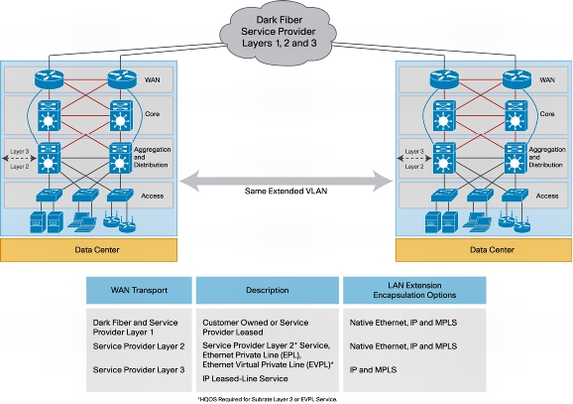
CSMA | Carrier-sense multiple access | Carrier-sense multiple access (CSMA) is a media access control (MAC) protocol in which a node verifies the absence of other traffic before transmitting on a shared transmission medium, such as an electrical bus or a band of the electromagnetic spectrum.  A transmitter attempts to determine whether another transmission is in progress before initiating a transmission using a carrier-sense mechanism. That is, it tries to detect the presence of a carrier signal from another node before attempting to transmit. If a carrier is sensed, the node waits for the transmission in progress to end before initiating its own transmission. Using CSMA, multiple nodes may, in turn, send and receive on the same medium. Transmissions by one node are generally received by all other nodes connected to the medium.  Variations on basic CSMA include addition of collision-avoidance, collision-detection and collision-resolution techniques.
CSS |  | Cascading Style Sheets (CSS) is a style sheet language used for describing the presentation of a document written in a markup language like HTML.[1] CSS is a cornerstone technology of the World Wide Web, alongside HTML and JavaScript.  CSS is designed to enable the separation of presentation and content, including layout, colors, and fonts. This separation can improve content accessibility, provide more flexibility and control in the specification of presentation characteristics, enable multiple web pages to share formatting by specifying the relevant CSS in a separate .css file, and reduce complexity and repetition in the structural content.  Separation of formatting and content also makes it feasible to present the same markup page in different styles for different rendering methods, such as on-screen, in print, by voice (via speech-based browser or screen reader), and on Braille-based tactile devices. CSS also has rules for alternate formatting if the content is accessed on a mobile device.  The name cascading comes from the specified priority scheme to determine which style rule applies if more than one rule matches a particular element. This cascading priority scheme is predictable.  The CSS specifications are maintained by the World Wide Web Consortium (W3C). Internet media type (MIME type) text/css is registered for use with CSS by RFC 2318 (March 1998). The W3C operates a free CSS validation service for CSS documents.  In addition to HTML, other markup languages support the use of CSS, including XHTML, plain XML, SVG, and XUL
C-Tag | Subscriber VLAN Tag | The IEEE standard 802.1ad provides for double-tagging by service providers so that they can use VLANs allocated internally together with traffic already tagged as VLANs by service provider customers.  In this double tagging, the C-Tag (customer tag) is the inner tag set by the customer. The S-Tag is the outer tag next to the MAC address.  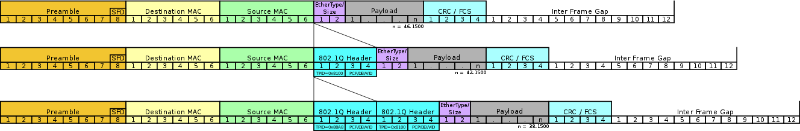  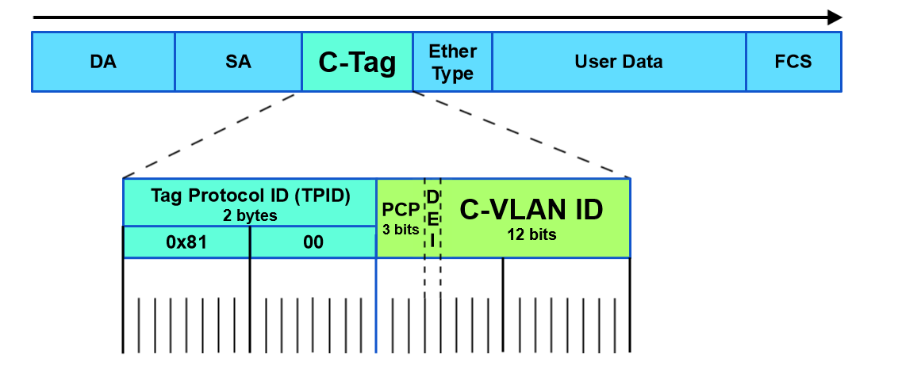
Customer Development |  | Customer development is a four-step framework that provides a way to use a scientific approach to validate assumptions about your product and business. (learn more)
CVSD | Continuously variable slope delta modulation | Continuously variable slope delta modulation (CVSD or CVSDM) is a voice coding method. It is a delta modulation with variable step size (i.e., special case of adaptive delta modulation), first proposed by Greefkes and Riemens in 1970.  CVSD encodes at 1 bit per sample, so that audio sampled at 16 kHz is encoded at 16 kbit/s.  The encoder maintains a reference sample and a step size. Each input sample is compared to the reference sample. If the input sample is larger, the encoder emits a 1 bit and adds the step size to the reference sample. If the input sample is smaller, the encoder emits a 0 bit and subtracts the step size from the reference sample. The encoder also keeps the previous N bits of output (N = 3 or N = 4 are very common) to determine adjustments to the step size; if the previous N bits are all 1s or 0s, the step size is increased. Otherwise, the step size is decreased (usually in an exponential manner, with {\displaystyle \tau } \tau being in the range of 5 ms). The step size is adjusted for every input sample processed.  To allow for bit errors to fade out and to allow (re)synchronization to an ongoing bitstream, the output register (which keeps the reference sample) is normally realized as a leaky integrator with a time constant ( {\displaystyle \tau } \tau ) of about 1 ms.  The decoder reverses this process, starting with the reference sample, and adding or subtracting the step size according to the bit stream. The sequence of adjusted reference samples are the reconstructed waveform, and the step size is adjusted according to the same all-1s-or-0s logic as in the encoder.  Adaptation of step size allows one to avoid slope overload (step of quantization increases when the signal rapidly changes) and decreases granular noise when the signal is constant (decrease of step of quantisation).  CVSD is sometimes called a compromise between simplicity, low bitrate, and quality. Common bitrates are 9.6–128 kbit/s.  Like other delta-modulation techniques, the output of the decoder does not exactly match the original input to the encoder.
CxOne | CxOne | Construx’s lightweight, tailorable, scalable, framework for software engineering knowledge management, process definition, and material reuse.

D
DAD |  | Disciplined agile delivery (DAD) is a process decision framework that enables simplified process decisions around incremental and iterative solution delivery. DAD builds on the many practices espoused by advocates of agile software development, including Scrum, agile modeling, lean software development, and others.  The primary reference for disciplined agile delivery is the book of same name, written by Scott Ambler and Mark Lines.  In particular, DAD has been identified as a means of moving beyond Scrum. According to Cutter Senior Consultant Bhuvan Unhelkar, "The DAD framework provides a carefully constructed mechanism that not only streamlines IT work, but more importantly, enables scaling." Paul Gorans and Philippe Kruchten call for more discipline in implementation of agile approaches and indicate that DAD, as an example framework, is "a hybrid agile approach to enterprise IT solution delivery that provides a solid foundation from which to scale.
Daily Meeting |  | The daily meeting is one of the most commonly practiced Agile techniques and presents opportunity for a team to get together on a regular basis to coordinate their activities.
Daily Scrum |  | Stand-up team meeting. A plan, do, review daily session.
Dark Fibre |  | A dark fibre or unlit fibre is an unused optical fibre, available for use in fibre-optic communication.  The term dark fibre was originally used when referring to the potential network capacity of telecommunication infrastructure, but now also refers to the increasingly common practice of leasing fibre optic cables from a network service provider, or, generally, to the fibre installations not owned or controlled by traditional carriers. In common vernacular, dark fibre may sometimes still be called "dark" if it has been lit by a fibre lessee and not the cable's owner.  A dark fibre network or simply dark network is a privately operated optical fiber network that is run directly by its operator over dark fibre leased or purchased from another supplier. This is in contrast to purchasing bandwidth or leased line capacity on an existing network. Dark fibre networks may be used for private networking, or as Internet access or infrastructure.
DASS1 |  | Digital Access Signalling System 1 (DASS1) is a proprietary protocol defined by British Telecom to provide ISDN services in the United Kingdom. It is now obsolete, having been replaced by DASS2. This too will become obsolete over the coming years as Q.931, a European standard, becomes widely adopted in the EU.
DASS2 |  | Digital Access Signalling System 2 (DASS2) is an obsolescent protocol defined by British Telecom for digital links to PSTN based on ISDN. Although still available on request, it has been superseded by ETS 300 102 ("EuroISDN").  DASS2 is an improved version over DASS1, based on experiences with DPNSS.  In the UK, the ISDN concept was first introduced to customers by BT with their DASS2 connections. DASS2 (Digital Access Signalling System) is a BT-designed signalling standard, and was introduced before the Q.931 standard was finalised by the international community. British Telecom used the term ISDN when describing their DASS2 lines.  DASS2 lines are provided to customers on a 2Mbit/s link and can handle 30 simultaneous calls (64kbit/s each). DASS2 is still offered by BT and other UK carriers. Q.931 is the name of the CCITT document that describes the agreed signalling format for International ISDN. CCITT had previously been known as International Telegraph and Telephone Consultative Committee. The organisation set out the internationally agreed standards for telecommunications, and subsequently evolved into the ITU. In the United Kingdom, the Q.931-based protocol is ETS 300 102 (also known as EuroISDN). This is a very close implementation of the original CCITT specification. It is a 2Mbit/s service as with DASS2, but the feature capability is far greater and has negated the problems associated with DASS2, including echo problems and circuit spikes. In the UK, both DASS 2 and EuroISDN (ETS 300 102) lines are available to customers with EuroISDN as the preferred signalling type. Customers normally choose the desired signalling system, as this will be dictated by their CPE (Customer Premises Equipment), usually a PABX.  Most modern PABXs can handle many different types of signalling system, however the trend seems to be away from the DASS2 (which is no longer being developed by BT and has been known to deny problems with their DASS2 circuits), and towards the internationally recognised Q.931 standard, which is utilised by many country's telephony service providers.  The CCITT specify the standards for the layers 1, 2 and 3 signalling messages. The layer 3 messages are the messages which actually control the call setup, teardown, and routing.  The layer 3 messages or call control messages are the minimum messages that must be understood by the interfacing equipment. Individual service providers may publish their own documentation which details further messages that will be transported in addition to Q.931 messages. There are a number of additional European documents that cover supplementary services. These cover features that may be instigated by exchanges via the ISDN and require a higher degree of layer 3 implementation.
data modeling |  | the analysis of data objects that are used in a business or other context and the identification of the relationships among these data objects.
Data Plane |  | See User Plane
Database Lead |  | Projects with large and/or critical database components may assign a database lead responsible for design and construction issues relating to the database portions of the system.
Date Warehouse |  | In computing, a data warehouse (DW or DWH), also known as an enterprise data warehouse (EDW), is a system used for reporting and data analysis, and is considered a core component of business intelligence. DWs are central repositories of integrated data from one or more disparate sources. They store current and historical data in one single place7that are used for creating analytical reports for workers throughout the enterprise.  The data stored in the warehouse is uploaded from the operational systems (such as marketing or sales). The data may pass through an operational data store and may require data cleansing for additional operations to ensure data quality before it is used in the DW for reporting.  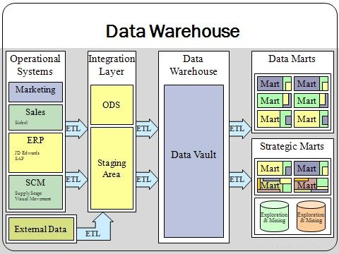  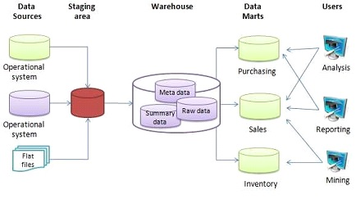
DCE | Data Circuit-terminating Equipment | data circuit-terminating equipment(DCE) is a device that sits between the data terminal equipment (DTE) and a data transmission circuit. It is also called data communication(s) equipment and data carrier equipment. Usually, the DTE device is the terminal (or computer), and the DCE is a modem.  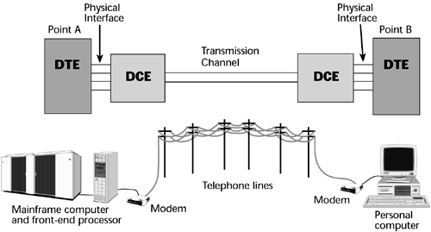
DDK | driver development kit | a set of programs and related files that are used to develop a new software or hardware driver or to update an existing legacy application driver for an operating system.
DDOS | Distributed Denial of Service | In computing, a denial-of-service attack (DoS attack) is a cyber-attack in which the perpetrator seeks to make a machine or network resource unavailable to its intended users by temporarily or indefinitely disrupting services of a host connected to the Internet. Denial of service is typically accomplished by flooding the targeted machine or resource with superfluous requests in an attempt to overload systems and prevent some or all legitimate requests from being fulfilled.[1]  In a distributed denial-of-service attack (DDoS attack), the incoming traffic flooding the victim originates from many different sources. This effectively makes it impossible to stop the attack simply by blocking a single source.  A DoS or DDoS attack is analogous to a group of people crowding the entry door of a shop, making it hard for legitimate customers to enter, disrupting trade.  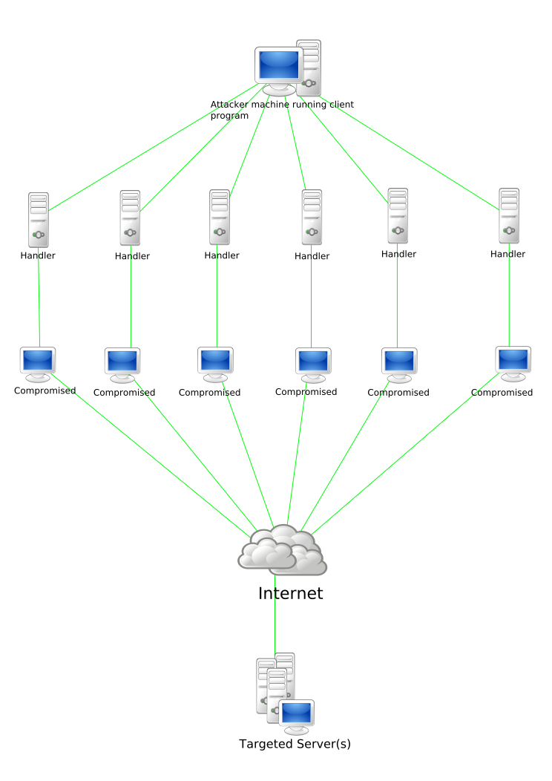
Decomposition Estimation |  | See bottom-up estimation. Refers specifically to creating estimates for the decomposed parts of a system.
Defect |  | A failure of a system or process to perform as specified, or expected.  A behavior or representation that does not conform to project plans or goals. Deviation from the expected or defined representation of information in an artifact. Nonconformance of a system, process, or artifact to a standard. Defects are a type of corrective activity management item.
Defect Management |  | The representation of identified defects and the planning, tracking, and control related to ensuring all identified defects are managed. Part of both quality and corrective activity management.
Defect Report |  | A request to modify an artifact due to lack of conformance to a standard, requirement, project need, or a failure/error.
Definition of Done |  | The definition of done is an agreed upon list of the activities deemed necessary to get a product increment, usually represented by a user story, to a done state by the end of a sprint.
Definition of Ready |  | involves creating clear criteria that a user story must meet before being accepted into an upcoming iteration. This is typically based on the INVEST matrix.
Deliverable |  | Any artifact or set of artifacts that are delivered as output from a project or other well defined set of work.
Deplhi |  | Object Pascal refers to a branch of object-oriented derivatives of Pascal, mostly known as the primary programming language of Delphi.
Deployment |  | The process and/or act of installing and readying a software system for use, including integration and customization that is specific to a particular site.
Deployment Lead |  | Projects with complex deployment needs may assign an individual to plan and oversee execution of deployment and possibly operational and maintenance related issues.
Deployment Plan |  | A plan specifying the method of releasing a system. Includes items like target platforms, configuration to release, etc.
DER | Distinguished Encoding Rules | ER (Distinguished Encoding Rules) is a restricted variant of BER for producing unequivocal transfer syntax for data structures described by ASN.1. Like CER, DER encodings are valid BER encodings. DER is the same thing as BER with all but one sender's options removed.  DER is a subset of BER providing for exactly one way to encode an ASN.1 value. DER is intended for situations when a unique encoding is needed, such as in cryptography, and ensures that a data structure that needs to be digitally signed produces a unique serialized representation. DER can be considered a canonical form of BER. For example, in BER a Boolean value of true can be encoded as any of 255 non-zero byte values, while in DER there is one way to encode a Boolean value of true.  The most significant DER encoding constraints are:  - Length encoding must use the definite form  - Additionally, the shortest possible length encoding must be used  - Bitstring, octetstring, and restricted character strings must use the primitive encoding  - Elements of a Set are encoded in sorted order, based on their tag value  DER is widely used for digital certificates such as X.509.
DES | Data Encryption Standard | The Data Encryption Standard is a symmetric-key algorithm for the encryption of electronic data. Although insecure, it was highly influential in the advancement of modern cryptography.  Developed in the early 1970s at IBM and based on an earlier design by Horst Feistel, the algorithm was submitted to the National Bureau of Standards (NBS) following the agency's invitation to propose a candidate for the protection of sensitive, unclassified electronic government data. In 1976, after consultation with the National Security Agency (NSA), the NBS eventually selected a slightly modified version (strengthened against differential cryptanalysis, but weakened against brute-force attacks), which was published as an official Federal Information Processing Standard (FIPS) for the United States in 1977.  The publication of an NSA-approved encryption standard simultaneously resulted in its quick international adoption and widespread academic scrutiny. Controversies arose out of classified design elements, a relatively short key length of the symmetric-key block cipher design, and the involvement of the NSA, nourishing suspicions about a backdoor. Today it is known that the S-boxes that had raised those suspicions were in fact designed by the NSA to actually remove a backdoor they secretly knew (differential cryptanalysis). However, the NSA also ensured that the key size was drastically reduced such that they could break it by brute force attack. The intense academic scrutiny the algorithm received over time led to the modern understanding of block ciphers and their cryptanalysis.  DES is insecure. This is mainly due to the 56-bit key size being too small. In January 1999, distributed.net and the Electronic Frontier Foundation collaborated to publicly break a DES key in 22 hours and 15 minutes (see chronology). There are also some analytical results which demonstrate theoretical weaknesses in the cipher, although they are infeasible to mount in practice. The algorithm is believed to be practically secure in the form of Triple DES, although there are theoretical attacks. This cipher has been superseded by the Advanced Encryption Standard (AES). Furthermore, DES has been withdrawn as a standard by the National Institute of Standards and Technology.  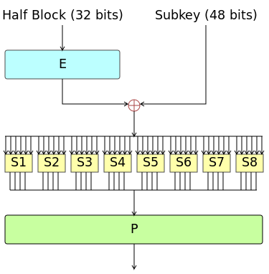
Design |  | Software design. The creation of abstracted models and plans for implementing requirements in software. Also denotes the design CKA. See CxStand_Design for more information.
Design Lead |  | Responsible for the system architecture and overseeing design activities.
Design Pattern |  | In software engineering, a software design pattern is a general, reusable solution to a commonly occurring problem within a given context in software design. It is not a finished design that can be transformed directly into source or machine code. It is a description or template for how to solve a problem that can be used in many different situations. Design patterns are formalized best practices that the programmer can use to solve common problems when designing an application or system.  Object-oriented design patterns typically show relationships and interactions between classes or objects, without specifying the final application classes or objects that are involved. Patterns that imply mutable state may be unsuited for functional programming languages, some patterns can be rendered unnecessary in languages that have built-in support for solving the problem they are trying to solve, and object-oriented patterns are not necessarily suitable for non-object-oriented languages.  Design patterns may be viewed as a structured approach to computer programming intermediate between the levels of a programming paradigm and a concrete algorithm.
Design to Tools |  | The content of a system is determined by what is directly supported by existing software tools
Desk Check |  | An informal review in which the author asks one or more people to read an artifact with the intent of finding defects.
Detailed Design |  | Commonly used term that captures parts of high level design and low level design. See CxStand_Design for more information.
Detailed Schedule |  | Fine grain project schedule that includes tasks, estimated effort, assigned resources, dependencies, etc. Usually created in a bottom-up fashion from a work plan. Normally implemented as a sliding window that covers a project’s headlights. Compare to business schedule.
Developer |  | Synonym for software engineer, usually used when referring to design and construction activities.
Developer Integration Test | DIT | Integration test performed by a developer in the system test environment after a project build as part of releasing functionality.
development environment |  | the set of processes and programming tools used to create the program or software product.
Development Environment | DE | The hardware and software environment that construction work occurs in.
development process |  | a set of tasks performed for a given purpose in a software development project.
DevOps | development/operations | bridges the gap between agile teams and operational delivery to production.
DHCP | Dynamic Host Configuration Protocol | The Dynamic Host Configuration Protocol (DHCP) is a network management protocol used on UDP/IP networks whereby a DHCP server dynamically assigns an IP address and other network configuration parameters to each device on a network so they can communicate with other IP networks. A DHCP server enables computers to request IP addresses and networking parameters automatically from the Internet service provider (ISP), reducing the need for a network administrator or a user to manually assign IP addresses to all network devices.
Diagram |  | A graphical representation of a system, process, or other information.
DLE | Digital Local Exchange | 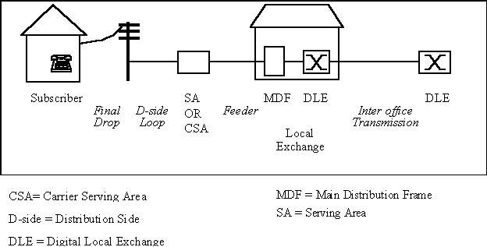  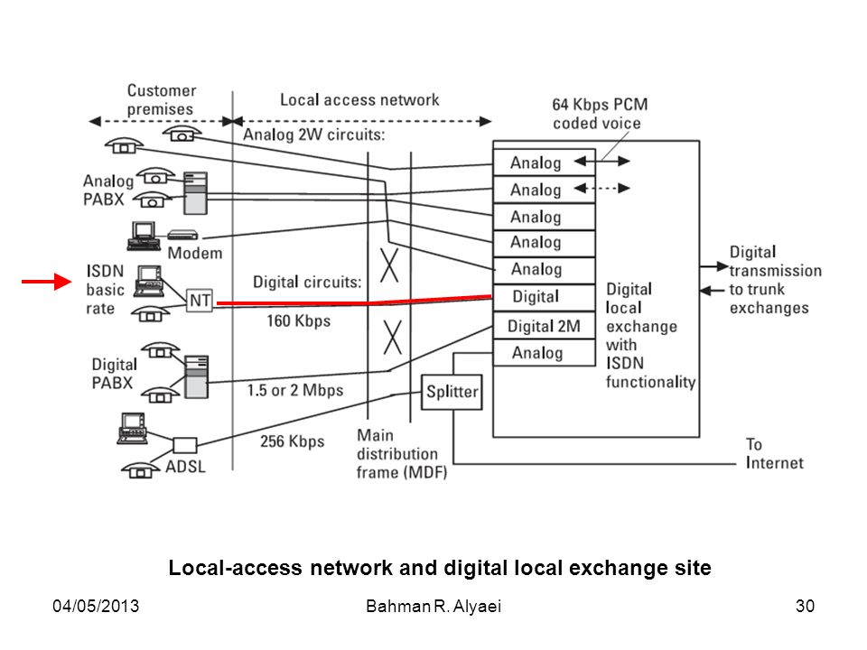
DLP | Data Link Protocol | Protocols that can be utilized at the Data Link layer of the OSI model. These protocols include token ring, FDDI, and Ethernet. Ethernet Data Link protocols are broken out into addressing and framing standards
DMZ | Demilitarized Zone | In computer security, a DMZ or demilitarized zone (sometimes referred to as a perimeter network) is a physical or logical subnetwork that contains and exposes an organization's external-facing services to an untrusted network, usually a larger network such as the Internet. The purpose of a DMZ is to add an additional layer of security to an organization's local area network (LAN): an external network node can access only what is exposed in the DMZ, while the rest of the organization's network is firewalled. The DMZ functions as a small, isolated network positioned between the Internet and the private network and, if its design is effective, allows the organization extra time to detect and address breaches before they would further penetrate into the internal networks.  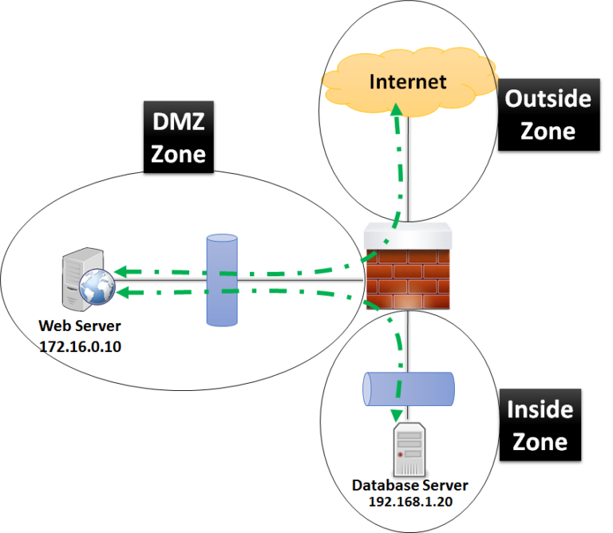
DN | Directory Number | A telephone number is a sequence of digits assigned to a fixed-line telephone subscriber station connected to a telephone line or to a wireless electronic telephony device, such as a radio telephone or a mobile telephone, or to other devices for data transmission via the public switched telephone network (PSTN) or other private networks.  A telephone number serves as an address for switching telephone calls using a system of destination code routing. Telephone numbers are entered or dialed by a calling party on the originating telephone set, which transmits the sequence of digits in the process of signaling to a telephone exchange. The exchange completes the call either to another locally connected subscriber or via the PSTN to the called party. Telephone numbers are assigned within the framework of a national or regional telephone numbering plan to subscribers by telephone service operators, which may be commercial entities, state-controlled administrations, or other telecommunication industry associations.
DNB |  | Dun and Bradstreet Business File
DNS | Domain Name System | The Domain Name System (DNS) is a hierarchical decentralized naming system for computers, services, or other resources connected to the Internet or a private network. It associates various information with domain names assigned to each of the participating entities. Most prominently, it translates more readily memorized domain names to the numerical IP addresses needed for locating and identifying computer services and devices with the underlying network protocols. By providing a worldwide, distributed directory service, the Domain Name System is an essential component of the functionality on the Internet, that has been in use since 1985.
DNS - A | IpV4 A Record | An A record maps a domain name to the IP address (IPv4) of the computer hosting the domain. Simply put, an A record is used to find the IP address of a computer connected to the internet from a name.  The A in A record stands for Address. Whenever you visit a web site, send an email, connect to Twitter or Facebook or do almost anything on the Internet, the address you enter is a series of words connected with dots.
DNS - AAAA | IPv6 DNS record | Returns a 128-bit IPv6 address, most commonly used to map hostnames to an IP address of the host
DNS - CNAME | Canonical name record | Alias of one name to another: the DNS lookup will continue by retrying the lookup with the new name.
DNS - DNAME |  | Alias for a name and all its subnames, unlike CNAME, which is an alias for only the exact name. Like a CNAME record, the DNS lookup will continue by retrying the lookup with the new name.
DNS - SRV | Service locator | Generalized service location record, used for newer protocols instead of creating protocol-specific records such as MX.
DNS - TXT | Txt Record | Originally for arbitrary human-readable text in a DNS record. Since the early 1990s, however, this record more often carries machine-readable data, such as specified by RFC 1464, opportunistic encryption, Sender Policy Framework, DKIM, DMARC, DNS-SD, etc.
DNS Spoofing |  | DNS spoofing, also referred to as DNS cache poisoning, is a form of computer security hacking in which corrupt Domain Name System data is introduced into the DNS resolver's cache, causing the name server to return an incorrect result record, e.g. an IP address. This results in traffic being diverted to the attacker's computer (or any other computer).
Docker |  | Docker is a collection of interoperating software-as-a-service and platform-as-a-service offerings that employ operating-system-level virtualization to cultivate development and delivery of software inside standardized software packages called containers.[The software that hosts the containers is called Docker Engine
Document Collaboration |  | Document and file collaboration are the tools or systems set up to help multiple people work together on a single document or file to achieve a single final version. Normally, this is software that allows teams to work on a single document, such as a Word document, at the same time from different computer terminals or mobile devices. Hence, document or file collaboration today is a system allowing people to collaborate across different locations using an Internet, or "cloud", enabled approach such as for Wikis such as Wikipedia  Tools such as Confluence & SharePoint can be used for Document Collaboration
Domain Name |  | A domain name is an identification string that defines a realm of administrative autonomy, authority or control within the Internet. Domain names are formed by the rules and procedures of the Domain Name System (DNS). Any name registered in the DNS is a domain name. Domain names are used in various networking contexts and for application-specific naming and addressing purposes. In general, a domain name represents an Internet Protocol (IP) resource, such as a personal computer used to access the Internet, a server computer hosting a web site, or the web site itself or any other service communicated via the Internet. In 2017, 330.6 million domain names had been registered.  Domain names are organized in subordinate levels (subdomains) of the DNS root domain, which is nameless. The first-level set of domain names are the top-level domains (TLDs), including the generic top-level domains (gTLDs), such as the prominent domains com, info, net, edu, and org, and the country code top-level domains (ccTLDs). Below these top-level domains in the DNS hierarchy are the second-level and third-level domain names that are typically open for reservation by end-users who wish to connect local area networks to the Internet, create other publicly accessible Internet resources or run web sites.  The registration of these domain names is usually administered by domain name registrars who sell their services to the public.  A fully qualified domain name (FQDN) is a domain name that is completely specified with all labels in the hierarchy of the DNS, having no parts omitted. Labels in the Domain Name System are case-insensitive, and may therefore be written in any desired capitalization method, but most commonly domain names are written in lowercase in technical contexts.  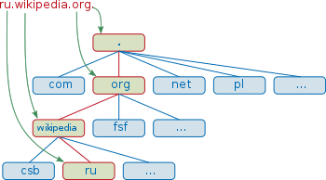  Domain name space  Today, the Internet Corporation for Assigned Names and Numbers (ICANN) manages the top-level development and architecture of the Internet domain name space. It authorizes domain name registrars, through which domain names may be registered and reassigned.  The hierarchical domain name system, organized into zones, each served by domain name servers.  The domain name space consists of a tree of domain names. Each node in the tree holds information associated with the domain name. The tree sub-divides into zones beginning at the DNS root zone.  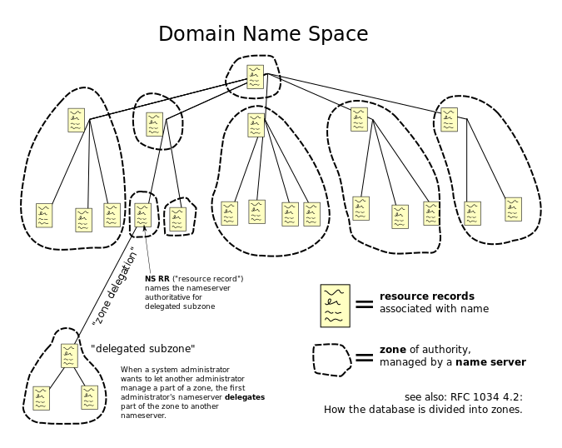
Dot1Q | IEEE 802.1Q, often referred to as Dot1q | IEEE 802.1Q, often referred to as Dot1q, is the networking standard that supports virtual LANs (VLANs) on an IEEE 802.3 Ethernet network. The standard defines a system of VLAN tagging for Ethernet frames and the accompanying procedures to be used by bridges and switches in handling such frames. The standard also contains provisions for a quality-of-service prioritization scheme commonly known as IEEE 802.1p and defines the Generic Attribute Registration Protocol.  Portions of the network which are VLAN-aware (i.e., IEEE 802.1Q conformant) can include VLAN tags. When a frame enters the VLAN-aware portion of the network, a tag is added to represent the VLAN membership.[a] Each frame must be distinguishable as being within exactly one VLAN. A frame in the VLAN-aware portion of the network that does not contain a VLAN tag is assumed to be flowing on the native VLAN.
Dot1Q trunking |  | A simple view for dot1q (802.1q) trunking:  For ease of understanding the Dot1q (802.1q) trunking between switches can be seen as pipes (VLANs) inside a main pipe (Trunk) to connect VLANs that are being distributed on different switches.  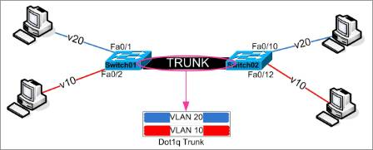  So if that makes sense then a better representation is that packets are tagged as they go into the trunk link, like below.  The packets are tagged with the VLAN ID, that the port they are received on is configured with. When they are received on the other end they are then sent to the appropriate VLAN ports.  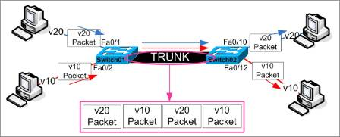  So how does the switch know which ports to send the packet to, the switches are assigned with the VLAN number.  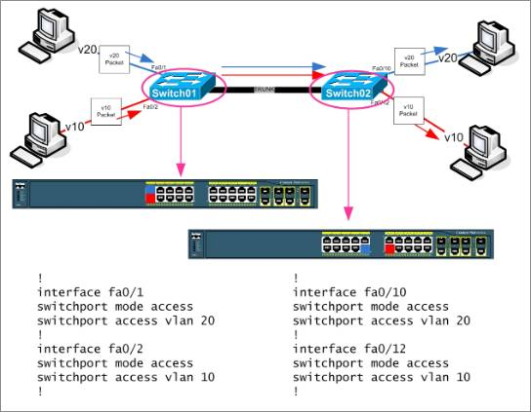
Downstream |  | In a telecommunications network or computer network, downstream refers to data sent from a network service provider to a customer.  Although the best dial-up modems are called 56 kbit/s modems, downstream speeds can be limited to a few tens of kilobits per second with even lower upstream speeds. Asymmetric digital subscriber line (ADSL) and cable modems, two popular Internet access technologies, greatly improved downstream speeds reaching several Mbit/s. Mobile broadband and satellite Internet access providers also often have lower upstream speeds than downstream.  One process sending data primarily in the downstream direction is downloading. However, the overall download speed depends on the downstream speed of the user, the upstream speed of the server, and the network between them.  In the client–server model, downstream can refer to the direction from the server to the client.
Downstream |  | Used to refer to project activities and artifacts that occur later in a project lifecycle, often after significant construction has begun. Includes coding, low level design, testing, deployment, and system use. See upstream.
DP | Distribution Point | In LLU - The green termination box which is situated between the exchange and the customer premise, utilized as a junction point.  In FTTC - A piece of equipment that separates out a fibre into smaller pieces  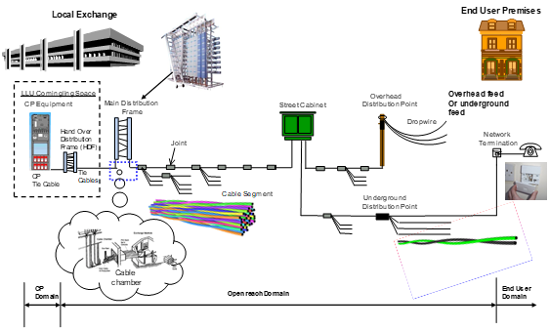
DPI | Deep Packet Inspection | Deep packet inspection (DPI) is a type of data processing that inspects in detail the data being sent over a computer network, and usually takes action by blocking, re-routing, or logging it accordingly. Deep packet inspection is often used to ensure that data is in the correct format, to check for malicious code, eavesdropping and internet censorship[1] among other purposes. There are multiple headers for IP packets; network equipment only needs to use the first of these (the IP header) for normal operation, but use of the second header (such as TCP or UDP) is normally considered to be shallow packet inspection (usually called stateful packet inspection) despite this definition.[2]  There are multiple ways to acquire packets for deep packet inspection. Using port mirroring (sometimes called Span Port) is a very common way, as well as an optical splitter.  Deep Packet Inspection (and filtering) enables advanced network management, user service, and security functions as well as internet data mining, eavesdropping, and internet censorship. Although DPI has been used for Internet management for many years, some advocates of net neutrality fear that the technique may be used anticompetitively or to reduce the openness of the Internet.[3]  DPI is used in a wide range of applications, at the so-called "enterprise" level (corporations and larger institutions), in telecommunications service providers, and in governments.
DPNSS | Digital Private Network Signalling System | The Digital Private Network Signalling System (DPNSS) is a network protocol used on digital trunk lines for connecting to PABX. It supports a defined set of inter-networking facilities.  DPNSS was originally defined by British Telecom. The specification for the protocol is defined in BTNR188. The specification currently comes under the Network Interoperability Consultative Committee.
DQ | Data Quality
Draft |  | An artifact under revision control but not yet under change control.
driver |  | a program that interacts with a particular device or special kind of software. The driver contains special knowledge of the device or special software interface that programs using the driver do not.
DSCP | Diff-Serve Code Point | Differentiated services or DiffServ is a computer networking architecture that specifies a simple and scalable mechanism for classifying and managing network traffic and providing quality of service (QoS) on modern IP networks. DiffServ can, for example, be used to provide low-latency to critical network traffic such as voice or streaming media while providing simple best-effort service to non-critical services such as web traffic or file transfers.  DiffServ uses a 6-bit differentiated services code point (DSCP) in the 8-bit differentiated services field (DS field) in the IP header for packet classification purposes. The DS field replaces the outdated IPv4 TOS field.
DSDM | dynamic systems development method | agile development methodology, now changed to the ‘DSDM project management framework’.
DSL | Digital Subscriber Line | Digital subscriber line (DSL; originally digital subscriber loop) is a family of technologies that are used to transmit digital data over telephone lines. In telecommunications marketing, the term DSL is widely understood to mean asymmetric digital subscriber line (ADSL), the most commonly installed DSL technology, for Internet access.  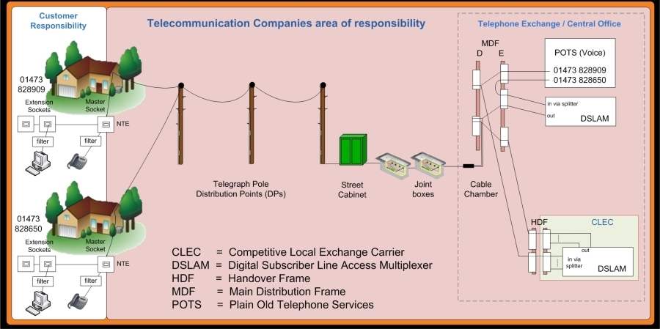
DSLAM | Digital Subscriber Line Access Multiplexor | Allows telephone lines to make faster connections to the Internet. It is a network device, located near the customer's premises and connects multiple customers Digital Subscriber Lines (DSL) to a high-speed Internet backbone line using multiplexing techniques.  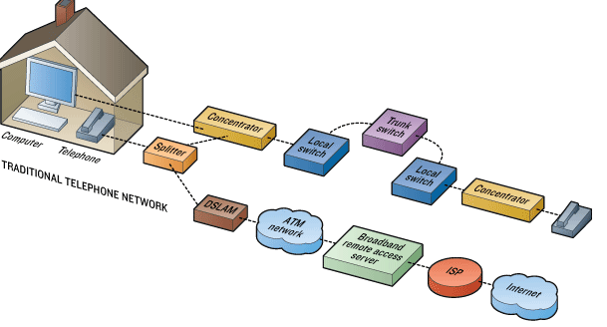
DTE | Data Terminal Equipment | Data terminal equipment (DTE) is an end instrument that converts user information into signals or reconverts received signals. These can also be called tail circuits. A DTE device communicates with the data circuit-terminating equipment (DCE). The DTE/DCE classification was introduced by IBM.
DTMF | Dual Tone Multi Frequency | Dual-tone multi-frequency signalling (DTMF) is an in-band telecommunication signalling system using the voice-frequency band over telephone lines between telephone equipment and other communications devices and switching centres. DTMF was first developed in the Bell System in the United States, and became known under the trademark Touch-Tone for use in push-button telephones supplied to telephone customers, starting in 1963.[1] DTMF is standardized as ITU-T Recommendation Q.23.[2] It is also known in the UK as MF4.  The Touch-Tone system using a telephone keypad gradually replaced the use of rotary dial and has become the industry standard for landline and mobile service. Other multi-frequency systems are used for internal signalling within the telephone network.  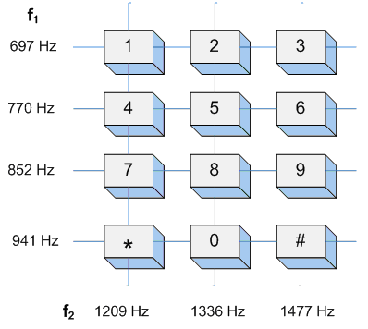
DTT | Digital Terrestrial TV | Digital terrestrial television (DTTV or DTT) is a technology for broadcast television in which land-based (terrestrial) television stations broadcast television content by radio waves to televisions in consumers' residences in a digital format. DTTV is a major technological advance over the previous analog television, and has largely replaced analog which had been in common use since the middle of the last century. Test broadcasts began in 1998 with the changeover to DTTV (aka Analog Switchoff (ASO) or Digital Switchover (DSO)) beginning in 2006 and is now complete in many countries. The advantages of digital terrestrial television are similar to those obtained by digitising platforms such as cable TV, satellite, and telecommunications: more efficient use of limited radio spectrum bandwidth, provision of more television channels than analog, better quality images, and potentially lower operating costs for broadcasters (after the initial upgrade costs).
DTV | Digital TV | Digital television (DTV) is the transmission of television signals, including the sound channel, using digital encoding, in contrast to the earlier television technology, analog television, in which the video and audio are carried by analog signals. It is an innovative advance that represents the first significant evolution in television technology since color television in the 1950s. Digital TV makes more economical use of scarce radio spectrum space; it can transmit multiple channels in the same bandwidth occupied by a single channel of analog television, and provides many new features that analog television cannot. A switchover from analog to digital broadcasting began around 2006 in some countries, and many industrial countries have now completed the changeover, while other countries are in various stages of adaptation. Different digital television broadcasting standards have been adopted in different parts of the world
Duplex |  | A duplex communication system is a point-to-point system composed of two or more connected parties or devices that can communicate with one another in both directions. Duplex systems are employed in many communications networks, either to allow for a communication "two-way street" between two connected parties or to provide a "reverse path" for the monitoring and remote adjustment of equipment in the field. There are two types of duplex communication systems: full-duplex (FDX) and half-duplex (HDX).  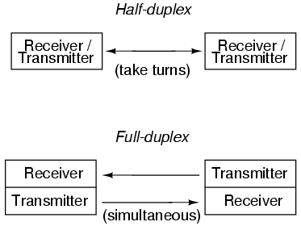  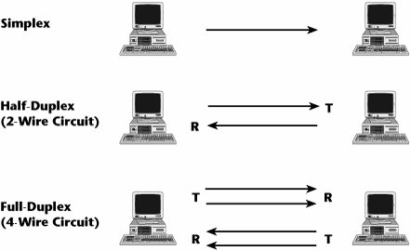  Full Duplex    Half Duplex  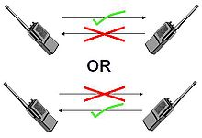
DVSR | Dynamically Verified Static Routing | Dynamically Verified Static Routing (DVSR) is a proprietary routing protocol of the former Redback (now Ericsson) available on SmartEdge and Smart Services Router products.  DVSR can be defined as a semi-dynamic and semi-static routing protocol.  A DVSR route is based on static routing principle, but the router regularly checks for the next hop availability before the prefix can be injected into the local routing table and redistributed towards other routing tables. The DVSR route configuration allows the setup of success and failure counters used to declare the route as active or not. It could be described as a number of DVSR router attempts to ping the next hop; in case of a given number of successful replies the route is added to the local routing table or, after a set number of consecutive failures, the route is withdrawn.  SmartEdge routers support DVSR as a unique edge routing feature in addition to static routing and regular IGPs, such as IS-IS, OSPF, and RIP. DVSR is similar to normal static routing. The main difference is that the DVSR’s next hop, or some other relevant host IP address, is dynamically verified by this protocol before the prefix can be injected into the local routing table. In many ISP networks, using static routing without proper next-hop checks results in black holing of network traffic.

E
E NodeB | Evolved Node-B | E-UTRAN Node B, also known as Evolved Node B (abbreviated as eNodeB or eNB), is the element in E-UTRA of LTE that is the evolution of the element Node B in UTRA of UMTS. It is the hardware that is connected to the mobile phone network that communicates directly wirelessly with mobile handsets (UEs), like a base transceiver station (BTS) in GSM networks.  Traditionally, a Node B has minimum functionality, and is controlled by a Radio Network Controller (RNC). However, with an eNB, there is no separate controller element. This simplifies the architecture and allows lower response times.
E.164 |  | E.164 is an ITU-T recommendation, titled The international public telecommunication numbering plan, that defines a numbering plan for the worldwide public switched telephone network (PSTN) and some other data networks.  E.164 defines a general format for international telephone numbers. Plan-conforming numbers are limited to a maximum of 15 digits, excluding the international call prefix.[1] The presentation of a number is usually prefixed with the plus sign (+), indicating that the number includes the country calling code. When dialing, the number must typically be prefixed with the appropriate international call prefix (in place of the plus sign), which is a trunk code to reach an international circuit from within the country of call origination.
EAD | Ethernet Access Direct | Ethernet Access Direct (EAD) provides point-to-point data connectivity between sites. It can be used to build and extend customer networks, develop new infrastructure, and meet low-capacity backhaul requirements (ie up to 1Gbps, which is the starting bandwidth for Ethernet Backhaul Direct). EAD supports a range of requirements including cloud computing, simultaneous online pupil access in classrooms and storage area network connectivity.  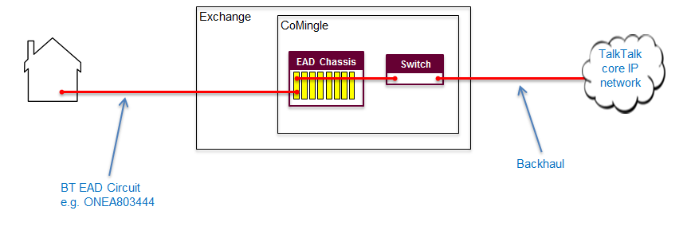
EAP | Extensible Authentication Protocol | Extensible Authentication Protocol, or EAP, is an authentication framework frequently used in wireless networks and point-to-point connections. It is defined in RFC 3748, which made RFC 2284 obsolete, and is updated by RFC 5247.  EAP is an authentication framework for providing the transport and usage of keying material and parameters generated by EAP methods. There are many methods defined by RFCs and a number of vendor specific methods and new proposals exist. EAP is not a wire protocol; instead it only defines message formats. Each protocol that uses EAP defines a way to encapsulate EAP messages within that protocol's messages.  EAP is in wide use. For example, in IEEE 802.11 (WiFi) the WPA and WPA2 standards have adopted IEEE 802.1X with one hundred EAP Types as the official authentication mechanisms  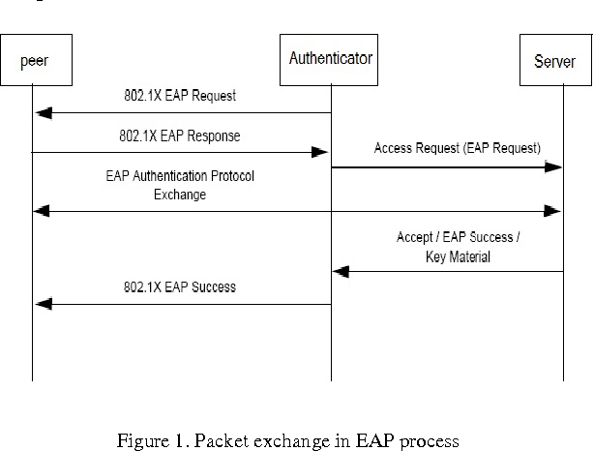
Earned Value | EV | A scheduling technique for tracking variance of actual performance to planned performance.
Earned Value Management | EVM | The act or discipline of managing projects utilizing earned value techniques and practices.
Echo |  | In audio signal processing and acoustics, Echo is a reflection of sound that arrives at the listener with a delay after the direct sound. The delay is proportional to the distance of the reflecting surface from the source and the listener. Typical examples are the echo produced by the bottom of a well, by a building, or by the walls of an enclosed room and an empty room. A true echo is a single reflection of the sound source.
Echo cancellation |  | Echo suppression and echo cancellation are methods used in telephony to improve voice quality by preventing echo from being created or removing it after it is already present. In addition to improving subjective audio quality, echo suppression increases the capacity achieved through silence suppression by preventing echo from traveling across a network. Echo suppressors were developed in the 1950s in response to the first use of satellites for telecommunications, but they have since been largely supplanted by better performing echo cancellers.  Echo suppression and cancellation methods are commonly called acoustic echo suppression (AES) and acoustic echo cancellation (AEC), and more rarely line echo cancellation (LEC). In some cases, these terms are more precise, as there are various types and causes of echo with unique characteristics, including acoustic echo (sounds from a loudspeaker being reflected and recorded by a microphone, which can vary substantially over time) and line echo (electrical impulses caused by, e.g., coupling between the sending and receiving wires, impedance mismatches, electrical reflections, etc., which varies much less than acoustic echo). In practice, however, the same techniques are used to treat all types of echo, so an acoustic echo canceller can cancel line echo as well as acoustic echo. AEC in particular is commonly used to refer to echo cancelers in general, regardless of whether they were intended for acoustic echo, line echo, or both.  Although echo suppressors and echo cancellers have similar goals—preventing a speaking individual from hearing an echo of their own voice—the methods they use are different:  - Echo suppressors work by detecting a voice signal going in one direction on a circuit, and then muting or attenuating the signal in other direction. Usually the echo suppressor at the far end of the circuit does this muting when it detects voice coming from the near-end of the circuit. This muting prevents the speaker from hearing their own voice returning from the far end.  - Echo cancellation involves first recognizing the originally transmitted signal that re-appears, with some delay, in the transmitted or received signal. Once the echo is recognized, it can be removed by subtracting it from the transmitted or received signal. This technique is generally implemented digitally using a digital signal processor or software, although it can be implemented in analog circuits as well.
Echo Cancellation - G.168 |  | Echo has a major effect on voice quality in telecommunication networks. The objectionable effect of echo results from a combination of reflections from network components such as 2- to 4-wire converters, together with signal processing and transmission delay. Echo may cause users difficulty in  talking or listening over a telephone connection. It may also affect the transmission of voiceband data, fax, and text telephones.  Digital network echo cancellers are designed to eliminate echo for the user and to allow successful transmission of voiceband data and fax. Recommendation ITU-T G.168 describes the characteristics of an echo canceller, including the requirement for in-band tone disabling and other control  mechanisms. It also describes a number of laboratory tests that should be performed on an echo canceller to assess its performance under conditions likely to be experienced in the network
EDB | Emergency Database
EDGE | Enhanced Data rates for GSM Evolution | Enhanced Data rates for GSM Evolution (EDGE) (also known as Enhanced GPRS (EGPRS), or IMT Single Carrier (IMT-SC), or Enhanced Data rates for Global Evolution) is a digital mobile phone technology that allows improved data transmission rates as a backward-compatible extension of GSM. EDGE is considered a pre-3G radio technology and is part of ITU's 3G definition. EDGE was deployed on GSM networks beginning in 2003 – initially by Cingular (now AT&T) in the United States.  EDGE is standardized also by 3GPP as part of the GSM family. A variant, so called Compact-EDGE, was developed for use in a portion of Digital AMPS network spectrum.  Through the introduction of sophisticated methods of coding and transmitting data, EDGE delivers higher bit-rates per radio channel, resulting in a threefold increase in capacity and performance compared with an ordinary GSM/GPRS connection.  EDGE can be used for any packet switched application, such as an Internet connection.
Editor |  | For inspections, performs any necessary rework on artifacts.
EEE 802.1Qay |  | Provider Backbone Bridge Traffic Engineering (PBB-TE) is an approved telecommunications networking standard, IEEE 802.1Qay-2009. PBB-TE adapts Ethernet technology to carrier class transport networks. It is based on the layered VLAN tags and MAC-in-MAC encapsulation defined in IEEE 802.1ah (Provider Backbone Bridges (PBB)), but it differs from PBB in eliminating flooding, dynamically created forwarding tables, and spanning tree protocols. Compared to PBB and its predecessors, PBB-TE behaves more predictably and its behavior can be more easily controlled by the network operator, at the expense of requiring up-front connection configuration at each bridge along a forwarding path. PBB-TE Operations, Administration, and Management (OAM) is usually based on IEEE 802.1ag. It was initially based on Nortel's Provider Backbone Transport (PBT).  PBB-TE's connection-oriented features and behaviors, as well as its OAM approach, are inspired by SDH/SONET. PBB-TE can also provide path protection levels similar to the UPSR (Unidirectional Path Switched Ring) protection in SDH/SONET networks.  Principle of operation  The IEEE 802.1Qay PBB-TE standard extends the functionality of IEEE 802.1ah Provider Backbone Bridges, adding a connection-oriented mode using point-to-point trunks that deliver resiliency and configurable performance levels.  A service is identified by an I-SID (Backbone Service Instance Identifier) and each service is associated with a PBB-TE trunk. Each PBB-TE trunk is identified by a triplet of B-SA, B-DA and B-VID. The B-SA and B-DA identify the source and destination bridges, respectively, that are the endpoints of the trunk. The B-VID is a backbone VLAN identifier that is used to distinguish different trunks to the same destination. The management system configures the PBB-TE trunks on all the edge and core bridges by creating static forwarding database entries; the management system is responsible for ensuring that there are no forwarding loops.  The backbone edge bridges map frames to and from an I-SID and perform the MAC header encapsulation and decapsulation functions. The core bridges act as transit nodes. The packets are forwarded based on outer VLAN ID (B-VID) and Destination MAC address (B-DA).  Forwarding is based on the static forwarding database (FDB) entries; dynamic MAC learning is not used. Any incoming broadcast or multicast frames are either dropped or encapsulated as unicast within the trunk. All Destination Lookup Failure packets are dropped rather than flooded. By eliminating any broadcasting or flooding, and by using only the loop-free forwarding paths configured by management, there is no longer any need to use a spanning tree protocol.  Path protection is provided by configuring one work and one protect B-VID for each backbone service instance. In case of work path failure (as indicated by loss of 802.1ag continuity check messages, CCMs) the source bridge swaps the B-VID value to redirect the traffic onto the preconfigured protection path within 50 ms.  PBB-TE equipment leverages economies of scale inherent in Ethernet, promising solutions that are 30% to 40% cheaper than T-MPLS networks with identical features and capabilities, giving PBB-TE a better overall return on investment.
EFM | Ethernet in the First Mile | describes the inclusion of an Ethernet connection at any point in the network where the provider and customer are immediately connected.
Egress |  | Egress traffic is network traffic that begins inside of a network and proceeds through its routers to a destination somewhere outside of the network. For example, an email message that is considered egress traffic will travel from a user's workstation and pass through the enterprise's LAN routers before it is delivered to the Internet to travel to its final destination.  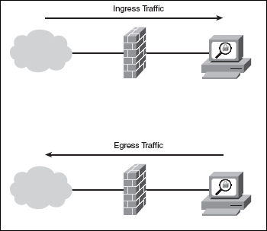
EIA | Electronic Industries Alliance | The Electronic Industries Alliance (EIA; until 1997 Electronic Industries Association) was a standards and trade organization composed as an alliance of trade associations for electronics manufacturers in the United States. They developed standards to ensure the equipment of different manufacturers was compatible and interchangeable. The EIA ceased operations on February 11, 2011, but the former sectors continue to serve the constituencies of EIA
EIGRP | Enhanced Interior Gateway Routing Protocol | Enhanced Interior Gateway Routing Protocol (EIGRP) is an advanced distance-vector routing protocol that is used on a computer network for automating routing decisions and configuration. The protocol was designed by Cisco Systems as a proprietary protocol, available only on Cisco routers. Functionality of EIGRP was converted to an open standard in 2013[1] and was published with informational status as RFC 7868 in 2016.  EIGRP is used on a router to share routes with other routers within the same autonomous system. Unlike other well known routing protocols, such as RIP, EIGRP only sends incremental updates, reducing the workload on the router and the amount of data that needs to be transmitted.  EIGRP replaced the Interior Gateway Routing Protocol (IGRP) in 1993. One of the major reasons for this was the change to classless IPv4 addresses in the Internet Protocol, which IGRP could not support.
embedded systems programming |  | the programming of an embedded system in some device using the permitted programming interfaces provided by that system.
Engineering Discussion |  | A brainstorming meeting designed to frame an issue and seek solutions for it.  If materials are prepared ahead of time for review by participants the meeting may be considered a preview.
Engineering Management | EM | Software engineering management. Planning, staffing, tracking, and controlling execution of software projects, along with team and organizational management. Also denotes the engineering management CKA. See CxStand_EngineeringManagement for more information.
Engineering Process |  | Software engineering process. Defining how software engineering activities occur. Also denotes the engineering process CKA. See CxStand_Process for more information.
EoFTTC | Ethernet over Fibre to the Cabinet | Ethernet over Fibre to the Cabinet (EoFTTC) is provided by copper from your business premises over the short distance to the green cabinets in the street. Unlike standard broadband where the copper then continues all the way to the exchange, Ethernet over Fibre to the Cabinet traffic travels across a shared fibre optic circuit to the exchange. The extra distance doesn’t lead to ongoing degradation of performance, which allows access to up to 20Mbps symmetrical speed with the additional boost downstream making a total of 76Mbps downstream bandwidth.  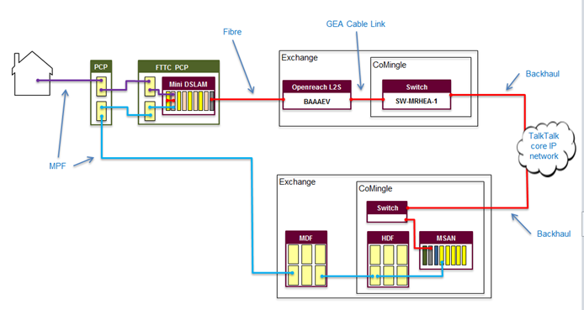
EoS | Ethernet Over SONET | Ethernet Over SDH (EoS or EoSDH) or Ethernet over SONET refers to a set of protocols which allow Ethernet traffic to be carried over synchronous digital hierarchy networks in an efficient and flexible way. The same functions are available using SONET.  Ethernet frames which are to be sent on the SDH link are sent through an "encapsulation" block (typically Generic Framing Procedure or GFP) to create a synchronous stream of data from the asynchronous Ethernet packets. The synchronous stream of encapsulated data is then passed through a mapping block which typically uses virtual concatenation (VCAT) to route the stream of bits over one or more SDH paths. As this is byte interleaved, it provides a better level of security compared to other mechanisms for Ethernet transport.
ePDG | Evolved Packet Data Gateway | The main function of the ePDG is to secure the data transmission with a UE connected to the EPC over an untrusted non-3GPP access. For this purpose, the ePDG acts as a termination node of IPsec tunnels established with the UE.
Epic |  | An epic is a large user story.
EPWS | Ethernet Private Wire Service
ESB | Enterprise Service Bus | An enterprise service bus (ESB) implements a communication system between mutually interacting software applications in a service-oriented architecture (SOA). It implements a software architecture as depicted in the picture. As it implements a distributed computing architecture, it implements a special variant of the more general client-server model, wherein, in general, any application using ESB can behave as server or client in turns. ESB promotes agility and flexibility with regard to high-level protocol communication between applications. The primary goal of the high-level protocol communication is enterprise application integration (EAI) of heterogeneous and complex service or application landscapes (a view from the network level).  The concept is analogous to the bus concept found in computer hardware architecture combined with the modular and concurrent design of high-performance computer operating systems. The motivation for the development of ESB was to find a standard, structured, and general purpose concept for describing implementation of loosely coupled software components (called services) that are expected to be independently deployed, running, heterogeneous, and disparate within a network. ESB is also a common implementation pattern for service-oriented architecture.  An ESB applies the design concept of modern operating systems to independent services running within networks of disparate and independent computers. Like concurrent operating systems, an ESB provides commodity services in addition to adoption, translation and routing of client requests to appropriate answering services.  The primary duties of an ESB are:  - Route messages between services  - Monitor and control routing of message exchange between services  - Resolve contention between communicating service components  - Control deployment and versioning of services  - Marshal use of redundant services  - Provide commodity services like event handling, data transformation and mapping, message and event queuing and sequencing, security or exception handling, protocol conversion and enforcing proper quality of communication service  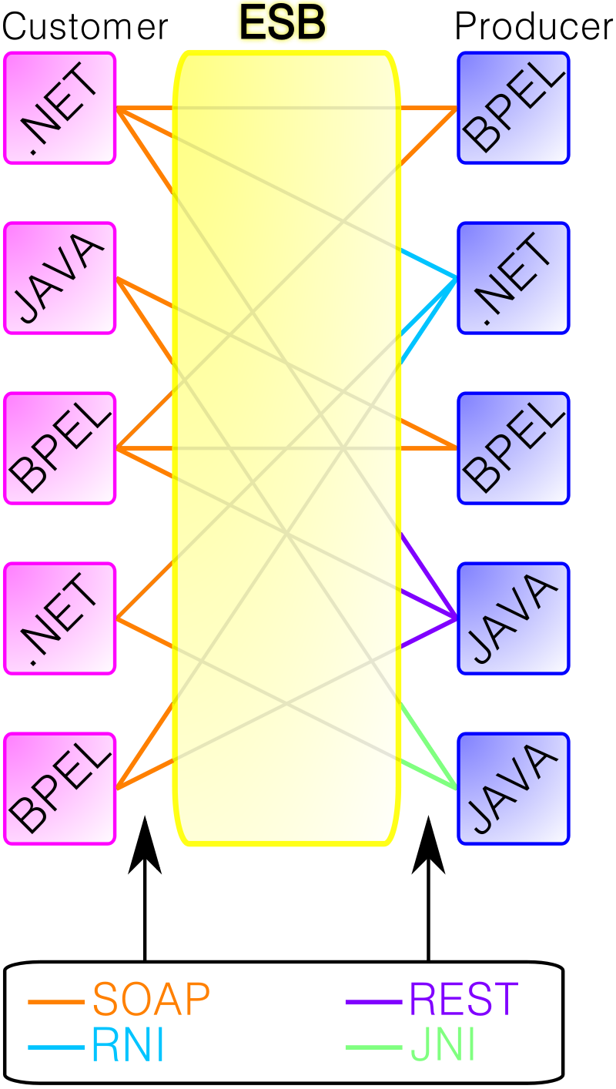
Estimate |  | The output of an estimation process, containing a description of inputs, assumptions, methodology, and the resulting estimate values. Depending on purpose and formality an estimate’s packaging can range from a document containing complete output of several different estimation techniques (see project estimate) to a terse summary (see task estimate).
Estimation |  | In software development, an "estimate" is the evaluation of the effort necessary to carry out a given development task; this is most often expressed in terms of duration.
Estimation |  | The process of determining the size, cost, schedule, effort, and/or quality estimates for a project. It is best to use as many different estimation techniques as possible when creating estimates, and to create estimates regularly through the life of a project.
Ethernet over twisted pair |  | Name Standard Status Speed (Mbit/s) [A] Pairs requi- red Lanes per direc- tion Bits per hertz [B] Max dist- ance (m) Cable req. [D] Cable rating (MHz) Usage  2.5GBASE-T 802.3bz-2016 Current 2500 4 4 6.25 100 Cat 5e 100 LAN  5GBASE-T 802.3bz-2016 Current 5000 4 4 6.25 100 Cat 6 250 LAN  10BASE-T 802.3i-1990 (CL14) Legacy 10 2 1 1 100 Cat 3 16 LAN [21]  10BASE-T1L 802.3cg-2019 Planned 10 1 1 ? 1000 ? ? Automotive, IoT, M2M  10BASE-T1S 802.3cg-2019 Planned 10 1 1 ? 15 ? ? Automotive, IoT, M2M  10GBASE-T 802.3an-2006 Current 10000 4 4 6.25 100 Cat 6A 500 LAN  25GBASE-T 802.3bq-2016 (CL113) in deployment 25000 4 4 6.25 30 Cat 8 2000 Data Centres  40GBASE-T 802.3bq-2016 (CL113) in deployment 40000 4 4 6.25 30 Cat 8 2000 Data Centres  100BASE-T1 802.3bw-2015 (CL96) Current 100 1 1 2.66 15 Cat 5e 100 Automotive, IoT, M2M  100BASE-T2 802.3y-1997 obsolete 100 2 2 4 100 Cat 3 16 Market Failure  100BASE-T4 802.3u-1995 obsolete 100 4 3 2.66 100 Cat 3 16 Market Failure  100BASE-TX 802.3u-1995 Current 100 2 1 3.2 100 Cat 5 100 LAN  100BaseVG 802.12-1995 obsolete 100 4 4 1.66 100 Cat 3 16 Market Failure  1000BASE-T1 802.3bp-2016 Current 1000 1 1 2.66 40 Cat 6A 500 Automotive, IoT, M2M  1000BASE-T 802.3ab-1999 (CL40) Current 1000 4 4 4 100 Cat 5e 100 LAN  1000BASE-TX TIA/EIA-854 (2001) obsolete 1000 4 2 4 100 Cat 6 250 Market Failure  LattisNet pre 802.3i-1990 obsolete 10 2 1 1 100 voice grade ~12 LAN  StarLAN-10 802.3e-1988 obsolete 10 2 1 1 ~100 voice grade ~12 LAN  StarLAN-1 1BASE5 802.3e-1987 obsolete 1 2 1 1 250 voice grade ~12 LAN  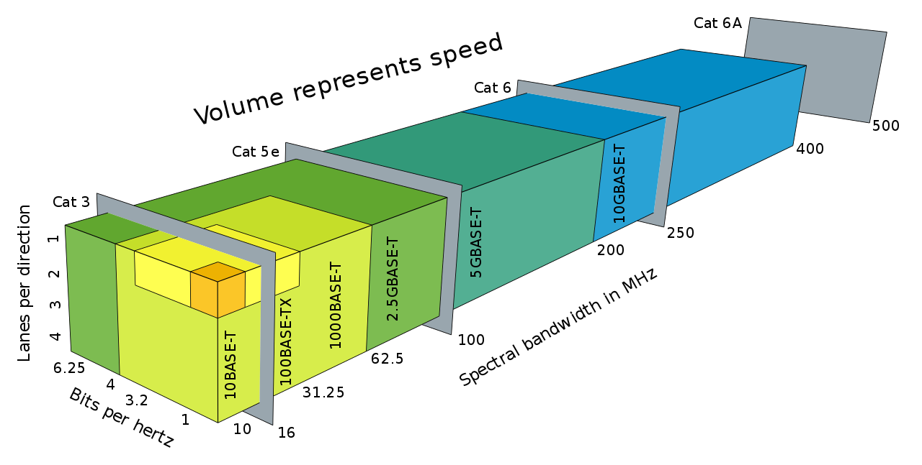
Ethical Hacking |  | The term "white hat" in Internet slang refers to an ethical computer hacker, or a computer security expert, who specializes in penetration testing and in other testing methodologies that ensures the security of an organization's information systems. Ethical hacking is a term meant to imply a broader category than just penetration testing. Contrasted with black hat, a malicious hacker, the name comes from Western films, where heroic and antagonistic cowboys might traditionally wear a white and a black hat respectively.
ETL | Extract, Transform, Load | ETL is short for extract, transform, load, three database functions that are combined into one tool to pull data out of one database and place it into another database.  - Extract is the process of reading data from a database. In this stage, the data is collected, often from multiple and different types of sources.  - Transform is the process of converting the extracted data from its previous form into the form it needs to be in so that it can be placed into another database. Transformation occurs by using rules or lookup tables or by combining the data with other data.  - Load is the process of writing the data into the target database.  Data from one or more sources is extracted and then copied to the data warehouse. When dealing with large volumes of data and multiple source systems, the data is consolidated. ETL is used to migrate data from one database to another, and is often the specific process required to load data to and from data marts and data warehouses, but is a process that is also used to large convert (transform) databases from one format or type to another.  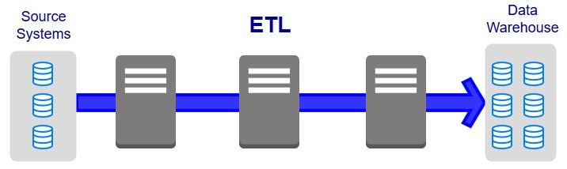
ETSI | European Telecommunications Standards Institute | The European Telecommunications Standards Institute (ETSI) is an independent, not-for-profit, standardization organization in the telecommunications industry (equipment makers and network operators) in Europe, headquartered in Sophia-Antipolis, France, with worldwide projection. ETSI produces globally-applicable standards for Information and Communications Technologies (ICT), including fixed, mobile, radio, converged, broadcast and internet technologies.  ETSI was created by CEPT in 1988 and is officially recognized by the European Commission and the EFTA secretariat. Based in Sophia Antipolis (France), ETSI is officially responsible for standardization of Information and Communication Technologies (ICT) within Europe.  ETSI publishes between 2,000 and 2,500 standards every year. Since its establishment in 1988, it has produced over 30,000. These include the standards that enable key global technologies such as GSM cell phone system, 3G, 4G, DECT, TETRA professional mobile radio system, and Short Range Device requirements including LPD radio, smart cards and many more standards success stories.  Significant ETSI technical committees and Industry Specification Groups (ISGs) include SmartM2M (for machine-to-machine communications), Intelligent Transport Systems, Network Functions Virtualisation, Cyber Security, Electronic Signatures and Infrastructures etc. ETSI inspired the creation of, and is a partner in, 3GPP and oneM2M.
E-UTRAN |  | E-UTRA is the air interface of 3rd Generation Partnership Project (3GPP) Long Term Evolution (LTE) upgrade path for mobile networks. It is an acronym for Evolved Universal Mobile Telecommunications System (UMTS) Terrestrial Radio Access, also referred to as the 3GPP work item on the Long Term Evolution (LTE) also known as the Evolved Universal Terrestrial Radio Access (E-UTRA) in early drafts of the 3GPP LTE specification. E-UTRAN is the initialism of Evolved UMTS Terrestrial Radio Access Network and is the combination of E-UTRA, user equipment (UE), and E-UTRAN Node B or Evolved Node B (EnodeB).  It is a radio access network (RAN) which is referred to under the name EUTRAN standard meant to be a replacement of the UMTS and HSDPA/HSUPA technologies specified in 3GPP releases 5 and beyond. Unlike HSPA, LTE's E-UTRA is an entirely new air interface system, unrelated to and incompatible with W-CDMA. It provides higher data rates, lower latency and is optimized for packet data. It uses OFDMA radio-access for the downlink and SC-FDMA on the uplink.  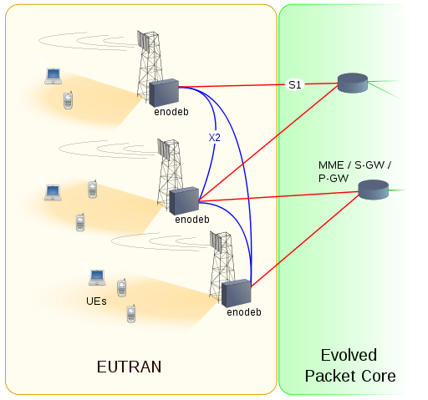
Evaluation | CxEval | CxOne evaluation material type, see CxOneOverview for description.
EVC | Ethernet Virtual Connection | Ethernet virtual circuits (EVCs) define a Layer 2 bridging architecture that supports Ethernet services. An EVC is defined by the Metro-Ethernet Forum (MEF) as an association between two or more user network interfaces that identifies a point-to-point or multipoint-to-multipoint path within the service provider network. An EVC is a conceptual service pipe within the service provider network. A bridge domain is a local broadcast domain that exists separately from VLANs.
Evolutionary Delivery Lifecycle |  | A combination of the evolutionary prototyping and staged delivery lifecycles.
Evolutionary Prototyping Lifecycle |  | A system concept is evolved through iteration until the system is ready for delivery.
EVPL | Ethernet Virtual Private Line | Ethernet private line (EPL) and Ethernet virtual private line (EVPL) are data services defined by the MEF. EPL provides a point-to-point Ethernet virtual connection (EVC) between a pair of dedicated user–network interfaces (UNIs), with a high degree of transparency. EVPL provides a point-to-point or point-to-multipoint connection between a pair of UNIs.  The services are categorized as an E-Line service type, with an expectation of low frame delay, frame delay variation and frame loss ratio. EPL is implemented using a point-to-point EVC with no Service Multiplexing at each UNI (physical interface), i.e., all service frames at the UNI are mapped to a single EVC (a.k.a. all-to-one bundling).  Due to a high degree of transparency, EPL is often used to provide point-to-point Transparent LAN Service (TLS), where the service frame's header and payload are identical at both the source and destination UNI. Some implementations tunnel most Ethernet Layer 2 Control Protocols (L2CPs) except for some link layer L2CPs such as IEEE 802.3x pause frames.  Unlike EPL, EVPL allows for service multiplexing, i.e., multiple EVCs or Ethernet services per UNI. The other difference between the EVPL and EPL is the degree of transparency - while EPL is highly transparent, filtering only the pause frames, EVPL is required to either peer or drop most of the Layer 2 Control Protocols.
Expert Judgment |  | Estimation technique that relies on participants creating estimates based on personal experience and heuristics.  Expert judgment can be used stand-alone, but is always best when combined with analogy, statistical, and decomposition estimation techniques.
Explicit Change Control |  | Refers to artifacts managed directly by a change control board. Requirements and project plans are often under explicit change control. Compare to implicit change control.
Explicit Risk Management |  | Synonym for extrinsic risk management.
Exploratory Testing |  | Exploratory testing is, more than strictly speaking a "practice," a style or approach to testing software which is often contrasted to "scripted testing."
Extrinsic Risk Management |  | Formal risk management techniques that are added to a project or processes to explicitly mange risks. An example would be using a top 10 risks list to explicitly identify, prioritize, plan mitigation, and report outcome of risk management. Compare to intrinsic risk management.  CxOne uses corrective activity management techniques to handles some details of extrinsic risk management.

F
Facilitation |  | A facilitator is a person who chooses or is given the explicit role of conducting a meeting.
FCS | Frame Check Sequence | A frame check sequence (FCS) refers to the extra error-detecting code added to a frame in a communications protocol. Frames are used to send upper-layer data and ultimately the application data from a source to a destination.  The detection does not imply error recovery; for example, Ethernet specifies that a damaged frame should be discarded, but at the same time does not specify any action to cause the frame to be retransmitted. Other protocols, notably the Transmission Control Protocol (TCP), can notice the data loss and initiate error recovery.
FDDI | Fiber Distributed Data Interface | Fiber Distributed Data Interface (FDDI) is a standard for data transmission in a local area network. It uses optical fiber as its standard underlying physical medium, although it was also later specified to use copper cable, in which case it may be called CDDI (Copper Distributed Data Interface), standardized as TP-PMD (Twisted-Pair Physical Medium-Dependent), also referred to as TP-DDI (Twisted-Pair Distributed Data Interface).  FDDI was effectively made obsolete in local networks by Fast Ethernet which offered the same 100 Mbit/s speeds, but at a much lower cost and, since 1998, by Gigabit Ethernet due to its speed, and even lower cost, and ubiquity.
Feature |  | Used in CxOne as an abstract measure or description of system functionality, i.e., the feature scope for a project.  Is also used to discuss a discrete piece of system behavior, e.g., “feature X”.
feature creep |  | a tendency for product or project requirements to increase during development beyond those originally foreseen, leading to features that weren't originally planned and resulting risk to product quality or schedule.
Feature Test |  | Testing a specific subset of system functionality after construction of the functionality is completed.
FemtoCell |  | In telecommunications, a femtocell is a small, low-power cellular base station, typically designed for use in a home or small business. A broader term which is more widespread in the industry is small cell, with femtocell as a subset. It is also called femto AccessPoint (AP). It connects to the service provider’s network via broadband (such as DSL or cable); current designs typically support four to eight simultaneously active mobile phones in a residential setting depending on version number and femtocell hardware, and eight to sixteen mobile phones in enterprise settings. A femtocell allows service providers to extend service coverage indoors or at the cell edge, especially where access would otherwise be limited or unavailable. Although much attention is focused on WCDMA, the concept is applicable to all standards, including GSM, CDMA2000, TD-SCDMA, WiMAX and LTE solutions.  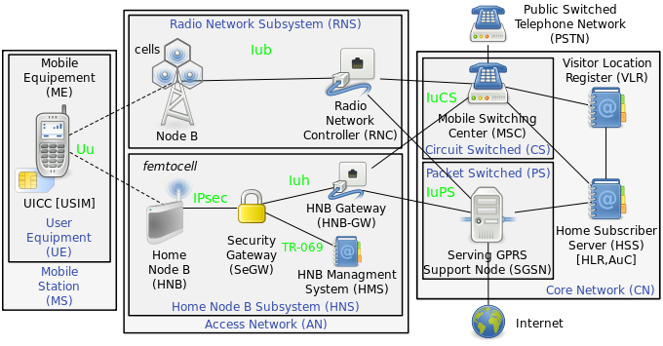
FIPS |  | Federal Information Processing Standards (FIPS) are publicly announced standards developed by the United States federal government for use in computer systems by non-military government agencies and government contractors.  FIPS standards are issued to establish requirements for various purposes such as ensuring computer security and interoperability, and are intended for cases in which suitable industry standards do not already exist. Many FIPS specifications are modified versions of standards used in the technical communities, such as the American National Standards Institute (ANSI), the Institute of Electrical and Electronics Engineers (IEEE), and the International Organization for Standardization (ISO).
FIPS 140-2 |  | The Federal Information Processing Standard (FIPS) Publication 140-2, (FIPS PUB 140-2), is a U.S. government computer security standard used to approve cryptographic modules. The title is Security Requirements for Cryptographic Modules. Initial publication was on May 25, 2001 and was last updated December 3, 2002  Purpose  The National Institute of Standards and Technology (NIST) issued the FIPS 140 Publication Series to coordinate the requirements and standards for cryptography modules that include both hardware and software components. Protection of a cryptographic module within a security system is necessary to maintain the confidentiality and integrity of the information protected by the module. This standard specifies the security requirements that will be satisfied by a cryptographic module. The standard provides four increasing, qualitative levels of security intended to cover a wide range of potential applications and environments. The security requirements cover areas related to the secure design and implementation of a cryptographic module. These areas include cryptographic module specification; cryptographic module ports and interfaces; roles, services, and authentication; finite state model; physical security; operational environment; cryptographic key management; electromagnetic interference/electromagnetic compatibility (EMI/EMC); self-tests; design assurance; and mitigation of other attacks.  Federal agencies and departments can validate that the module in use is covered by an existing FIPS 140-1 or FIPS 140-2 certificate that specifies the exact module name, hardware, software, firmware, and/or applet version numbers. The cryptographic modules are produced by the private sector or open source communities for use by the U.S. government and other regulated industries (such as financial and health-care institutions) that collect, store, transfer, share and disseminate sensitive but unclassified (SBU) information. A commercial cryptographic module is also commonly referred to as a hardware security module (HSM).  Security levels  FIPS 140-2 defines four levels of security, simply named "Level 1" to "Level 4". It does not specify in detail what level of security is required by any particular application.  Level 1  Security Level 1 provides the lowest level of security. Basic security requirements are specified for a cryptographic module (e.g., at least one Approved algorithm or Approved security function shall be used). No specific physical security mechanisms are required in a Security Level 1 cryptographic module beyond the basic requirement for production-grade components. An example of a Security Level 1 cryptographic module is a personal computer (PC) encryption board.  Level 2  Security Level 2 improves upon the physical security mechanisms of a Security Level 1 cryptographic module by requiring features that show evidence of tampering, including tamper-evident coatings or seals that must be broken to attain physical access to the plaintext cryptographic keys and critical security parameters (CSPs) within the module, or pick-resistant locks on covers or doors to protect against unauthorized physical access.  Level 3  In addition to the tamper-evident physical security mechanisms required at Security Level 2, Security Level 3 attempts to prevent the intruder from gaining access to CSPs held within the cryptographic module. Physical security mechanisms required at Security Level 3 are intended to have a high probability of detecting and responding to attempts at physical access, use or modification of the cryptographic module. The physical security mechanisms may include the use of strong enclosures and tamper-detection/response circuitry that zeroes all plaintext CSPs when the removable covers/doors of the cryptographic module are opened.  Level 4  Security Level 4 provides the highest level of security. At this security level, the physical security mechanisms provide a complete envelope of protection around the cryptographic module with the intent of detecting and responding to all unauthorized attempts at physical access. Penetration of the cryptographic module enclosure from any direction has a very high probability of being detected, resulting in the immediate deletion of all plaintext CSPs.  Security Level 4 cryptographic modules are useful for operation in physically unprotected environments. Security Level 4 also protects a cryptographic module against a security compromise due to environmental conditions or fluctuations outside of the module's normal operating ranges for voltage and temperature. Intentional excursions beyond the normal operating ranges may be used by an attacker to thwart a cryptographic module's defenses. A cryptographic module is required to either include special environmental protection features designed to detect fluctuations and delete CSPs, or to undergo rigorous environmental failure testing to provide a reasonable assurance that the module will not be affected by fluctuations outside of the normal operating range in a manner that can compromise the security of the module.
Firewall |  | n computing, a firewall is a network security system that monitors and controls incoming and outgoing network traffic based on predetermined security rules. A firewall typically establishes a barrier between a trusted internal network and untrusted external network, such as the Internet.  Firewalls are often categorized as either network firewalls or host-based firewalls. Network firewalls filter traffic between two or more networks and run on network hardware. Host-based firewalls run on host computers and control network traffic in and out of those machines.  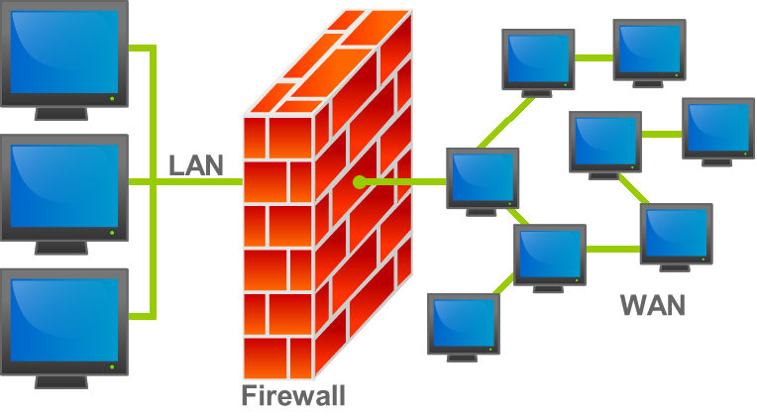  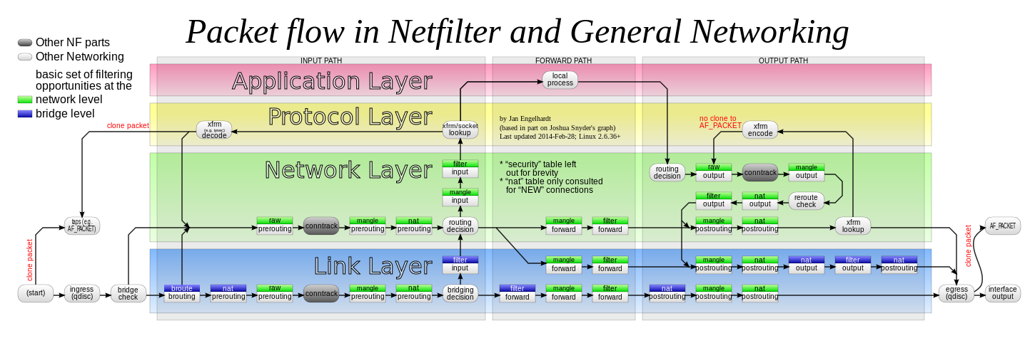
FNA | Full Network Authentication | This is where your line is assigned a NetworkID and the authentication is done on that. If the line connected matches the NetworkID records on the RADIUS servers it creates an auth session.
Formal Testing |  | Execution of testing using documented test cases. Compare to informal testing.
Fortran |  | Fortran is a general-purpose, compiled imperative programming language that is especially suited to numeric computation and scientific computing.  Originally developed by IBM in the 1950s for scientific and engineering applications, FORTRAN came to dominate this area of programming early on and has been in continuous use for over half a century in computationally intensive areas such as numerical weather prediction, finite element analysis, computational fluid dynamics, computational physics, crystallography and computational chemistry. It is a popular language for high-performance computing and is used for programs that benchmark and rank the world's fastest supercomputers.  Fortran encompasses a lineage of versions, each of which evolved to add extensions to the language while usually retaining compatibility with prior versions. Successive versions have added support for structured programming and processing of character-based data (FORTRAN 77), array programming, modular programming and generic programming (Fortran 90), high performance Fortran (Fortran 95), object-oriented programming (Fortran 2003) and concurrent programming (Fortran 2008).  Fortran's design was the basis for many other programming languages. Among the better known is BASIC, which is a based on FORTRAN II with a number of syntax cleanups, notably better logical structures, and other changes to more easily work in an interactive environment.
Forwarding plane |  | See User Plane
FQDN | Fully Qualified Domain Name | A fully qualified domain name (FQDN), sometimes also referred to as an absolute domain name, is a domain name that specifies its exact location in the tree hierarchy of the Domain Name System (DNS). It specifies all domain levels, including at least a second-level domain and a top-level domain. A fully qualified domain name is distinguished by its lack of ambiguity: it can be interpreted only in one way.  The DNS root domain is unnamed which is expressed by having an empty label in the DNS hierarchy, resulting in a fully qualified domain name ending with the top-level domain. However, in some cases the full stop (period) character is required at the end of the fully qualified domain name.  In contrast to a domain name that is fully specified, a domain name that does not include the full path of labels up to the DNS root is often called a partially qualified domain name.  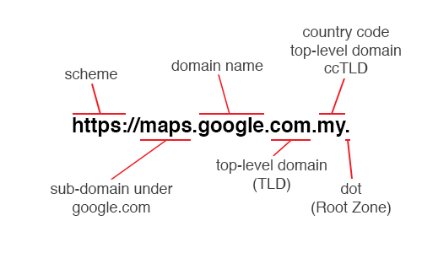
Frame Relay |  | Frame Relay is a standardized wide area network technology that specifies the physical and data link layers of digital telecommunications channels using a packet switching methodology. Originally designed for transport across Integrated Services Digital Network (ISDN) infrastructure, it may be used today in the context of many other network interfaces.  Network providers commonly implement Frame Relay for voice (VoFR) and data as an encapsulation technique used between local area networks (LANs) over a wide area network (WAN). Each end-user gets a private line (or leased line) to a Frame Relay node. The Frame Relay network handles the transmission over a frequently changing path transparent to all end-user extensively used WAN protocols. It is less expensive than leased lines and that is one reason for its popularity. The extreme simplicity of configuring user equipment in a Frame Relay network offers another reason for Frame Relay's popularity.  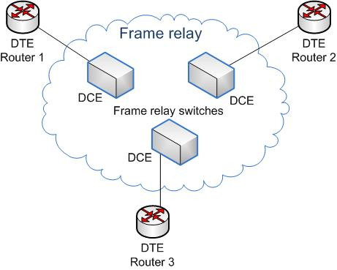
Frequent Releases |  | An Agile team frequently releases its product into the hands of end users, listening to feedback, whether critical or appreciative.
Frequently Asked Question | FAQ | Documents commonly asked questions and their answers.
FSK |  | Frequency-shift keying (FSK) is a frequency modulation scheme in which digital information is transmitted through discrete frequency changes of a carrier signal. The technology is used for communication systems such as amateur radio, caller ID and emergency broadcasts. The simplest FSK is binary FSK (BFSK). BFSK uses a pair of discrete frequencies to transmit binary (0s and 1s) information. With this scheme, the "1" is called the mark frequency and the "0" is called the space frequency.  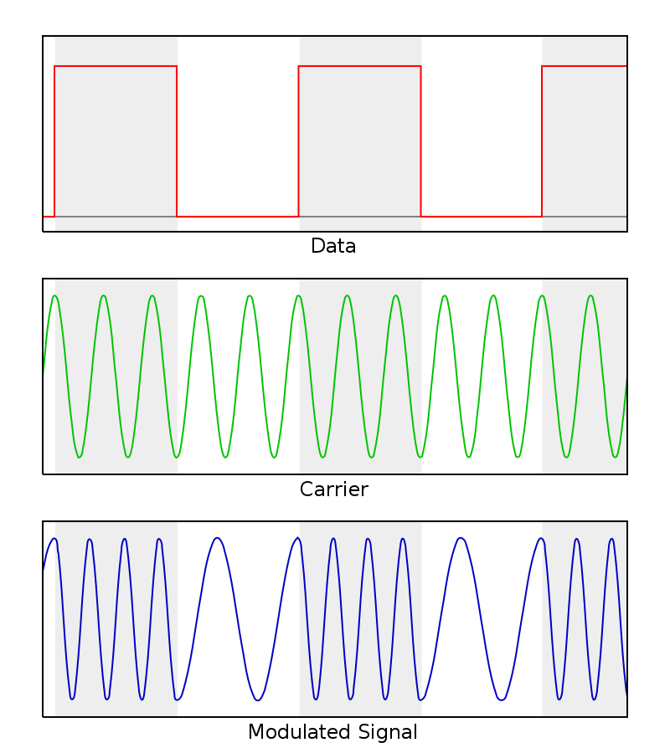
FTP | File Transfer Protocol | The File Transfer Protocol (FTP) is a standard network protocol used for the transfer of computer files between a client and server on a computer network.  FTP is built on a client-server model architecture and uses separate control and data connections between the client and the server.
FTPS | File Transfer Protocol Secure | FTPS (also known as FTPES, FTP-SSL, and FTP Secure) is an extension to the commonly used File Transfer Protocol (FTP) that adds support for the Transport Layer Security (TLS) and the Secure Sockets Layer (SSL) cryptographic protocols.  FTPS should not be confused with the SSH File Transfer Protocol (SFTP), a secure file transfer subsystem for the Secure Shell (SSH) protocol it is not compatible with. It is also different from FTP over SSH, the practice of tunneling FTP through an SSH connection.
Full duplex |  | In a full-duplex system, both parties can communicate with each other simultaneously. An example of a full-duplex device is a telephone; the parties at both ends of a call can speak and be heard by the other party simultaneously. The earphone reproduces the speech of the remote party as the microphone transmits the speech of the local party, because there is a two-way communication channel between them, or more strictly speaking, because there are two communication channels between them.
Function Point |  | Size measure for a software system based on abstracted measure of system functionality.
Functional Requirement |  | Functionality that must be built into the system to satisfy the business requirements. Also known as a what requirement.
Functional Testing |  | Comparing a system’s behavior against expected behavior, without concern for the internal workings of the system.
Fuzzy Front End |  | Term coined by Steve McConnell to describes the initial inception phases of a project. CxOne defines the start of the fuzzy front end as the point someone starts thinking about a project and working on chartering it, and the end as the point at which the charter is approved and the project begins.
Fuzzy Logic |  | A relative ranking technique for describing characteristics. Often used in conjunction with items that contain uncertainty, like estimates. A general example is to take three buckets called small, medium, and large. Items are assigned t each bucket, and then the bucket values are used as stand-ins for a possible range of quantitative values. One common characteristic of fuzzy logic buckets is that the high end value from one bucket overlaps the low end value of the next bucket.
FXO | Foreign Exchange Office | FXS (Foreign Exchange Station) means the wall jack or the interface to the telephone system which FXO devices can be connected to. Using these interfaces a call can be established. The port provides the necessary electricity as well as the dialtone and the call signal.  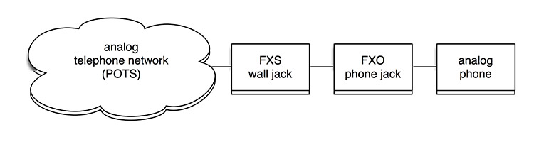
FXS | Foreign Exchange Station | FXO (Foreign Exchange Office) is the port that receives the analog line on the telephone or fax machine. It establishes the connection to the analog line (FXS). FXS devices connected to phone system are referred to as endpoints (e.g. a phone).

G
G.711 |  | G.711 is an ITU-T standard for audio companding. It is primarily used in telephony. The standard was released for usage in 1972. Its formal name is Pulse code modulation (PCM) of voice frequencies. It is a required standard in many technologies, for example in H.320 and H.323 specifications. It can also be used for fax communication over IP networks (as defined in T.38 specification). G.711, also known as Pulse Code Modulation (PCM), is a very commonly used waveform codec. G.711 is a narrowband audio codec that provides toll-quality audio at 64 kbit/s. G.711 passes audio signals in the range of 300–3400 Hz and samples them at the rate of 8,000 samples per second, with the tolerance on that rate of 50 parts per million (ppm). Non-uniform (logarithmic) quantization with 8 bits is used to represent each sample, resulting in a 64 kbit/s bit rate. There are two slightly different versions: μ-law, which is used primarily in North America and Japan, and A-law, which is in use in most other countries outside North America.  Two enhancements to G.711 have been published: G.711.0 utilizes lossless data compression to reduce the bandwidth usage and G.711.1 increases audio quality by increasing bandwidth.  Types  G.711 defines two main companding algorithms, the µ-law algorithm and A-law algorithm. Both are logarithmic, but A-law was specifically designed to be simpler for a computer to process. The standard also defines a sequence of repeating code values which defines the power level of 0 dB.  The µ-law and A-law algorithms encode 14-bit and 13-bit signed linear PCM samples (respectively) to logarithmic 8-bit samples. Thus, the G.711 encoder will create a 64 kbit/s bitstream for a signal sampled at 8 kHz.  G.711 μ-law tends to give more resolution to higher range signals while G.711 A-law provides more quantization levels at lower signal levels.  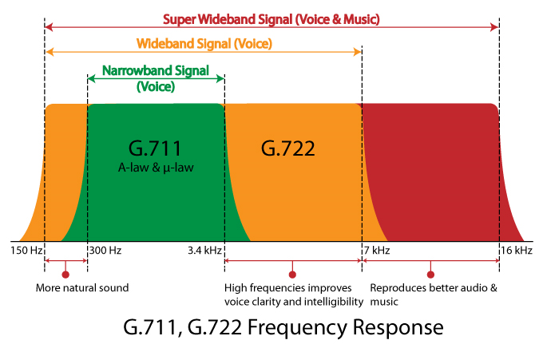
G.711.1 |  | G.711.1 is an extension to G.711, published as ITU-T Recommendation G.711.1 in March 2008. Its formal name is Wideband embedded extension for G.711 pulse code modulation.  G.711.1, allows the addition of narrowband and/or wideband (16000 samples/s) enhancements, each at 25% of the bitrate of the (included) base G.711 bitstream, leading to data rates of 64, 80 or 96 kbit/s.  G.711.1 is compatible with G.711 at 64 kbit/s, hence an efficient deployment in existing G.711-based voice over IP (VoIP) infrastructures is foreseen. The G.711.1 coder can encode signals at 16 kHz with a bandwidth of 50–7000 Hz at 80 and 96 kbit/s, and for 8-kHz sampling the output may produce signals with a bandwidth ranging from 50 up to 4000 Hz, operating at 64 and 80 kbit/s.  The G.711.1 encoder creates an embedded bitstream structured in three layers corresponding to three available bit rates: 64, 80 and 96 kbit/s. The bitstream does not contain any information on which layers are contained, an implementation would require outband signalling on which layers are available. The three G.711.1 layers are: log companded pulse code modulation (PCM) of the lower band including noise feedback, embedded PCM extension with adaptive bit allocation for enhancing the quality of the base layer in the lower band, and weighted vector quantization coding of the higher band based on modified discrete cosine transformation (MDCT).  Two extensions for G.711.1 are planned in 2010: superwideband extension (bandwidth to 14000 Hz) and lossless bitstream compression.
G.719 |  | G.719 is an ITU-T standard audio coding format providing high quality, moderate bit rate (32 to 128 kbit/s) wideband (20 Hz - 20 kHz audio bandwidth, 48 kHz audio sample rate) audio coding at low computational load. It was produced through a collaboration between Polycom and Ericsson.  G.719 incorporates elements of Polycom's Siren22 codec (22 kHz) and Ericsson codec technology, as well as Polycom's Siren7 and Siren14 codecs (G.722.1 and G.722.1 Annex C), which have been used in videoconferencing systems for many years. As ITU-T Recommendation G.719, it was approved on June 13, 2008.  G.719 is optimized for both speech and music. It is based on transform coding with adaptive time-resolution, adaptive bit-allocation and low complexity lattice vector quantization. The computational complexity is quite low (18 floating-point MIPS) for an efficient high-quality compressor. The codec operates on 20 ms frames, and the algorithmic delay end-to-end is 40 ms. The encoder input and decoder output are sampled at 48 kHz.  In addition to the nominal bit rates of 32, 48 and 64 kbit/s, the G.719 codec has an inherent feature of flexible rate selection. In fact, it is possible to accommodate any rate between 32 kbit/s and 64 kbit/s by steps of 4 kbit/s. Moreover, the codec can also provide higher rates than 64 kbit/s and up to 128 kbit/s.
G.722 |  | G.722 is an ITU-T standard 7 kHz Wideband audio codec operating at 48, 56 and 64 kbit/s. It was approved by ITU-T in November 1988. Technology of the codec is based on sub-band ADPCM (SB-ADPCM).  G722 provides improved speech quality due to a wider speech bandwidth of 50–7000 Hz compared to narrowband speech coders like G.711 which in general are optimized for POTS wireline quality of 300–3400 Hz. G.722 sample audio data at a rate of 16 kHz (using 14 bits), double that of traditional telephony interfaces, which results in superior audio quality and clarity.[2]  Other ITU-T 7 kHz wideband codecs include G.722.1 and G.722.2. These codecs are not variants of G.722 and they use different patented compression technologies. G.722.1 is based on Siren codecs and offers lower bit-rate compressions (24 kbit/s or 32 kbit/s). A more recent G.722.2, also known as AMR-WB ("Adaptive Multirate Wideband") is based on ACELP and offers even lower bit-rate compressions (6.6 kbit/s to 23.85 kbit/s), as well as the ability to quickly adapt to varying compressions as the network topography mutates. In the latter case, bandwidth is automatically conserved when network congestion is high. When congestion returns to a normal level, a lower-compression, higher-quality bitrate is restored.
G.723.1 |  | G.723.1 is an audio codec for voice that compresses voice audio in 30 ms frames. An algorithmic look-ahead of 7.5 ms duration means that total algorithmic delay is 37.5 ms. Its official name is Dual rate speech coder for multimedia communications transmitting at 5.3 and 6.3 kbit/s. It is sometimes associated with a Truespeech trademark in coprocessors produced by DSP Group.[1]  This is a completely different codec from G.723.  There are two bit rates at which G.723.1 can operate:  6.3 kbit/s (using 24 byte frames) using a MPC-MLQ algorithm (MOS 3.9)  5.3 kbit/s (using 20 byte frames) using an ACELP algorithm (MOS 3.62)
G.726 |  | G.726 is an ITU-T ADPCM speech codec standard covering the transmission of voice at rates of 16, 24, 32, and 40 kbit/s. It was introduced to supersede both G.721, which covered ADPCM at 32 kbit/s, and G.723, which described ADPCM for 24 and 40 kbit/s. G.726 also introduced a new 16 kbit/s rate. The four bit rates associated with G.726 are often referred to by the bit size of a sample, which are 2, 3, 4, and 5-bits respectively.  The most commonly used mode is 32 kbit/s, which doubles the usable network capacity by using half the rate of G.711. It is primarily used on international trunks in the phone network and is the standard codec used in DECT wireless phone systems. The principal application of 24 and 16 kbit/s channels is for overload channels carrying voice in digital circuit multiplication equipment (DCME). The principal application of 40 kbit/s channels is to carry data modem signals in DCME, especially for modems operating at greater than 4800 bit/s.

G.729
G.Fast |  | G.fast is a digital subscriber line (DSL) protocol standard for local loops shorter than 500 m, with performance targets between 100 Mbit/s and 1 Gbit/s, depending on loop length. High speeds are only achieved over very short loops. Although G.fast was initially designed for loops shorter than 250 meters, Sckipio in early 2015 demonstrated G.fast delivering speeds over 100 Mbit/s nearly 500 meters and the EU announced a research project.[  Formal specifications have been published as ITU-T G.9700 and G.9701, with approval of G.9700 granted in April 2014 and approval of G.9701 granted on December 5, 2014. Development was coordinated with the Broadband Forum's FTTdp (fiber to the distribution point) project.  The letter G in G.fast stands for the ITU-T G series of recommendations; fast is an acronym for fast access to subscriber terminals. Limited demonstration hardware was demonstrated in mid-2013. The first chipsets were introduced in October 2014, with commercial hardware introduced in 2015, and first deployments started in 2016.  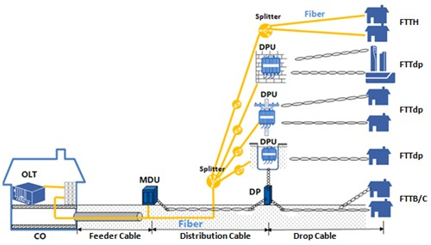  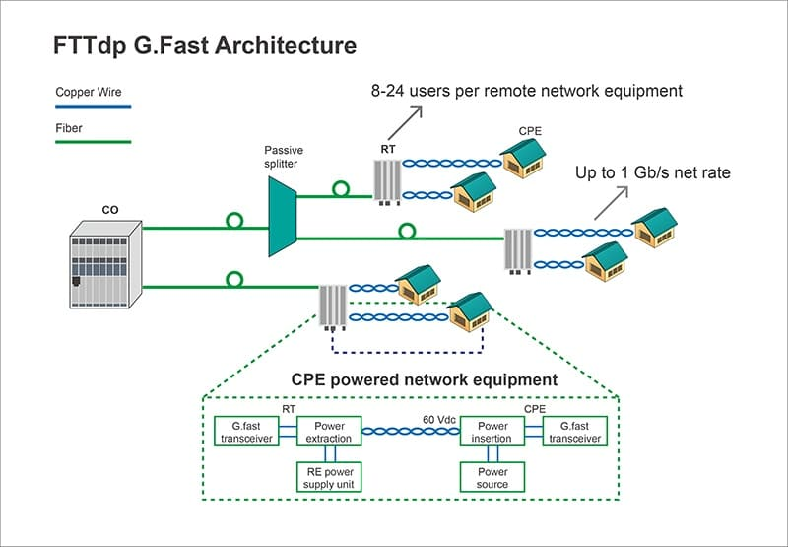  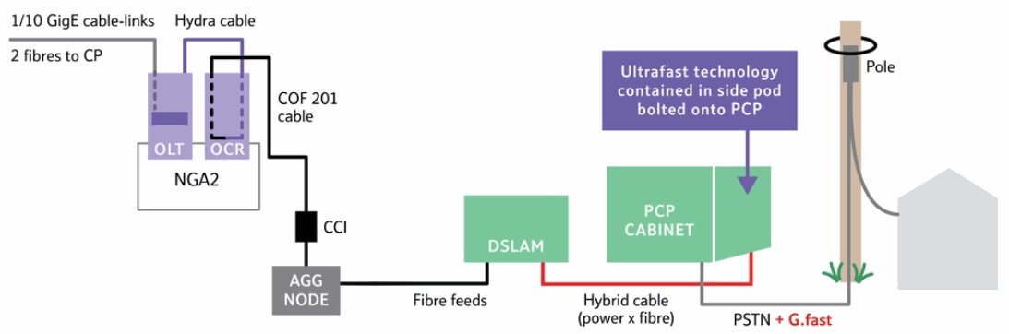
Gantt chart |  | a horizontal bar chart frequently used in project management that provides a graphical illustration of a schedule that helps to plan, coordinate, and track specific tasks in a project.  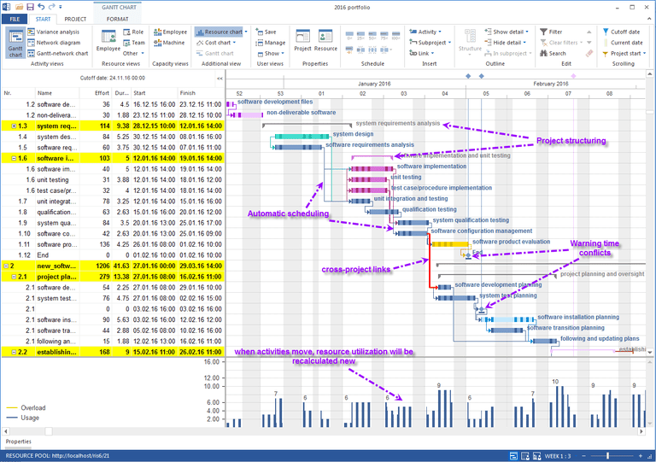
gap analysis |  | the study of the differences between two different information systems or applications, often for the purpose of determining how to get from one state to a new state. Sometimes spoken of as "the space between where we are and where we want to be."
Gate |  | A set of defined criteria that must be completed for an artifact or even to be complete, or to allow a process or workflow to move from one phase to the next.
Gate Checklist |  | A special checklist type that defines and supports verification of a gate.
GBE / GE | Gigabit Ethernet
GCHQ | Government Communications Headquarters | The Government Communications Headquarters (GCHQ) is an intelligence and security organisation responsible for providing signals intelligence (SIGINT) and information assurance to the government and armed forces of the United Kingdom. Based in "The Doughnut" in the suburbs of Cheltenham, GCHQ is the responsibility of the country's Secretary of State for Foreign and Commonwealth Affairs, but it is not a part of the Foreign Office and its director ranks as a Permanent Secretary.  GCHQ was originally established after the First World War as the Government Code and Cypher School (GC&CS) and was known under that name until 1946. During the Second World War it was located at Bletchley Park, where it was responsible for breaking of the German Enigma codes. Currently there are two main components of the GCHQ, the Composite Signals Organisation (CSO), which is responsible for gathering information, and the National Cyber Security Centre (NCSC), which is responsible for securing the UK's own communications. The Joint Technical Language Service (JTLS) is a small department and cross-government resource responsible for mainly technical language support and translation and interpreting services across government departments. It is co-located with GCHQ for administrative purposes.
Geocast |  | Geocast refers to the delivery of information to a group of destinations in a network identified by their geographical locations. It is a specialized form of multicast addressing used by some routing protocols for mobile ad hoc networks.  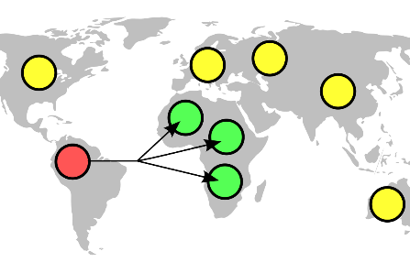
GERAN |  | GERAN is an abbreviation for GSM EDGE Radio Access Network. The standards for GERAN are maintained by the 3GPP (Third Generation Partnership Project). GERAN is a key part of GSM, and also of combined UMTS/GSM networks.  GERAN is the radio part of GSM/EDGE together with the network that joins the base stations (the Ater and Abis interfaces) and the base station controllers (A interfaces, etc.) The network represents the core of a GSM network, through which phone calls and packet data are routed from and to the PSTN and Internet to and from subscriber handsets. A mobile phone operator's network comprises one or more GERANs, coupled with UTRANs in the case of a UMTS/GSM network.  A GERAN without EDGE is a GRAN, but is otherwise identical in concept.  A GERAN without GSM is an ERAN.  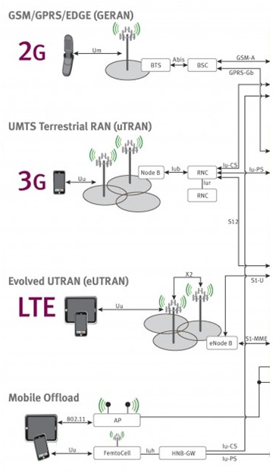
GGSN | Gateway GPRS support node | The gateway GPRS support node (GGSN) is a main component of the GPRS network. The GGSN is responsible for the internetworking between the GPRS network and external packet switched networks, such as the Internet or an X.25 network.  From an external network's point of view, the GGSN is a router to a "sub-network", because the GGSN ‘hides’ the GPRS infrastructure from the external network. When the GGSN receives data addressed to a specific user, it checks if the user is active. If it is, the GGSN forwards the data to the SGSN serving the mobile user, but if the mobile user is inactive, the data is discarded. In the other direction, mobile-originated packets are routed to the right network by the GGSN.  The GGSN is the anchor point that enables the mobility of the user terminal in the GPRS/UMTS networks. In essence, it carries out the role in GPRS equivalent to the home agent in Mobile IP. It maintains routing necessary to tunnel the protocol data units (PDUs) to the SGSN that services a particular MS (mobile station).  The GGSN converts the GPRS packets coming from the SGSN into the appropriate packet data protocol (PDP) format (e.g., IP or X.25) and sends them out on the corresponding packet data network. In the other direction, PDP addresses of incoming data packets are converted to the GSM address of the destination user. The readdressed packets are sent to the responsible SGSN. For this purpose, the GGSN stores the current SGSN address of the user and his or her profile in its location register. The GGSN is responsible for IP address assignment and is the default router for the connected user equipment (UE). The GGSN also performs authentication and charging functions.  Other functions include subscriber screening, IP pool management and address mapping, QoS and PDP context enforcement.  With LTE scenario the GGSN functionality moves to SAE gateway (with SGSN functionality working in MME).
Gigabit Ethernet |  | In computer networking, Gigabit Ethernet (GbE or 1 GigE) is the various technologies for transmitting Ethernet frames at a rate of a gigabit per second (1,000,000,000 bits per second), as defined by the IEEE 802.3-2008 standard. It came into use beginning in 1999, gradually supplanting Fast Ethernet in wired local networks, as a result of being considerably faster. The cables and equipment are very similar to previous standards and have been very common and economical since 2010.  Comparison of fibre based and other Ethernet Physical transport layers (TP-PHYs)[3]  MMF FDDI 62,5/125 µm (1987) MMF OM1 62,5/125 µm (1989) MMF OM2 50/125 µm (1998) MMF OM3 50/125 µm (2003) MMF OM4 50/125 µm (2008) MMF OM5 50/125 µm (2016) SMF OS1 9/125 µm (1998) SMF OS2 9/125 µm (2000)  160 MHz·km @850 nm 200 MHz·km @850 nm 500 MHz·km @850 nm 1500 MHz·km @850 nm 3500 MHz·km @850 nm 3500 MHz·km @850 nm & 1850 MHz·km @950 nm 1 dB/km @1300/ 1550 nm 0.4 dB/km @1300/ 1550 nm  Name Standard Status Media OFC or RFC Transceiver Module Reach in km Notes  1000BASE -CX 802.3z-1998 (CL39) legacy TWP shielded balanced (150 Ω) 8P8C DE-9 FC/HSSDC CX4 (SFF-8470) (IEC 61076-3-103) N/A 0.025 Data centres; predates 1000BASE-T; rarely used.  1000BASE -KX 802.3ap-2007 (CL70) current Cu-Backplane N/A N/A 0.001 PCBs  1000BASE -SX 802.3z-1998 (CL38) current Fibre 770 – 860 nm ST SC LC MT-RJ [4] SFP direct-plug OM1: 0.275  OM2: 0.55  OM3: 1  1000BASE -LX 802.3z-1998 (CL38) current Fibre 1270 – 1355 nm SC LC SFP GBIC direct-plug OM1: 0.55  OM2: 0.55  OM3: 0.55  OSx: 5  1000BASE -LX10 802.3ah-2004 (CL59) current Fibre 1260 – 1360 nm LC SFP OM1: 0.55 identical with -LX but with increased power/sensitivity; commonly simply referred to as -LX or -LH prior to 802.3ah  OM2: 0.55  OM3: 0.55  OSx: 10  1000BASE -BX10 current Fibre TX: 1260 – 1360 nm RX: 1480 – 1500 nm OSx: 10 often simply referred to as -BX  1000BASE -EX proprietary (non IEEE) current Fibre 1310 nm SC LC SFP GBIC OSx: 40 vendor-specific  1000BASE -ZX / -EZX proprietary (non IEEE) current Fibre 1550 nm SC LC SFP GBIC OSx: 70 vendor-specific  1000BASE -RHx 802.3bv-2017 (CL115) current Fibre 650 nm FOT (PMD/MDI) N/A POF: ≤ 0.05 Automotive, Industry, Home; [5][6] Line code: 64b65b × PAM16 Line rate: 325 MBd Variants: -RHA (50 m), -RHB (40 m), -RHC (15 m).  1000BASE -PX 802.3ah-2004 802.3bk-2013 (CL60) current Fibre TX: 1270 nm RX: 1577 nm SC SFP XFP OSx: 10 – 40 EPON; FTTH; using point-to-multipoint topology.
Git |  | Git is a version control system for tracking changes in computer files and coordinating work on those files among multiple people. It is primarily used for source code management in software development, but it can be used to keep track of changes in any set of files. As a distributed revision control system, it is aimed at speed, data integrity, and support for distributed, non-linear workflows.  Git was created by Linus Torvalds in 2005 for development of the Linux kernel, with other kernel developers contributing to its initial development. Its current maintainer since 2005 is Junio Hamano.  As with most other distributed version control systems, and unlike most client–server systems, every Git directory on every computer is a full-fledged repository with complete history and full version tracking abilities, independent of network access or a central server.
Given When Then |  | The Given-When-Then formula is a template intended to guide the writing of acceptance tests for a User Story: (Given) some context, (When) some action is carried out, (Then) a particular set of observable consequences should obtain.
GMSC | Gateway Mobile Switching Centre | The Gateway Mobile Switching Centre (GMSC) is a special kind of MSC that is used to route calls outside the mobile network. Whenever a call for a mobile subscriber comes from outside the mobile network, or the subscriber wants to make a call to somebody outside the mobile network the call is routed through the GMSC.  In practice, the GMSC is just a function that can be part of a MSC.
GNU |  | GNU is an operating system and an extensive collection of computer software. GNU is composed wholly of free software, most of which is licensed under the GNU Project's own General Public License (GPL).  GNU is a recursive acronym for "GNU's Not Unix!", chosen because GNU's design is Unix-like, but differs from Unix by being free software and containing no Unix code.The GNU project includes an operating system kernel, GNU HURD, which was the original focus of the Free Software Foundation (FSF). However, non-GNU kernels, most famously Linux, can also be used with GNU software; as the Hurd kernel is not yet production-ready,[20] this is how the GNU system is usually used.The combination of GNU software and the Linux kernel is commonly known as Linux (or less frequently GNU/Linux; see GNU/Linux naming controversy).
Go |  | Go (often referred to as Golang) is a programming language created by Google in 2009 by Robert Griesemer, Rob Pike, and Ken Thompson. Go is a statically typed, compiled language in the tradition of C, with memory safety, garbage collection, structural typing, and CSP-style concurrency. The compiler, tools and source code are all free and open source.
Goals |  | The desired results of a project, process, or activity.  In general, software projects exist to meet business or organizational goals through the creation of software. Goal and objective are synonyms in CxOne.
GoF | Gang of Four Design patterns | Design Patterns: Elements of Reusable Object-Oriented Software is a software engineering book describing software design patterns. The book's authors are Erich Gamma, Richard Helm, Ralph Johnson and John Vlissides with a foreword by Grady Booch. The book is divided into two parts, with the first two chapters exploring the capabilities and pitfalls of object-oriented programming, and the remaining chapters describing 23 classic software design patterns. The book includes examples in C++ and Smalltalk.  It has been influential to the field of software engineering and is regarded as an important source for object-oriented design theory and practice. More than 500,000 copies have been sold in English and in 13 other languages. The authors are often referred to as the Gang of Four (GoF).
Google Cloud Platform |  | Google Cloud Platform, offered by Google, is a suite of cloud computing services that runs on the same infrastructure that Google uses internally for its end-user products, such as Google Search and YouTube. Alongside a set of management tools, it provides a series of modular cloud services including computing, data storage, data analytics and machine learning. Registration requires a credit card or bank account details.  Google Cloud Platform provides Infrastructure as a Service, Platform as a Service, and Serverless Computing environments.  In April 2008, Google announced App Engine, a platform for developing and hosting web applications in Google-managed data centers, which was the first cloud computing service from the company. The service became generally available in November 2011. Since the announcement of App Engine, Google added multiple cloud services to the platform.  Google Cloud Platform is a part of Google Cloud, which includes the Google Cloud Platform public cloud infrastructure, as well as G Suite, enterprise versions of Android and Chrome OS, and application programming interfaces (APIs) for machine learning and Google Maps
GPL |  | The GNU General Public License (GNU GPL or GPL) is a widely used free software license, which guarantees end users the freedom to run, study, share and modify the software. The license was originally written by Richard Stallman of the Free Software Foundation (FSF) for the GNU Project, and grants the recipients of a computer program the rights of the Free Software Definition. The GPL is a copyleft license, which means that derivative work can only be distributed under the same license terms. This is in distinction to permissive free software licenses, of which the BSD licenses and the MIT License are widely used examples. GPL was the first copyleft license for general use.  Historically, the GPL license family has been one of the most popular software licenses in the free and open-source software domain. Prominent free software programs licensed under the GPL include the Linux kernel and the GNU Compiler Collection (GCC). David A. Wheeler argues that the copyleft provided by the GPL was crucial to the success of Linux-based systems, giving the programmers who contributed to the kernel the assurance that their work would benefit the whole world and remain free, rather than being exploited by software companies that would not have to give anything back to the community.  In 2007, the third version of the license (GNU GPLv3) was released to address some perceived problems with the second version (GNU GPLv2) that were discovered during its long-time usage. To keep the license up to date, the GPL license includes an optional "any later version" clause, allowing users to choose between the original terms or the terms in new versions as updated by the FSF. Developers can omit it when licensing their software; for instance the Linux kernel is licensed under GPLv2 without the "any later version" clause.
GPRS | General Packet Radio Service | General Packet Radio Service (GPRS) is a packet oriented mobile data standard on the 2G and 3G cellular communication network's global system for mobile communications (GSM). GPRS was established by European Telecommunications Standards Institute (ETSI) in response to the earlier CDPD and i-mode packet-switched cellular technologies. It is now maintained by the 3rd Generation Partnership Project (3GPP).  GPRS is typically sold according to the total volume of data transferred during the billing cycle, in contrast with circuit switched data, which is usually billed per minute of connection time, or sometimes by one-third minute increments. Usage above the GPRS bundled data cap may be charged per Mb of data, speed limited, or disallowed.  GPRS is a best-effort service, implying variable throughput and latency that depend on the number of other users sharing the service concurrently, as opposed to circuit switching, where a certain quality of service (QoS) is guaranteed during the connection. In 2G systems, GPRS provides data rates of 56–114 kbit/sec. 2G cellular technology combined with GPRS is sometimes described as 2.5G, that is, a technology between the second (2G) and third (3G) generations of mobile telephony. It provides moderate-speed data transfer, by using unused time division multiple access (TDMA) channels in, for example, the GSM system. GPRS is integrated into GSM Release 97 and newer releases.  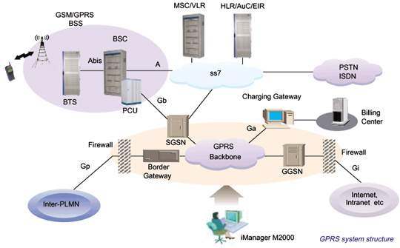
GSM |  | GSM (Global System for Mobile communications) is a standard developed by the European Telecommunications Standards Institute (ETSI) to describe the protocols for second-generation digital cellular networks used by mobile devices such as tablets. It was first deployed in Finland in December 1991. As of 2014, it has become the global standard for mobile communications – with over 90% market share, operating in over 193 countries and territories.  2G networks developed as a replacement for first generation (1G) analog cellular networks, and the GSM standard originally described a digital, circuit-switched network optimized for full duplex voice telephony. This expanded over time to include data communications, first by circuit-switched transport, then by packet data transport via GPRS (General Packet Radio Services) and EDGE (Enhanced Data rates for GSM Evolution, or EGPRS).  Subsequently, the 3GPP developed third-generation (3G) UMTS standards, followed by fourth-generation (4G) LTE Advanced standards, which do not form part of the ETSI GSM standard.
GSM AMR | GSM Adaptive Multi-Rate | The Adaptive Multi-Rate (AMR, AMR-NB or GSM-AMR) audio codec is an audio compression format optimized for speech coding. AMR speech codec consists of a multi-rate narrowband speech codec that encodes narrowband (200–3400 Hz) signals at variable bit rates ranging from 4.75 to 12.2 kbit/s with toll quality speech starting at 7.4 kbit/s.  AMR was adopted as the standard speech codec by 3GPP in October 1999 and is now widely used in GSM[4] and UMTS. It uses link adaptation to select from one of eight different bit rates based on link conditions.  AMR is also a file format for storing spoken audio using the AMR codec. Many modern mobile telephone handsets can store short audio recordings in the AMR format, and both free and proprietary programs exist (see Software support) to convert between this and other formats, although AMR is a speech format and is unlikely to give ideal results for other audio. The common filename extension is .amr. There also exists another storage format for AMR that is suitable for applications with more advanced demands on the storage format, like random access or synchronization with video. This format is the 3GPP-specified 3GP container format based on ISO base media file format.
GSM-FR | GSM Full Rate | Full Rate (FR or GSM-FR or GSM 06.10 or sometimes simply GSM) was the first digital speech coding standard used in the GSM digital mobile phone system. The bit rate of the codec is 13 kbit/s, or 1.625 bits/audio sample (often padded out to 33 bytes/20 ms or 13.2 kbit/s). The quality of the coded speech is quite poor by modern standards, but at the time of development (early 1990s) it was a good compromise between computational complexity and quality, requiring only on the order of a million additions and multiplications per second. The codec is still widely used in networks around the world. Gradually FR will be replaced by Enhanced Full Rate (EFR) and Adaptive Multi-Rate (AMR) standards, which provide much higher speech quality with lower bit rate.
GSM-R |  | GSM-R, Global System for Mobile Communications – Railway or GSM-Railway is an international wireless communications standard for railway communication and applications.  A sub-system of European Rail Traffic Management System (ERTMS), it is used for communication between train and railway regulation control centres. The system is based on GSM and EIRENE – MORANE specifications which guarantee performance at speeds up to 500 km/h (310 mph), without any communication loss.
GSN | GPRS support node | A GSN is a network node which supports the use of GPRS in the GSM core network. All GSNs should have a Gn interface and support the GPRS tunneling protocol. There are two key variants of the GSN, namely Gateway and Serving GPRS support node.
Guide | CxGuide | CxOne guide material type. Provides detailed, educational information for creating an artifact or performing an action. See CxOneOverview.

H
H.248 |  | The Gateway Control Protocol (Megaco, H.248) is an implementation of the media gateway control protocol architecture for providing telecommunication services across a converged internetwork consisting of the traditional public switched telephone network (PSTN) and modern packet networks, such as the Internet. H.248 is the designation of the recommendations developed by the ITU Telecommunication Standardization Sector (ITU-T) and Megaco is a contraction of media gateway control protocol used by the earliest specifications by the Internet Engineering Task Force (IETF). The standard published in March 2013 by ITU-T is entitled H.248.1: Gateway control protocol: Version 3.  Megaco/H.248 follows the guidelines published in RFC 2805 in April 2000, entitled Media Gateway Control Protocol Architecture and Requirements. The protocol performs the same functions as the Media Gateway Control Protocol (MGCP), is however a formal standard while MGCP has only informational status. Using different syntax and symbolic representation, the two protocols are not directly interoperable. They are both complementary to H.323 and the Session Initiation Protocol (SIP) protocols.  H.248 was the result of collaboration of the MEGACO working group of the Internet Engineering Task Force (IETF) and the International Telecommunication Union Telecommunication Study Group 16. The IETF originally published the standard as RFC 3015, which was superseded by RFC 3525. The term Megaco is the IETF designation. Megaco combines concepts from MGCP and the Media Device Control Protocol (MDCP). MGCP originated from a combination of the Simple Gateway Control Protocol (SGCP) with the Internet Protocol Device Control (IPDC).  After the ITU took responsibility of the protocol maintenance, the IETF reclassified its publications as historic in RFC 5125. The ITU has published three versions of H.248, the most recent in September 2005. H.248 encompasses not only the base protocol specification in H.248.1, but many extensions defined throughout the H.248 sub-series.  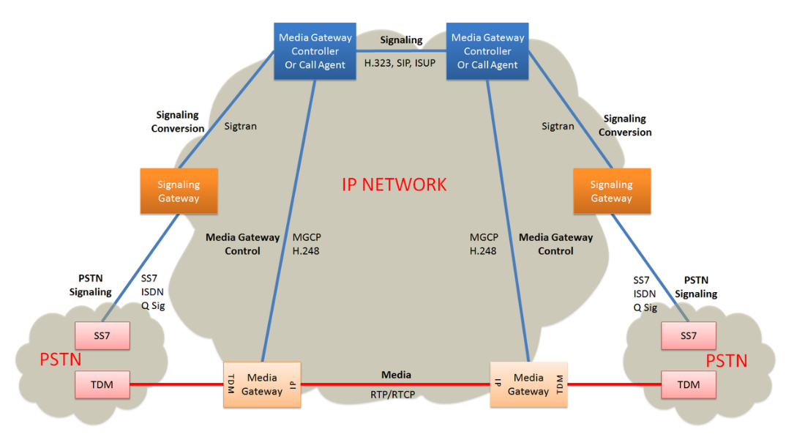
H.323 |  | H.323 is a recommendation from the ITU Telecommunication Standardization Sector (ITU-T) that defines the protocols to provide audio-visual communication sessions on any packet network. The H.323 standard addresses call signaling and control, multimedia transport and control, and bandwidth control for point-to-point and multi-point conferences.[1]  It is widely implemented[2] by voice and videoconferencing equipment manufacturers, is used within various Internet real-time applications such as GnuGK and NetMeeting and is widely deployed worldwide by service providers and enterprises for both voice and video services over IP networks.  It is a part of the ITU-T H.32x series of protocols, which also address multimedia communications over ISDN, the PSTN or SS7, and 3G mobile networks.  H.323 call signaling is based on the ITU-T Recommendation Q.931 protocol and is suited for transmitting calls across networks using a mixture of IP, PSTN, ISDN, and QSIG over ISDN. A call model, similar to the ISDN call model, eases the introduction of IP telephony into existing networks of ISDN-based PBX systems, including transitions to IP-based PBXs.  Within the context of H.323, an IP-based PBX might be a gatekeeper or other call control element which provides service to telephones or videophones. Such a device may provide or facilitate both basic services and supplementary services, such as call transfer, park, pick-up, and hold.  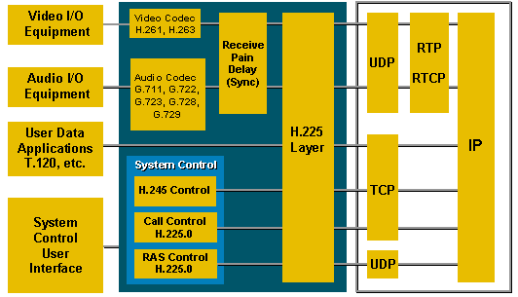
Half Duplex |  | In a half-duplex system, both parties can communicate with each other, but not simultaneously; the communication is one direction at a time. An example of a half-duplex device is a walkie-talkie two-way radio that has a "push-to-talk" button; when the local user wants to speak to the remote person they push this button, which turns on the transmitter but turns off the receiver, so they cannot hear the remote person. To listen to the other person they release the button, which turns on the receiver but turns off the transmitter.
Happy Path |  | See nominal path.
Hash Function |  | hash function is any function that can be used to map data of arbitrary size to data of a fixed size. The values returned by a hash function are called hash values, hash codes, digests, or simply hashes. Hash functions are often used in combination with a hash table, a common data structure used in computer software for rapid data lookup. Hash functions accelerate table or database lookup by detecting duplicated records in a large file. One such application is finding similar stretches in DNA sequences. They are also useful in cryptography. A cryptographic hash function allows one to easily verify that some input data maps to a given hash value, but if the input data is unknown, it is deliberately difficult to reconstruct it (or any equivalent alternatives) by knowing the stored hash value. This is used for assuring integrity of transmitted data, and is the building block for HMACs, which provide message authentication.  Hash functions are related to (and often confused with) checksums, check digits, fingerprints, lossy compression, randomization functions, error-correcting codes, and ciphers. Although the concepts overlap to some extent, each one has its own uses and requirements and is designed and optimized differently. The HashKeeper database maintained by the American National Drug Intelligence Center, for instance, is more aptly described as a catalogue of file fingerprints than of hash values.  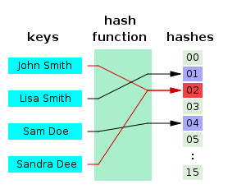
HDF | Handover Distribution Frame | Used to terminate the cable from the exchange and to make the pairs available to the operator.  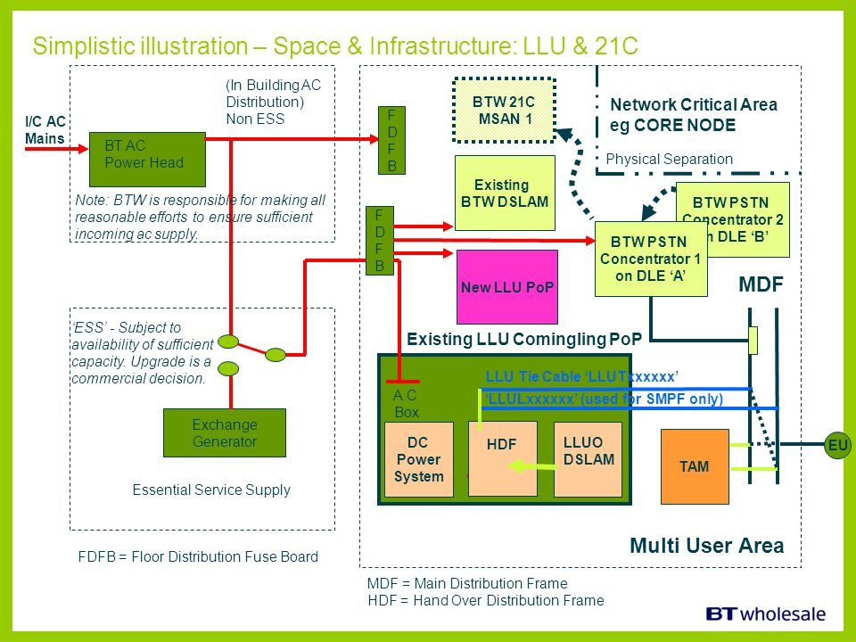
HDLC | High-Level Datalink Control | High-Level Data Link Control (HDLC) is a bit-oriented code-transparent synchronous data link layer protocol developed by the International Organization for Standardization (ISO). The original ISO standards for HDLC are as follows:  ISO 3309-1979 – Frame Structure  ISO 4335-1979 – Elements of Procedure  ISO 6159-1980 – Unbalanced Classes of Procedure  ISO 6256-1981 – Balanced Classes of Procedure  The current standard for HDLC is ISO/IEC 13239:2002, which replaces all of those standards.  HDLC provides both connection-oriented and connectionless service.  HDLC can be used for point-to-multipoint connections via the original master-slave modes Normal Response Mode (NRM) and Asynchronous Response Mode (ARM), but they are now rarely used; is now used almost exclusively to connect one device to another, using Asynchronous Balanced Mode (ABM).  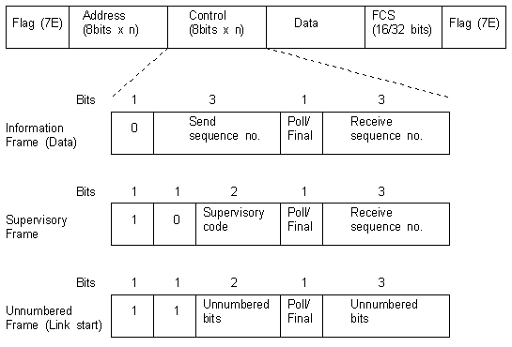
HDSL | High Speed Digital Subscriber Line (also known as High-speed Digital Subscriber Loop) | A copper delivered service on Copper Wideband Serving Section (CWSS). It is subject to reach limitations and is used primarily to provide 2 Mbit service to singleton sites.
Heartbeat Retrospective |  | The team meets regularly to reflect on the most significant events that occurred since the previous such meeting, and identify opportunities for improvement.
HiFi Prototype |  | See high fidelity prototype.
High Fidelity Prototype |  | Mockup of a system using a software or technology based tool, usually one with a RAD environment, e.g., Visual Basic or Delphi.
High Level Design | HLD | Design level between architecture and low level design. Focuses defining the details of the software solution at levels abstracted from their construction. See CxStand_Design for more information.
HLR | Home Location Register | The home location register (HLR) is a central database that contains details of each mobile phone subscriber that is authorized to use the GSM core network. There can be several logical, and physical, HLRs per public land mobile network (PLMN), though one international mobile subscriber identity (IMSI)/MSISDN pair can be associated with only one logical HLR (which can span several physical nodes) at a time.  The HLRs store details of every SIM card issued by the mobile phone operator. Each SIM has a unique identifier called an IMSI which is the primary key to each HLR record.  Another important item of data associated with the SIM are the MSISDNs, which are the telephone numbers used by mobile phones to make and receive calls. The primary MSISDN is the number used for making and receiving voice calls and SMS, but it is possible for a SIM to have other secondary MSISDNs associated with it for fax and data calls. Each MSISDN is also a primary key to the HLR record. The HLR data is stored for as long as a subscriber remains with the mobile phone operator.  Examples of other data stored in the HLR against an IMSI record is:  - GSM services that the subscriber has requested or been given.  - General Packet Radio Service (GPRS) settings to allow the subscriber to access packet services.  - Current location of subscriber (VLR and serving GPRS support node/SGSN).  - Call divert settings applicable for each associated MSISDN.  The HLR is a system which directly receives and processes MAP transactions and messages from elements in the GSM network, for example, the location update messages received as mobile phones roam around.
Hotfix |  | code (sometimes called a patch) that fixes a bug in a product.
How Requirement |  | Often a synonym for non-functional requirement. Sometimes used to refer to design issues.
How Well Requirement |  | Synonym for non-functional requirement.
HSRP | Hot Standby Router Protocol | In computer networking, the Hot Standby Router Protocol (HSRP) is a Cisco proprietary redundancy protocol for establishing a fault-tolerant default gateway. Version 1 of the protocol was described in RFC 2281 in 1998. There is no RFC for version 2 of the protocol.  The protocol establishes an association between gateways in order to achieve default gateway failover if the primary gateway becomes inaccessible. HSRP gateways send multicast hello messages to other gateways to notify them of their priorities (which gateway is preferred) and current status (active or standby).  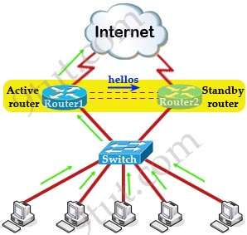
HSS | Home subscriber server | The home subscriber server (HSS), or user profile server function (UPSF), is a master user database that supports the IMS network entities that actually handle calls. It contains the subscription-related information (subscriber profiles), performs authentication and authorization of the user, and can provide information about the subscriber's location and IP information. It is similar to the GSM home location register (HLR) and Authentication centre (AuC).
HTTP | Hypertext Transfer Protocol | The Hypertext Transfer Protocol (HTTP) is an application protocol for distributed, collaborative, and hypermedia information systems.[1] HTTP is the foundation of data communication for the World Wide Web.  Hypertext is structured text that uses logical links (hyperlinks) between nodes containing text. HTTP is the protocol to exchange or transfer hypertext.  Development of HTTP was initiated by Tim Berners-Lee at CERN in 1989. Standards development of HTTP was coordinated by the Internet Engineering Task Force (IETF) and the World Wide Web Consortium (W3C), culminating in the publication of a series of Requests for Comments (RFCs). The first definition of HTTP/1.1, the version of HTTP in common use, occurred in RFC 2068 in 1997, although this was made obsolete by RFC 2616 in 1999 and then again by the RFC 7230 family of RFCs in 2014.  A later version, the successor HTTP/2, was standardized in 2015, and is now supported by major web servers and browsers over TLS using ALPN extension where TLS 1.2 or newer is required  Example session  Below is a sample conversation between an HTTP client and an HTTP server running on www.example.com, port 80. As mentioned in the previous sections, all the data is sent in a plain-text (ASCII) encoding, using a two-byte CR LF ('\r\n') line ending at the end of each line.  Client request  GET /index.html HTTP/1.1  Host: www.example.com  Server response  HTTP/1.1 200 OK  Date: Mon, 23 May 2005 22:38:34 GMT  Content-Type: text/html; charset=UTF-8  Content-Length: 138  Last-Modified: Wed, 08 Jan 2003 23:11:55 GMT  Server: Apache/1.3.3.7 (Unix) (Red-Hat/Linux)  ETag: "3f80f-1b6-3e1cb03b"  Accept-Ranges: bytes  Connection: close  <html>  <head>  <title>An Example Page</title>  </head>  <body>  Hello World, this is a very simple HTML document.  </body>  </html>
HTTPS |  | HTTP Secure (HTTPS) is an extension of the Hypertext Transfer Protocol (HTTP) for secure communication over a computer network, and is widely used on the Internet. In HTTPS, the communication protocol is encrypted using Transport Layer Security (TLS), or formerly, its predecessor, Secure Sockets Layer (SSL). The protocol is therefore also often referred to as HTTP over TLS, or HTTP over SSL.  The principal motivation for HTTPS is authentication of the accessed website and protection of the privacy and integrity of the exchanged data while in transit. It protects against man-in-the-middle attacks. The bidirectional encryption of communications between a client and server protects against eavesdropping and tampering of the communication. In practice, this provides a reasonable assurance that one is communicating without interference by attackers with the website that one intended to communicate with, as opposed to an impostor.  Historically, HTTPS connections were primarily used for payment transactions on the World Wide Web, e-mail and for sensitive transactions in corporate information systems. Since 2018, HTTPS is used more often by webusers than the original non-secure HTTP, primarily to protect page authenticity on all types of websites; secure accounts; and keep user communications, identity, and web browsing private.
Hub |  | An Ethernet hub, active hub, network hub, repeater hub, multiport repeater, or simply hub is a network hardware device for connecting multiple Ethernet devices together and making them act as a single network segment. It has multiple input/output (I/O) ports, in which a signal introduced at the input of any port appears at the output of every port except the original incoming. A hub works at the physical layer (layer 1) of the OSI model. A repeater hub also participates in collision detection, forwarding a jam signal to all ports if it detects a collision. In addition to standard 8P8C ("RJ45") ports, some hubs may also come with a BNC or an Attachment Unit Interface (AUI) connector to allow connection to legacy 10BASE2 or 10BASE5 network segments.  Hubs are now largely obsolete, having been replaced by network switches except in very old installations or specialized applications. As of 2011, connecting network segments by repeaters or hubs is deprecated by IEEE 802.3.  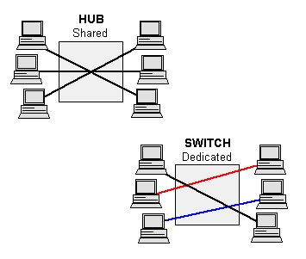
human factors |  | the study of how humans behave physically and psychologically in relation to particular environments, products, or services.
Hungarian notation |  | Hungarian notation is an identifier naming convention in computer programming, in which the name of a variable or function indicates its intention or kind, and in some dialects its type. The original Hungarian Notation uses intention or kind in its naming convention and is sometimes called Apps Hungarian as it became popular in the Microsoft Apps division in the development of Word, Excel and other apps. As the Microsoft Windows division adopted the naming convention, they used the actual data type for naming, and this convention became widely spread through the Windows API; this is sometimes called Systems Hungarian notation.  - bBusy : boolean  - chInitial : char  - cApples : count of items  - dwLightYears : double word (Systems)  - fBusy : flag (or float)  - nSize : integer (Systems) or count (Apps)  - iSize : integer (Systems) or index (Apps)  - fpPrice: floating-point  - dbPi : double (Systems)  - pFoo : pointer  - rgStudents : array, or range  - szLastName : zero-terminated string  - u16Identifier : unsigned 16-bit integer (Systems)  - u32Identifier : unsigned 32-bit integer (Systems)  - stTime : clock time structure  - fnFunction : function name

I
IA | Information Assurance | Information assurance (IA) is the practice of assuring information and managing risks related to the use, processing, storage, and transmission of information or data and the systems and processes used for those purposes. Information assurance includes protection of the integrity, availability, authenticity, non-repudiation and confidentiality of user data. It uses physical, technical and administrative controls to accomplish these tasks. While focused predominantly on information in digital form, the full range of IA encompasses not only digital but also analog or physical form. These protections apply to data in transit, both physical and electronic forms as well as data at rest in various types of physical and electronic storage facilities. Information assurance as a field has grown from the practice of information security.
IaaS | Infrastructure as a Service | Infrastructure as a service (IaaS) is a form of cloud computing that provides virtualized computing resources over the internet. IaaS is one of the three main categories of cloud computing services, alongside software as a service (SaaS) and platform as a service (PaaS).  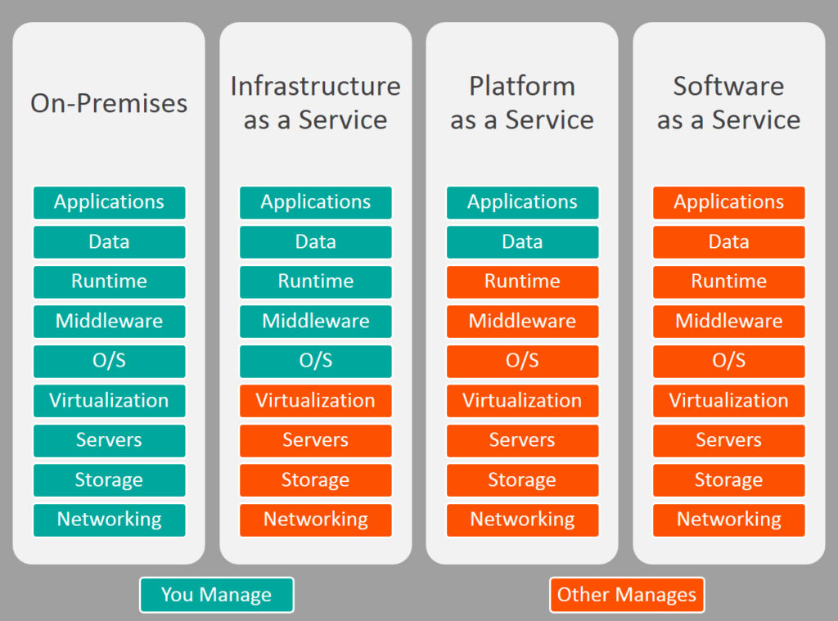
ICE | Interactive Connectivity Establishment | Interactive Connectivity Establishment (ICE) is a technique used in computer networking to find ways for two computers to talk to each other as directly as possible in peer-to-peer networking. This is most commonly used for interactive media such as Voice over Internet Protocol (VoIP), peer-to-peer communications, video, and instant messaging. In such applications, you want to avoid communicating through a central server (which would slow down communication, and be expensive), but direct communication between client applications on the Internet is very tricky due to network address translators (NATs), firewalls, and other network barriers.  ICE is developed by the Internet Engineering Task Force MMUSIC working group and is published as RFC 5245, which has obsoleted RFC 4091
ICMP | Internet Control Message Protocol | The Internet Control Message Protocol (ICMP) is a supporting protocol in the Internet protocol suite. It is used by network devices, including routers, to send error messages and operational information indicating, for example, that a requested service is not available or that a host or router could not be reached. ICMP differs from transport protocols such as TCP and UDP in that it is not typically used to exchange data between systems, nor is it regularly employed by end-user network applications (with the exception of some diagnostic tools like ping and traceroute).
ICMPv6 | Internet Control Message Protocol version 6 (for IPv6) | Internet Control Message Protocol version 6 (ICMPv6) is the implementation of the Internet Control Message Protocol (ICMP) for Internet Protocol version 6 (IPv6). ICMPv6 is defined in RFC 4443.[1] ICMPv6 is an integral part of IPv6 and performs error reporting and diagnostic functions (e.g., ping), and has a framework for extensions to implement future changes.  Several extensions have been published, defining new ICMPv6 message types as well as new options for existing ICMPv6 message types. Neighbor Discovery Protocol (NDP) is a node discovery protocol in IPv6 which replaces and enhances functions of ARP.[2] Secure Neighbor Discovery (SEND) is an extension of NDP with extra security. Multicast Listener Discovery (MLD) is used by IPv6 routers for discovering multicast listeners on a directly attached link, much like Internet Group Management Protocol (IGMP) is used in IPv4. Multicast Router Discovery (MRD) allows discovery of multicast routers.
IDE | integrated development environment | a programming environment that has been packaged as an application program, typically consisting of a code editor, a compiler, a debugger, and a GUI
IDQ | Informatica Data Quality | A tool that can be used by business analysts & developers to analyse, profile, cleanse, standardize & scorecard data in an enterprise.
IEC | International Electrotechnical Commission | The International Electrotechnical Commission is an international standards organization that prepares and publishes International Standards for all electrical, electronic and related technologies – collectively known as "electrotechnology". IEC standards cover a vast range of technologies from power generation, transmission and distribution to home appliances and office equipment, semiconductors, fibre optics, batteries, solar energy, nanotechnology and marine energy as well as many others. The IEC also manages three global conformity assessment systems that certify whether equipment, system or components conform to its International Standards.  The IEC charter embraces all electrotechnologies including energy production and distribution, electronics, magnetics and electromagnetics, electroacoustics, multimedia, telecommunication and medical technology, as well as associated general disciplines such as terminology and symbols, electromagnetic compatibility (by its Advisory Committee on Electromagnetic Compatibility, ACEC), measurement and performance, dependability, design and development, safety and the environment.
IEEE | Institute of Electrical and Electronics Engineers | The Institute of Electrical and Electronics Engineers (IEEE) is a professional association with its corporate office in New York City and its operations center in Piscataway, New Jersey. It was formed in 1963 from the amalgamation of the American Institute of Electrical Engineers and the Institute of Radio Engineers. As of 2018, it is the world's largest association of technical professionals with more than 423,000 members in over 160 countries around the world.[2] Its objectives are the educational and technical advancement of electrical and electronic engineering, telecommunications, computer engineering and allied disciplines.
IEEE 802.1ah |  | Provider Backbone Bridges (PBB; known as "mac-in-mac") is a set of architecture and protocols for routing over a provider's network allowing interconnection of multiple Provider Bridge Networks without losing each customer's individually defined VLANs. It was initially created by Nortel before being submitted to the IEEE 802.1 committee for standardization. The final standard was approved by the IEEE in June 2008 as IEEE 802.1ah-2008 and has been integrated into IEEE 802.1Q-2011.  The idea of PBB is to offer complete separation of customer and provider domains. For this purpose, a new Ethernet header has been defined. This header may take multiple different forms, but the main components of the header are:  - Backbone component, that has:  - Backbone destination address (B-DA) (six bytes)  - Backbone source address (B-SA) (six bytes)  - EtherType 0x88A8 (two bytes)  - B-TAG/B-VID (two bytes), this is the backbone VLAN indicator  - Service encapsulation, that has:  - EtherType 0x88E7 (two bytes)  - Flags that contain priority, Drop Eligible Indicator (DEI) and No Customer Address (NCA) indication (e.g. OAM frames).  - I-SID, the service identifier (three bytes)  - Original customer frame  - Customer destination address (six bytes)  - Customer source address (six bytes)  - EtherType 0x8100 (two bytes)  - Customer VLAN identifier (two bytes)  - EtherType (e.g. 0x0800)  - Customer payload  PBB defines a 48 bit B-DA and 48 bit B-SA to indicate the backbone source and destination MAC addresses. It also defines a 12 bit B-VID (backbone VLAN ID) and 24 bit I-SID (Service Instance VLAN ID). The bridges in the PBB domain switch based on the B-VID and B-DA values, which contain 60 bits total. Bridges learn based on the B-SA and ingress port value and hence is completely unaware of the customer MAC addresses. I-SID allows distinguishing the services within a PBB domain.  PBB is the foundation for the IEEE 802.1Qay PBB-TE standard, which was standardized in 2009.  PBB is sometimes referred to as Mac-in-Mac.
IETF | Internet Engineering Task Force | The Internet Engineering Task Force (IETF) develops and promotes voluntary Internet standards, in particular the standards that comprise the Internet protocol suite (TCP/IP). It is an open standards organization, with no formal membership or membership requirements. All participants and managers are volunteers, though their work is usually funded by their employers or sponsors.  The IETF started out as an activity supported by the U.S. federal government, but since 1993 it has operated as a standards development function under the auspices of the Internet Society, an international membership-based non-profit organization.
IGMP |  | The Internet Group Management Protocol (IGMP) is a communications protocol used by hosts and adjacent routers on IPv4 networks to establish multicast group memberships. IGMP is an integral part of IP multicast.  IGMP can be used for one-to-many networking applications such as online streaming video and gaming, and allows more efficient use of resources when supporting these types of applications.  IGMP is used on IPv4 networks. Multicast management on IPv6 networks is handled by Multicast Listener Discovery (MLD) which is a part of ICMPv6 in contrast to IGMP's bare IP encapsulation.  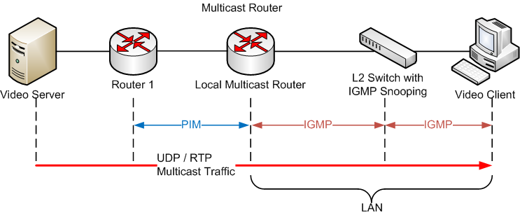
IGP | Interior Gateway Protocol | An interior gateway protocol (IGP) is a type of protocol used for exchanging routing information between gateways (commonly routers) within an autonomous system (for example, a system of corporate local area networks). This routing information can then be used to route network-layer protocols like IP.  Interior gateway protocols can be divided into two categories: distance-vector routing protocols and link-state routing protocols. Specific examples of IGPs include Open Shortest Path First (OSPF), Routing Information Protocol (RIP), Intermediate System to Intermediate System (IS-IS) and Enhanced Interior Gateway Routing Protocol (EIGRP).
IGRP | Interior Gateway Routing Protocol | Interior Gateway Routing Protocol (IGRP) is a distance vector interior gateway protocol (IGP) developed by Cisco. It is used by routers to exchange routing data within an autonomous system.  IGRP is a proprietary protocol. IGRP was created in part to overcome the limitations of RIP (maximum hop count of only 15, and a single routing metric) when used within large networks. IGRP supports multiple metrics for each route, including bandwidth, delay, load, and reliability; to compare two routes these metrics are combined together into a single metric, using a formula which can be adjusted through the use of pre-set constants. By default, the IGRP composite metric is a sum of the segment delays and the lowest segment bandwidth. The maximum configurable hop count of IGRP-routed packets is 255 (default 100), and routing updates are broadcast every 90 seconds (by default). IGRP uses protocol number 9 for communication.
IIS | Internet Information Services | Internet Information Services (IIS, formerly Internet Information Server) is an extensible web server created by Microsoft for use with the Windows NT family. IIS supports HTTP, HTTP/2, HTTPS, FTP, FTPS, SMTP and NNTP. It has been an integral part of the Windows NT family since Windows NT 4.0, though it may be absent from some editions (e.g. Windows XP Home edition), and is not active by default.
IKE | Internet Key Exchange | In computing, Internet Key Exchange (IKE, sometimes IKEv1 or IKEv2, depending on version) is the protocol used to set up a security association (SA) in the IPsec protocol suite. IKE builds upon the Oakley protocol and ISAKMP. IKE uses X.509 certificates for authentication ‒ either pre-shared or distributed using DNS (preferably with DNSSEC) and a Diffie–Hellman key exchange ‒ to set up a shared session secret from which cryptographic keys are derived. In addition, a security policy for every peer which will connect must be manually maintained.  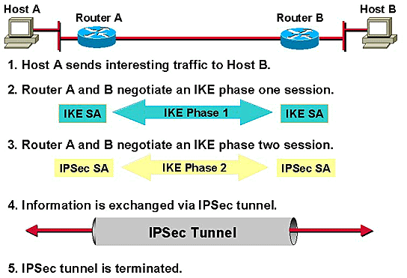
iLBC | Internet Low Bitrate Codec | Internet Low Bitrate Codec (iLBC) is an open source royalty-free narrowband speech audio coding format codec and reference implementation, developed by Global IP Solutions (GIPS) formerly Global IP Sound. It was formerly freeware with limitations on commercial use, but since 2011 it is available under a free software/open source (3-clause BSD license) license as a part of the open source WebRTC project. It is suitable for VoIP applications, streaming audio, archival and messaging. The algorithm is a version of block-independent linear predictive coding, with the choice of data frame lengths of 20 and 30 milliseconds. The encoded blocks have to be encapsulated in a suitable protocol for transport, usually the Real-time Transport Protocol (RTP).  iLBC handles lost frames through graceful speech quality degradation. Lost frames often occur in connection with lost or delayed IP packets. Ordinary low-bitrate codecs exploit dependencies between speech frames, which cause errors to propagate when packets are lost or delayed. In contrast, iLBC-encoded speech frames are independent and so this problem will not occur.
iManager |  | Huawei MSAN and DSLAM management tool
IMAP | Internet Message Access Protocol | In computing, the Internet Message Access Protocol (IMAP) is an Internet standard protocol used by email clients to retrieve email messages from a mail server over a TCP/IP connection. IMAP is defined by RFC 3501.  IMAP was designed with the goal of permitting complete management of an email box by multiple email clients, therefore clients generally leave messages on the server until the user explicitly deletes them. An IMAP server typically listens on port number 143. IMAP over SSL (IMAPS) is assigned the port number 993.  Virtually all modern e-mail clients and servers support IMAP. IMAP and the earlier POP3 (Post Office Protocol) are the two most prevalent standard protocols for email retrieval, with many webmail service providers such as Gmail, Outlook.com and Yahoo! Mail also providing support for either IMAP or POP3.
Implementation |  | Used as a synonym for both construction and deployment.
Implementation Lead |  | Sometimes used as a synonym for construction lead and/or deployment lead.
Implicit Change Control |  | Artifacts under implicit change control are not managed directly by the CCB, but changes to the artifacts are controlled by upstream artifacts that are directly managed by the CCB. Source code is often under implicit change control. Compare to explicit change control.
Implicit Risk Management |  | Synonym for intrinsic risk management.
IMS | IP Multimedia Core Network Subsystem | The IP Multimedia Subsystem or IP Multimedia Core Network Subsystem (IMS) is an architectural framework for delivering IP multimedia services. Historically, mobile phones have provided voice call services over a circuit-switched-style network, rather than strictly over an IP packet-switched network. Alternative methods of delivering voice (VoIP) or other multimedia services have become available on smartphones, but they have not become standardized across the industry. IMS is an architectural framework to provide such standardization.  IMS was originally designed by the wireless standards body 3rd Generation Partnership Project (3GPP), as a part of the vision for evolving mobile networks beyond GSM. Its original formulation (3GPP Rel-5) represented an approach for delivering Internet services over GPRS. This vision was later updated by 3GPP, 3GPP2 and ETSI TISPAN by requiring support of networks other than GPRS, such as Wireless LAN, CDMA2000 and fixed lines.  IMS uses IETF protocols wherever possible, e.g., the Session Initiation Protocol (SIP). According to the 3GPP, IMS is not intended to standardize applications, but rather to aid the access of multimedia and voice applications from wireless and wireline terminals, i.e., to create a form of fixed-mobile convergence (FMC). This is done by having a horizontal control layer that isolates the access network from the service layer. From a logical architecture perspective, services need not have their own control functions, as the control layer is a common horizontal layer. However, in implementation this does not necessarily map into greater reduced cost and complexity.
IMSI | International Mobile Subscriber Identity | The International Mobile Subscriber Identity or IMSI is used to identify the user of a cellular network and is a unique identification associated with all cellular networks. It is stored as a 64 bit field and is sent by the phone to the network. It is also used for acquiring other details of the mobile in the home location register (HLR) or as locally copied in the visitor location register. To prevent eavesdroppers identifying and tracking the subscriber on the radio interface, the IMSI is sent as rarely as possible and a randomly generated TMSI is sent instead.  The IMSI is used in any mobile network that interconnects with other networks. For GSM, UMTS and LTE networks, this number was provisioned in the SIM card and for cdmaOne and CDMA2000 networks, in the phone directly or in the R-UIM card (the CDMA equivalent of the SIM card). Both cards have been superseded by the UICC.  An IMSI is usually presented as a 15 digit number but can be shorter. For example, MTN South Africa's old IMSIs that are still being used in the market are shown as 14 digits. The first 3 digits are the mobile country code (MCC), which are followed by the mobile network code (MNC), either 2 digits (European standard) or 3 digits (North American standard). The length of the MNC depends on the value of the MCC, and it is recommended that the length is uniform within a MCC area. The remaining digits are the mobile subscription identification number (MSIN) within the network's customer base (mostly 10 or 9 digits depending on the MNC length).  The IMSI conforms to the ITU E.212 numbering standard.
IN | Intelligent Network | The Intelligent Network (IN) is the standard network architecture specified in the ITU-T Q.1200 series recommendations. It is intended for fixed as well as mobile telecom networks. It allows operators to differentiate themselves by providing value-added services in addition to the standard telecom services such as PSTN, ISDN on fixed networks, and GSM services on mobile phones or other mobile devices.  The intelligence is provided by network nodes on the service layer, distinct from the switching layer of the core network, as opposed to solutions based on intelligence in the core switches or equipment. The IN nodes are typically owned by telecommunications service providers such as a telephone company or mobile phone operator.  IN is supported by the Signaling System #7 (SS7) protocol between network switching centers and other network nodes owned by network operators.
INAP |  | INAP stands for Intelligent Network Application Protocol or Intelligent Network Application Part. It is the signalling protocol used in Intelligent Networking (IN). It is part of the Signalling System No. 7 (SS7) protocol suite, typically layered on top of the Transaction Capabilities Application Part (TCAP). It can also be termed as logic for controlling telecommunication services migrated from traditional switching points to computer based service independent platform.
Inch-Pebble |  | Synonym for miniature milestone.
Incremental Development |  | In an Agile context, Incremental Development is when each successive version of a product is usable, and each builds upon the previous version by adding user-visible functionality.
Informal Review |  | Any form of review, e.g. walkthrough or desk check, other than an inspection.
Informal Testing |  | Expert judgment testing that is conducted without the use of documented test cases. Compare to formal testing.
information architecture |  | the set of ideas about how all information in a given context should be treated philosophically and, in a general way, how it should be organized; this is expressed in an information architecture document .
information design |  | the detailed planning of specific information that is to be provided to a particular audience to meet specific objectives. In one hierarchical model, the information design follows the information architecture and information planning stages.
Information Radiators |  | "Information radiator" is the term for any of a number of visual displays which a team places in a highly visible location, so that all team members can see the latest information at a glance.  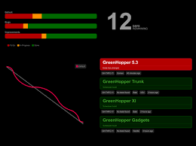
Ingress |  | Ingress traffic is network traffic that originates from outside of the network's routers and proceeds toward a destination inside of the network. For example, an email message that is considered ingress traffic will originate somewhere outside of a enterprise's LAN, pass over the Internet and enter the company's LAN before it is delivered to the recipient.
Inspection |  | A formally defined review process.
Inspector |  | A reviewer in the inspection process
Institute of Electrical and Electronics Engineers | IEEE | Electrical engineering organization whose Computer Society is the world’s largest professional organization for computer and software engineers. Developers of the SWEBOK  www.ieee.org
Integrated Development Environment | IDE | Refers to a software tool that combines one or more programming languages with editing and debugging tools. Often IDEs will also include reusable software components.
Integration |  | "Integration" (or "integrating") refers to any efforts still required for a project team to deliver a product suitable for release as a functional whole.
Integration |  | The activity of combining multiple software components and making them work together.
Integration Test |  | Test focused on verifying functionality and stability of a software system or component after changes or additions.
International Organization for Standardization | ISO | An international organization established to promote the development of standards.
Internet Protocol Suite |  | The Internet protocol suite is the conceptual model and set of communications protocols used on the Internet and similar computer networks. It is commonly known as TCP/IP because the foundational protocols in the suite are the Transmission Control Protocol (TCP) and the Internet Protocol (IP). It is occasionally known as the Department of Defense (DoD) model because the development of the networking method was funded by the United States Department of Defense through DARPA.  The Internet protocol suite provides end-to-end data communication specifying how data should be packetized, addressed, transmitted, routed, and received. This functionality is organized into four abstraction layers, which classify all related protocols according to the scope of networking involved. From lowest to highest, the layers are the link layer, containing communication methods for data that remains within a single network segment (link); the internet layer, providing internetworking between independent networks; the transport layer, handling host-to-host communication; and the application layer, providing process-to-process data exchange for applications.  Technical standards specifying the Internet protocol suite and many of its constituent protocols are maintained by the Internet Engineering Task Force (IETF). The Internet protocol suite predates the OSI model, a more comprehensive reference framework for general networking systems.  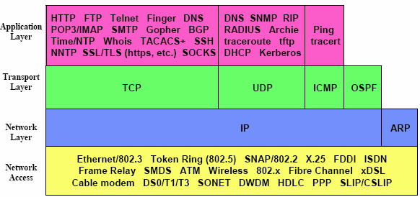
Interpreted Language |  | An interpreted language is a type of programming language for which most of its implementations execute instructions directly and freely, without previously compiling a program into machine-language instructions. The interpreter executes the program directly, translating each statement into a sequence of one or more subroutines, and then into another language (often machine code).  The terms interpreted language and compiled language are not well defined because, in theory, any programming language can be either interpreted or compiled. In modern programming language implementation, it is increasingly popular for a platform to provide both options.  Interpreted languages can also be contrasted with machine languages. Functionally, both execution and interpretation mean the same thing — fetching the next instruction/statement from the program and executing it. Although interpreted byte code is additionally identical to machine code in form and has an assembler representation, the term "interpreted" is practically reserved for "software processed" languages (by virtual machine or emulator) on top of the native (i.e. hardware) processor.  In principle, programs in many languages may be compiled or interpreted, emulated or executed natively, so this designation is applied solely based on common implementation practice, rather than representing an essential property of a language.  Many languages have been implemented using both compilers and interpreters, including BASIC, C, Lisp, Pascal, and Python. Java and C# are compiled into bytecode, the virtual-machine-friendly interpreted language. Lisp implementations can freely mix interpreted and compiled code.
Intrinsic Risk Management |  | Performing risk management as part of all project and organizational processes. Intrinsic risk management includes activities like risk-focused project and issue management and selecting lifecycles and processes that create environments which naturally manage risks.
INVEST |  | The acronym INVEST stands for a set of criteria used to assess the quality of a user story. If the story fails to meet one of these criteria, the team may want to reword it.
IOS cisco OS |  | Cisco IOS (originally Internetwork Operating System) is a family of software used on most Cisco Systems routers and current Cisco network switches. (Earlier switches ran CatOS.) IOS is a package of routing, switching, internetworking and telecommunications functions integrated into a multitasking operating system. Although the IOS code base includes a cooperative multitasking kernel, most IOS features have been ported to other kernels such as QNX and Linux for use in Cisco products or simulators such as Cisco VIRL.
IPS | Intrusion Prevention Services | An intrusion detection system (IDS) is a device or software application that monitors a network or systems for malicious activity or policy violations. Any malicious activity or violation is typically reported either to an administrator or collected centrally using a security information and event management (SIEM) system. A SIEM system combines outputs from multiple sources, and uses alarm filtering techniques to distinguish malicious activity from false alarms.  While there are several types of IDS, ranging in scope from single computers to large networks,[1]. the most common classifications are network intrusion detection systems (NIDS) and host-based intrusion detection systems (HIDS). A system that monitors important operating system files is an example of a HIDS, while a system that analyzes incoming network traffic is an example of a NIDS. It is also possible to classify IDS by detection approach: the most well-known variants are signature-based detection (recognizing bad patterns, such as malware) and anomaly-based detection (detecting deviations from a model of "good" traffic, which often relies on machine learning). Some IDS have the ability to respond to detected intrusions. Systems with response capabilities are typically referred to as an intrusion prevention system.
IPSC | IP Stream Connect | 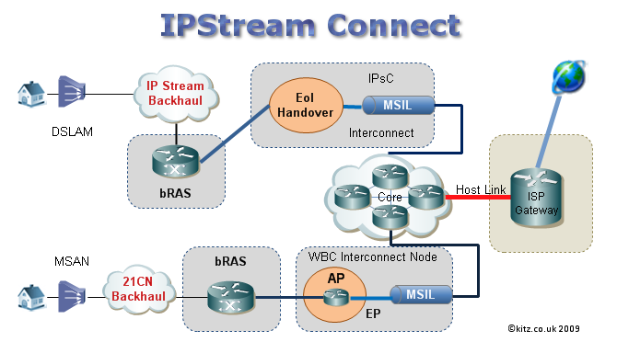
IPSec | IP Security | In computing, Internet Protocol Security (IPsec) is a secure network protocol suite of IPv4 that authenticates and encrypts the packets of data sent over an IPv4 network. Because of the complexity or immaturity of the IP security protocols, the initial IPv4 was developed without or barely with security protocols such that the IP version was incomplete, open or left for further research development. IPsec includes protocols for establishing mutual authentication between agents at the beginning of the session and negotiation of cryptographic keys to use during the session. IPsec can protect data flows between a pair of hosts (host-to-host), between a pair of security gateways (network-to-network), or between a security gateway and a host (network-to-host).[1] Internet Protocol security (IPsec) uses cryptographic security services to protect communications over Internet Protocol (IP) networks. IPsec supports network-level peer authentication, data-origin authentication, data integrity, data confidentiality (encryption), and replay protection.  As a part of the IPv4 enhancement, IPsec is a layer 3 OSI model or Internet Layer for an end-to-end security scheme operating in the Internet Protocol Suite in version 4, while some other Internet security systems in widespread use are above the layer 3, such as Transport Layer Security (TLS) and Secure Shell (SSH), operate in the upper layers at the Transport Layer (TLS) and the Application layer (SSH). IPsec can automatically secure applications at the IP layer.
IPTV | Internet Protocol television | Internet Protocol television (IPTV) is the delivery of television content over Internet Protocol (IP) networks. This is in contrast to delivery through traditional terrestrial, satellite, and cable television formats. Unlike downloaded media, IPTV offers the ability to stream the source media continuously. As a result, a client media player can begin playing the content (such as a TV channel) almost immediately. This is known as streaming media.  Although IPTV uses the Internet protocol it is not limited to television streamed from the Internet, (Internet television). IPTV is widely deployed in subscriber-based telecommunications networks with high-speed access channels into end-user premises via set-top boxes or other customer-premises equipment. IPTV is also used for media delivery around corporate and private networks. IPTV in the telecommunications arena is notable for its ongoing standardisation process (e.g., European Telecommunications Standards Institute).  IPTV services may be classified into three main groups:  - Live television and live media, with or without related interactivity;  - Time-shifted media: e.g. catch-up TV (replays a TV show that was broadcast hours or days ago), start-over TV (replays the current TV show from its beginning);  - Video on demand (VOD): browse and view items in a stored media catalogue.
IPv4 | Internet Protocol version 6 | Internet Protocol version 4 (IPv4) is the fourth version of the Internet Protocol (IP). It is one of the core protocols of standards-based internetworking methods in the Internet, and was the first version deployed for production in the ARPANET in 1983. It still routes most Internet traffic today, despite the ongoing deployment of a successor protocol, IPv6. IPv4 is described in IETF publication RFC 791 (September 1981), replacing an earlier definition (RFC 760, January 1980).  IPv4 is a connectionless protocol for use on packet-switched networks. It operates on a best effort delivery model, in that it does not guarantee delivery, nor does it assure proper sequencing or avoidance of duplicate delivery. These aspects, including data integrity, are addressed by an upper layer transport protocol, such as the Transmission Control Protocol (TCP).  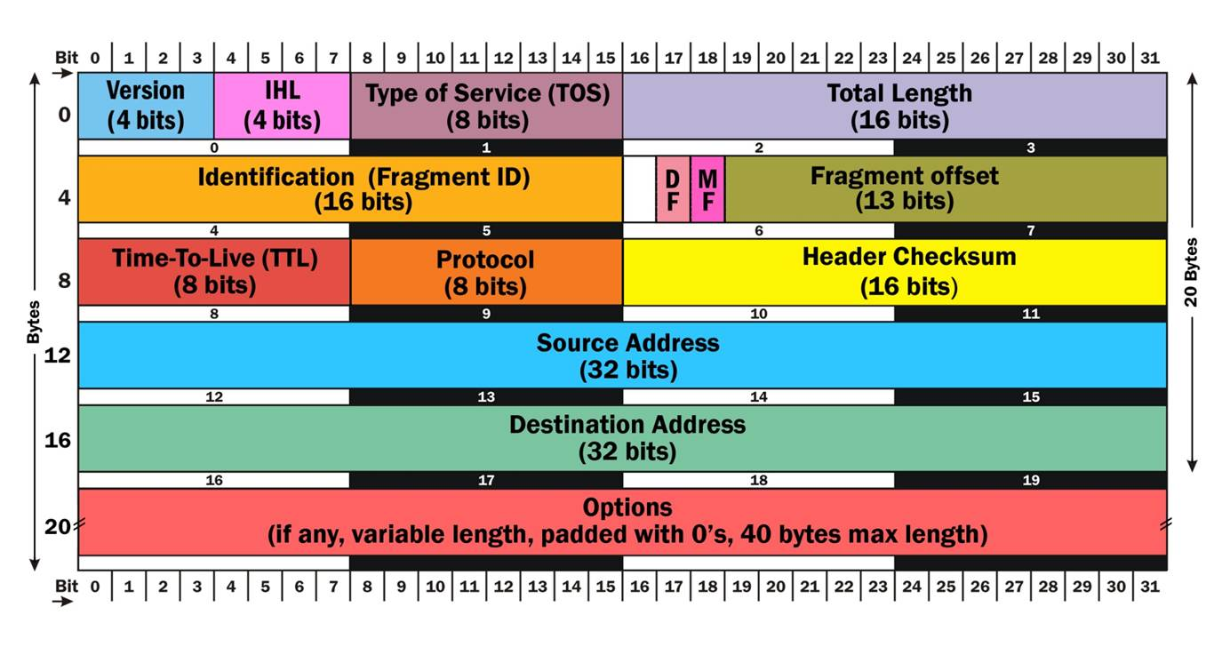
IPv6 | Internet Protocol version 4 | Internet Protocol version 6 (IPv6) is the most recent version of the Internet Protocol (IP), the communications protocol that provides an identification and location system for computers on networks and routes traffic across the Internet. IPv6 was developed by the Internet Engineering Task Force (IETF) to deal with the long-anticipated problem of IPv4 address exhaustion. IPv6 is intended to replace IPv4. IPv6 became a Draft Standard in December 1998, and became an Internet Standard on 14 July 2017.  Every device on the Internet is assigned a unique IP address for identification and location definition. With the rapid growth of the Internet after commercialization in the 1990s, it became evident that far more addresses would be needed to connect devices than the IPv4 address space had available. By 1998, the Internet Engineering Task Force (IETF) had formalized the successor protocol. IPv6 uses a 128-bit address, theoretically allowing 2128, or approximately 3.4×1038 addresses. The actual number is slightly smaller, as multiple ranges are reserved for special use or completely excluded from use. The total number of possible IPv6 addresses is more than 7.9×1028 times as many as IPv4, which uses 32-bit addresses and provides approximately 4.3 billion addresses. The two protocols are not designed to be interoperable, complicating the transition to IPv6. However, several IPv6 transition mechanisms have been devised to permit communication between IPv4 and IPv6 hosts.  IPv6 provides other technical benefits in addition to a larger addressing space. In particular, it permits hierarchical address allocation methods that facilitate route aggregation across the Internet, and thus limit the expansion of routing tables. The use of multicast addressing is expanded and simplified, and provides additional optimization for the delivery of services. Device mobility, security, and configuration aspects have been considered in the design of the protocol.  IPv6 addresses are represented as eight groups of four hexadecimal digits with the groups being separated by colons, for example 2001:0db8:0000:0042:0000:8a2e:0370:7334, but methods to abbreviate this full notation exist.  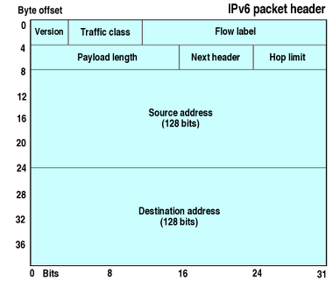  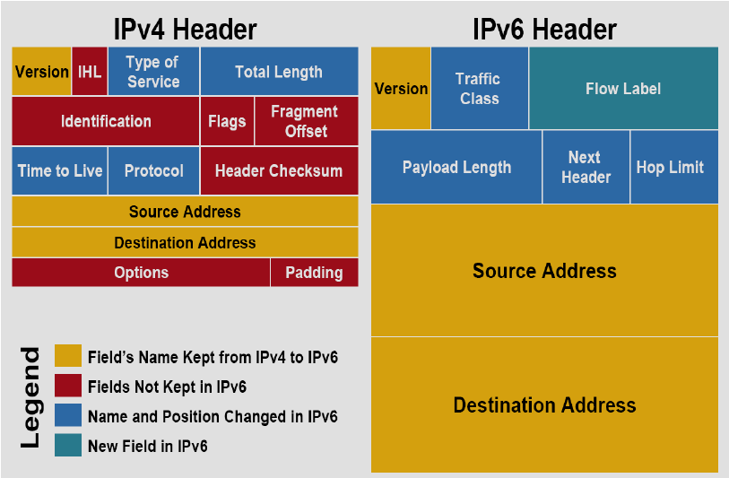
ISDN | Integrated Services Digital Network | Integrated Services Digital Network (ISDN) is a set of communication standards for simultaneous digital transmission of voice, video, data, and other network services over the traditional circuits of the public switched telephone network. It was first defined in 1988 in the CCITT red book.[1] Prior to ISDN, the telephone system was viewed as a way to transport voice, with some special services available for data. The key feature of ISDN is that it integrates speech and data on the same lines, adding features that were not available in the classic telephone system. The ISDN standards define several kinds of access interfaces, such as Basic Rate Interface (BRI), Primary Rate Interface (PRI), Narrowband ISDN (N-ISDN), and Broadband ISDN (B-ISDN).  ISDN is a circuit-switched telephone network system, which also provides access to packet switched networks, designed to allow digital transmission of voice and data over ordinary telephone copper wires, resulting in potentially better voice quality than an analog phone can provide. It offers circuit-switched connections (for either voice or data), and packet-switched connections (for data), in increments of 64 kilobit/s. In some countries, ISDN found major market application for Internet access, in which ISDN typically provides a maximum of 128 kbit/s bandwidth in both upstream and downstream directions. Channel bonding can achieve a greater data rate; typically the ISDN B-channels of three or four BRIs (six to eight 64 kbit/s channels) are bonded.  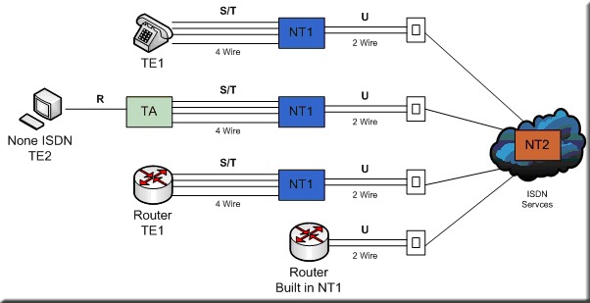
ISDN2  BRI | Basic Rate Interface | Basic Rate Interface (BRI, 2B+D, 2B1D) or Basic Rate Access is an Integrated Services Digital Network (ISDN) configuration intended primarily for use in subscriber lines similar to those that have long been used for voice-grade telephone service. As such, an ISDN BRI connection can use the existing telephone infrastructure at a business.  The BRI configuration provides 2 data (bearer) channels (B channels) at 64 kbit/s each and 1 control (delta) channel (D channel) at 16 kbit/s. The B channels are used for voice or user data, and the D channel is used for any combination of data, control/signaling, and X.25 packet networking. The 2 B channels can be aggregated by channel bonding providing a total data rate of 128 kbit/s. The BRI ISDN service is commonly installed for residential or small business service (ISDN PABX) in many countries.  In contrast to the BRI, the Primary Rate Interface (PRI) configuration provides more B channels and operates at a higher bit rate.
ISDN30  PRI | Primary Rate Interface | The Primary Rate Interface (PRI) is a telecommunications interface standard used on an Integrated Services Digital Network (ISDN) for carrying multiple DS0 voice and data transmissions between the network and a user.  PRI is the standard for providing telecommunication services to enterprises and offices. It is based on T-carrier (T1) transmission in the US, Canada, and Japan, while the E-carrier (E1) is common in Europe and Australia. The T1 line consists of 23 bearer (B) channels and one data (D) channel for control purposes, for a total bandwidth of 24x64-kbit/s or 1.544 Mbit/s. The E1 carrier provides 30 B- and two D-channels for a bandwidth of 2.048 Mbit/s. The first timeslot on the E1 is used for synchronization purposes and is not considered to be a B- or D-channel. The D-channel typically uses timeslot 16 on an E1, while it is timeslot 24 for a T1. Fewer active bearer channels, sometimes called user channels, may be used in fractional T1 or E1 services.
ISO | International Organization for Standardization | The International Organization for Standardization (ISO) is an international standard-setting body composed of representatives from various national standards organizations.
ISP | Internet Service Provider | An Internet service provider (ISP) is an organization that provides services for accessing, using, or participating in the Internet. Internet service providers may be organized in various forms, such as commercial, community-owned, non-profit, or otherwise privately owned.  Internet services typically provided by ISPs include Internet access, Internet transit, domain name registration, web hosting, Usenet service, and colocation.  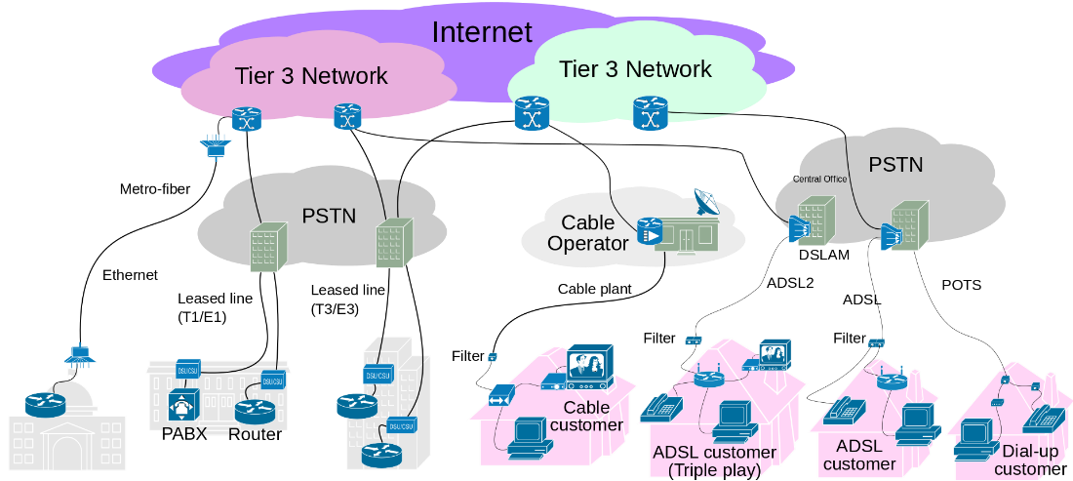
Issue |  | Something that needs to be resolved.  An issue is a catch-all term for a unit of work that will impact the project if not addressed, and which is not captured by project planning (work planning, scheduling, etc.) or a formally identified change, defect, or risk. Issues are a type of corrective activity management item.
Issue Management |  | The management of issues on a project. Part of corrective activity management.
Issue tracker |  | An issue tracking system (also ITS, trouble ticket system, support ticket, request management or incident ticket system) is a computer software package that manages and maintains lists of issues, as needed by an organization. Issue tracking systems are commonly used in an organization's customer support call center to create, update, and resolve reported customer issues, or even issues reported by that organization's other employees. A support ticket should include vital information for the account involved and the issue encountered. An issue tracking system often also contains a knowledge base containing information on each customer, resolutions to common problems, and other such data. An issue tracking system is similar to a "bugtracker", and often, a software company will sell both, and some bugtrackers are capable of being used as an issue tracking system, and vice versa. Consistent use of an issue or bug tracking system is considered one of the "hallmarks of a good software team".  A ticket element, within an issue tracking system, is a running report on a particular problem, its status, and other relevant data. They are commonly created in a help desk or call center environment and almost always have a unique reference number, also known as a case, issue or call log number which is used to allow the user or help staff to quickly locate, add to or communicate the status of the user's issue or request.
ISUP |  | The ISDN (Integrated Services Digital Network) User Part or ISUP is part of Signaling System No. 7 (SS7), which is used to set up telephone calls in the public switched telephone network (PSTN). It is specified by the ITU-T as part of the Q.76x series.  When a telephone call is set up from one subscriber to another, several telephone exchanges could be involved, possibly across international boundaries. To allow a call to be set up correctly, where ISUP is supported, a switch will signal call-related information like called party number to the next switch in the network using ISUP messages.  The telephone exchanges may be connected via E1 or T1 trunks which transport the speech from the calls. These trunks are divided into 64 kbit/s timeslots, and one timeslot can carry exactly one call. Regardless of what facilities are used to interconnect switches, each circuit between two switches is uniquely identified by a circuit identification code (CIC) that is included in the ISUP messages. The exchange uses this information along with the received signaling information (especially the called party number) to determine which inbound and outbound circuits should be connected together to provide an end to end speech path.  In addition to call related information, ISUP is also used to exchange status information for, and permit management of, the available circuits. In the case of no outbound circuit being available on a particular exchange, a release message is sent back to the preceding switches in the chain.  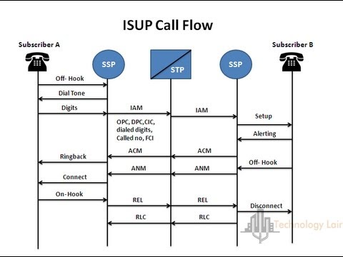
Item |  | Sometimes used as a synonym for CAM item; representing a change request, defect, risk, or issue.
Iteration |  | An iteration is a timebox during which development takes place. The duration may vary from project to project and is usually fixed.
Iterative Development |  | Agile projects are iterative insofar as they intentionally allow for "repeating" software development activities, and for potentially "revisiting" the same work products (the phrase "planned rework" is sometimes used; refactoring is a good example).
ITIL |  | TIL (formerly an acronym for Information Technology Infrastructure Library) is a set of detailed practices for IT service management (ITSM) that focuses on aligning IT services with the needs of business. In its current form (known as ITIL 2011), ITIL is published as a series of five core volumes, each of which covers a different ITSM lifecycle stage. Although ITIL underpins ISO/IEC 20000 (previously BS 15000), the International Service Management Standard for IT service management, there are some differences between the ISO 20000 standard, ICT Standard by IFGICT and the ITIL framework.  ITIL describes processes, procedures, tasks, and checklists which are not organization-specific or technology-specific, but can be applied by an organization for establishing integration with the organization's strategy, delivering value, and maintaining a minimum level of competency. It allows the organization to establish a baseline from which it can plan, implement, and measure. It is used to demonstrate compliance and to measure improvement.
ITU | International Telecommunication Union | The International Telecommunication Union (ITU; French: Union Internationale des Télécommunications (UIT)), originally the International Telegraph Union (French: Union Télégraphique Internationale), is a specialized agency of the United Nations (UN) that is responsible for issues that concern information and communication technologies.[1]  The ITU coordinates the shared global use of the radio spectrum, promotes international cooperation in assigning satellite orbits, works to improve telecommunication infrastructure in the developing world, and assists in the development and coordination of worldwide technical standards. The ITU is active in areas including broadband Internet, latest-generation wireless technologies, aeronautical and maritime navigation, radio astronomy, satellite-based meteorology, convergence in fixed-mobile phone, Internet access, data, voice, TV broadcasting, and next-generation networks. The agency also organizes worldwide and regional exhibitions and forums, such as ITU Telecom World, bringing together representatives of government and the telecommunications and ICT industry to exchange ideas, knowledge and technology.
ITU-T | ITU Telecommunication Standardization Sector | The ITU Telecommunication Standardization Sector (ITU-T) is one of the three sectors (divisions or units) of the International Telecommunication Union (ITU); it coordinates standards for telecommunications.  The standardization efforts of ITU commenced in 1865 with the formation of the International Telegraph Union (ITU). ITU became a specialized agency of the United Nations in 1947. The International Telegraph and Telephone Consultative Committee (CCITT, from French: Comité Consultatif International Téléphonique et Télégraphique) was created in 1956, and was renamed ITU-T in 1993.
IUP | Interconnect User Part | Interconnect User Part (IUP) is a national specific Signaling System 7 protocol for interconnect between public telephone networks in the United Kingdom. This protocol was formerly known as BTNUP.
IVR |  | Interactive voice response (IVR) is a technology that allows a computer to interact with humans through the use of voice and DTMF tones input via a keypad. In telecommunications, IVR allows customers to interact with a company’s host system via a telephone keypad or by speech recognition, after which services can be inquired about through the IVR dialogue. IVR systems can respond with pre-recorded or dynamically generated audio to further direct users on how to proceed. IVR systems deployed in the network are sized to handle large call volumes and also used for outbound calling, as IVR systems are more intelligent than many predictive dialer systems

J
Java |  | Java is a general-purpose computer-programming language that is concurrent, class-based, object-oriented, and specifically designed to have as few implementation dependencies as possible. It is intended to let application developers "write once, run anywhere" (WORA), meaning that compiled Java code can run on all platforms that support Java without the need for recompilation. Java applications are typically compiled to bytecode that can run on any Java virtual machine (JVM) regardless of computer architecture. As of 2016, Java is one of the most popular programming languages in use, particularly for client-server web applications, with a reported 9 million developers. Java was originally developed by James Gosling at Sun Microsystems (which has since been acquired by Oracle Corporation) and released in 1995 as a core component of Sun Microsystems' Java platform. The language derives much of its syntax from C and C++, but it has fewer low-level facilities than either of them.  The original and reference implementation Java compilers, virtual machines, and class libraries were originally released by Sun under proprietary licenses. As of May 2007, in compliance with the specifications of the Java Community Process, Sun relicensed most of its Java technologies under the GNU General Public License. Others have also developed alternative implementations of these Sun technologies, such as the GNU Compiler for Java (bytecode compiler), GNU Classpath (standard libraries), and IcedTea-Web (browser plugin for applets).
Javascript |  | JavaScript, often abbreviated as JS, is a high-level, interpreted programming language. It is a language which is also characterized as dynamic, weakly typed, prototype-based and multi-paradigm.  Alongside HTML and CSS, JavaScript is one of the three core technologies of the World Wide Web. JavaScript enables interactive web pages and thus is an essential part of web applications. The vast majority of websites use it,[9] and all major web browsers have a dedicated JavaScript engine to execute it.  As a multi-paradigm language, JavaScript supports event-driven, functional, and imperative (including object-oriented and prototype-based) programming styles. It has an API for working with text, arrays, dates, regular expressions, and basic manipulation of the DOM, but the language itself does not include any I/O, such as networking, storage, or graphics facilities, relying for these upon the host environment in which it is embedded.  Initially only implemented client-side in web browsers, JavaScript engines are now embedded in many other types of host software, including server-side in web servers and databases, and in non-web programs such as word processors and PDF software, and in runtime environments that make JavaScript available for writing mobile and desktop applications, including desktop widgets.  Although there are strong outward similarities between JavaScript and Java, including language name, syntax, and respective standard libraries, the two languages are distinct and differ greatly in design; JavaScript was influenced by programming languages such as Self and Scheme.
Jitter |  | In electronics and telecommunications, jitter is the deviation from true periodicity of a presumably periodic signal, often in relation to a reference clock signal. In clock recovery applications it is called timing jitter. Jitter is a significant, and usually undesired, factor in the design of almost all communications links.  Jitter can be quantified in the same terms as all time-varying signals, e.g., root mean square (RMS), or peak-to-peak displacement. Also like other time-varying signals, jitter can be expressed in terms of spectral density.  Jitter period is the interval between two times of maximum effect (or minimum effect) of a signal characteristic that varies regularly with time. Jitter frequency, the more commonly quoted figure, is its inverse. ITU-T G.810 classifies jitter frequencies below 10 Hz as wander and frequencies at or above 10 Hz as jitter.  Jitter may be caused by electromagnetic interference and crosstalk with carriers of other signals. Jitter can cause a display monitor to flicker, affect the performance of processors in personal computers, introduce clicks or other undesired effects in audio signals, and cause loss of transmitted data between network devices. The amount of tolerable jitter depends on the affected application.  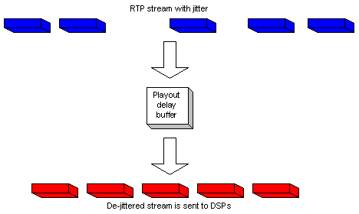  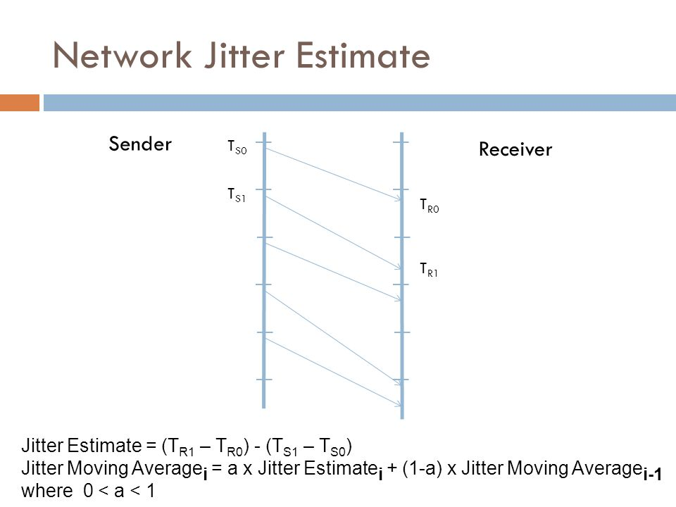
Jitter buffer |  | Jitter buffers or de-jitter buffers are used to counter jitter introduced by queuing in packet switched networks so that a continuous playout of audio (or video) transmitted over the network can be ensured. The maximum jitter that can be countered by a de-jitter buffer is equal to the buffering delay introduced before starting the play-out of the mediastream. In the context of packet-switched networks, the term packet delay variation is often preferred over jitter.  Some systems use sophisticated delay-optimal de-jitter buffers that are capable of adapting the buffering delay to changing network jitter characteristics. These are known as adaptive de-jitter buffers and the adaptation logic is based on the jitter estimates computed from the arrival characteristics of the media packets. Adaptive de-jittering involves introducing discontinuities in the media play-out, which may appear offensive to the listener or viewer. Adaptive de-jittering is usually carried out for audio play-outs that feature a VAD/DTX encoded audio, that allows the lengths of the silence periods to be adjusted, thus minimizing the perceptual impact of the adaptation.  Packet jitter in computer networks  In the context of computer networks, jitter is the variation in latency as measured in the variability over time of the packet latency across a network. A network with constant latency has no variation (or jitter). Packet jitter is expressed as an average of the deviation from the network mean latency. However, for this use, the term is imprecise. The standards-based term is "packet delay variation" (PDV). PDV is an important quality of service factor in assessment of network performance.  Burst transmission or burstiness, i.e. transmitting a burst of traffic at a high rate followed by an interval or period of lower or zero rate transmission, may also be seen as a form of jitter, as it represents a deviation from the average transmission rate. However, unlike the jitter caused by variation in latency, transmitting in bursts is commonly seen a desirable feature, e.g. in variable bitrate transmissions. Usage/Network Parameter Control (UPC and NPC), as implemented in ATM networks, allows both a Maximum Burst Size (MBS) parameter on the average or Sustained Cell Rate (SCR), and a Cell Delay Variation tolerance (CDVt) on the Peak Cell Rate (PCR) at which the bursts are transmitted. This MBS can be derived from or used to derive the maximum variation between the arrival time of traffic in the bursts from the time it would arrive at the SCR, i.e. a jitter about that SCR.
Joint Application Development | JAD | A facilitated workshop that produces a draft set of requirements. JAD sessions must involve customer representatives.
JSON | JavaScript Object Notation | In computing, JavaScript Object Notation or JSON is an open-standard file format that uses human-readable text to transmit data objects consisting of attribute–value pairs and array data types (or any other serializable value). It is a very common data format used for asynchronous browser–server communication, including as a replacement for XML in some AJAX-style systems.  JSON is a language-independent data format. It was derived from JavaScript, but as of 2017 many programming languages include code to generate and parse JSON-format data. The official Internet media type for JSON is application/json. JSON filenames use the extension .json.  {  "firstName": "John",  "lastName": "Smith",  "isAlive": true,  "age": 27,  "address": {  "streetAddress": "21 2nd Street",  "city": "New York",  "state": "NY",  "postalCode": "10021-3100"  },  "phoneNumbers": [  {  "type": "home",  "number": "212 555-1234"  },  {  "type": "office",  "number": "646 555-4567"  },  {  "type": "mobile",  "number": "123 456-7890"  }  ],  "children": [],  "spouse": null  }
JSON-RPC |  | JSON-RPC is a remote procedure call protocol encoded in JSON. It is a very simple protocol (and very similar to XML-RPC), defining only a few data types and commands. JSON-RPC allows for notifications (data sent to the server that does not require a response) and for multiple calls to be sent to the server which may be answered out of order.

K
K & R | Kernighan and Ritchie | Brian Wilson Kernighan is a Canadian computer scientist who worked at Bell Labs alongside Unix creators Ken Thompson and Dennis Ritchie and contributed to the development of Unix. He is also coauthor of the AWK and AMPL programming languages. The "K" of K&R C and the "K" in AWK both stand for "Kernighan".  Dennis MacAlistair Ritchie was an American computer scientist. He created the C programming language and, with long-time colleague Ken Thompson, the Unix operating system.
K & R C |  | In 1978, Brian Kernighan and Dennis Ritchie published the first edition of The C Programming Language. This book, known to C programmers as "K&R", served for many years as an informal specification of the language. The version of C that it describes is commonly referred to as K&R C. The second edition of the book covers the later ANSI C standard, described below.
K & R indent style |  | The K&R style is commonly used in C, C++, and other curly brace programming languages. Used in Kernighan and Ritchie's book The C Programming Language, it had its origins in Kernighan and Plauger's The Elements of Programming Style.  When following K&R, each function has its opening brace at the next line on the same indentation level as its header, the statements within the braces are indented, and the closing brace at the end is on the same indentation level as the header of the function at a line of its own.  The blocks inside a function, however, have their opening braces at the same line as their respective control statements; closing braces remain in a line of their own, unless followed by a keyword else or while. Such non-aligned braces are nicknamed "Egyptian braces" (or "Egyptian brackets") for their resemblance to arms in some fanciful poses of ancient Egyptians.  int main(int argc, char *argv[])  {  ...  while (x == y) {  something();  somethingelse();  if (some_error)  do_correct();  else  continue_as_usual();  }  finalthing();  ...  }
Kanban |  | a method for managing work, with an emphasis on just-in-time delivery. The Kanban Method is a means to design, manage and improve flow for knowledge work and allows teams to start where they are to drive evolutionary change.
Kanban Board |  | A Kanban Board is a visual workflow tool consisting of multiple columns. Each column represents a different stage in the workflow process.  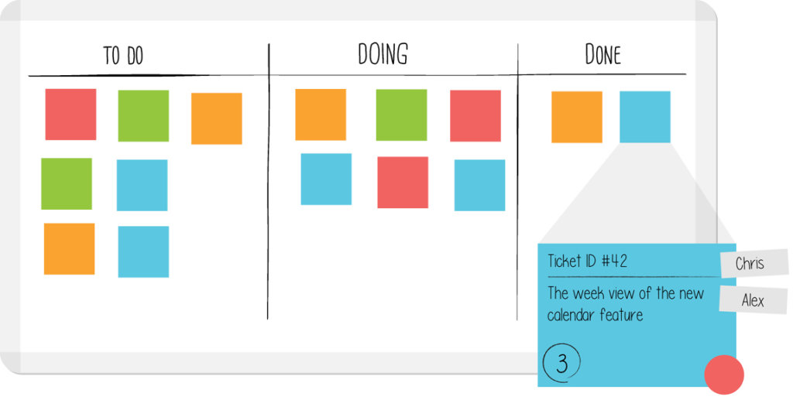
Kerberos |  | Kerberos is a computer network authentication protocol that works on the basis of tickets to allow nodes communicating over a non-secure network to prove their identity to one another in a secure manner. The protocol was named after the character Kerberos (or Cerberus) from Greek mythology, the ferocious three-headed guard dog of Hades. Its designers aimed it primarily at a client–server model and it provides mutual authentication—both the user and the server verify each other's identity. Kerberos protocol messages are protected against eavesdropping and replay attacks.  Kerberos builds on symmetric key cryptography and requires a trusted third party, and optionally may use public-key cryptography during certain phases of authentication. Kerberos uses UDP port 88 by default.
Kernel |  | The kernel is a computer program that is the core of a computer's operating system, with complete control over everything in the system. On most systems, it is one of the first programs loaded on start-up (after the bootloader). It handles the rest of start-up as well as input/output requests from software, translating them into data-processing instructions for the central processing unit. It handles memory and peripherals like keyboards, monitors, printers, and speakers.  The critical code of the kernel is usually loaded into a separate area of memory, which is protected from access by application programs or other, less critical parts of the operating system. The kernel performs its tasks, such as running processes, managing hardware devices such as the hard disk, and handling interrupts, in this protected kernel space. In contrast, everything a user does is in user space: writing text in a text editor, running programs in a GUI, etc. This separation prevents user data and kernel data from interfering with each other and causing instability and slowness, as well as preventing malfunctioning application programs from crashing the entire operating system.  The kernel's interface is a low-level abstraction layer. When a process makes requests of the kernel, it is called a system call. Kernel designs differ in how they manage these system calls and resources. A monolithic kernel runs all the operating system instructions in the same address space for speed. A microkernel runs most processes in user space, for modularity.  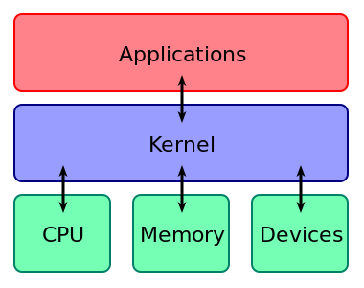
KISS Principle | Keep It Simple, Stupid | the principle that people want products that are easy to learn and use, and that companies realize time and cost benefits by producing such products.
Knowledge Management | KM | A mechanism or method of retaining, reusing, and providing people with useful and relevant information.
KPI | Key Performance Indicator | A performance indicator or key performance indicator (KPI) is a type of performance measurement. KPIs evaluate the success of an organization or of a particular activity (such as projects, programs, products and other initiatives) in which it engages.  Often success is simply the repeated, periodic achievement of some levels of operational goal (e.g. zero defects, 10/10 customer satisfaction, etc.), and sometimes success is defined in terms of making progress toward strategic goals. Accordingly, choosing the right KPIs relies upon a good understanding of what is important to the organization.[citation needed] What is deemed important often depends on the department measuring the performance – e.g. the KPIs useful to finance will differ from the KPIs assigned to sales.  Since there is a need to understand well what is important, various techniques to assess the present state of the business, and its key activities, are associated with the selection of performance indicators. These assessments often lead to the identification of potential improvements, so performance indicators are routinely associated with 'performance improvement' initiatives. A very common way to choose KPIs is to apply a management framework such as the balanced scorecard.
ksh |  | KornShell (ksh) is a Unix shell which was developed by David Korn at Bell Labs in the early 1980s and announced at USENIX on July 14, 1983. The initial development was based on Bourne shell source code. Other early contributors were Bell Labs developers Mike Veach and Pat Sullivan, who wrote the Emacs and vi-style line editing modes' code, respectively. KornShell is backward-compatible with the Bourne shell and includes many features of the C shell, inspired by the requests of Bell Labs users

L
L1 | Layer 1 | In the seven-layer OSI model of computer networking, the physical layer or layer 1 is the first and lowest layer. This layer may be implemented by a PHY chip.  The physical layer consists of the electronic circuit transmission technologies of a network. It is a fundamental layer underlying the higher level functions in a network. Due to the plethora of available hardware technologies with widely varying characteristics, this is perhaps the most complex layer in the OSI architecture.[citation needed]  The physical layer defines the means of transmitting raw bits rather than logical data packets over a physical data link connecting network nodes. The bitstream may be grouped into code words or symbols and converted to a physical signal that is transmitted over a transmission medium. The physical layer provides an electrical, mechanical, and procedural interface to the transmission medium. The shapes and properties of the electrical connectors, the frequencies to broadcast on, the line code to use and similar low-level parameters, are specified here.  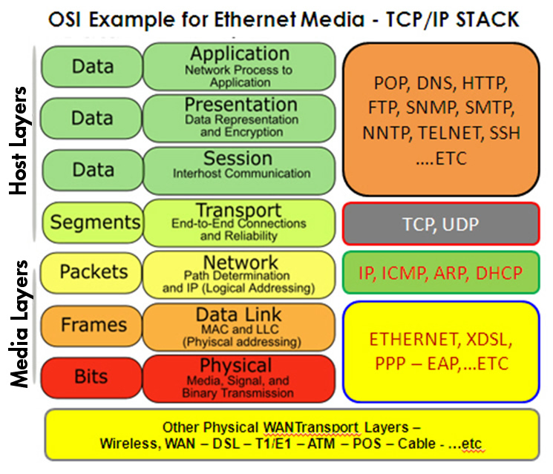
L2 | Layer 2 | The data link layer, or layer 2, is the second layer of the seven-layer OSI model of computer networking. This layer is the protocol layer that transfers data between adjacent network nodes in a wide area network (WAN) or between nodes on the same local area network (LAN) segment. The data link layer provides the functional and procedural means to transfer data between network entities and might provide the means to detect and possibly correct errors that may occur in the physical layer.  The data link layer is concerned with local delivery of frames between nodes on the same level of the network. Data-link frames, as these protocol data units are called, do not cross the boundaries of a local network. Inter-network routing and global addressing are higher-layer functions, allowing data-link protocols to focus on local delivery, addressing, and media arbitration. This way, the data link layer is analogous to a neighborhood traffic cop; it endeavors to arbitrate between parties contending for access to a medium, without concern for their ultimate destination. When devices attempt to use a medium simultaneously, frame collisions occur. Data-link protocols specify how devices detect and recover from such collisions, and may provide mechanisms to reduce or prevent them.  Examples of data link protocols are Ethernet for local area networks (multi-node), the Point-to-Point Protocol (PPP), HDLC and ADCCP for point-to-point (dual-node) connections. In the Internet Protocol Suite (TCP/IP), the data link layer functionality is contained within the link layer, the lowest layer of the descriptive model.
L2F | Layer 2 Forwarding | L2F, or Layer 2 Forwarding, is a tunneling protocol developed by Cisco Systems, Inc. to establish virtual private network connections over the Internet. L2F does not provide encryption or confidentiality by itself; It relies on the protocol being tunneled to provide privacy. L2F was specifically designed to tunnel Point-to-Point Protocol (PPP) traffic.
L2S | Local Layer 2 Primary Switch Local Exchange (EX4200) | 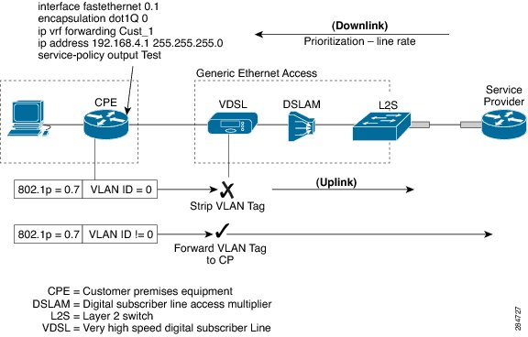
L2TP | Layer 2 Tunnelling Protocol | In computer networking, Layer 2 Tunnelling Protocol (L2TP) is a tunnelling protocol used to support virtual private networks (VPNs) or as part of the delivery of services by ISPs. It does not provide any encryption or confidentiality by itself.
L2TP | Layer 2 Tunneling Protocol | In computer networking, Layer 2 Tunneling Protocol (L2TP) is a tunneling protocol used to support virtual private networks (VPNs) or as part of the delivery of services by ISPs. It does not provide any encryption or confidentiality by itself. Rather, it relies on an encryption protocol that it passes within the tunnel to provide privacy.
L2VPN | Layer 2 Virtual Private Network | A Layer 2 MPLS VPN is a term in computer networking. It is a method that Internet service providers use to segregate their network for their customers, to allow them to transmit data over an IP network. This is often sold as a service to businesses.  Layer 2 VPNs are a type of Virtual Private Network (VPN) that uses MPLS labels to transport data. The communication occurs between routers that are known as Provider Edge routers (PEs), as they sit on the edge of the provider's network, next to the customer's network.  Internet providers who have an existing Layer 2 network (such as ATM or Frame Relay) may choose to use these VPNs instead of the other common MPLS VPN, Layer 3. There is no one IETF standard for Layer 2 MPLS VPNs. Instead, two methodologies may be used. Both methods use a standard MPLS header to encapsulate data. However, they differ in their signaling protocols.
L3VPN | Layer 3 Virtual Private Network | Layer 3 Virtual Private Networks (l3vpn): L3VPN is a technology based on PE. It uses MPLS to forward VPN packets over service provider backbones.  L3VPN comprises the following types of devices:  Customer edge (CE) device—A CE resides on a customer network and has one or more interfaces directly connected to service provider networks. It can be a router, a switch, or a host.  · Provider edge (PE) device—A PE resides at the edge of a service provider network and connects one or more CEs. On an MPLS network, all VPN services are processed on the PEs.  · Provider (P) device—A P device is a core device on a service provider network. It is not directly connected to any CE. It has only basic MPLS forwarding capability.
LAC | L2TP Access Concentrator | The two endpoints of an L2TP tunnel are called the LAC (L2TP Access Concentrator) and the LNS (L2TP Network Server). The LNS waits for new tunnels. Once a tunnel is established, the network traffic between the peers is bidirectional. To be useful for networking, higher-level protocols are then run through the L2TP tunnel. To facilitate this, an L2TP session (or 'call') is established within the tunnel for each higher-level protocol such as PPP. Either the LAC or LNS may initiate sessions. The traffic for each session is isolated by L2TP, so it is possible to set up multiple virtual networks across a single tunnel. MTU should be considered when implementing L2TP.  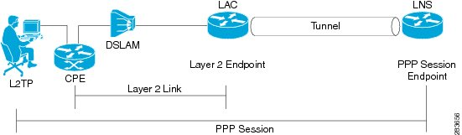
LACP | Link Aggregation Control Protocol | Within the IEEE specification, the Link Aggregation Control Protocol (LACP) provides a method to control the bundling of several physical ports together to form a single logical channel. LACP allows a network device to negotiate an automatic bundling of links by sending LACP packets to the peer (directly connected device that also implements LACP).  LACP Features and practical examples  - Maximum number of bundled ports allowed in the port channel: Valid values are usually from 1 to 8.  - LACP packets are sent with multicast group MAC address 01:80:c2:00:00:02 (01-80-c2-00-00-02)  - During LACP detection period  - LACP packets are transmitted every second  - Keep alive mechanism for link member: (default: slow = 30s, fast=1s)  - LACP can have the port-channel load-balance mode :  - link (link-id) Integer that identifies the member link for load balancing. The range is from 1 to 8.  - LACP mode :  - active: Enables LACP unconditionally.  - passive: Enables LACP only when an LACP device is detected. (This is the default state)
LAG | Link Aggregation Group | In computer networking, the term link aggregation applies to various methods of combining (aggregating) multiple network connections in parallel in order to increase throughput beyond what a single connection could sustain, and to provide redundancy in case one of the links should fail. A Link Aggregation Group (LAG) combines a number of physical ports together to make a single high-bandwidth data path, so as to implement the traffic load sharing among the member ports in the group and to enhance the connection reliability.  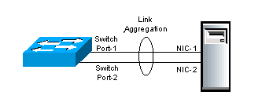
LAN | Local Area Network | A local area network (LAN) is a computer network that interconnects computers within a limited area such as a residence, school, laboratory, university campus or office building. By contrast, a wide area network (WAN) not only covers a larger geographic distance, but also generally involves leased telecommunication circuits.  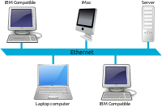
LANE | ATM LAN Emulation | LAN Emulation (LANE) is a technology that allows an ATM network to function as a LAN backbone. The ATM network must provide multicast and broadcast support, address mapping (MAC-to-ATM), SVC management, and a usable packet format. LANE also defines Ethernet and Token Ring ELANs.
LAS | MPLS L2/B2B Aggregation Local (M2F) | MPLS L2/B2B Aggregation Local (M2F) - Location: Local
Latency |  | Latency refers to a short period of delay (usually measured in milliseconds) between when an audio signal enters and when it emerges from a system. Potential contributors to latency in an audio system include analog-to-digital conversion, buffering, digital signal processing, transmission time, digital-to-analog conversion and the speed of sound in the transmission medium.  Latency can be a critical performance metric in professional audio including sound reinforcement systems, foldback systems (especially those using in-ear monitors) live radio and television. Excessive audio latency has the potential to degrade call quality in telecommunications applications. Low latency audio in computers is important for interactivity.  Telephone calls  In all systems, latency can be said to consist of three elements: codec delay, playout delay and network delay.  Latency in telephone calls is sometimes referred to as mouth-to-ear delay; the telecommunications industry also uses the term quality of experience (QoE). Voice quality is measured according to the ITU model; measurable quality of a call degrades rapidly where the mouth-to-ear delay latency exceeds 200 milliseconds. The mean opinion score (MOS) is also comparable in a near-linear fashion with the ITU's quality scale - defined in standards G.107 (page 800),G.108 and G.109 - with a quality factor R ranging from 0 to 100. An MOS of 4 ('Good') would have an R score of 80 or above; to achieve 100R requires an MOS exceeding 4.5.  Cellular calls  The AMR narrowband codec, used currently in UMTS networks, is a low bitrate, highly compressed, adaptive bitrate codec achieving rates from 4.75 to 12.2 kbit/s with 'toll quality' (MOS 4.0 or above) from 7.4 kbit/s. 2G networks use the AMR-12.2 codec, equivalent to GSM-EFR. As mobile operators upgrade existing best-effort networks to support concurrent multiple types of service over all-IP networks, services such as Hierarchical Quality of Service (H-QoS) allow for per-user, per-service QoS policies to prioritise time-sensitive protocols like voice calls and other wireless backhaul traffic. Along with more efficient voice codecs, this helps to maintain a sufficient MOS rating whilst the volume of overall traffic on often oversubscribed mobile networks increases with demand.  Another overlooked aspect of mobile latency is the inter-network handoff; as a customer on Network A calls a Network B customer the call must traverse two separate Radio Access Networks, two core networks and an interlinking Gateway Mobile Switching Centre (GMSC) which performs the physical interconnecting between the two providers.  IP calls  On a stable connection with sufficient bandwidth and minimal latency, VoIP systems typically have a minimum of 20 ms inherent latency and target 150 ms as a maximum latency for general consumer use. With end-to-end QoS managed and assured rate connections, latency can be reduced to analogue PSTN/POTS levels. Latency is a larger consideration in these systems when an echo is present therefore popular VoIP codecs such as G.729 perform complex voice detection and noise suppression.  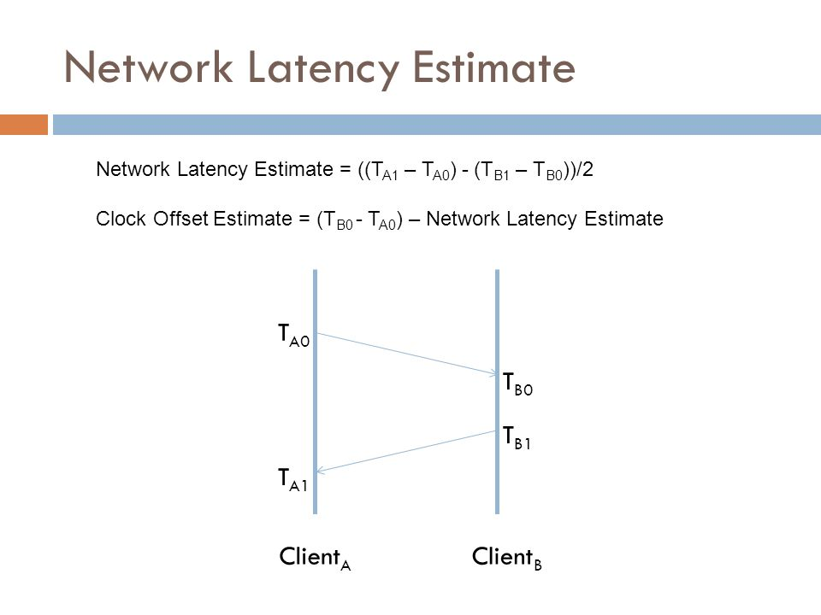
Lawful intercept |  | Lawful interception (LI) refers to the facilities in telecommunications and telephone networks that allow law enforcement agencies with court order or other legal authorization to selectively wiretap individual subscribers. Most countries require licensed telecommunications operators to provide their networks with Legal Interception gateways and nodes for the interception of communications. The interfaces of these gateways have been standardized by telecommunication standardization organizations.  With the legacy public switched telephone network (PSTN), wireless, and cable systems, lawful interception (LI) was generally performed by accessing the mechanical or digital switches supporting the targets' calls. The introduction of packet switched networks, softswitch technology, and server-based applications the past two decades fundamentally altered how LI is undertaken.  Lawful interception differs from the dragnet-type mass surveillance sometimes done by intelligence agencies, where all data passing a fiber-optic splice or other collection point is extracted for storage or filtering. It is also separate from the data retention of metadata that has become a legal requirement in some jurisdictions.
LCR | Least Cost Routing | In voice telecommunications, least-cost routing (LCR) is the process of selecting the path of outbound communications traffic based on cost. Within a telecoms carrier, an LCR team might periodically (monthly, weekly or even daily) choose between routes from several or even hundreds of carriers for destinations across the world. This function might also be automated by a device or software program known as a "Least Cost Router."
LDAP |  | The Lightweight Directory Access Protocol is an open, vendor-neutral, industry standard application protocol for accessing and maintaining distributed directory information services over an Internet Protocol (IP) network. Directory services play an important role in developing intranet and Internet applications by allowing the sharing of information about users, systems, networks, services, and applications throughout the network. As examples, directory services may provide any organized set of records, often with a hierarchical structure, such as a corporate email directory. Similarly, a telephone directory is a list of subscribers with an address and a phone number.  LDAP is specified in a series of Internet Engineering Task Force (IETF) Standard Track publications called Request for Comments (RFCs), using the description language ASN.1. The latest specification is Version 3, published as RFC 4511 (a road map to the technical specifications is provided by RFC4510).  A common use of LDAP is to provide a central place to store usernames and passwords. This allows many different applications and services to connect to the LDAP server to validate users.  LDAP is based on a simpler subset of the standards contained within the X.500 standard. Because of this relationship, LDAP is sometimes called X.500-lite.
Lead Time |  | Lead Time is the time between a customer order and delivery. In software development, it can also be the time between a requirement made and its fulfillment.
Lean |  | a method of working focused on ‘eliminating waste’ by avoiding anything that does not produce value for the customer.
lean programming |  | a concept that emphasizes optimizing efficiency and minimizing waste in the development of a computer program; the concept is also applicable to all enterprise practices.
Leased Line |  | A leased line is a private bidirectional or symmetric telecommunications circuit between two or more locations provided in exchange for a monthly rent. Sometimes known as a private circuit or data line in the UK.  Unlike traditional PSTN lines they do not have telephone numbers, each side of the line being permanently connected and dedicated to the other. Leased lines can be used for telephone, Internet, or other data services. Some are ringdown services, and some connect to a private branch exchange or router.  Typically, leased lines are used by businesses to connect geographically distant offices. Unlike dial-up connections, a leased line is always active. The fee for the connection is a fixed monthly rate. The primary factors affecting the monthly fee are distance between end points and the speed of the circuit. Because the connection does not carry anybody else's communications, the carrier can assure a given level of quality.  An Internet leased line is a premium Internet connectivity product, normally delivered over fiber, which provides uncontended, symmetrical speeds with full duplex. It is also known as an ethernet leased line, dedicated line, data circuit or private line.  For example, a T1 can be leased and provides a maximum transmission speed of 1.544 Mbit/s. The user can channelize the T1 to separate the 24 DS0 circuits for voice communication, partial the T1 for data and voice communications, or multiplex the channels into a single data circuit. Leased lines, as opposed to DSL, are being used by companies and individuals for Internet access because they afford faster data transfer rates and are cost-effective for heavy users of the Internet.
LeSS | large-scale Scrum | agile development method.
Lifecycle |  | A model of all activities between the initial idea for a system and its last use, often heavily focused on the creation of the system as part of a project. Lifecycles are quite varied, but normally separate activities into phases that reflect progression of time and/or grouping of similar activities. Projects select and customize lifecycles to define ordering and optimize performance of activities .
Lines of Code | LOC  KLOC | Size measure for a software system that captures the number of lines of source code in the system. Normally created by a tool that seeks to count non-comment, non-blank source code instructions.  KLOC is often used for ‘thousands of LOC’.
Link |  | Reference to content inside of CxOne, usually denoted as an italicized file name. Compare to pointer.
Linux |  | Linux is a family of free and open-source software operating systems built around the Linux kernel. Typically, Linux is packaged in a form known as a Linux distribution (or distro for short) for both desktop and server use. The defining component of a Linux distribution is the Linux kernel, an operating system kernel first released on September 17, 1991, by Linus Torvalds. Many Linux distributions use the word "Linux" in their name. The Free Software Foundation uses the name GNU/Linux to refer to the operating system family, as well as specific distributions, to emphasize that most Linux distributions are not just the Linux kernel, and that they have in common not only the kernel, but also numerous utilities and libraries, a large proportion of which are from the GNU project.  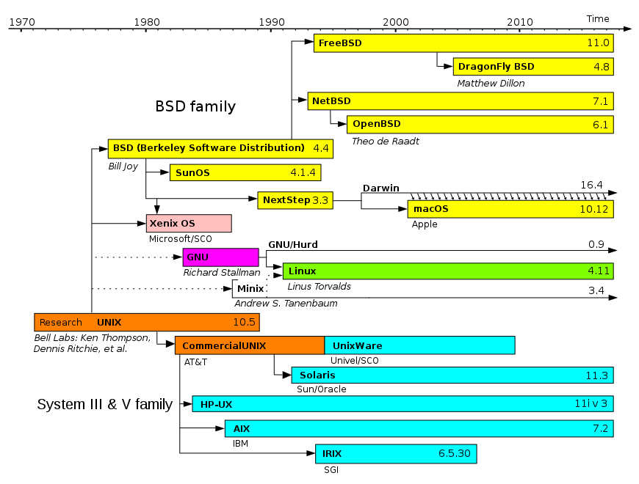  Widely used distributions  - Debian, a non-commercial distribution and one of the earliest, maintained by a volunteer developer community with a strong commitment to free software principles and democratic project management  - Knoppix, the first Live CD distribution to run completely from removable media without installation to a hard disk, derived from Debian  - Linux Mint Debian Edition (LMDE) uses Debian packages directly (rather than Ubuntu's)  - Ubuntu, a desktop and server distribution derived from Debian, maintained by British company Canonical Ltd.  - Kubuntu, the KDE version of Ubuntu  - Linux Mint, a distribution based on and compatible with Ubuntu. Supports multiple desktop environments, among others GNOME Shell fork Cinnamon and GNOME 2 fork MATE.  - Trisquel, an Ubuntu-based distribution based on Linux-libre kernel composed entirely of free software  - Elementary OS, an Ubuntu-based distribution with strong focus on the visual experience without sacrificing performance.  - Fedora, a community distribution sponsored by American company Red Hat and the successor to the company's previous offering, Red Hat Linux. It aims to be a technology testbed for Red Hat's commercial Linux offering, where new open source software is prototyped, developed, and tested in a communal setting before maturing into Red Hat Enterprise Linux.  - Red Hat Enterprise Linux (RHEL), a derivative of Fedora, maintained and commercially supported by Red Hat. It seeks to provide tested, secure, and stable Linux server and workstation support to businesses.  - CentOS, a distribution derived from the same sources used by Red Hat, maintained by a dedicated volunteer community of developers with both 100% Red Hat-compatible versions and an upgraded version that is not always 100% upstream compatible.  - Oracle Linux, which is a derivative of Red Hat Enterprise Linux, maintained and commercially supported by Oracle  - Scientific Linux, a distribution derived from the same sources used by Red Hat, maintained by Fermilab  - Mandriva Linux was a Red Hat derivative popular in several European countries and Brazil, backed by the French company of the same name. After the company went bankrupt, it was superseded by OpenMandriva Lx,[20][21] although a number of derivatives now have a larger user base.  - Mageia, a community fork of Mandriva Linux created in 2010  - PCLinuxOS, a derivative of Mandriva, which grew from a group of packages into a community-spawned desktop distribution  - ROSA Linux, another former derivative of Mandriva, now developed independently  - openSUSE, a community distribution mainly sponsored by German company SUSE.  - SUSE Linux Enterprise, derived from openSUSE, maintained and commercially supported by SUSE  - Arch Linux, a rolling release distribution targeted at experienced Linux users and maintained by a volunteer community, offers official binary packages and a wide range of unofficial user-submitted source packages. Packages are usually defined by a single PKGBUILD text file.  - Manjaro Linux, a derivative of Arch Linux that includes a graphical installer and other ease-of-use features for less experienced Linux users. Rolling release packages from Arch repositories are held for further testing to achieve increased stability, and packages identified as addressing security issues of critical or high severity are "fast-tracked" to the stable branch.  - Gentoo, a distribution targeted at power users, known for its FreeBSD Ports-like automated system for compiling applications from source code  - Chrome OS, Google's commercial operating system (using Gentoo and its Portage) that primarily runs web applications  - Chromium OS, the fully open-source version of Chrome OS  - Slackware, created in 1993, one of the first Linux distributions and among the earliest still maintained, committed to remain highly Unix-like and easily modifiable by end users  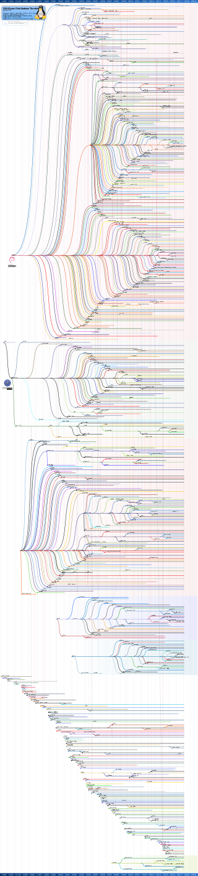
lisp |  | Lisp (historically, LISP) is a family of computer programming languages with a long history and a distinctive, fully parenthesized prefix notation. Originally specified in 1958, Lisp is the second-oldest high-level programming language in widespread use today. Only Fortran is older, by one year. Lisp has changed since its early days, and many dialects have existed over its history. Today, the best known general-purpose Lisp dialects are Common Lisp and Scheme.  Lisp was originally created as a practical mathematical notation for computer programs, influenced by the notation of Alonzo Church's lambda calculus. It quickly became the favored programming language for artificial intelligence (AI) research. As one of the earliest programming languages, Lisp pioneered many ideas in computer science, including tree data structures, automatic storage management, dynamic typing, conditionals, higher-order functions, recursion, the self-hosting compiler, and the read–eval–print loop.  The name LISP derives from "LISt Processor". Linked lists are one of Lisp's major data structures, and Lisp source code is made of lists. Thus, Lisp programs can manipulate source code as a data structure, giving rise to the macro systems that allow programmers to create new syntax or new domain-specific languages embedded in Lisp.  The interchangeability of code and data gives Lisp its instantly recognizable syntax. All program code is written as s-expressions, or parenthesized lists. A function call or syntactic form is written as a list with the function or operator's name first, and the arguments following; for instance, a function f that takes three arguments would be called as (f arg1 arg2 arg3).
Lite | Lite | CxOne concept, see CxOneOverview for description.
LL | Local Loop | 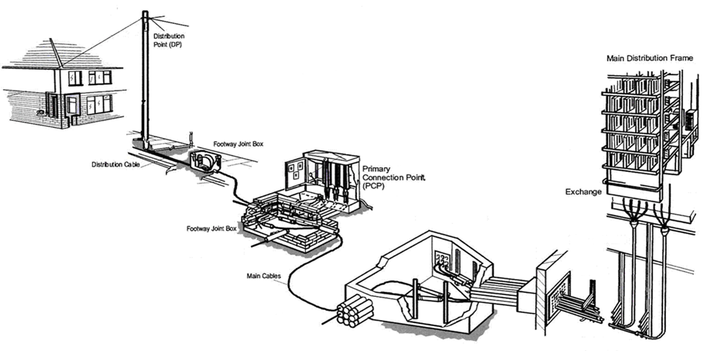
LNS | L2TP Network Server | The two endpoints of an L2TP tunnel are called the LAC (L2TP Access Concentrator) and the LNS (L2TP Network Server). The LNS waits for new tunnels. Once a tunnel is established, the network traffic between the peers is bidirectional.
Local Build | LB | Build performed in a local development environment. Compare to project build.
Local Development Environment | LDE | A development environment that is local to an individual engineer. This is normally the machines in an engineer’s office. Compare to build environment.
Local Loop |  | In telephony, the local loop (also referred to as a local tail, subscriber line, or in the aggregate as the last mile) is the physical link or circuit that connects from the demarcation point of the customer premises to the edge of the common carrier or telecommunications service provider's network.  At the edge of the carrier access network in a traditional public telephone network, the local loop terminates in a circuit switch housed in an incumbent local exchange carrier or telephone exchange.
Local Test Environment | LTE | The portion of the local development environment that supports construction testing.
LoFi Prototype |  | See low fidelity prototype.
Low Fidelity Prototype |  | A mockup of a system using pencil and paper, post-its, or other non-technology based tools.
Low Level Design | LLD | Design level between high level design and construction. Defines design in a way that directly supports construction. See CxStand_Design for more information.
LPS | MPLS Primary Switch Local Exchange (M2F) | MPLS Primary Switch Local Exchange (M2F) - Location: Local
LSP | Label Switched Path | A label-switched path (LSP) is a path through an MPLS network, set up by a signaling protocol such as LDP, RSVP-TE, BGP (or the now deprecated CR-LDP). The path is set up based on criteria in the FEC.  The path begins at a label edge router (LER), which makes a decision on which label to prefix to a packet, based on the appropriate FEC. It then forwards the packet along to the next router in the path, which swaps the packet's outer label for another label, and forwards it to the next router. The last router in the path removes the label from the packet and forwards the packet based on the header of its next layer, for example IPv4. Due to the forwarding of packets through an LSP being opaque to higher network layers, an LSP is also sometimes referred to as an MPLS tunnel.  The router which first prefixes the MPLS header to a packet is called an ingress router. The last router in an LSP, which pops the label from the packet, is called an egress router. Routers in between, which need only swap labels, are called transit routers or label switch routers (LSRs).  Note that LSPs are unidirectional; they enable a packet to be label switched through the MPLS network from one endpoint to another. Since bidirectional communication is typically desired, the aforementioned dynamic signaling protocols can set up an LSP in the other direction to compensate for this.
LSR | Label Switched Router | An MPLS router that performs routing based only on the label is called a label switch router (LSR) or transit router. This is a type of router located in the middle of an MPLS network. It is responsible for switching the labels used to route packets.
LTE (4G) |  | Long-Term Evolution (LTE) is a standard for high-speed wireless communication for mobile devices and data terminals, based on the GSM/EDGE and UMTS/HSPA technologies. It increases the capacity and speed using a different radio interface together with core network improvements. The standard is developed by the 3GPP (3rd Generation Partnership Project) and is specified in its Release 8 document series, with minor enhancements described in Release 9. LTE is the upgrade path for carriers with both GSM/UMTS networks and CDMA2000 networks. The different LTE frequencies and bands used in different countries mean that only multi-band phones are able to use LTE in all countries where it is supported.  LTE is commonly marketed as 4G LTE & Advance 4G, but it does not meet the technical criteria of a 4G wireless service, as specified in the 3GPP Release 8 and 9 document series for LTE Advanced. The requirements were originally set forth by the ITU-R organization in the IMT Advanced specification. However, due to marketing pressures and the significant advancements that WiMAX, Evolved High Speed Packet Access and LTE bring to the original 3G technologies, ITU later decided that LTE together with the aforementioned technologies can be called 4G technologies. The LTE Advanced standard formally satisfies the ITU-R requirements to be considered IMT-Advanced.[4] To differentiate LTE Advanced and WiMAX-Advanced from current 4G technologies, ITU has defined them as "True 4G"
LTE and Mobile Internet |  | 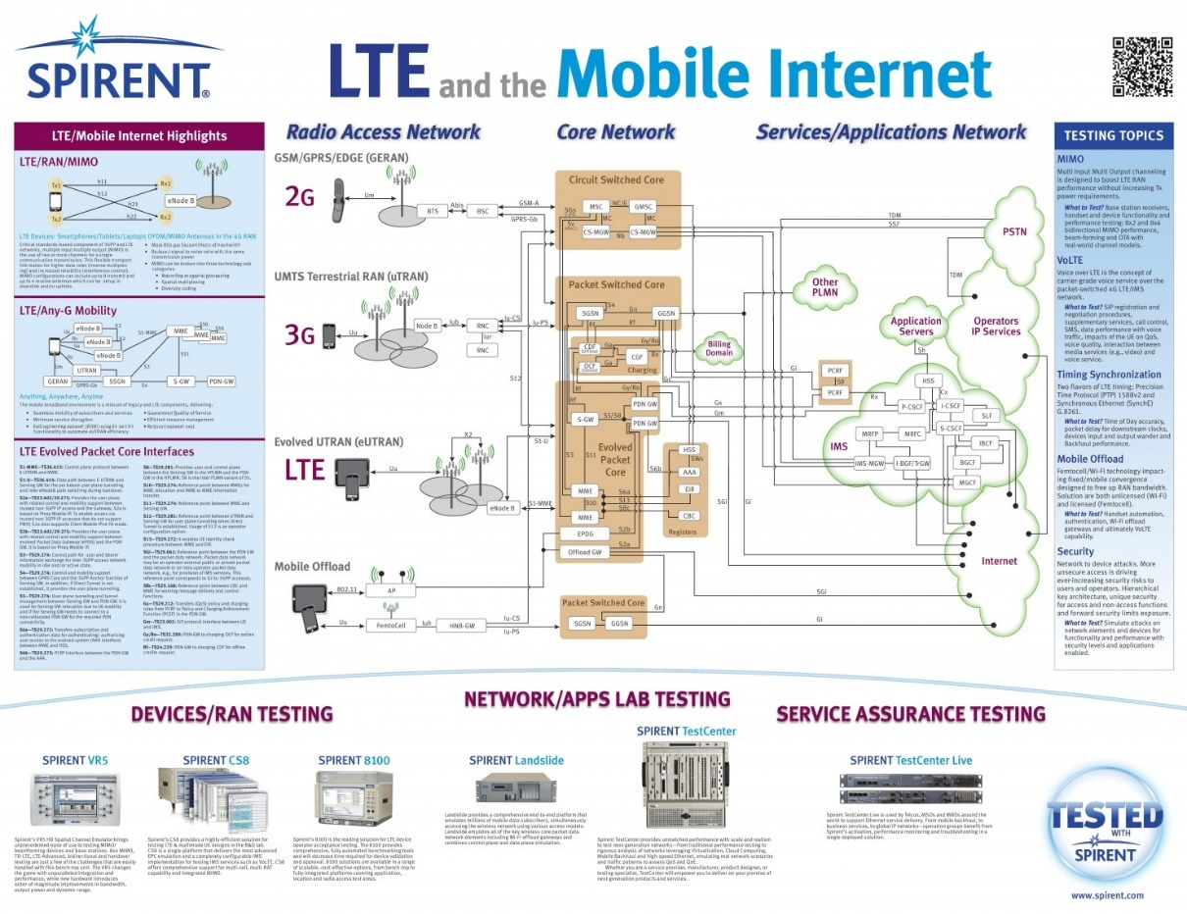
LTS | L2TP Tunnel Switch | L2TP tunnel switching, also known as L2TP multihop, simplifies the deployment of an L2TP network across multiple domains. A router that lies between a LAC and an LNS is configured as an L2TP tunnel switch (LTS)—sometimes referred to simply as a tunnel switch or a tunnel switching aggregator (TSA). The LTS is configured as both an LNS and a LAC. When a remote LAC sends encapsulated PPP packets to the LNS configured on the LTS, the LTS can forward or redirect the packets through a different tunnel to a different LNS beyond the LTS. The logical termination point of the original L2TP session is switched to a different endpoint.  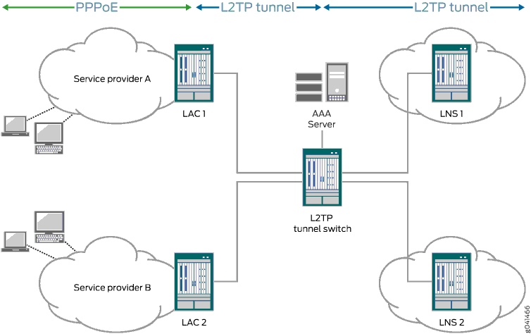
Lua |  | Lua is a lightweight, multi-paradigm programming language designed primarily for embedded use in applications. Lua is cross-platform, since the interpreter is written in ANSI C, and has a relatively simple C API.  Lua was originally designed in 1993 as a language for extending software applications to meet the increasing demand for customization at the time. It provided the basic facilities of most procedural programming languages, but more complicated or domain-specific features were not included; rather, it included mechanisms for extending the language, allowing programmers to implement such features. As Lua was intended to be a general embeddable extension language, the designers of Lua focused on improving its speed, portability, extensibility, and ease-of-use in development.

M
M2M | Machine to machine | Machine to machine (commonly abbreviated as M2M) refers to direct communication between devices using any communications channel, including wired and wireless. Machine to machine communication can include industrial instrumentation, enabling a sensor or meter to communicate the data it records (such as temperature, inventory level, etc.) to application software that can use it (for example, adjusting an industrial process based on temperature or placing orders to replenish inventory). Such communication was originally accomplished by having a remote network of machines relay information back to a central hub for analysis, which would then be rerouted into a system like a personal computer.  More recent machine to machine communication has changed into a system of networks that transmits data to personal appliances. The expansion of IP networks around the world has made machine to machine communication quicker and easier while using less power. These networks also allow new business opportunities for consumers and suppliers.
MAC | Media Access Control | In IEEE 802 LAN/MAN standards, the medium access control (MAC) sublayer (also known as the media access control sublayer) and the logical link control (LLC) sublayer together make up the data link layer. Within that data link layer, the LLC provides flow control and multiplexing for the logical link (i.e. EtherType, 802.1Q VLAN tag etc), while the MAC provides flow control and multiplexing for the transmission medium.  These two sublayers together correspond to layer 2 of the OSI model. For compatibility reasons, LLC is optional for implementations of IEEE 802.3 (the frames are then "raw"), but compulsory for implementations of all other IEEE 802 standards. Within the hierarchy of the OSI model and IEEE 802 standards, the MAC block provides a control abstraction of the physical layer such that the complexities of physical link control are invisible to the LLC and upper layers of the network stack. Thus any LLC block (and higher layers) may be used with any MAC. In turn, the medium access control block is formally connected to the PHY via a media-independent interface. Although the MAC block is today typically integrated with the PHY within the same device package, historically any MAC could be used with any PHY, independent of the transmission medium.  When sending data to another device on the network, the MAC block encapsulates higher-level frames into frames appropriate for the transmission medium (i.e. the MAC adds a syncword preamble and also padding if necessary), adds a frame check sequence to identify transmission errors, and then forwards the data to the physical layer as soon as the appropriate channel access method permits it. Controlling when data is sent and when to wait is necessary to avoid congestion and collisions, especially for topologies with a collision domain (bus, ring, mesh, point-to-multipoint topologies). Additionally, the MAC is also responsible for compensating for congestion and collisions by initiating retransmission if a jam signal is detected, and/or negotiating a slower transmission rate if necessary. When receiving data from the physical layer, the MAC block ensures data integrity by verifying the sender's frame check sequences, and strips off the sender's preamble and padding before passing the data up to the higher layers.
MAC Address | Media Access Control Address | A media access control address (MAC address) of a device is a unique identifier assigned to a network interface controller (NIC) for communications at the data link layer of a network segment. MAC addresses are used as a network address for most IEEE 802 network technologies, including Ethernet and Wi-Fi. In this context, MAC addresses are used in the medium access control protocol sublayer.  A MAC may be referred to as the burned-in address (BIA). It may also be known as an Ethernet hardware address (EHA), hardware address or physical address (not to be confused with a memory physical address).  A network node may have multiple NICs and each NIC must have a unique MAC address. Sophisticated network equipment such as a multilayer switch or router may require one or more permanently assigned MAC addresses.  MAC addresses are most often assigned by the manufacturer of a NIC and are stored in its hardware, such as the card's read-only memory or some other firmware mechanism. A MAC address may include the manufacturer's organizationally unique identifier (OUI). MAC addresses are formed according to the rules of one of three numbering name spaces managed by the Institute of Electrical and Electronics Engineers (IEEE): MAC-48, EUI-48, and EUI-64.[1][2] EUI is an abbreviation for Extended Unique Identifier.  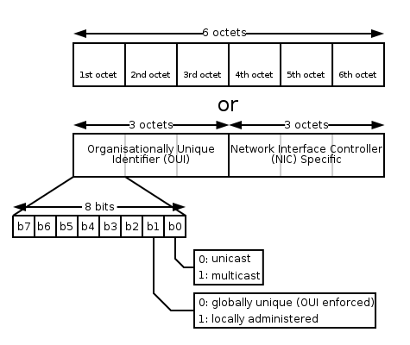
MAC Flooding |  | In computer networking, a media access control attack or MAC flooding is a technique employed to compromise the security of network switches. The attack works by forcing legitimate MAC table contents out of the switch and forcing a unicast flooding behavior potentially sending sensitive information to portions of the network where it is not normally intended to go.
MAC Spoofing |  | MAC spoofing is a technique for changing a factory-assigned Media Access Control (MAC) address of a network interface on a networked device. The MAC address that is hard-coded on a network interface controller (NIC) cannot be changed. However, many drivers allow the MAC address to be changed. Additionally, there are tools which can make an operating system believe that the NIC has the MAC address of a user's choosing. The process of masking a MAC address is known as MAC spoofing. Essentially, MAC spoofing entails changing a computer's identity, for any reason, and it is relatively easy.
Machine code |  | Machine code is a computer program written in machine language instructions that can be executed directly by a computer's central processing unit (CPU). Each instruction causes the CPU to perform a very specific task, such as a load, a jump, or an ALU operation on a unit of data in a CPU register or memory.  Machine code is a strictly numerical language which is intended to run as fast as possible, and may be regarded as the lowest-level representation of a compiled or assembled computer program or as a primitive and hardware-dependent programming language. While it is possible to write programs directly in machine code, it is tedious and error prone to manage individual bits and calculate numerical addresses and constants manually. For this reason, programs are very rarely written directly in machine code in modern contexts, but may be done for low level debugging, program patching, and assembly language disassembly.  The overwhelming majority of practical programs today are written in higher-level languages or assembly language. The source code is then translated to executable machine code by utilities such as compilers, assemblers, and linkers, with the important exception of interpreted programs, which are not translated into machine code. However, the interpreter itself, which may be seen as an executor or processor, performing the instructions of the source code, typically consists of directly executable machine code (generated from assembly or high-level language source code).  Machine code is by definition the lowest level of programming detail visible to the programmer, but internally many processors use microcode or optimise and transform machine code instructions into sequences of micro-ops, this is not generally considered to be a machine code per se
Macro Estimation |  | Refers to estimating the whole of something. See top-down estimation. Also a synonym for project estimate.
MAG | L2/B2B Aggregation Metro (All Legacy L2 Devices for B2B) | L2/B2B Aggregation Metro (All Legacy L2 Devices for B2B) - Location: Metro
Maintenance |  | Software maintenance. Deploying, updating, correcting, evolving, and operating software systems. Also denotes the maintenance CKA. See CxStand_Maintenance for more information.
Maintenance Plan |  | A plan specifying the method for maintaining the system after its initial release.
MAN | Metropolitan Area Network | A metropolitan area network (MAN) is a [computer network] that interconnects users with computer resources in a geographic area or region larger than that covered by even a large local area network (LAN) but smaller than the area covered by a wide area network (WAN). The term MAN is applied to the interconnection of networks in a city into a single larger network which may then also offer efficient connection to a wide area network.It is also used to mean the interconnection of several local area networks in a metropolitan area through the use of point-to-point connections between them. The latter usage is also sometimes referred to as a campus network.  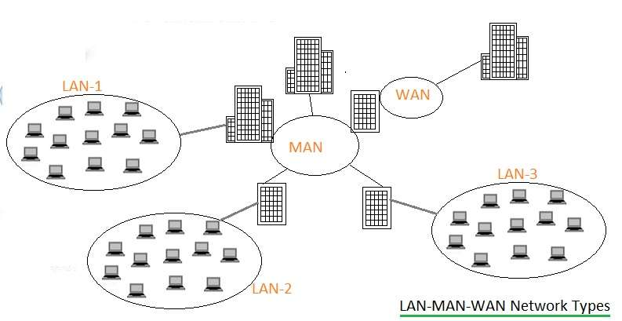
Management by Walking Around | MBWA | Term used to describe set of management techniques focused on frequent, informal communication with team members. MBWA can be used is conjunction with more formal techniques to help manage project risks, track actual progress to plan, and facilitate quick issue resolution.  CxOne encourages MBWA by all project leads and others with project responsibilities.
Management Plane |  | In computer networking, the management plane of a networking device is the element of a system that configures, monitors, and provides management, monitoring and configuration services to, all layers of the network stack and other parts of the system. It should be distinguished from the control plane, which is primarily concerned with routing table and forwarding information base computation.  In system diagrams, the management plane is typically shown in three dimensions as overlapping the network stack, separated by a dimension that delineates the power plane, data plane, control plane and management plane.
MANET | Mobile Adhoc NETwork | A mobile ad hoc network (MANET), also known as wireless ad hoc network or ad hoc wireless network, is a continuously self-configuring, infrastructure-less network of mobile devices connected wirelessly.  Each device in a MANET is free to move independently in any direction, and will therefore change its links to other devices frequently. Each must forward traffic unrelated to its own use, and therefore be a router. The primary challenge in building a MANET is equipping each device to continuously maintain the information required to properly route traffic.[4] Such networks may operate by themselves or may be connected to the larger Internet. They may contain one or multiple and different transceivers between nodes. This results in a highly dynamic, autonomous topology.  MANETs are a kind of wireless ad hoc network (WANET) that usually has a routable networking environment on top of a Link Layer ad hoc network. MANETs consist of a peer-to-peer, self-forming, self-healing network. MANETs circa 2000–2015 typically communicate at radio frequencies (30 MHz – 5 GHz).  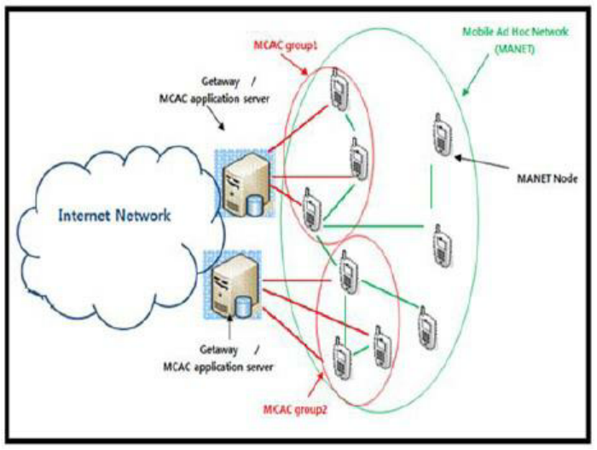  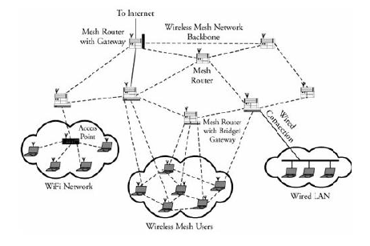
Manual Testing |  | Executing of test cases by a human operator exercising a system and noting results.
MAP | Mobile Application Part | The Mobile Application Part (MAP) is an SS7 protocol that provides an application layer for the various nodes in GSM and UMTS mobile core networks and GPRS core networks to communicate with each other in order to provide services to users. The Mobile Application Part is the application-layer protocol used to access the Home Location Register, Visitor Location Register, Mobile Switching Center, Equipment Identity Register, Authentication Centre, Short message service center and Serving GPRS Support Node (SGSN).
MAS | MPLS L2/B2B Aggregation Metro (M2F) | MPLS L2/B2B Aggregation Metro (M2F) - Location: Metro
Material |  | Materials support the creation, review, and maintenance of different types of artifacts. See CxOneOverview for additional information.
MBMS | Multimedia Broadcast Multicast Services | Multimedia Broadcast Multicast Services (MBMS) is a point-to-multipoint interface specification for existing and upcoming 3GPP cellular networks, which is designed to provide efficient delivery of broadcast and multicast services, both within a cell as well as within the core network. For broadcast transmission across multiple cells, it defines transmission via single-frequency network configurations. The specification is referred to as Evolved Multimedia Broadcast Multicast Services (eMBMS) when transmissions are delivered through an LTE (Long Term Evolution) network. eMBMS is also known as LTE Broadcast.  Target applications include mobile TV and radio broadcasting, live streaming video services, as well as file delivery and emergency alerts.
MBORC | Matter Beyond Our Reasonable Control | MBORC is a contractual provision contained in all Openreach contracts which releases Openreach from liability under the relevant product terms and conditions in circumstances where the following criteria apply to our failure to perform the contract:  - The cause of the incident is beyond our reasonable control and  - The fix to remedy within contractual timescales is also beyond our reasonable control.  Examples of MBORC situations are:  - Network attacks, i.e. criminal damage to network apparatus  - BT plant damaged by non-BT contractors  - a PCP or pole being knocked over or damaged in a traffic accident  - damage caused by exceptionally severe weather, eg floods or storm damage  a gas leak preventing access to underground cables/joints
MD5 | Message Digest 5 | The MD5 algorithm is a widely used hash function producing a 128-bit hash value. Although MD5 was initially designed to be used as a cryptographic hash function, it has been found to suffer from extensive vulnerabilities. It can still be used as a checksum to verify data integrity, but only against unintentional corruption.  Like most hash functions, MD5 is neither encryption nor encoding. It can be cracked by brute-force attack and suffers from extensive vulnerabilities as detailed in the security section below.  MD5 was designed by Ronald Rivest in 1991 to replace an earlier hash function MD4.[3] The source code in RFC 1321 contains a "by attribution" RSA license. The abbreviation "MD" stands for "Message Digest."  The security of MD5 has been severely compromised, with its weaknesses having been exploited in the field, most infamously by the Flame malware in 2012. The CMU Software Engineering Institute considers MD5 essentially "cryptographically broken and unsuitable for further use"
MDF | Main Distribution Frame | A point in a telephone exchange where cables from outside can be connected to the exchange equipment.
Mediation |  | Telecommunications mediation is a process that converts call data to pre-defined layouts that can be imported by a specific billing system or other OSS applications  A billing mediation platform is a system used to convert data of certain datatypes to other datatypes, usually for billing purposes. Billing Mediation Platforms are used mostly by telephone companies, who typically need to process UDRs (Usage Detail Records). In call scenarios UDRs are most often known as CDRs (Call Detail Records), and among broadband carriers they are often referred to as IPDR  Billing mediation platforms get their name from their behavior: they "mediate" data between systems. In a typical telephone company scenario, the systems providing data to the mediation platform are network elements, such as telephone switches, and the systems receiving data from the mediation platform perform accounting, auditing, archiving, or bill-generation functions. The mediation system collects, collates and prepares data for consumption by the downstream systems, which often accept data only in a limited set of formats.  Functionality  Typically a mediation platform is used for the following tasks:  - Collection and validation of CDRs  - Filtering out of non billing-relevant CDRs  - Collating  - Correlation of different input sources CDRs  - Aggregation of partial CDRs related to the same call  - Format change and CDRs normalization  - Business transformation of data  In a telecom billing scenario, mediation is the first step after receiving a CDR. The mediated CDR is forwarded to a rating engine, which calculates the charge associated with the CDRs. In today's world Rating Engines are more becoming necessary for the telecom billing system to meet the growing variant customer needs for different services.[citation needed]  Despite the name, not all of the data transferred via billing mediation platforms is actually used for billing purposes. For instance, the mediation software might generate traffic volume statistics based on the number and origin of the records passing through it. Those statistics could then be used for capacity planning, as part of a network monitoring procedure, or for any other business intelligence applications.  At core Mediation involves data transfer between various systems with or without modification of data starting from Network elements to OSS/BSS systems.  Sophisticated Billing Mediation software serves end to end functionality for telecom operators. Mediation software performs various operation from data collection to downstream distribution to modules like retail billing, interconnect settlement, business intelligence, fraud detection and revenue assurance.  Following list provides insight on mediation software activities  - Collection and Archive  - Decoding/Encoding  - Normalization (Common Format)  - Filtering  - Conversion  - Validation  - Record Enrichment (Using Complex Reference Data)  - Duplicate Record Detection  - Aggregation or Correlation  - Buffering  - Cloning  - Sorting  - Downstream Format Mapping  - Header and Trailer generation  - Downstream Distribution  - Error Messaging and Alarms  - Auditing and Reports  - Reconciliation  - Reference Data Configuration  - Provisioning services for the subscription.  Complementary to Billing Mediation functions, comprehensive mediation platforms also provide functionality dedicated to Service Provisioning (the two areas frequently intermix as services configured and used by the end customer result in usage data records generation in the network).  Mediating between the systems is not the only job that Mediation Platform can do. Actually this can be used as a provisioning agent. The basic provisioning commands can be configured within the mediation system and whenever we get a request for the system which does the provisioning, the request can be converted into a file, in which mediation can append the service provisioning commands and send it to HLR for activating any request. This of course, load dependent but can come very handy when there is a crisis in the other system.  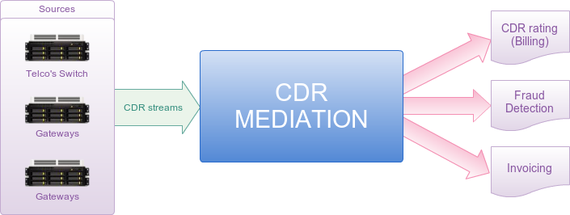
MELP | Mixed-excitation linear prediction | Mixed-excitation linear prediction (MELP) is a United States Department of Defense speech coding standard used mainly in military applications and satellite communications, secure voice, and secure radio devices. Its standardization and later development was led and supported by NSA, and NATO.  Compression level  MELPe is intended for the compression of speech. Given an audio input sampled at 8 kHz, the MELPe codec yields the following compression ratios over a 64 kbit/s μ-Law G.711 datastream, discounting the effects of protocol overhead:  Bitrate Compression ratio over G.711 Payload size Payload interval  2400 bit/s 26.7 X 54 bits 22.5 ms  1200 bit/s 53.3 X 81 bits 67.5 ms  600 bit/s 106.7 X 54 bits 90 ms  Generally, speech coding involves a trade-off of different aspects including bit-rate, speech quality, delay (frame size and lookahead), computational complexity, robustness to different speakers and languages, robustness to different background noises, channel error robustness, and also codec state recovery in the face of packet loss. Since the MELPe's lower rates (600 and 1200 bit/s) are supersets of the 2400 bit/s rate, the algorithm complexity (e.g. in MIPS) is about the same for all rates. The lower rates use increased frames and lookahead, as well as codebook size, therefore they require more memory.
Metric |  | Data collected or derived from a project or organization to determine if it posses the desired attributes.
MGCF | media gateway controller function | A media gateway controller function (MGCF) is a SIP endpoint that does call control protocol conversion between SIP and ISUP/BICC and interfaces with the SGW over SCTP. It also controls the resources in a Media Gateway (MGW) across an H.248 interface.
MGCP | Media Gateway Control Protocol | The Media Gateway Control Protocol (MGCP) is a signaling and call control communications protocol used in voice over IP (VoIP) telecommunication systems. It implements the media gateway control protocol architecture for controlling media gateways on Internet Protocol (IP) networks connected to the public switched telephone network (PSTN). The protocol is a successor to the Simple Gateway Control Protocol (SGCP), which was developed by Bellcore and Cisco, and the Internet Protocol Device Control (IPDC).  The methodology of MGCP reflects the structure of the PSTN with the power of the network residing in a call control center softswitch which is analogous to the central office in the telephone network. The endpoints are low-intelligence devices, mostly executing control commands and providing result indications in response. The protocol represents a decomposition of other VoIP models, such as H.323, in which the H.323 Gatekeeper, have higher levels of signaling intelligence.  MGCP is a text-based protocol consisting of commands and responses. It uses the Session Description Protocol (SDP) for specifying and negotiating the media streams to be transmitted in a call session and the Real-time Transport Protocol (RTP) for framing the media streams.  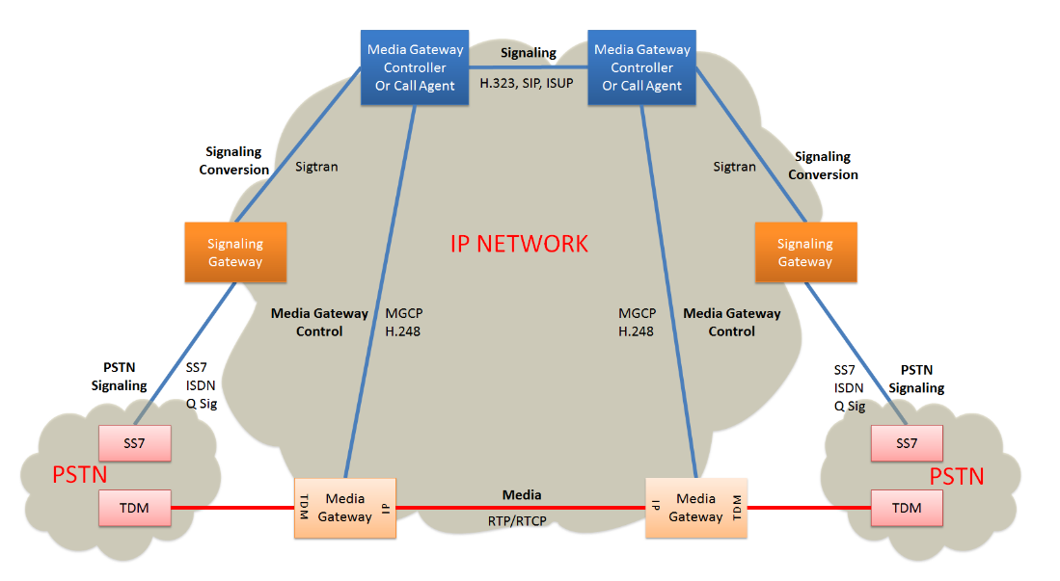
MGW | Media Gateway | A media gateway (MGW) interfaces with the media plane of the CS network, by converting between RTP and PCM. It can also transcode when the codecs don't match (e.g., IMS might use AMR, PSTN might use G.711).
MIB | management information base | A management information base (MIB) is a database used for managing the entities in a communication network. Most often associated with the Simple Network Management Protocol (SNMP), the term is also used more generically in contexts such as in OSI/ISO Network management model. While intended to refer to the complete collection of management information available on an entity, it is often used to refer to a particular subset, more correctly referred to as MIB-module.  Objects in the MIB are defined using a subset of Abstract Syntax Notation One (ASN.1) called "Structure of Management Information Version 2 (SMIv2)" RFC 2578. The software that performs the parsing is a MIB compiler.  The database is hierarchical (tree-structured) and each entry is addressed through an object identifier (OID). Internet documentation RFCs discuss MIBs, notably RFC 1155, "Structure and Identification of Management Information for TCP/IP based internets", and its two companions, RFC 1213, "Management Information Base for Network Management of TCP/IP-based internets", and RFC 1157, "A Simple Network Management Protocol".  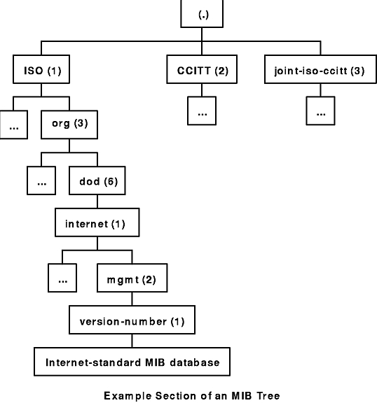
Micro Estimation |  | Refers to estimating the details of something. See bottom-up estimation. Also a synonym for task estimate.
Microservice |  | Microservices - also known as the microservice architecture - is an architectural style that structures an application as a collection of services that are  - Highly maintainable and testable  - Loosely coupled  - Independently deployable  - Organized around business capabilities.  The microservice architecture enables the continuous delivery/deployment of large, complex applications. It also enables an organization to evolve its technology stack.  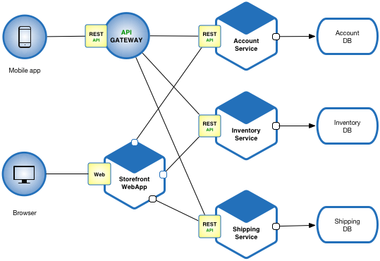  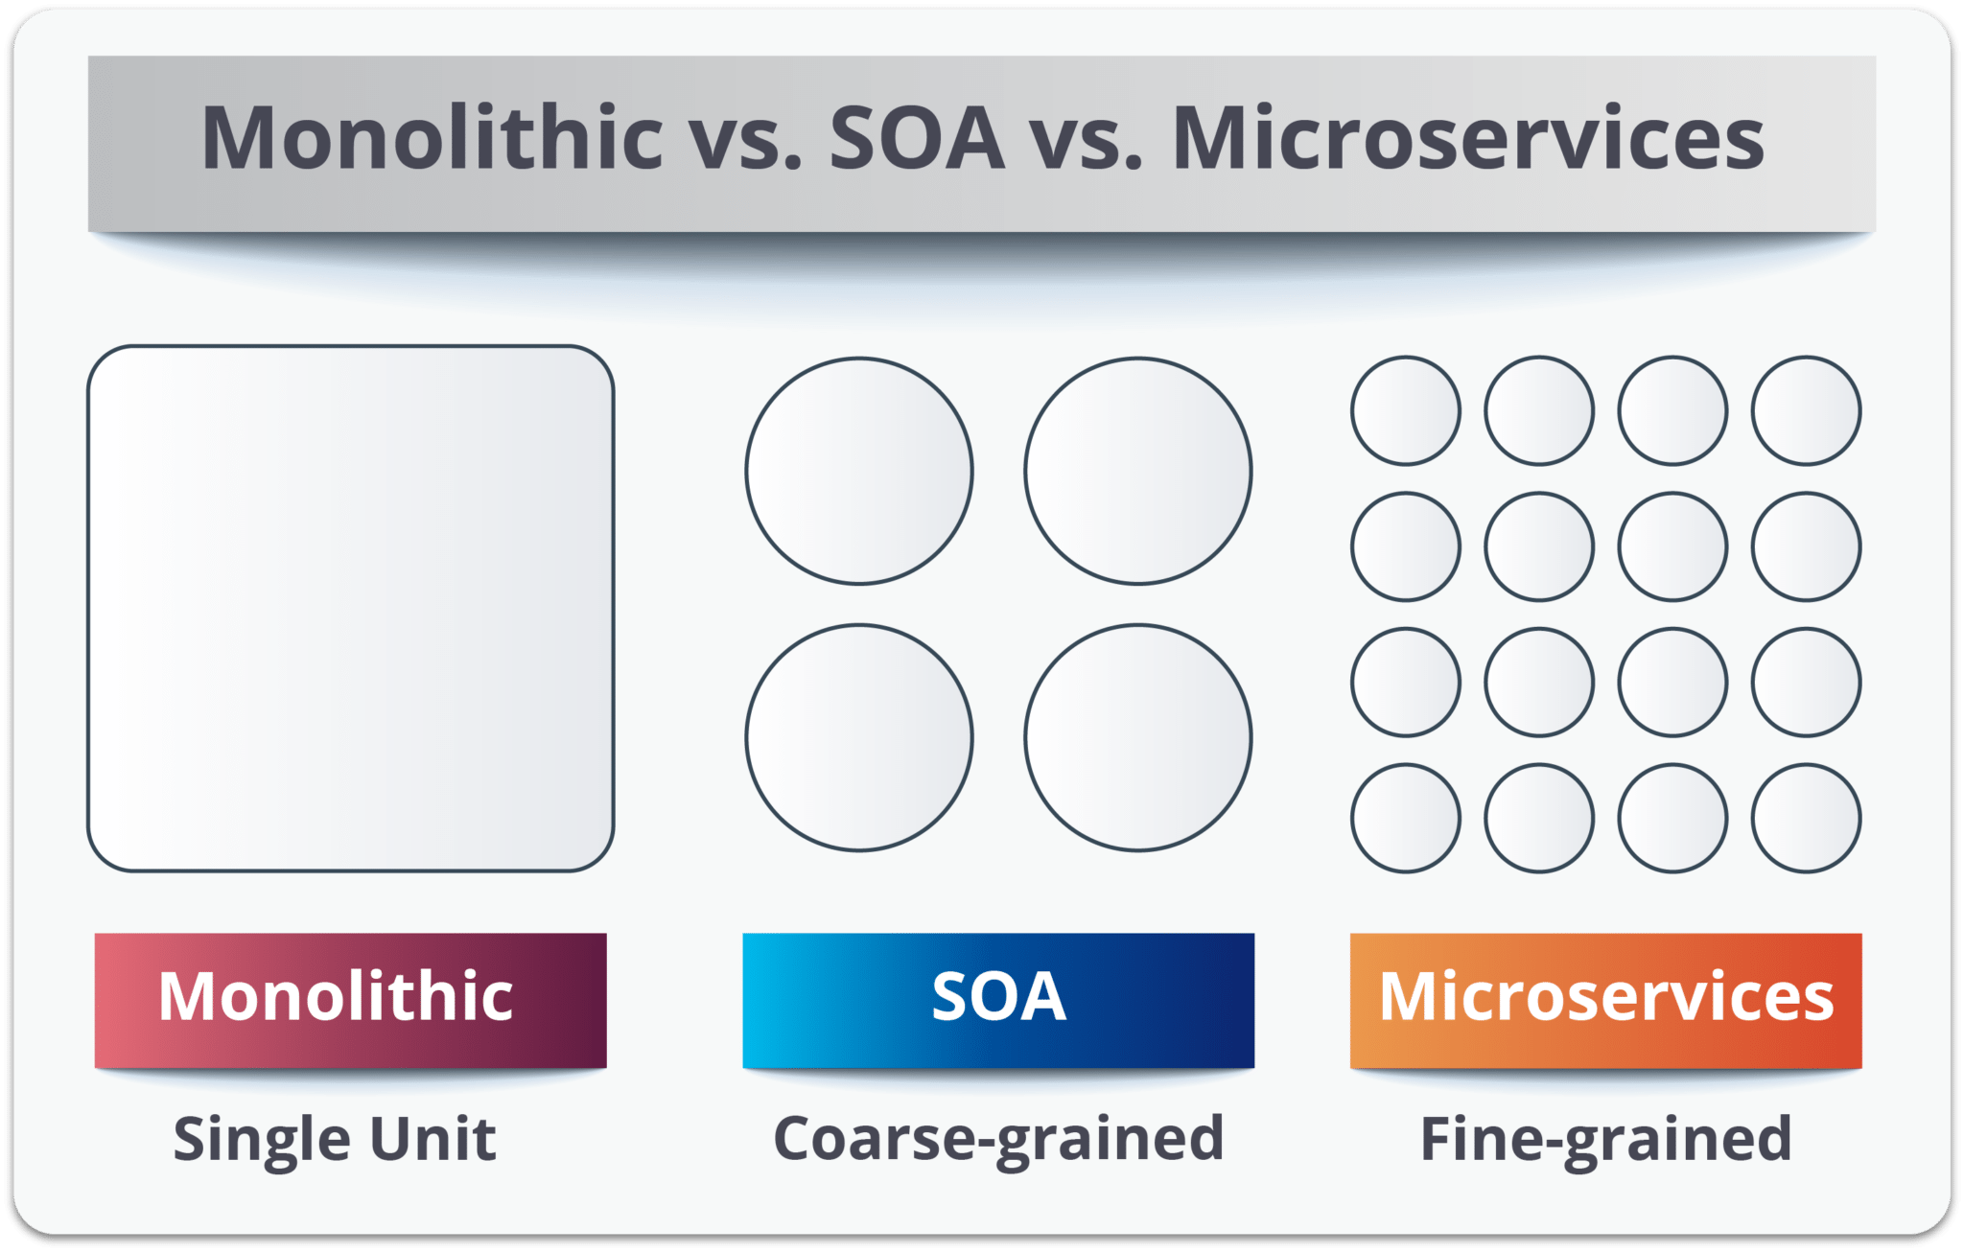
Microstone |  | Synonym for miniature milestone.
Mil-COTS |  | See COTS
Milestone |  | A waypoint in a schedule. Often represents a notable accomplishment or date.
Milestone Release |  | A release that is produced for a milestone in a project plan.
Milestone Retrospective |  | A Milestone Retrospective is a team's detailed analysis of the project's significant events after a set period of time or at the project's end.
Milestone Schedule |  | A synonym for a business schedule focused on defining formally project milestones.
MIMO | multiple-input and multiple-output | In radio, , or MIMO, is a method for multiplying the capacity of a radio link using multiple transmit and receive antennas to exploit multipath propagation. MIMO has become an essential element of wireless communication standards including IEEE 802.11n (Wi-Fi), IEEE 802.11ac (Wi-Fi), HSPA+ (3G), WiMAX (4G), and Long Term Evolution (LTE 4G). More recently, MIMO has been applied to power-line communication for 3-wire installations as part of ITU G.hn standard and HomePlug AV2 specification.  At one time, in wireless the term "MIMO" referred to the use of multiple antennas at the transmitter and the receiver. In modern usage, "MIMO" specifically refers to a practical technique for sending and receiving more than one data signal simultaneously over the same radio channel by exploiting multipath propagation. MIMO is fundamentally different from smart antenna techniques developed to enhance the performance of a single data signal, such as beamforming and diversity.  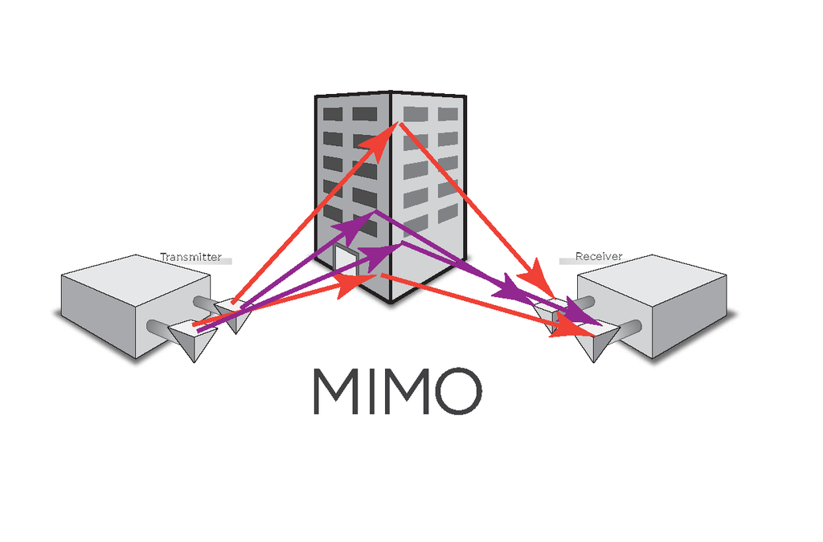
Miniature Milestone |  | A milestone capturing a collection of short, coherent tasks that requires a couple of days or less to complete. For project tracking purposes completion is binary; a miniature milestone is considered to be either done or not done, but never partially done.
Miniature Milestones |  | Plural for miniature milestone. Also used to describe the best practice of breaking a project’s tasks down into a rolling window of miniature milestones.  See CxBest_MiniatureMilestones.
Mini-milestone |  | Synonym for miniature milestone.
MME | Mobility Management Entity | The MME is the key control-node for the LTE access-network. It is responsible for idle mode UE (User Equipment) paging and tagging procedure including retransmissions. It is involved in the bearer activation/deactivation process and is also responsible for choosing the SGW for a UE at the initial attach and at time of intra-LTE handover involving Core Network (CN) node relocation. It is responsible for authenticating the user (by interacting with the HSS). The Non Access Stratum (NAS) signaling terminates at the MME and it is also responsible for generation and allocation of temporary identities to UEs. It checks the authorization of the UE to camp on the service provider’s Public Land Mobile Network (PLMN) and enforces UE roaming restrictions. The MME is the termination point in the network for ciphering/integrity protection for NAS signaling and handles the security key management. Lawful interception of signaling is also supported by the MME. The MME also provides the control plane function for mobility between LTE and 2G/3G access networks with the S3 interface terminating at the MME from the SGSN. The MME also terminates the S6a interface towards the home HSS for roaming UEs.
MMF | Minimum Marketable Feature | A Minimum Marketable Feature is a small, self-contained feature that can be developed quickly and that delivers significant value to the user.
MNC | Bayonet Neill–Concelman | The BNC (Bayonet Neill–Concelman) connector is a miniature quick connect/disconnect radio frequency connector used for coaxial cable. It features two bayonet lugs on the female connector; mating is fully achieved with a quarter turn of the coupling nut. BNC connectors are used with miniature-to-subminiature coaxial cable in radio, television, and other radio-frequency electronic equipment, test instruments, and video signals. The BNC was commonly used for early computer networks, including ARCnet, the IBM PC Network, and the 10BASE2 variant of Ethernet. BNC connectors are made to match the characteristic impedance of cable at either 50 ohms or 75 ohms. They are usually applied for frequencies below 4 GHz[ and voltages below 500 volts.
Mob Programming |  | Mob Programming is a software development approach where the whole team works on the same thing, at the same time, in the same space, and at the same computer.
Mobile Cell |  | Modern mobile phone networks use cells because radio frequencies are a limited, shared resource. Cell-sites and handsets change frequency under computer control and use low power transmitters so that the usually limited number of radio frequencies can be simultaneously used by many callers with less interference.  A cellular network is used by the mobile phone operator to achieve both coverage and capacity for their subscribers. Large geographic areas are split into smaller cells to avoid line-of-sight signal loss and to support a large number of active phones in that area. All of the cell sites are connected to telephone exchanges (or switches), which in turn connect to the public telephone network.  In cities, each cell site may have a range of up to approximately 1⁄2 mile (0.80 km), while in rural areas, the range could be as much as 5 miles (8.0 km). It is possible that in clear open areas, a user may receive signals from a cell site 25 miles (40 km) away.  Since almost all mobile phones use cellular technology, including GSM, CDMA, and AMPS (analog), the term "cell phone" is in some regions, notably the US, used interchangeably with "mobile phone". However, satellite phones are mobile phones that do not communicate directly with a ground-based cellular tower, but may do so indirectly by way of a satellite.  There are a number of different digital cellular technologies, including: Global System for Mobile Communications (GSM), General Packet Radio Service (GPRS), cdmaOne, CDMA2000, Evolution-Data Optimized (EV-DO), Enhanced Data Rates for GSM Evolution (EDGE), Universal Mobile Telecommunications System (UMTS), Digital Enhanced Cordless Telecommunications (DECT), Digital AMPS (IS-136/TDMA), and Integrated Digital Enhanced Network (iDEN). The transition from existing analog to the digital standard followed a very different path in Europe and the US.[11] As a consequence, multiple digital standards surfaced in the US, while Europe and many countries converged towards the GSM standard.  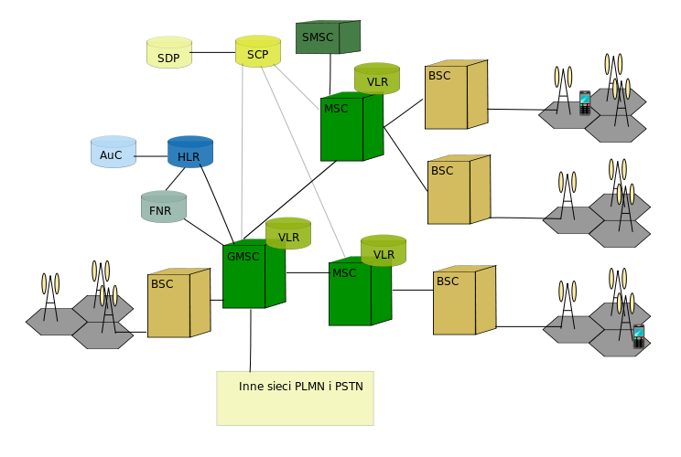
Mobile Networks 2G/3G |  | 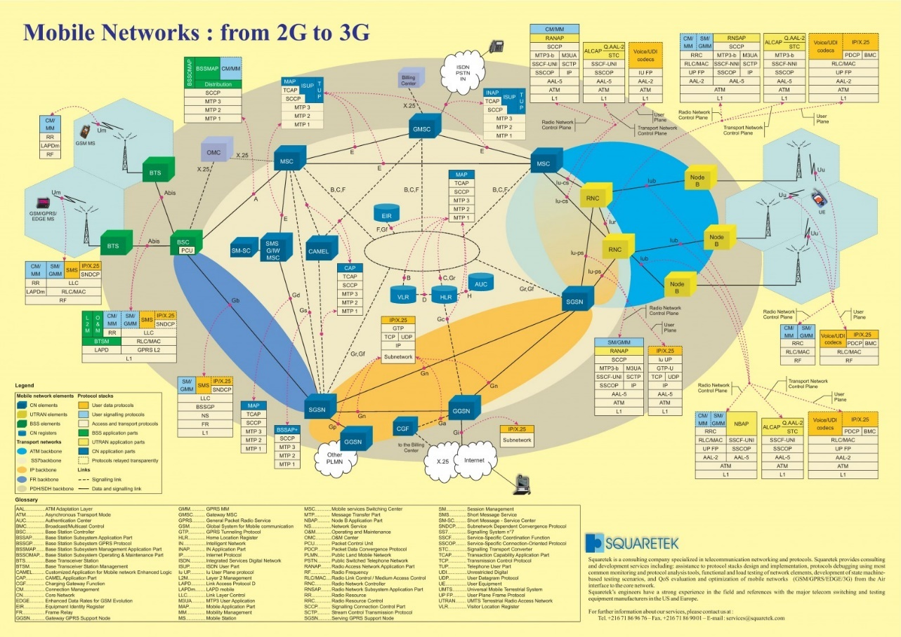
Mock Objects |  | Mock Objects (commonly used in the context of crafting automated unit tests) consist of instantiating a test-specific version of a software component.
Model |  | A representation of a system or process that uses diagrams and abstraction to describe characteristics of the systems.
Modeling |  | The practice of using models in requirements and design activities.
Moderator |  | Leads an inspection meeting.
MOS | Mean Opinion Score | Mean opinion score (MOS) is a measure used in the domain of Quality of Experience and telecommunications engineering, representing overall quality of a stimulus or system. It is the arithmetic mean over all individual “values on a predefined scale that a subject assigns to his opinion of the performance of a system quality”. Such ratings are usually gathered in a subjective quality evaluation test, but they can also be algorithmically estimated.  MOS is a commonly used measure for video, audio, and audiovisual quality evaluation, but not restricted to those modalities. ITU-T has defined several ways of referring to a MOS in Recommendation P.800.1, depending on whether the score was obtained from audiovisual, conversational, listening, talking, or video quality tests.  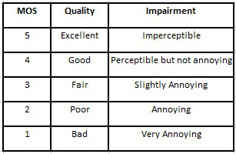
MP3 |  | MP3 (formally MPEG-1 Audio Layer III or MPEG-2 Audio Layer III) is an audio coding format for digital audio. Originally defined as the third audio format of the MPEG-1 standard, it was retained and further extended—defining additional bit rates and support for more audio channels—as the third audio format of the subsequent MPEG-2 standard. A third version, known as MPEG 2.5—extended to better support lower bit rates—is commonly implemented, but is not a recognized standard.  MP3 (or mp3) as a file format commonly designates files containing an elementary stream of MPEG-1 audio and video encoded data, without other complexities of the MP3 standard.  In the aspects of MP3 pertaining to audio compression—the aspect of the standard most apparent to end users (and for which is it best known)—MP3 uses lossy data compression to encode data using inexact approximations and the partial discarding of data. This allows a large reduction in file size when compared to uncompressed audio. The combination of small size and acceptable fidelity led to a boom in the distribution of music over the Internet in the mid to late 1990s, as an enabling technology when bandwidth and storage were still at a premium. The MP3 format soon became associated with controversies surrounding copyright infringement, music piracy, the file ripping/sharing services MP3.com and Napster, among others. With the advent of portable media players, a product category also including smartphones, MP3 support remains near-universal.  MP3 compression works by reducing (or approximating) the accuracy of certain components of sound that are considered to be beyond the hearing capabilities of most humans. This method is commonly referred to as perceptual coding, or psychoacoustic modeling. The remaining audio information is then recorded in a space-efficient manner. Compared to CD-quality digital audio, MP3 compression can commonly achieve a 75 to 95% reduction in size. For example, an MP3 encoded at a constant bitrate of 128 kbit/s would result in a file approximately 9% the size of the original CD audio.  Also designed as a streamable format, segments of a transmission can be lost without affecting the ability to decode later segments.
MPEG | Moving Picture Experts Group | The Moving Picture Experts Group (MPEG) is a working group of authorities that was formed by ISO and IEC to set standards for audio and video compression and transmission. s
MPEG4 |  | MPEG-4 is a method of defining compression of audio and visual (AV) digital data. It was introduced in late 1998 and designated a standard for a group of audio and video coding formats and related technology agreed upon by the ISO/IEC Moving Picture Experts Group (MPEG) (ISO/IEC JTC1/SC29/WG11) under the formal standard ISO/IEC 14496 – Coding of audio-visual objects. Uses of MPEG-4 include compression of AV data for web (streaming media) and CD distribution, voice (telephone, videophone) and broadcast television applications.
MPF | Metallic Path Facility | Pair of copper wires (unshielded twisted pair) that run from a Main Distribution Frame (MDF) at a exchange to the end user.  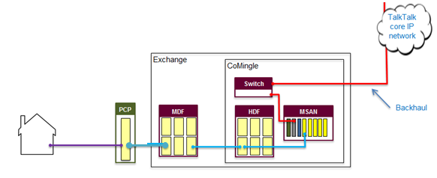
MPS | Metro Primary Switch | Metro Primary Switch (M2F) - Location: Metro  Formally known as NGM  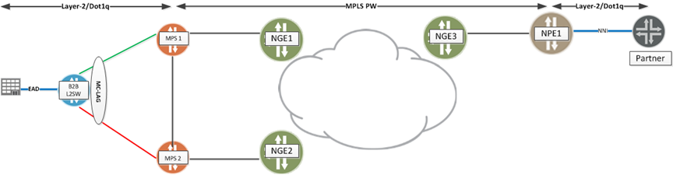
MQTT | Message Queuing Telemetry Transport | MQTT (Message Queuing Telemetry Transport) is an ISO standard (ISO/IEC PRF 20922) publish-subscribe-based messaging protocol. It works on top of the TCP/IP protocol. It is designed for connections with remote locations where a "small code footprint" is required or the network bandwidth is limited. The publish-subscribe messaging pattern requires a message broker.  Andy Stanford-Clark of IBM and Arlen Nipper of Cirrus Link authored the first version of the protocol in 1999.  The specification does not specify the meaning of "small code footprint" or the meaning of "limited network bandwidth". Thus, the protocol's availability for use depends on the context. In 2013, IBM submitted MQTT v3.1 to the OASIS specification body with a charter that ensured only minor changes to the specification could be accepted. MQTT-SN is a variation of the main protocol aimed at embedded devices on non-TCP/IP networks, such as ZigBee.  Historically, the "MQ" in "MQTT" came from IBM's MQ Series message queuing product line.[6] However, queuing itself is not required to be supported as a standard feature in all situations.
MRF | Media Resource Function | The Media Resource Function (MRF) provides media related functions such as media manipulation (e.g. voice stream mixing) and playing of tones and announcements.
MRS | Multi-Residence data | Royal Mail Multi-Residence data
MRTIE | Maximum Relative Time Interval Error
MSAN | Multi-Service Access Node | A multi-service access node (MSAN), also known as a multi-service access gateway (MSAG), is a device typically installed in a telephone exchange (although sometimes in a roadside serving area interface cabinet) which connects customers' telephone lines to the core network, to provide telephone, ISDN, and broadband such as DSL all from a single platform.  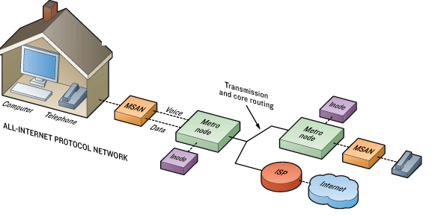
MSC | Mobile switching center | The mobile switching center (MSC) is the primary service delivery node for GSM/CDMA, responsible for routing voice calls and SMS as well as other services (such as conference calls, FAX and circuit switched data).  The MSC sets up and releases the end-to-end connection, handles mobility and hand-over requirements during the call and takes care of charging and real time prepaid account monitoring.  In the GSM mobile phone system, in contrast with earlier analogue services, fax and data information is sent digitally encoded directly to the MSC. Only at the MSC is this re-coded into an "analogue" signal (although actually this will almost certainly mean sound is encoded digitally as a pulse-code modulation (PCM) signal in a 64-kbit/s timeslot, known as a DS0 in America).  There are various different names for MSCs in different contexts which reflects their complex role in the network, all of these terms though could refer to the same MSC, but doing different things at different times.  The gateway MSC (G-MSC) is the MSC that determines which "visited MSC" (V-MSC) the subscriber who is being called is currently located at. It also interfaces with the PSTN. All mobile to mobile calls and PSTN to mobile calls are routed through a G-MSC. The term is only valid in the context of one call, since any MSC may provide both the gateway function and the visited MSC function. However, some manufacturers design dedicated high capacity MSCs which do not have any base station subsystems (BSS) connected to them. These MSCs will then be the gateway MSC for many of the calls they handle.  The visited MSC (V-MSC) is the MSC where a customer is currently located. The visitor location register (VLR) associated with this MSC will have the subscriber's data in it.  The anchor MSC is the MSC from which a handover has been initiated. The target MSC is the MSC toward which a handover should take place. A mobile switching center server is a part of the redesigned MSC concept starting from 3GPP Release 4.
MTP | Message Transfer Part | The (MTP) is part of the Signaling System 7 (SS7) used for communication in Public Switched Telephone Networks. MTP is responsible for reliable, unduplicated and in-sequence transport of SS7 messages between communication partners.  MTP is formally defined primarily in ITU-T recommendations Q.701, Q.702, Q.703, Q.704 and Q.705. Tests for the MTP are specified in the ITU-T recommendations Q.781 for MTP2 and in Q.782 for MTP3. These tests are used to validate the correct implementation of the MTP protocol.  Functional levels  The SS7 stack can be separated into four functional levels: Level 1 through Level 3 comprise the MTP, and Level 4 the MTP user. MTP Level 3 is sometimes abbreviated MTP3; MTP Level 2, MTP2. MTP and SCCP are together referred to as the Network Service Part (NSP).  There is no one-to-one mapping of MTP Levels 1 through 3 onto the OSI model. Instead, MTP provides the functionality of layers 1, 2 and part of layer 3 in the OSI model. The part of layer 3 of the OSI model that MTP does not provide, is provided by SCCP or other Level 4 parts (MTP users).  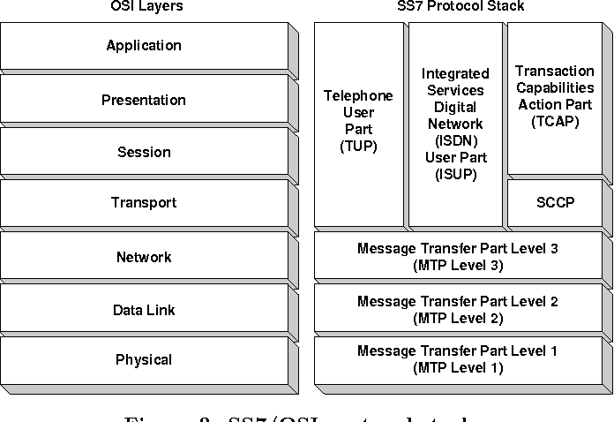
MTR | Mean Time to Repair | Mean time to repair (MTTR) is the average time required to troubleshoot and repair failed equipment and return it to normal operating conditions. It is a basic technical measure of the maintainability of equipment and repairable parts.
MTU |  | In computer networking, the maximum transmission unit (MTU) is the size of the largest protocol data unit (PDU) that can be communicated in a single network layer transaction. The MTU relates to, but is not identical to the maximum frame size that can be transported on the data link layer, e.g. Ethernet frame.  Larger MTU is associated with reduced overhead. Smaller MTU values can reduce network delay. In many cases, MTU is dependent on underlying network capabilities and must be adjusted manually or automatically so as to not exceed these capabilities. MTU parameters may appear in association with a communications interface or standard. Some systems may decide MTU at connect time.
Multicast |  | In computer networking, multicast is group communication where data transmission is addressed to a group of destination computers simultaneously. Multicast can be one-to-many or many-to-many distribution. Multicast should not be confused with physical layer point-to-multipoint communication.  Group communication may either be application layer multicast or network assisted multicast, where the latter makes it possible for the source to efficiently send to the group in a single transmission. Copies are automatically created in other network elements, such as routers, switches and cellular network base stations, but only to network segments that currently contain members of the group. Network assisted multicast may be implemented at the data link layer using one-to-many addressing and switching such as Ethernet multicast addressing, Asynchronous Transfer Mode (ATM), point-to-multipoint virtual circuits (P2MP)[3] or Infiniband multicast. Network assisted multicast may also be implemented at the Internet layer using IP multicast. In IP multicast the implementation of the multicast concept occurs at the IP routing level, where routers create optimal distribution paths for datagrams sent to a multicast destination address.  Multicast is often employed in Internet Protocol (IP) applications of streaming media, such as IPTV and multipoint videoconferencing.  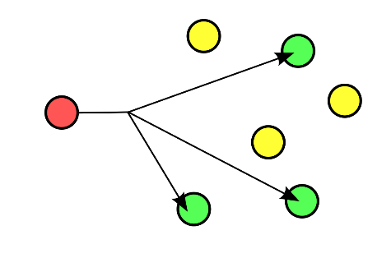
Multiplex |  | In telecommunications and computer networks, multiplexing (sometimes contracted to muxing) is a method by which multiple analog or digital signals are combined into one signal over a shared medium. The aim is to share a scarce resource. For example, in telecommunications, several telephone calls may be carried using one wire. Multiplexing originated in telegraphy in the 1870s, and is now widely applied in communications. In telephony, George Owen Squier is credited with the development of telephone carrier multiplexing in 1910.  The multiplexed signal is transmitted over a communication channel such as a cable. The multiplexing divides the capacity of the communication channel into several logical channels, one for each message signal or data stream to be transferred. A reverse process, known as demultiplexing, extracts the original channels on the receiver end.  A device that performs the multiplexing is called a multiplexer (MUX), and a device that performs the reverse process is called a demultiplexer (DEMUX or DMX).
Mutex |  | In computer science, a lock or mutex (from mutual exclusion) is a synchronization mechanism for enforcing limits on access to a resource in an environment where there are many threads of execution. A lock is designed to enforce a mutual exclusion concurrency control policy.
Mutual Exclusion |  | In computer science, mutual exclusion is a property of concurrency control, which is instituted for the purpose of preventing race conditions; it is the requirement that one thread of execution never enter its critical section at the same time that another concurrent thread of execution enters its own critical section.  The requirement of mutual exclusion was first identified and solved by Edsger W. Dijkstra in his seminal 1965 paper titled Solution of a problem in concurrent programming control,[1][2] which is credited as the first topic in the study of concurrent algorithms.  A simple example of why mutual exclusion is important in practice can be visualized using a singly linked list of four items, where the second and third are to be removed. The removal of a node that sits between 2 other nodes is performed by changing the next pointer of the previous node to point to the next node (in other words, if node i is being removed, then the next pointer of node i − 1 is changed to point to node i + 1, thereby removing from the linked list any reference to node i). When such a linked list is being shared between multiple threads of execution, two threads of execution may attempt to remove two different nodes simultaneously, one thread of execution changing the next pointer of node i − 1 to point to node i + 1, while another thread of execution changes the next pointer of node i to point to node i + 2. Although both removal operations complete successfully, the desired state of the linked list is not achieved: node i + 1 remains in the list, because the next pointer of node i − 1 points to node i + 1.  This problem (called a race condition) can be avoided by using the requirement of mutual exclusion to ensure that simultaneous updates to the same part of the list cannot occur.  The term mutual exclusion is also used in reference to the simultaneous writing of a memory address by one thread while the aforementioned memory address is being manipulated or read by another thread or other threads.
MVNE | mobile virtual network enabler | A mobile virtual network enabler (MVNE) is a company that provides network infrastructure and related services, such as business support systems, administration and operations support systems to a Mobile Virtual Network Operator (MVNO). This enables MVNOs to offer services to their own customers with their own brands. The MVNE does not have a relationship with consumers, but rather is a provider of network enablement platforms and services.
MVNO | Mobile Virtual Network Operator | A mobile virtual network operator (MVNO), virtual network operator (VNO), or mobile other licensed operator (MOLO), is a wireless communications services provider that does not own the wireless network infrastructure over which it provides services to its customers. An MVNO enters into a business agreement with a mobile network operator to obtain bulk access to network services at wholesale rates, then sets retail prices independently. An MVNO may use its own customer service, billing support systems, marketing, and sales personnel, or it could employ the services of a mobile virtual network enabler (MVNE).
MVP | Minimum Viable Product | A Minimum Viable Product is, as Eric Ries said, the "version of a new product which allows a team to collect the maximum amount of validated learning about customers with the least effort."

N
NaaS | Network as a Service | Network as a service (NaaS) describes services for network transport connectivity. NaaS involves the optimization of resource allocations by considering network and computing resources as a unified whole  The term "Network as a service" (NaaS) is often used along with other marketing terms like cloud computing, along with acronyms such as Infrastructure-as-a-Service (IaaS), Platform-as-a-Service (PaaS), Software-as-a-Service (SaaS), and Communication-as-a-Service (CaaS).  NaaS sometimes includes the provision of a virtual network service by the owners of the network infrastructure to a third party. Often this includes network virtualization using a protocol such as OpenFlow.[  Some service models are:  - Virtual Private Network (VPN): Extends a private network and the resources contained in the network across networks like the public Internet. It enables a host computer to send and receive data across shared or public networks as if it were a private network with the functionality and policies of the private network.[6]  - Bandwidth on demand (BoD): Technique by which network capacity is assigned based on requirements between different nodes or users. Under this model link rates can be dynamically adapted to the traffic demands of the nodes connected to the link.  - Mobile network virtualization: Model in which a telecommunications manufacturer or independent network operator builds and operates a network (wireless, or transport connectivity) and sells its communication access capabilities to third parties (commonly mobile phone operators) charging by capacity utilization. A mobile virtual network operator (MVNO), is a mobile communications services provider that does not own the radio spectrum or wireless network infrastructure over which it provides services. Commonly a MVNO offers its communication services using the network infrastructure of an established mobile network operator.
NAPT | Network Address Port Translation | All IP packets have a source IP address and a destination IP address. Typically packets passing from the private network to the public network will have their source address modified, while packets passing from the public network back to the private network will have their destination address modified. To avoid ambiguity in how replies are translated, further modifications to the packets are required. The vast bulk of Internet traffic uses Transmission Control Protocol (TCP) or User Datagram Protocol (UDP). For these protocols the port numbers are changed so that the combination of IP address and port information on the returned packet can be unambiguously mapped to the corresponding private network destination. RFC 2663 uses the term network address and port translation (NAPT) for this type of NAT. Other names include port address translation (PAT), IP masquerading, NAT overload and many-to-one NAT. This is the most common type of NAT and has become synonymous with the term "NAT" in common usage.
NAS | Network Access Server | A system that provides access to a network. In some cases also known as a Terminal Server or Remote Access Server (RAS).  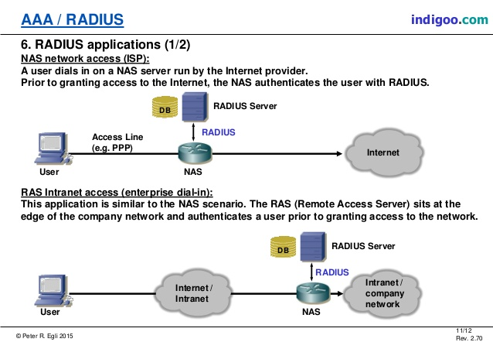
NAT | Network Address Translation | Network address translation (NAT) is a method of remapping one IP address space into another by modifying network address information in the IP header of packets while they are in transit across a traffic routing device. The technique was originally used as a shortcut to avoid the need to readdress every host when a network was moved. It has become a popular and essential tool in conserving global address space in the face of IPv4 address exhaustion. One Internet-routable IP address of a NAT gateway can be used for an entire private network.  IP masquerading is a technique that hides an entire IP address space, usually consisting of private IP addresses, behind a single IP address in another, usually public address space. The address that has to be hidden is changed into a single (public) IP address as "new" source address of the outgoing IP packet so it appears as originating not from the hidden host but from the routing device itself. Because of the popularity of this technique to conserve IPv4 address space, the term NAT has become virtually synonymous with IP masquerading.  As network address translation modifies the IP address information in packets, it has serious consequences on the quality of Internet connectivity and requires careful attention to the details of its implementation. NAT implementations vary widely in their specific behavior in various addressing cases and their effect on network traffic. The specifics of NAT behavior are not commonly documented by vendors of equipment containing NAT implementations.  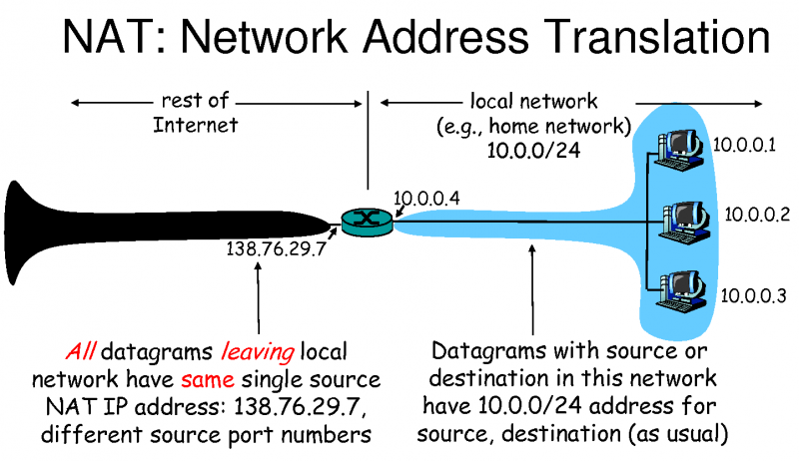
Native Risk Management |  | See intrinsic risk management.
NBAP | Node-B Application Part | In the 3GPP UTRAN architecture, NBAP (Node B Application Part) is the signalling protocol responsible for the control of the Node B by the RNC. NBAP is subdivided into Common and Dedicated NBAP (C-NBAP and D-NBAP), where Common NBAP controls overall Node B functionality, and Dedicated NBAP controls radio links to specific user equipment. NBAP forms part of the Iub interface.  NBAP handles two kind of Procedures for different NBAP functionalities Common Procedures for Managing Logical O & M Functions for Controlling BCCH Broadcast for creating new Node B Communication Context Dedicated Procedures for handling procedures of an existing Node B Communication Context in a TTP/CCP.
NCSC | National Cyber Security Centre | The National Cyber Security Centre (NCSC) is an organisation of the United Kingdom Government that provides advice and support for the public and private sector in how to avoid computer security threats. Based in London, it became operational in October 2016, and its parent organisation is GCHQ.
Network Topologies |  | Network topology is the arrangement of the elements (links, nodes, etc.) of a communication network.  Network topology is the topological[3] structure of a network and may be depicted physically or logically. It is an application of graph theory[4] wherein communicating devices are modeled as nodes and the connections between the devices are modeled as links or lines between the nodes. Physical topology is the placement of the various components of a network (e.g., device location and cable installation), while logical topology illustrates how data flows within a network. Distances between nodes, physical interconnections, transmission rates, or signal types may differ between two different networks, yet their topologies may be identical. A network’s physical topology is a particular concern of the physical layer of the OSI model. Network topology can be used to define or describe the arrangement of various types of telecommunication networks, including command and control radio networks,[4] industrial fieldbusses, and computer networks.  Examples of network typologies are found in local area networks (LAN), a common computer network installation. Any given node in the LAN has one or more physical links to other devices in the network; graphically mapping these links results in a geometric shape that can be used to describe the physical topology of the network. A wide variety of physical topologies have been used in LANs, including ring, bus, mesh and star. Conversely, mapping the data flow between the components determines the logical topology of the network. In comparison, Controller Area Networks, common in vehicles, are primarily distributed control system networks of one or more controllers interconnected with sensors and actuators over, invariably, a physical bus topology.  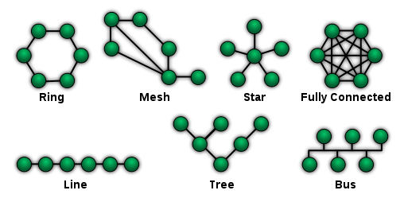
NFS | Network File System | Network File System (NFS) is a distributed file system protocol originally developed by Sun Microsystems in 1984, allowing a user on a client computer to access files over a computer network much like local storage is accessed. NFS, like many other protocols, builds on the Open Network Computing Remote Procedure Call (ONC RPC) system. The NFS is an open standard defined in Request for Comments (RFC), allowing anyone to implement the protocol.
NGN | Next Generation Networks | The next-generation network (NGN) is a body of key architectural changes in telecommunication core and access networks. The general idea behind the NGN is that one network transports all information and services (voice, data, and all sorts of media such as video) by encapsulating these into IP packets, similar to those used on the Internet. NGNs are commonly built around the Internet Protocol, and therefore the term all IP is also sometimes used to describe the transformation of formerly telephone-centric networks toward NGN.  According to ITU-T, the definition is:  A next-generation network (NGN) is a packet-based network which can provide services including Telecommunication Services and is able to make use of multiple broadband, quality of Service-enabled transport technologies and in which service-related functions are independent from underlying transport-related technologies. It offers unrestricted access by users to different service providers. It supports generalized mobility which will allow consistent and ubiquitous provision of services to users.  From a practical perspective, NGN involves three main architectural changes that need to be looked at separately:  - In the core network, NGN implies a consolidation of several (dedicated or overlay) transport networks each historically built for a different service into one core transport network (often based on IP and Ethernet). It implies amongst others the migration of voice from a circuit-switched architecture (PSTN) to VoIP, and also migration of legacy services such as X.25, frame relay (either commercial migration of the customer to a new service like IP VPN, or technical emigration by emulation of the "legacy service" on the NGN).  - In the wired access network, NGN implies the migration from the dual system of legacy voice next to xDSL setup in local exchanges to a converged setup in which the DSLAMs integrate voice ports or VoIP, making it possible to remove the voice switching infrastructure from the exchange.[2]  - In the cable access network, NGN convergence implies migration of constant bit rate voice to CableLabs PacketCable standards that provide VoIP and SIP services. Both services ride over DOCSIS as the cable data layer standard.  In an NGN, there is a more defined separation between the transport (connectivity) portion of the network and the services that run on top of that transport. This means that whenever a provider wants to enable a new service, they can do so by defining it directly at the service layer without considering the transport layer – i.e. services are independent of transport details. Increasingly applications, including voice, tend to be independent of the access network (de-layering of network and applications) and will reside more on end-user devices (phone, PC, set-top box).  Underlying technology components  Next-generation networks are based on Internet technologies including Internet Protocol (IP) and multiprotocol label switching (MPLS). At the application level, Session Initiation Protocol (SIP) seems to be taking over from ITU-T H.323.  Initially H.323 was the most popular protocol, though its popularity decreased in the "local loop" due to its original poor traversal of network address translation (NAT) and firewalls. For this reason as domestic VoIP services have been developed, SIP has been more widely adopted. However, in voice networks where everything is under the control of the network operator or telco, many of the largest carriers use H.323 as the protocol of choice in their core backbones.[citation needed] With the most recent changes introduced for H.323, it is now possible for H.323 devices to easily and consistently traverse NAT and firewall devices, opening up the possibility that H.323 may again be looked upon more favorably in cases where such devices encumbered its use previously. Nonetheless, most of the telcos are extensively researching and supporting IP Multimedia Subsystem (IMS), which gives SIP a major chance of being the most widely adopted protocol.  For voice applications one of the most important devices in NGN is a Softswitch – a programmable device that controls Voice over IP (VoIP) calls. It enables correct integration of different protocols within NGN. The most important function of the Softswitch is creating the interface to the existing telephone network, PSTN, through Signalling Gateways and Media Gateways. However, the Softswitch as a term may be defined differently by the different equipment manufacturers and have somewhat different functions.  One may quite often find the term Gatekeeper in NGN literature. This was originally a VoIP device, which converted (using gateways) voice and data from their analog or digital switched-circuit form (PSTN, SS7) to the packet-based one (IP). It controlled one or more gateways. As soon as this kind of device started using the Media Gateway Control Protocol, the name was changed to Media Gateway Controller (MGC).  A Call Agent is a general name for devices/systems controlling calls.  The IP Multimedia Subsystem (IMS) is a standardised NGN architecture for an Internet media-services capability defined by the European Telecommunications Standards Institute (ETSI) and the 3rd Generation Partnership Project (3GPP).
NGWFQ | Weighted Fair Queueing | See PWFQ  Weighted fair queueing (WFQ) is a network scheduler scheduling algorithm. WFQ is both a packet-based implementation of the generalized processor sharing (GPS) policy, and a natural extension of fair queuing (FQ). Whereas FQ shares the link's capacity in equal subparts, WFQ allows schedulers to specify, for each flow, which fraction of the capacity will be given.  Weighted fair queuing is also known as packet-by-packet GPS (PGPS or P-GPS) since it approximates generalized processor sharing "to within one packet transmission time, regardless of the arrival patterns."  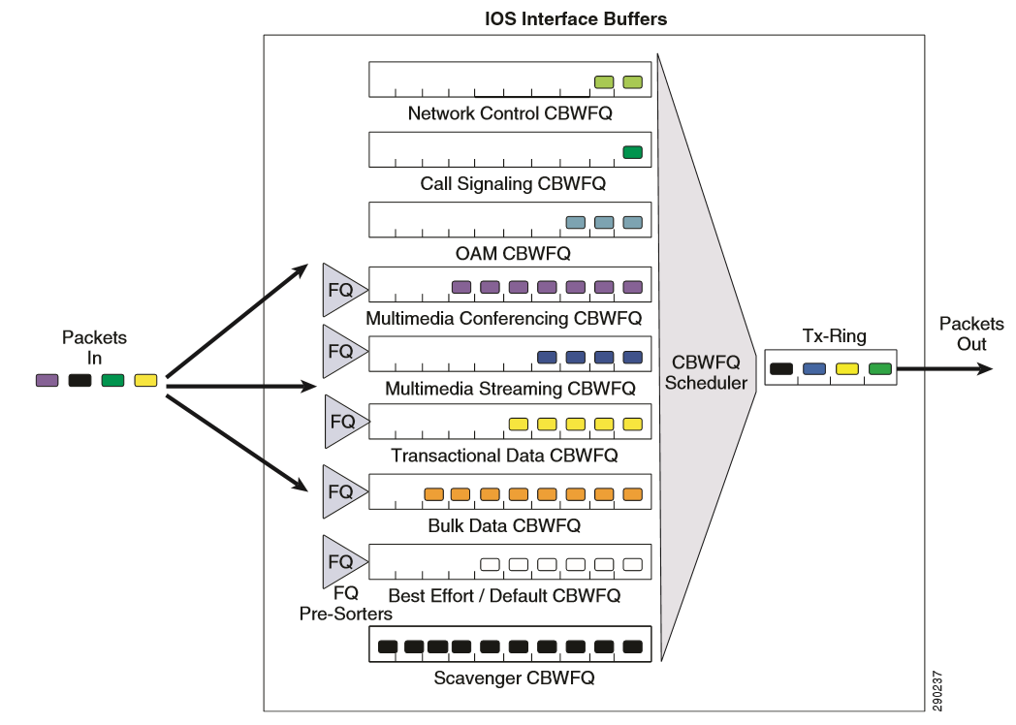
Niko-niko Calendar |  | A Niko-niko Calendar is updated daily with each team member's mood for that day. Over time the calendar reveals patterns of change in the moods of the team, or of individual members.  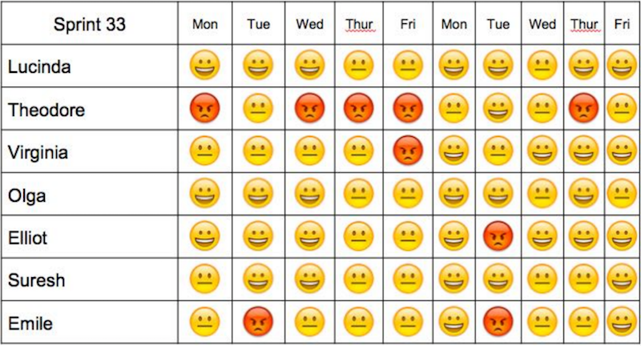
NIST | National Institute of Standards and Technology | The National Institute of Standards and Technology (NIST) is a physical sciences laboratory, and a non-regulatory agency of the United States Department of Commerce. Its mission is to promote innovation and industrial competitiveness. NIST's activities are organized into laboratory programs that include nanoscale science and technology, engineering, information technology, neutron research, material measurement, and physical measurement.
NNI | Network-to-network interface | See UNI  In telecommunications, a network-to-network interface (NNI) is an interface that specifies signalling and management functions between two networks. An NNI circuit can be used for interconnection of signalling (e.g., SS7), Internet Protocol (IP) (e.g., MPLS) or ATM networks.  In networks based on MPLS or GMPLS, NNI is used for the interconnection of core Provider Routers (class 4 or higher). In the case of GMPLS, the type of interconnection can vary across Back-to-Back, EBGP or mixed NNI connection scenarios, depending on the type of VRF exchange used for interconnection. In case of Back-to-Back, VRF is necessary to create VLANs and subsequently sub-interfaces (VLAN headers and DLCI headers for Ethernet and frame relay network packets) on each interface used for the NNI circuit. In the case of eBGP NNI interconnection, P routers are taught how to dynamically exchange VRF records without VLAN creation. NNI also can be used for interconnection of two VoIP nodes. In cases of mixed or full-mesh scenarios, other NNI types are possible.  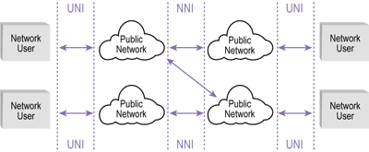
NNTP | Network News Transfer Protocol | The Network News Transfer Protocol (NNTP) is an application protocol used for transporting Usenet news articles (netnews) between news servers and for reading and posting articles by end user client applications. Brian Kantor of the University of California, San Diego and Phil Lapsley of the University of California, Berkeley wrote RFC 977, the specification for the Network News Transfer Protocol, in March 1986. Other contributors included Stan O. Barber from the Baylor College of Medicine and Erik Fair of Apple Computer.  Usenet was originally designed based on the UUCP network, with most article transfers taking place over direct point-to-point telephone links between news servers, which were powerful time-sharing systems. Readers and posters logged into these computers reading the articles directly from the local disk.  As local area networks and Internet participation proliferated, it became desirable to allow newsreaders to be run on personal computers connected to local networks. The resulting protocol was NNTP, which resembled the Simple Mail Transfer Protocol (SMTP) but was tailored for exchanging newsgroup articles.
NOC | Network Operation Centre | A network operations center (NOC, pronounced like the word knock), also known as a "network management center", is one or more locations from which network monitoring and control, or network management, is exercised over a computer, telecommunication or satellite network.
Node B |  | Node B is the telecommunications node in particular mobile communication networks, namely those that adhere to the UMTS standard. The Node B provides the connection between mobile phones (UEs) and the wider telephone network. UMTS is the dominating 3G standard.  Node B corresponds to BTS (base transceiver station) in GSM.  Functionality  This is the hardware that is connected to the mobile phone network that communicates directly with mobile handsets. In contrast with GSM base stations, Node B uses WCDMA/TD-SCDMA as the air interface technology. As in all cellular systems, such as UMTS and GSM, the Node B contains radio frequency transmitter(s) and the receiver(s) used to communicate directly with mobile devices, which move freely around it. In this type of cellular network, the mobile devices cannot communicate directly with each other but have to communicate with the NodeB.  Traditionally, the Node Bs have minimum functionality, and are controlled by an RNC (Radio Network Controller). However, this is changing with the emergence of High Speed Downlink Packet Access (HSDPA), where some logic (e.g., retransmission) is handled on the Node B for lower response times.
Nominal Path |  | Execution path for software system that performs functionality without encountering exceptional conditions.
Non-functional Requirement |  | Captures requirements such as compatibility, usability, performance, reliability, etc. Also known as the how or how well requirements
NoSQL |  | A NoSQL (originally referring to "non SQL" or "non relational") database provides a mechanism for storage and retrieval of data that is modeled in means other than the tabular relations used in relational databases. Such databases have existed since the late 1960s, but did not obtain the "NoSQL" moniker until a surge of popularity in the early twenty-first century, triggered by the needs of Web 2.0 companies. NoSQL databases are increasingly used in big data and real-time web applications. NoSQL systems are also sometimes called "Not only SQL" to emphasize that they may support SQL-like query languages.  Motivations for this approach include: simplicity of design, simpler "horizontal" scaling to clusters of machines (which is a problem for relational databases), and finer control over availability. The data structures used by NoSQL databases (e.g. key-value, wide column, graph, or document) are different from those used by default in relational databases, making some operations faster in NoSQL. The particular suitability of a given NoSQL database depends on the problem it must solve. Sometimes the data structures used by NoSQL databases are also viewed as "more flexible" than relational database tables.  Many NoSQL stores compromise consistency (in the sense of the CAP theorem) in favor of availability, partition tolerance, and speed. Barriers to the greater adoption of NoSQL stores include the use of low-level query languages (instead of SQL, for instance the lack of ability to perform ad-hoc joins across tables), lack of standardized interfaces, and huge previous investments in existing relational databases.[ Most NoSQL stores lack true ACID transactions, although a few databases, such as MarkLogic, Aerospike, FairCom c-treeACE, Google Spanner (though technically a NewSQL database), Symas LMDB, and OrientDB have made them central to their designs. (See ACID and join support.)  Instead, most NoSQL databases offer a concept of "eventual consistency" in which database changes are propagated to all nodes "eventually" (typically within milliseconds) so queries for data might not return updated data immediately or might result in reading data that is not accurate, a problem known as stale reads. Additionally, some NoSQL systems may exhibit lost writes and other forms of data loss. Some NoSQL systems provide concepts such as write-ahead logging to avoid data loss. For distributed transaction processing across multiple databases, data consistency is an even bigger challenge that is difficult for both NoSQL and relational databases. Even current relational databases "do not allow referential integrity constraints to span databases." There are few systems that maintain both ACID transactions and X/Open XA standards for distributed transaction processing.
NPE | Network Provider Edge | A Provider Edge router (PE router) is a router between one network service provider's area and areas administered by other network providers. A network provider is usually an Internet service provider as well (or only that).#  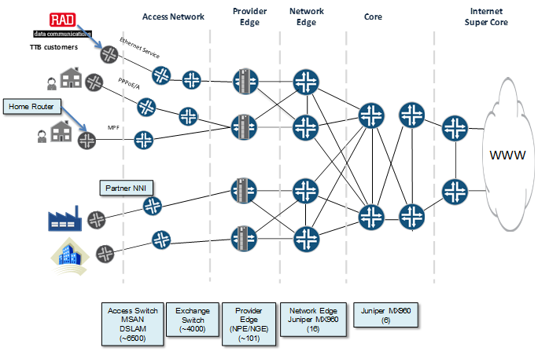
NSS | Network switching subsystem | Network switching subsystem (NSS) (or GSM core network) is the component of a GSM system that carries out call out and mobility management functions for mobile phones roaming on the network of base stations. It is owned and deployed by mobile phone operators and allows mobile devices to communicate with each other and telephones in the wider public switched telephone network4g LET(PSTN). The architecture contains specific features and functions which are needed because the phones are not fixed in one location.  The NSS originally consisted of the circuit-switched core network, used for traditional GSM services such as voice calls, SMS, and circuit switched data calls. It was extended with an overlay architecture to provide packet-switched data services known as the GPRS core network. This allows mobile phones to have access to services such as WAP, MMS and the Internet.  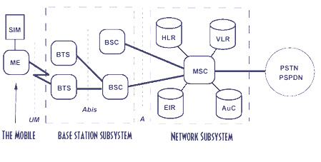
NTP | Network Time Protocol | Network Time Protocol (NTP) is a networking protocol for clock synchronization between computer systems over packet-switched, variable-latency data networks. In operation since before 1985, NTP is one of the oldest Internet protocols in current use. NTP was designed by David L. Mills of the University of Delaware.  NTP is intended to synchronize all participating computers to within a few milliseconds of Coordinated Universal Time (UTC).[1]:3 It uses the intersection algorithm, a modified version of Marzullo's algorithm, to select accurate time servers and is designed to mitigate the effects of variable network latency. NTP can usually maintain time to within tens of milliseconds over the public Internet, and can achieve better than one millisecond accuracy in local area networks under ideal conditions. Asymmetric routes and network congestion can cause errors of 100 ms or more
NTS | Number Translation Service | A number translation service translates a dialled telephone number, typically beginning 08 in the UK to a geographical 'connect number' beginning 01 or 02 in the UK. The connect number may be changed without changing the published dialled number. Originally NTS numbers were used, for example, to allow any caller to dial a local call to the called party irrespective of location, saving money if the connect number was not also a local call, but the system gradually came to be seen as a way of making money and now most phone companies charge the caller more for 08 numbers than for 01, 02 or 03 numbers.
NTU | Network Termination Unit | Point between user and operator network  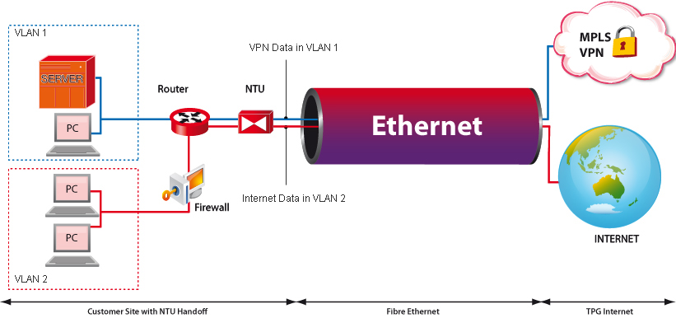
NTU | Network Termination Unit | In telecommunications, a network interface device (NID; also known by several other names) is a device that serves as the demarcation point between the carrier's local loop and the customer's premises wiring. Outdoor telephone NIDs also provide the subscriber with access to the station wiring and serve as a convenient test point for verification of loop integrity and of the subscriber’s inside wiring.
NYB | Not Yet Built data | Royal Mail Not Yet Built data

O
Objective C |  | Objective-C is a general-purpose, object-oriented programming language that adds Smalltalk-style messaging to the C programming language. It was the main programming language used by Apple for the OS X and iOS operating systems, and their respective application programming interfaces (APIs) Cocoa and Cocoa Touch prior to the introduction of Swift.
Objectives |  | Synonym for goals.
ODF | Optical Distribution Frame | In telecommunications, a distribution frame is a passive device which terminates cables, allowing arbitrary interconnections to be made.
OFC | Optical fiber connector | An optical fiber connector terminates the end of an optical fiber, and enables quicker connection and disconnection than splicing. The connectors mechanically couple and align the cores of fibers so light can pass. Better connectors lose very little light due to reflection or misalignment of the fibers. In all, about 100 different types of fiber optic connectors have been introduced to the market.  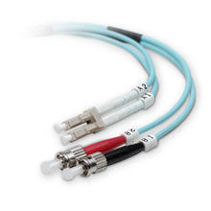
Ofcom |  | The Office of Communications, commonly known as Ofcom, is the UK government-approved regulatory and competition authority for the broadcasting, telecommunications and postal industries of the United Kingdom.  Ofcom has wide-ranging powers across the television, radio, telecoms and postal sectors. It has a statutory duty to represent the interests of citizens and consumers by promoting competition and protecting the public from harmful or offensive material.  Some of the main areas Ofcom presides over are licensing, research, codes and policies, complaints, competition and protecting the radio spectrum from abuse (e.g. pirate radio stations).  The regulator was initially established by the Office of Communications Act 2002 and received its full authority from the Communications Act 2003.
OFDMA | Orthogonal frequency-division multiple access | Orthogonal frequency-division multiple access (OFDMA) is a multi-user version of the popular orthogonal frequency-division multiplexing (OFDM) digital modulation scheme. Multiple access is achieved in OFDMA by assigning subsets of subcarriers to individual users. This allows simultaneous low-data-rate transmission from several users
OO | Object-oriented | Object-oriented programming (OOP) is a programming paradigm based on the concept of "objects", which may contain data, in the form of fields, often known as attributes; and code, in the form of procedures, often known as methods. A feature of objects is that an object's procedures can access and often modify the data fields of the object with which they are associated (objects have a notion of "this" or "self"). In OOP, computer programs are designed by making them out of objects that interact with one another. There is significant diversity of OOP languages, but the most popular ones are class-based, meaning that objects are instances of classes, which typically also determine their type.  Many of the most widely-used programming languages (such as C++, Object Pascal, Java, Python etc.) are multi-paradigm programming languages that support object-oriented programming to a greater or lesser degree, typically in combination with imperative, procedural programming. Significant object-oriented languages include Java, C++, C#, Python, PHP, Ruby, Perl, Object Pascal, Objective-C, Dart, Swift, Scala, Common Lisp, and Smalltalk.
Operations Plan |  | A plan specifying how a system will be utilized after deployment along with other information such as roles, responsibilities, maintenance schedules, etc.
OPUS |  | Opus is a lossy audio coding format developed by the Xiph.Org Foundation and standardized by the Internet Engineering Task Force, designed to efficiently code speech and general audio in a single format, while remaining low-latency enough for real-time interactive communication and low-complexity enough for low-end embedded processors. Opus replaces both Vorbis and Speex for new applications, and several blind listening tests have ranked it higher-quality than any other standard audio format at any given bitrate until transparency is reached, including MP3, AAC, and HE-AAC.  Opus combines the speech-oriented linear predictive coding SILK algorithm and the lower-latency, MDCT-based CELT algorithm, switching between or combining them as needed for maximal efficiency. Bitrate, audio bandwidth, complexity, and algorithm can all be adjusted seamlessly in each frame. Opus has the low algorithmic delay (26.5 ms by default) necessary for use as part of a real-time communication link, permitting natural conversation, networked music performances, and live lip sync; by trading-off quality or bitrate, the delay can be reduced down to 5 ms. Its delay is exceptionally low compared to competing codecs, which require well over 100 ms, yet Opus performs very competitively with these formats in terms of quality per bitrate
OS X |  | macOS (previously Mac OS X and later OS X) is a series of graphical operating systems developed and marketed by Apple Inc. since 2001. It is the primary operating system for Apple's Mac family of computers. Within the market of desktop, laptop and home computers, and by web usage, it is the second most widely used desktop OS, after Microsoft Windows.  macOS is the second major series of Macintosh operating systems. The first is colloquially called the "classic" Mac OS, which was introduced in 1984, and the final release of which was Mac OS 9 in 1999. The first desktop version, Mac OS X 10.0, was released in March 2001, with its first update, 10.1, arriving later that year. After this, Apple began naming its releases after big cats, which lasted until OS X 10.8 Mountain Lion. Since OS X 10.9 Mavericks, releases have been named after landmarks in California. Apple shortened the name to "OS X" in 2012 and then changed it to "macOS" in 2016, adopting the nomenclature that they were using for their other operating systems, iOS, watchOS, and tvOS. The latest version is macOS High Sierra, which was publicly released in September 2017.
OSA-FC | Optical Spectrum Access Filter Connect | Openreach virtual dark fibre service that provides CPs all the key benefits of dark fibre – like the freedom to control and increase bandwidth usage at no extra cost – without compromising on service and maintenance levels.  It works by enabling CPs to operate their own network electronics on top of a managed connection which Openreach can monitor 24/7 and provide rapid response and repair times over.  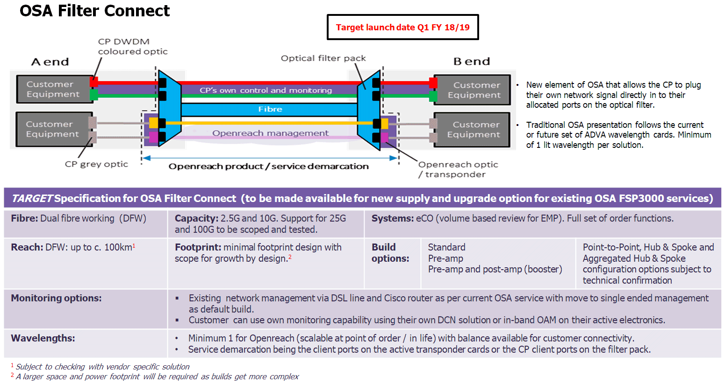
OSPF | Open Shortest Path First | Open Shortest Path First (OSPF) is a routing protocol for Internet Protocol (IP) networks. It uses a link state routing (LSR) algorithm and falls into the group of interior gateway protocols (IGPs), operating within a single autonomous system (AS). It is defined as OSPF Version 2 in RFC 2328 (1998) for IPv4. The updates for IPv6 are specified as OSPF Version 3 in RFC 5340 (2008). OSPF supports the Classless Inter-Domain Routing (CIDR) addressing model.  OSPF is a widely used IGP in large enterprise networks. IS-IS, another LSR-based protocol, is more common in large service provider networks.
OSS | Operations support systems | Operations support systems (OSS), or operational support systems in British usage, are computer systems used by telecommunications service providers to manage their networks (e.g., telephone networks). They support management functions such as network inventory, service provisioning, network configuration and fault management.  Together with business support systems (BSS), they are used to support various end-to-end telecommunication services. BSS and OSS have their own data and service responsibilities. The two systems together are often abbreviated OSS/BSS, BSS/OSS or simply B/OSS.  The abbreviation OSS is also used in a singular form to refer to all the Operations Support Systems viewed as a whole system.  Different subdivisions of OSS have been proposed by the TM Forum, industrial research labs or OSS vendors. In general, an OSS covers at least the following five functions:  - Network management systems  - Service delivery  - Service fulfillment, including the network inventory, activation and provisioning  - Service assurance  - Customer care  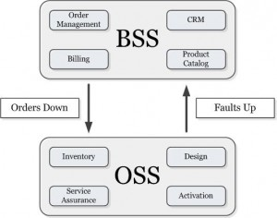
OTN | Optical Transport Network | ITU-T defines an Optical Transport Network (OTN) as a set of Optical Network Elements (ONE) connected by optical fiber links, able to provide functionality of transport, multiplexing, switching, management, supervision and survivability of optical channels carrying client signals.
Out-of-order delivery |  | In computer networking, out-of-order delivery is the delivery of data packets in a different order from which they were sent. Out-of-order delivery can be caused by packets following multiple paths through a network, or via parallel processing paths within network equipment that are not designed to ensure that packet ordering is preserved. One of the functions of TCP is to prevent the out-of-order delivery of data, either by reassembling packets into order or forcing retries of out-of-order packets.  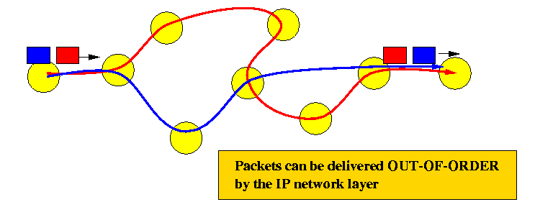
Overlap Dialling |  | Overlap dialing is required by CAS signaled lines. Overlap dial provides for a longer time-out period between digits, also called the inter-digit timer. With overlap dial set to off, the gateway expects to receive the digits one right after the other coming in to this line with very little delay between digits. With overlap dial set to on, then the device waits up to about 2 seconds between digits.  Basically overlap dialing is a mechanism where a destination number can be specified partially to complete the first stage of a routing path. For example, if the number was “23168104”, it may be possible for the telecom to dial “23168” to reach the first port of call as quickly as possible (to save time on sending the remaining 3 digits) and then deliver the remaining 3 digits “104” in overlap mode.

P
PaaS | Platform As A Service | Platform as a Service (PaaS) or Application Platform as a Service (aPaaS) or platform-based service is a category of cloud computing services that provides a platform allowing customers to develop, run, and manage applications without the complexity of building and maintaining the infrastructure typically associated with developing and launching an app
packet sniffing |  | A packet analyzer (also known as a packet sniffer) is a computer program or piece of computer hardware (such as a packet capture appliance) that can intercept and log traffic that passes over a digital network or part of a network. Packet capture is the process of intercepting and logging traffic. As data streams flow across the network, the sniffer captures each packet and, if needed, decodes the packet's raw data, showing the values of various fields in the packet, and analyzes its content according to the appropriate RFC or other specifications.  A packet analyzer used for intercepting traffic on wireless networks is known as a wireless analyzer or WiFi analyzer. A packet analyzer can also be referred to as a network analyzer or protocol analyzer though these terms also have other meanings.  Capabilities  On wired shared medias networks, such as Ethernet, Token Ring, and FDDI networks, depending on the network structure (hub or switch), it may be possible to capture all traffic on the network from a single machine on the network. On modern networks, traffic can be captured using a network switch with a so-called monitoring port that mirrors all packets that pass through designated ports of the switch. A network tap is an even more reliable solution than to use a monitoring port, since taps are less likely to drop packets during high traffic load.  On wireless LANs, traffic can be captured on one channel at a time, or by using multiple adapters, on several channels simultaneously.  On wired broadcast and wireless LANs, to capture unicast traffic between other machines, the network adapter capturing the traffic must be in promiscuous mode. On wireless LANs, even if the adapter is in promiscuous mode, packets not for the service set the adapter is configured for are usually ignored. To see those packets, the adapter must be in monitor mode. No special provisions are required to capture multicast traffic to a multicast group the packet analyzer is already monitoring, or broadcast traffic.  When traffic is captured, either the entire contents of packets are recorded, or just the headers are recorded. Recording just headers reduces storage requirements, and avoids some legal issues, yet often provides sufficient information to diagnose problems.  Captured information is decoded from raw digital form into a human-readable format that lets users easily review exchanged information. Protocol analyzers vary in their abilities to display and analyze data.  Some protocol analyzers can also generate traffic and thus act as the reference device. These can act as protocol testers. Such testers generate protocol-correct traffic for functional testing, and may also have the ability to deliberately introduce errors to test the DUT's ability to handle errors.  Protocol analyzers can also be hardware-based, either in probe format or, as is increasingly common, combined with a disk array. These devices record packets (or a slice of the packet) to a disk array. This allows historical forensic analysis of packets without users having to recreate any fault.
Packet Switched |  | Packet switching is a method of grouping data which is transmitted over a digital network into packets which are made of a header and a payload. Data in the header is used by networking hardware to direct the packet to its destination where the payload is extracted and used by application software. Packet switching is the primary basis for data communications in computer networks worldwide.  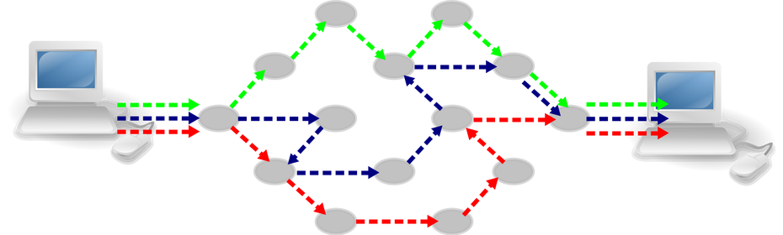
PAF | Postal Address File | Royal Mail Postal Address File data
Pair Programming |  | Pair programming consists of two programmers sharing a single workstation (one screen, keyboard and mouse among the pair).
PAP | Password Authentication Protocol | Password Authentication Protocol (PAP) is a password-based authentication protocol used by Point to Point Protocol (PPP) to validate users. Almost all network operating system remote servers support PAP.  PAP is considered a weak authentication scheme (weak schemes are simple and have lighter computational overhead but are much more vulnerable to attack; while weak schemes may have limited application in some constrained environments, they are avoided in general). Among PAP's deficiencies is the fact that it transmits unencrypted passwords over the network. PAP is therefore used only as a last resort when the remote server does not support a stronger scheme such as CHAP or EAP  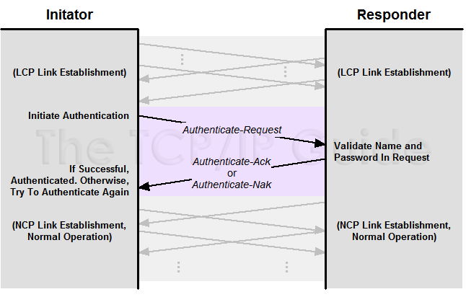
Parametric Estimation |  | Estimation using an algorithmic model, normally as part of a software tool. Models work by taking input factors and calculating outputs with algorithms based on historical data.
Pascal |  | Pascal is an imperative and procedural programming language, which Niklaus Wirth designed in 1968–69 and published in 1970, as a small, efficient language intended to encourage good programming practices using structured programming and data structuring. It is named in honor of the French mathematician, philosopher and physicist Blaise Pascal.  Pascal was developed on the pattern of the ALGOL 60 language. Wirth had already developed several improvements to this language as part of the ALGOL X proposals, but these were not accepted and Pascal was developed separately and released in 1970. A derivative known as Object Pascal designed for object-oriented programming was developed in 1985; this was used by Apple Computer and Borland in the late 1980s and later developed into Delphi on the Microsoft Windows platform. Extensions to the Pascal concepts led to the Pascal-like languages Modula-2 and Oberon
Pattern | CxPattern | CxOne pattern material type. A predefined model or template used to create an artifact or accomplish a goal. See CxOneOverview for description.
PCM | Pulse-code modulation | Pulse-code modulation (PCM) is a method used to digitally represent sampled analog signals. It is the standard form of digital audio in computers, compact discs, digital telephony and other digital audio applications. In a PCM stream, the amplitude of the analog signal is sampled regularly at uniform intervals, and each sample is quantized to the nearest value within a range of digital steps.  Linear pulse-code modulation (LPCM) is a specific type of PCM where the quantization levels are linearly uniform. This is in contrast to PCM encodings where quantization levels vary as a function of amplitude (as with the A-law algorithm or the μ-law algorithm). Though PCM is a more general term, it is often used to describe data encoded as LPCM.  A PCM stream has two basic properties that determine the stream's fidelity to the original analog signal: the sampling rate, which is the number of times per second that samples are taken; and the bit depth, which determines the number of possible digital values that can be used to represent each sample.
PCP | Primary Connection Point | Part of the line plant, in the form of a metal cabinet at the roadside, that enables flexibility between the main cables from the exchange and the smaller cables to individual streets or premises, also known as a Cabinet, or Cab" "Primary Cross-connection Point - this is the local street cabinet in which cables extending out to local distribution points are aggregated and connected to larger copper and fibre optic cables to move the voice and data signals to and from the local exchange  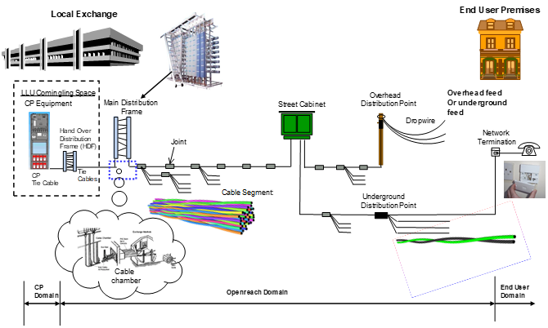
PCRF | Policy and Charging Rules Function | Policy and Charging Rules Function (PCRF) is the software node designated in real-time to determine policy rules in a multimedia network. As a policy tool, the PCRF plays a central role in next-generation networks. Unlike earlier policy engines that were added onto an existing network to enforce policy, the PCRF is a software component that operates at the network core and accesses subscriber databases and other specialized functions, such as a charging system, in a centralized manner. Because it operates in real time, the PCRF has an increased strategic significance and broader potential role than traditional policy engines. This has led to a proliferation of PCRF products since 2008.  The PCRF is the part of the network architecture that aggregates information to and from the network, operational support systems, and other sources (such as portals) in real time, supporting the creation of rules and then automatically making policy decisions for each subscriber active on the network. Such a network might offer multiple services, quality of service (QoS) levels, and charging rules. PCRF can provide a network agnostic solution (wire line and wireless) and can also enable multi-dimensional approach which helps in creating a lucrative and innovative platform for operators. PCRF can also be integrated with different platforms like billing, rating, charging, and subscriber database or can also be deployed as a standalone entity.  PCRF plays a key role in VoLTE as a mediator of network resources for the IP Multimedia Systems network for establishing the calls and allocating the requested bandwidth to the call bearer with configured attributes.
PCS | Physical Coding Sub-layer | The Physical Coding Sublayer (PCS) is a networking protocol sublayer in the Fast Ethernet, Gigabit Ethernet, and 10 Gigabit Ethernet standards. It resides at the top of the physical layer (PHY), and provides an interface between the Physical Medium Attachment (PMA) sublayer and the Media Independent Interface (MII). It is responsible for data encoding and decoding, scrambling and descrambling, alignment marker insertion and removal, block and symbol redistribution, and lane block synchronization and deskew.
PDCP | Packet Data Convergence Protocol | PDCP is an abbreviation for Packet Data Convergence Protocol. This protocol is specified by 3GPP in TS 25.323 for UMTS, TS 36.323 for LTE and TS 38.323 for 5G New Radio [NR). The PDCP is located in the Radio Protocol Stack in the UMTS/LTE/5G Air interface on top of the RLC layer.  PDCP provides its services to the RRC and user plane upper layers, e.g. IP at the UE or to the relay at the base station.
PDH | plesiochronous digital hierarchy | The plesiochronous digital hierarchy (PDH) is a technology used in telecommunications networks to transport large quantities of data over digital transport equipment such as fibre optic and microwave radio systems. The term plesiochronous is derived from Greek plēsios, meaning near, and chronos, time, and refers to the fact that PDH networks run in a state where different parts of the network are nearly, but not quite perfectly, synchronized.  Backbone transport networks replaced PDH networks with synchronous digital hierarchy (SDH) or synchronous optical networking (SONET) equipment over the ten years ending around the turn of the millennium (2000), whose floating payloads relaxed the more stringent timing requirements of PDH network technology.  PDH allows transmission of data streams that are nominally running at the same rate, but allowing some variation on the speed around a nominal rate. By analogy, any two watches are nominally running at the same rate, clocking up 60 seconds every minute. However, there is no link between watches to guarantee that they run at exactly the same rate, and it is highly likely that one is running slightly faster than the other.
PDU | Protocol Data Unit | In telecommunications, a protocol data unit (PDU) is information that is transmitted as a single unit among peer entities of a computer network. A PDU may contain user data or control information and network addressing. In layered architectures of communication protocol stacks, each layer implements protocols tailored to the specific type or mode of data exchange, or network function of the layer. For example, the Transmission Control Protocol (TCP) implements a connection-oriented transfer mode, and the PDU of this protocol is called a segment, while the User Datagram Protocol (UDP) uses datagrams as protocol data unit for connection-less transfer. A layer lower in the Internet Protocol Suite, at the Internet Layer, the PDU is called a packet, irrespective of its payload type.  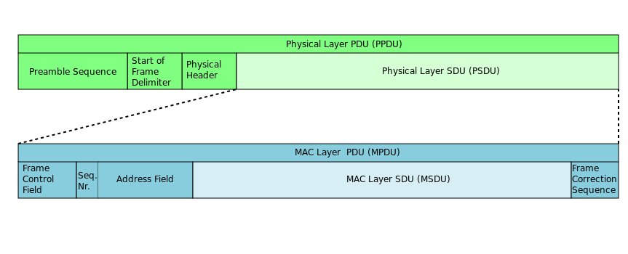
PEAP | Protected Extensible Authentication Protocol | The Protected Extensible Authentication Protocol, also known as Protected EAP or simply PEAP, is a protocol that encapsulates the Extensible Authentication Protocol (EAP) within an encrypted and authenticated Transport Layer Security (TLS) tunnel. The purpose was to correct deficiencies in EAP; EAP assumed a protected communication channel, such as that provided by physical security, so facilities for protection of the EAP conversation were not provided.  PEAP was jointly developed by Cisco Systems, Microsoft, and RSA Security. PEAPv0 was the version included with Microsoft Windows XP and was nominally defined in draft-kamath-pppext-peapv0-00. PEAPv1 and PEAPv2 were defined in different versions of draft-josefsson-pppext-eap-tls-eap. PEAPv1 was defined in draft-josefsson-pppext-eap-tls-eap-00 through draft-josefsson-pppext-eap-tls-eap-05, and PEAPv2 was defined in versions beginning with draft-josefsson-pppext-eap-tls-eap-06.  The protocol only specifies chaining multiple EAP mechanisms and not any specific method. However, use of the EAP-MSCHAPv2 and EAP-GTC methods are the most commonly supported  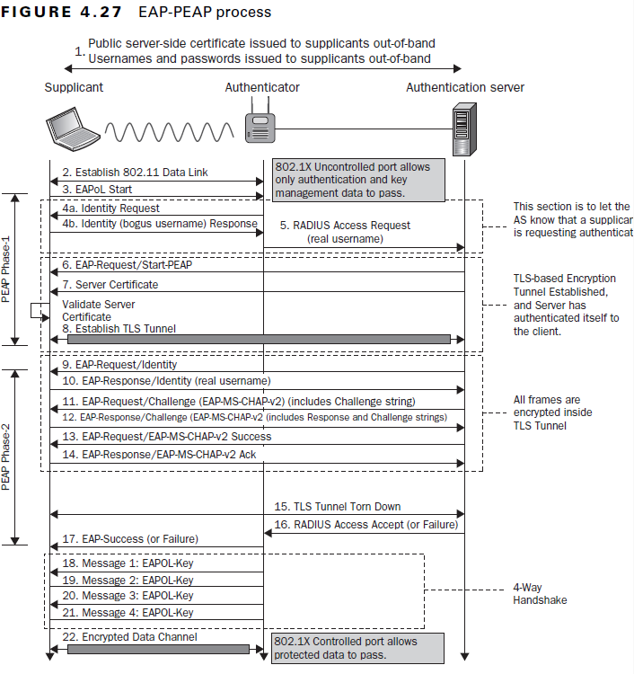
peer review |  | a process used for checking the work performed by one's equals (peers) to ensure it meets specific criteria.
Pen testing | Penetration Testing | A penetration test, colloquially known as a pen test, is an authorized simulated attack on a computer system, performed to evaluate the security of the system. The test is performed to identify both weaknesses (also referred to as vulnerabilities), including the potential for unauthorized parties to gain access to the system's features and data, as well as strengths, enabling a full risk assessment to be completed.  The process typically identifies the target systems and a particular goal—then reviews available information and undertakes various means to attain the goal. A penetration test target may be a white box (which provides background and system information) or black box (which provides only basic or no information except the company name). A penetration test can help determine whether a system is vulnerable to attack if the defenses were sufficient, and which defenses (if any) the test defeated.  Security issues that the penetration test uncovers should be reported to the system owner. Penetration test reports may also assess potential impacts to the organization and suggest countermeasures to reduce risk.  The goals of a penetration test vary depending on the type of approved activity for any given engagement with the primary goal focused on finding vulnerabilities that could be exploited by a nefarious actor and informing the client of those vulnerabilities along with recommended mitigation strategies.  Penetration tests are a component of a full security audit. For example, the Payment Card Industry Data Security Standard requires penetration testing on a regular schedule, and after system changes.  Flaw hypothesis methodology is a systems analysis and penetration prediction technique where a list of hypothesized flaws in a software system are compiled through analysis of the specifications and documentation for the system. The list of hypothesized flaws is then prioritized on the basis of the estimated probability that a flaw actually exists, and on the ease of exploiting it to the extent of control or compromise. The prioritized list is used to direct the actual testing of the system.
PER | Packed Encoding Rules | Packed Encoding Rules (PER) are ASN.1 encoding rules for producing a compact transfer syntax for data structures described in ASN.1, defined in 1994.  This Recommendation or International Standard describes a set of encoding rules that can be applied to values of all ASN.1 types to achieve a much more compact representation than that achieved by the BER and its derivatives (described in ITU-T Rec. X.690 | ISO/IEC 8825-1).  It uses additional information, such as the lower and upper limits for numeric values, from the ASN.1 specification to represent the data units using the minimum number of bits. The compactness requires that the decoder knows the complete abstract syntax of the data structure to be decoded, however.  There are two variations of packed encoding rules: unaligned and aligned. With the unaligned encoding, the bits are packed with no regard for octet (byte) boundaries. With aligned encoding, certain types of data structures are aligned on octet boundaries, meaning there may be some number of wasted padding bits. Unaligned encoding uses the least number of bits, but presumably at some cost in processing time.
Performance |  | May be used to describe the combination of feature and quality a system has (or that a project delivers).  Also used in relation to the level of support for various non-functional system requirements such as speed, resource usage, reliability, availability, etc.
Perl |  | Perl is a family of two high-level, general-purpose, interpreted, dynamic programming languages, Perl 5 and Perl 6.  Though Perl is not officially an acronym, there are various backronyms in use, including "Practical Extraction and Reporting Language". Perl was originally developed by Larry Wall in 1987 as a general-purpose Unix scripting language to make report processing easier. Since then, it has undergone many changes and revisions. Perl 6, which began as a redesign of Perl 5 in 2000, eventually evolved into a separate language. Both languages continue to be developed independently by different development teams and liberally borrow ideas from one another.  The Perl languages borrow features from other programming languages including C, shell script (sh), AWK, and sed; Wall also alludes to Basic and Lisp in the introduction to Learning Perl (Schwartz & Christiansen) and so on. They provide text processing facilities without the arbitrary data-length limits of many contemporary Unix commandline tools, facilitating manipulation of text files. Perl 5 gained widespread popularity in the late 1990s as a CGI scripting language, in part due to its then unsurpassed regular expression and string parsing abilities.
Personas |  | Personas are synthetic biographies of fictitious users of the future product.
Perspective |  | During an inspection, an assigned focus used to increase the likelihood that each inspector will find unique issues or to focus attention an particular aspects of an artifact.
PERT chart |  | The program (or project) evaluation and review technique, commonly abbreviated PERT, is a statistical tool, used in project management, which was designed to analyze and represent the tasks involved in completing a given project.  First developed by the United States Navy in the 1950s, it is commonly used in conjunction with the critical path method (CPM).  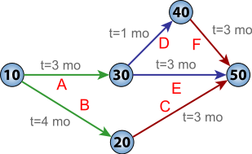
PGP | Pretty Good Privacy | Pretty Good Privacy (PGP) is an encryption program that provides cryptographic privacy and authentication for data communication. PGP is used for signing, encrypting, and decrypting texts, e-mails, files, directories, and whole disk partitions and to increase the security of e-mail communications. Phil Zimmermann developed PGP in 1991.  PGP and similar software follow the OpenPGP standard (RFC 4880) for encrypting and decrypting data.  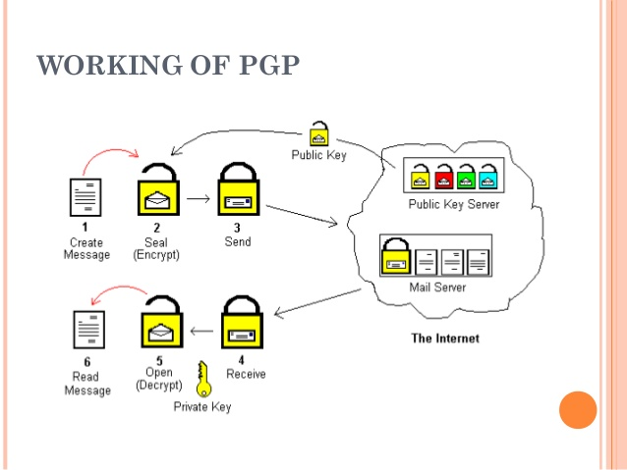
PGW | Packet Data Network Gateway | The PDN Gateway provides connectivity from the UE to external packet data networks by being the point of exit and entry of traffic for the UE. A UE may have simultaneous connectivity with more than one PGW for accessing multiple PDNs. The PGW performs policy enforcement, packet filtering for each user, charging support, lawful interception and packet screening. Another key role of the PGW is to act as the anchor for mobility between 3GPP and non-3GPP technologies such as WiMAX and 3GPP2 (CDMA 1X and EvDO).
Phase |  | A translation of a group of activities onto a portion of a lifecycle or a period of time defined by a schedule. Often used in conjunction with denoting a major transition in project activities or lifecycle processes.  Sometimes used as a synonym for stage. Sometimes used (incorrectly) as a synonym for milestone.
Phased Estimation |  | The practice of creating estimates throughout a project’s lifecycle, utilizing groups of estimation techniques optimized for each lifecycle phase.
PHP |  | PHP: Hypertext Preprocessor (or simply PHP) is a server-side scripting language designed for Web development, but also used as a general-purpose programming language. It was originally created by Rasmus Lerdorf in 1994, the PHP reference implementation is now produced by The PHP Group.[6] PHP originally stood for Personal Home Page, but it now stands for the recursive acronym PHP: Hypertext Preprocessor.  PHP code may be embedded into HTML code, or it can be used in combination with various web template systems, web content management systems, and web frameworks. PHP code is usually processed by a PHP interpreter implemented as a module in the web server or as a Common Gateway Interface (CGI) executable. The web server combines the results of the interpreted and executed PHP code, which may be any type of data, including images, with the generated web page. PHP code may also be executed with a command-line interface (CLI) and can be used to implement standalone graphical applications.  The standard PHP interpreter, powered by the Zend Engine, is free software released under the PHP License. PHP has been widely ported and can be deployed on most web servers on almost every operating system and platform, free of charge.  The PHP language evolved without a written formal specification or standard until 2014, with the original implementation acting as the de facto standard which other implementations aimed to follow. Since 2014 work has gone on to create a formal PHP specification.
Planning and Tracking Lead | PTL | Directs overall flow of technical work on the project. Directly responsible for project planning and overseeing the execution of work breakdown, estimation, scheduling, and tracking.
Planning Poker |  | An approach to estimation used by Agile teams. Each team member "plays" a card bearing a numerical value corresponding to a point estimation for a user story.
PLL | Phase Locked Loop | A phase-locked loop or phase lock loop abbreviated as PLL is a control system that generates an output signal whose phase is related to the phase of an input signal. There are several different types; the simplest is an electronic circuit consisting of a variable frequency oscillator and a phase detector in a feedback loop. The oscillator generates a periodic signal, and the phase detector compares the phase of that signal with the phase of the input periodic signal, adjusting the oscillator to keep the phases matched.  Keeping the input and output phase in lock step also implies keeping the input and output frequencies the same. Consequently, in addition to synchronizing signals, a phase-locked loop can track an input frequency, or it can generate a frequency that is a multiple of the input frequency. These properties are used for computer clock synchronization, demodulation, and frequency synthesis.  Phase-locked loops are widely employed in radio, telecommunications, computers and other electronic applications. They can be used to demodulate a signal, recover a signal from a noisy communication channel, generate a stable frequency at multiples of an input frequency (frequency synthesis), or distribute precisely timed clock pulses in digital logic circuits such as microprocessors. Since a single integrated circuit can provide a complete phase-locked-loop building block, the technique is widely used in modern electronic devices, with output frequencies from a fraction of a hertz up to many gigahertz.
PNT | Pointer data | OSNI Pointer data
Pointer |  | Reference to material outside of CxOne, usually captured in a CxRef file. Compare to link.
Points |  | (estimates in) Agile teams generally prefer to express estimates in units other than the time-honored "man-hours." Possibly the most widespread unit is "story points."
polymorphism |  | from the Greek meaning "having multiple forms," the characteristic of being able to assign a different meaning or usage to something in different contexts - specifically, to allow an entity such as a variable, a function, or an object to have more than one form.
POP | Point Of Presence | A point of presence (PoP) is an artificial demarcation point or interface point between communicating entities.  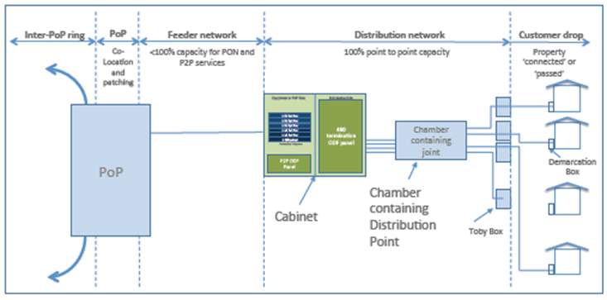
portability |  | a characteristic attributed to a computer program if it can be used in an operating systems other than the one in which it was created without requiring major rework.
POSIX |  | The Portable Operating System Interface (POSIX) is a family of standards specified by the IEEE Computer Society for maintaining compatibility between operating systems. POSIX defines the application programming interface (API), along with command line shells and utility interfaces, for software compatibility with variants of Unix and other operating systems.
Postmortem |  | A phase at the end of a software project during which project team members evaluate the project and learn lessons that can be applied to the next project. "Postmortem" also refers to the report created during the postmortem phase.
POTS | Plain Old Telephone Service or  Plain Ordinary Telephone Service | POTS is a retronym for voice-grade telephone service employing analog signal transmission over copper loops  See FXO & FXS  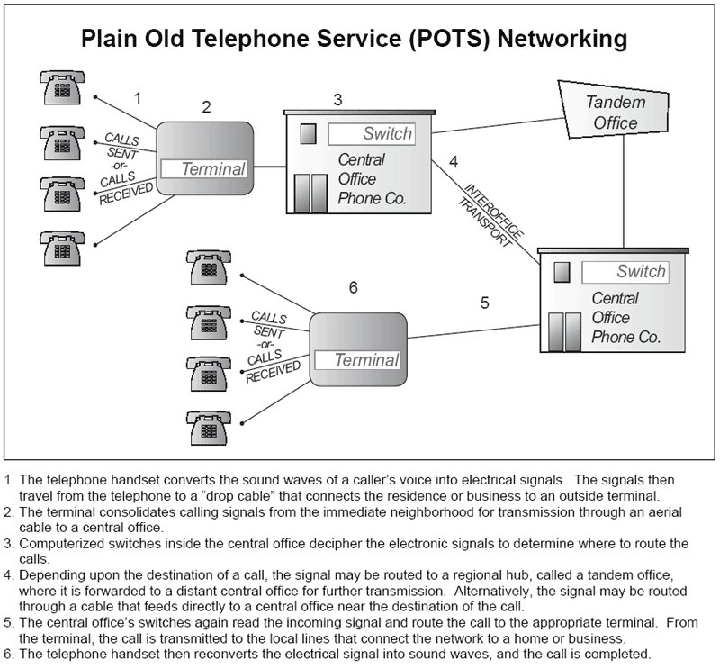
PPP | Point-to-Point Protocol | In computer networking, Point-to-Point Protocol (PPP) is a data link layer (layer 2) communications protocol used to establish a direct connection between two nodes. It connects two routers directly without any host or any other networking device in between. It can provide connection authentication, transmission encryption,[1] and compression.  PPP is used over many types of physical networks including serial cable, phone line, trunk line, cellular telephone, specialized radio links, and fiber optic links such as SONET. Internet service providers (ISPs) have used PPP for customer dial-up access to the Internet, since IP packets cannot be transmitted over a modem line on their own, without some data link protocol.  Two derivatives of PPP, Point-to-Point Protocol over Ethernet (PPPoE) and Point-to-Point Protocol over ATM (PPPoA), are used most commonly by Internet Service Providers (ISPs) to establish a Digital Subscriber Line (DSL) Internet service connection with customers.
PPPoE | PPP over Ethernet | The Point-to-Point Protocol over Ethernet (PPPoE) is a network protocol for encapsulating PPP frames inside Ethernet frames. It appeared in 1999, in the context of the boom of DSL as the solution for tunneling packets over the DSL connection to the ISP's IP network, and from there to the rest of the Internet. A 2005 networking book noted that "Most DSL providers use PPPoE, which provides authentication, encryption, and compression." Typical use of PPPoE involves leveraging the PPP facilities for authenticating the user with a username and password, predominately via the PAP protocol and less often via CHAP.
PPTP | Point-to-Point Tunneling Protocol | The Point-to-Point Tunneling Protocol (PPTP) is an obsolete method for implementing virtual private networks, with many known security issues. PPTP uses a TCP control channel and a Generic Routing Encapsulation tunnel to encapsulate PPP packets.  The PPTP specification does not describe encryption or authentication features and relies on the Point-to-Point Protocol being tunneled to implement security functionality. However, the most common PPTP implementation shipping with the Microsoft Windows product families implements various levels of authentication and encryption natively as standard features of the Windows PPTP stack. The intended use of this protocol is to provide security levels and remote access levels comparable with typical VPN products.  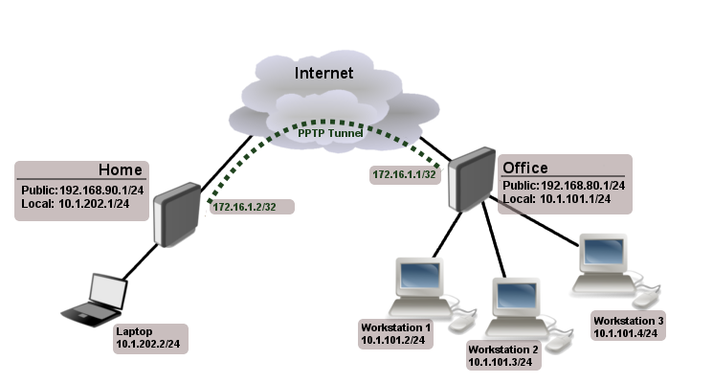
Preemption |  | In computing, preemption is the act of temporarily interrupting a task being carried out by a computer system, without requiring its cooperation, and with the intention of resuming the task at a later time. Such changes of the executed task are known as context switches. It is normally carried out by a privileged task or part of the system known as a preemptive scheduler, which has the power to preempt, or interrupt, and later resume, other tasks in the system.
Preview |  | An engineering discussion where materials have been prepared ahead of time for review and discussion in a meeting. The goal is to probe proposed solution to detect defects and suggest alternatives.  Previews differ from reviews in that they are solution oriented rather than detection oriented.
PRINCE2 |  | a project management methodology developed by the government of the United Kingdom that makes use of the best proven practices from a variety of industries and backgrounds.
Process |  | A standard method for performing an activity or task.  Processes may or may not be documented; a defined process implies that it is documented. Processes are often supported by materials, tools, conventions, and other infrastructure. The terms process may also refer to the execution of the activities and tasks that make up the process, e.g., “the outcome of the build process”.
Process Flow |  | A process model which defines the materials, structure, techniques, actions, events, and other elements necessary to implement a lifecycle, workflow, or methodology. CxOne uses process flow handbooks to guide use of CxOne materials with common lifecycles and methodologies.
Process Flow Handbook | CxProcess | CxOne material type that documents the use of particular process flows. See CxOneOverview for description.
Product |  | Sometimes used in CxOne as a synonym for the ‘output of a project’ meaning of system (e.g., when referring to product quality separate from project quality).
Product Owner |  | The product owner is a role created by the Scrum Framework responsible for making sure the team delivers the desired outcome.
Product Release |  | A release that is produced for distribution and/or deployment to end users.
programming language |  | A programming language is a formal language which comprises a set of instructions used to produce various kinds of output. Programming languages are used to create programs that implement specific algorithms.  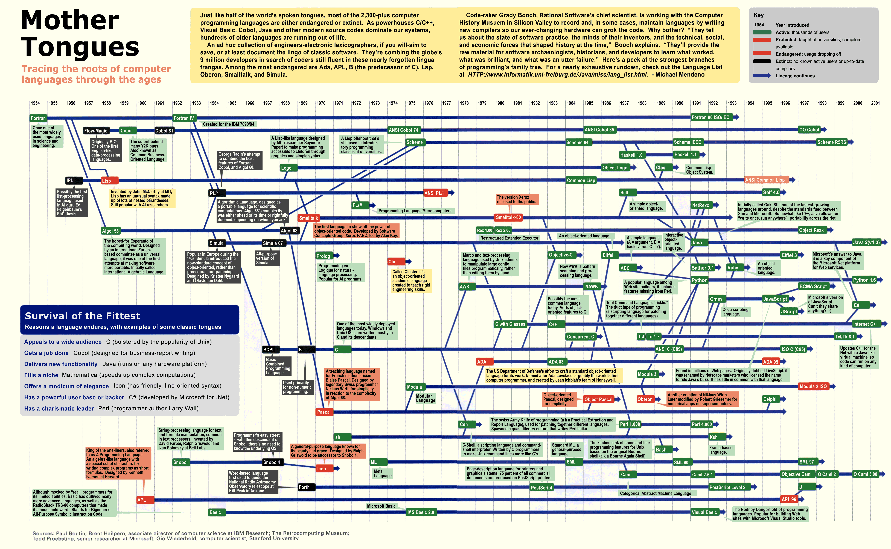  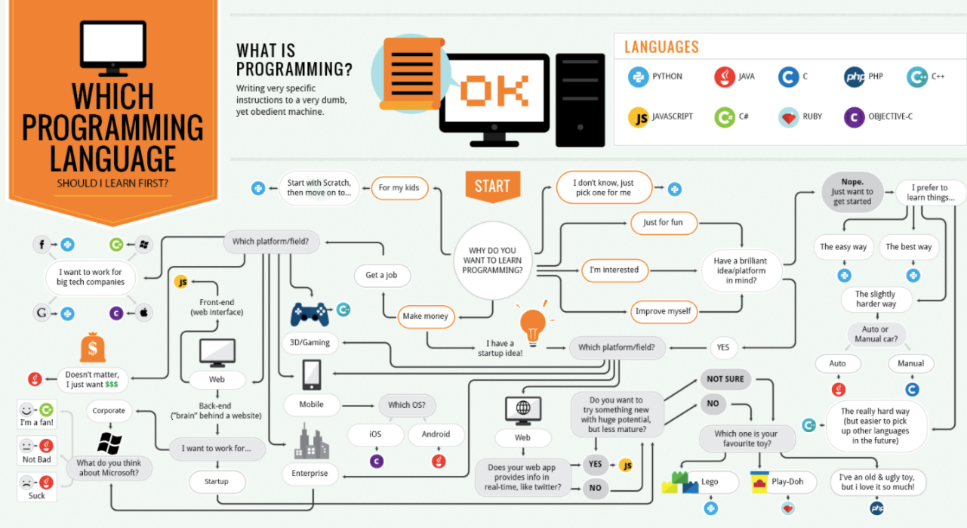
Programming paradigm |  | Programming paradigms are a way to classify programming languages based on their features. Languages can be classified into multiple paradigms.  Some paradigms are concerned mainly with implications for the execution model of the language, such as allowing side effects, or whether the sequence of operations is defined by the execution model. Other paradigms are concerned mainly with the way that code is organized, such as grouping a code into units along with the state that is modified by the code. Yet others are concerned mainly with the style of syntax and grammar.  Common programming paradigms include:  - imperative which allows side effects,  - object-oriented which groups code together with the state the code modifies,  - procedural which groups code into functions,  - declarative which does not state the order in which operations execute,  - functional which disallows side effects,  - logic which has a particular style of execution model coupled to a particular style of syntax and grammar, and  - symbolic programming which has a particular style of syntax and grammar.  For example, languages that fall into the imperative paradigm have two main features: they state the order in which operations occur, with constructs that explicitly control that order, and they allow side effects, in which state can be modified at one point in time, within one unit of code, and then later read at a different point in time inside a different unit of code. The communication between the units of code is not explicit. Meanwhile, in object-oriented programming, code is organized into objects that contain state that is only modified by the code that is part of the object. Most object-oriented languages are also imperative languages. In contrast, languages that fit the declarative paradigm do not state the order in which to execute operations. Instead, they supply a number of operations that are available in the system, along with the conditions under which each is allowed to execute. The implementation of the language's execution model tracks which operations are free to execute and chooses the order on its own. More at Comparison of multi-paradigm programming languages.  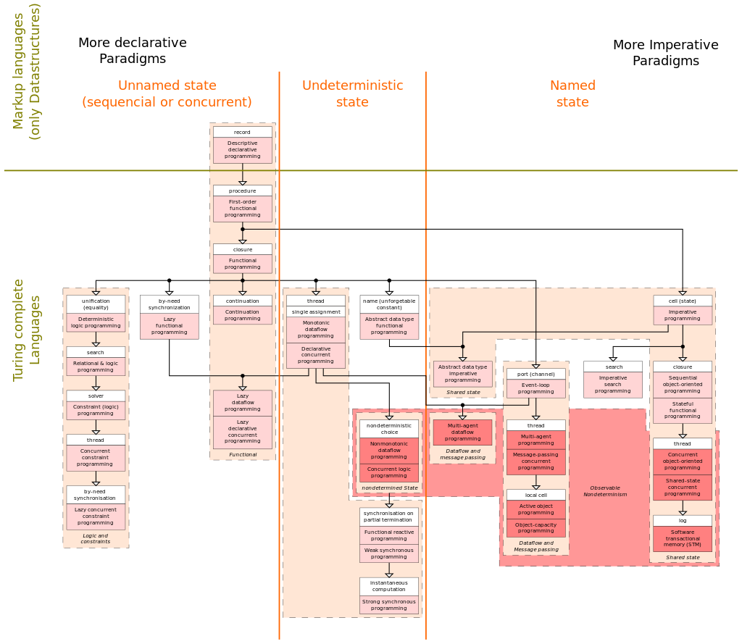
Progressive Elaboration |  | PMBOK term for iteratively defining a project’s requirements, moving from the general to the specific as the project is underway. Most software lifecycles and projects employ some degree of progressive elaboration. Relates to project headlights and rolling wave planning.
Project |  | A temporary endeavor undertaken to create a unique product or service. Normally used with CxOne to refer to a project creating a software system.
Project Build | PB | Build performed as part of a shared project build process, usually in a dedicated build environment. Compare to local build.
Project Business Manager | PBM | Responsible for successful business outcome of the project. In charge of project staffing, acquiring resources for the project, personnel issues, top-level work assignments, and client interaction. Is the top decision maker on the project, but normally defers technical decisions to the appropriate technical lead.
Project Charter |  | Used to incept and define a project. Documents the objectives, business case, risks and assets, resources, and constraints of a project.
Project Chartering |  | A high-level summary of the project's key success factors displayed on one wall of the team room as a flipchart-sized sheet of paper.
Project Estimate |  | An estimate that characterizes work on an entire project or large portion of a project. Project estimates are often the result of significant effort to predict a large phase of a project, and utilize several different techniques. Compare to task estimate.
Project Headlights |  | The concept that there is a sliding window of time that a project’s plan can be clearly defined with confidence. Beyond this “lighted” area, project planning is less precise and entails more uncertainty. Derives from the phrase “don’t drive beyond your headlights”. See rolling wave planning and CxBest_ProjectHeadlights.
Project History |  | Summarizes the significant information and statistics about an entire project.
Project Log |  | Describes significant information and statistics about each phase of a project.
Project Management | PM | The act of managing a project, including planning, tracking, control, and reporting activities.
Project Management Body of Knowledge | PMBOK | PMI developed definition of the essential knowledge related to the science and discipline of project management.
Project Management Institute | PMI | Professional organization for project managers. Developers of the PMBOK.  www.pmi.org
Project Manager | PM | Often used as synonym for project business manager, especially when one person is playing both project business manager and planning and tracking lead roles. Also used to refer generically to an individual playing a management role on a project.
Project Plan | PP | The controlling document for a project that defines how the project will be executed.
Project Reviewer |  | Performs reviews and audits on projects using personnel who are not participating on the project. Ensures processes are being followed and risks are being identified and managed.
Project Sponsor |  | Individual or entity responsible for sponsoring a project. Synonym for authority in a project charter. Initiates and staffs a project, directly oversees the project business manager. Ensures that the project is meeting the technical and business needs of external and internal stakeholders.
pseudocode |  | a detailed yet readable description of what a computer program or algorithm must do, expressed in a formally-styled natural language rather than in a programming language.
PSTN | Public Switched Telephone Network | The public switched telephone network (PSTN) is the aggregate of the world's circuit-switched telephone networks that are operated by national, regional, or local telephony operators, providing infrastructure and services for public telecommunication.  The PSTN consists of telephone lines, fiber optic cables, microwave transmission links, cellular networks, communications satellites, and undersea telephone cables, all interconnected by switching centers, thus allowing most telephones to communicate with each other.  Originally a network of fixed-line analog telephone systems, the PSTN is now almost entirely digital in its core network and includes mobile and other networks, as well as fixed telephones  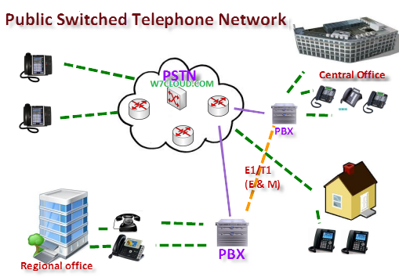
PTP | Precision Time Protocol | The Precision Time Protocol (PTP) is a protocol used to synchronize clocks throughout a computer network. On a local area network, it achieves clock accuracy in the sub-microsecond range, making it suitable for measurement and control systems.  PTP was originally defined in the IEEE 1588-2002 standard, officially entitled "Standard for a Precision Clock Synchronization Protocol for Networked Measurement and Control Systems" and published in 2002. In 2008, IEEE 1588-2008 was released as a revised standard; also known as PTP Version 2, it improves accuracy, precision and robustness but is not backward compatible with the original 2002 version.  "IEEE 1588 is designed to fill a niche not well served by either of the two dominant protocols, NTP and GPS. IEEE 1588 is designed for local systems requiring accuracies beyond those attainable using NTP. It is also designed for applications that cannot bear the cost of a GPS receiver at each node, or for which GPS signals are inaccessible."
PTT | Push-to-talk | Push-to-talk (PTT), also known as press-to-transmit, is a method of having conversations or talking on half-duplex communication lines, including two-way radio, using a momentary button to switch from voice reception mode to transmit mode.
PVC | Permanent Virtual Circuit | A permanent virtual circuit (PVC) is a virtual circuit established for repeated/continuous use between the same DTE. In a PVC, the long-term association is identical to the data transfer phase of a virtual call. Permanent virtual circuits eliminate the need for repeated call set-up and clearing. Frame relay is typically used to provide PVCs.
PW | PseudoWire | A pseudowire (or pseudo-wire) is an emulation of a point-to-point connection over a packet-switching network  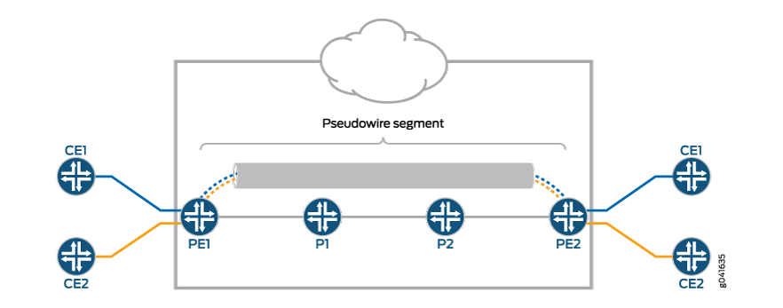
PWFQ | Priority-based Weighted Fair Queueing | See WFQ
Python (2.x & 3.x) |  | Python is an interpreted high-level programming language for general-purpose programming. Created by Guido van Rossum and first released in 1991, Python has a design philosophy that emphasizes code readability, notably using significant whitespace. It provides constructs that enable clear programming on both small and large scales. In July 2018, the creator Van Rossum stepped down as the leader in the language community after 30 years.  Python features a dynamic type system and automatic memory management. It supports multiple programming paradigms, including object-oriented, imperative, functional and procedural, and has a large and comprehensive standard library  Python 2.0 was released on 16 October 2000 and had many major new features, including a cycle-detecting garbage collector and support for Unicode. With this release, the development process became more transparent and community-backed.  Python 3.0 (initially called Python 3000 or py3k) was released on 3 December 2008 after a long testing period. It is a major revision of the language that is not completely backward-compatible with previous versions. However, many of its major features have been backported to the Python 2.6.x and 2.7.x version series, and releases of Python 3 include the 2to3 utility, which automates the translation of Python 2 code to Python 3

Q
Q.931 |  | ITU-T Recommendation Q.931 is the ITU standard ISDN connection control signalling protocol, forming part of Digital Subscriber Signalling System No. 1. Unlike connectionless systems like UDP, ISDN is connection oriented and uses explicit signalling to manage call state: Q.931. Q.931 typically does not carry user data. Q.931 does not have a direct equivalent in the Internet Protocol stack, but can be compared to SIP. Q.931 does not provide flow control or perform retransmission, since the underlying layers are assumed to be reliable and the circuit-oriented nature of ISDN allocates bandwidth in fixed increments of 64 kbit/s. Amongst other things, Q.931 manages connection setup and breakdown. Like TCP, Q.931 documents both the protocol itself and a protocol state machine.  Q.931 was designed for ISDN call establishment, maintenance, and release of network connections between two DTEs on the ISDN D channel. Q.931 has more recently been used as part of the VoIP H.323 protocol stack (see H.225.0) and in modified form in some mobile phone transmission systems and in ATM.  A Q.931 frame contains the following elements:  - Protocol discriminator (PD) – Specifies which signaling protocol is used for the connection (e.g. PD=8 for DSS1)  - Call reference value (CR) – Addresses different connections which can exist simultaneously. The value is valid only during the actual time period of the connection  - Message type (MT) – Specifies the type of a layer 3 message out of the Q.931-defined Message type set for call control (e.g. SETUP). There are messages defined for the call setup, the call release and the control of call features.  - Information elements (IE) – Specify further information which is associated to the actual message. An IE contains the IE name (e.g. bearer capability), their length and a variable field of contents.
QA Lead | QAL | Responsible for a project’s process and product quality.
QAM | Quadrature Amplitude Modulation | Quadrature amplitude modulation (QAM) is the name of a family of digital modulation methods and a related family of analog modulation methods widely used in modern telecommunications to transmit information. It conveys two analog message signals, or two digital bit streams, by changing (modulating) the amplitudes of two carrier waves, using the amplitude-shift keying (ASK) digital modulation scheme or amplitude modulation (AM) analog modulation scheme. The two carrier waves of the same frequency are out of phase with each other by 90°, a condition known as orthogonality or quadrature. The transmitted signal is created by adding the two carrier waves together. At the receiver, the two waves can be coherently separated (demodulated) because of their orthogonality property. Another key property is that the modulations are low-frequency/low-bandwidth waveforms compared to the carrier frequency, which is known as the narrowband assumption.  Phase modulation (analog PM) and phase-shift keying (digital PSK) can be regarded as a special case of QAM, where the amplitude of the transmitted signal is a constant, but its phase varies. This can also be extended to frequency modulation (FM) and frequency-shift keying (FSK), for these can be regarded as a special case of phase modulation.  QAM is used extensively as a modulation scheme for digital telecommunication systems, such as in 802.11 Wi-Fi standards. Arbitrarily high spectral efficiencies can be achieved with QAM by setting a suitable constellation size, limited only by the noise level and linearity of the communications channel. QAM is being used in optical fiber systems as bit rates increase; QAM16 and QAM64 can be optically emulated with a 3-path interferometer.
QoS | Quality of Service | Quality of service (QoS) is the description or measurement of the overall performance of a service, such as a telephony or computer network or a cloud computing service, particularly the performance seen by the users of the network. To quantitatively measure quality of service, several related aspects of the network service are often considered, such as packet loss, bit rate, throughput, transmission delay, availability, jitter, etc.  In the field of computer networking and other packet-switched telecommunication networks, quality of service refers to traffic prioritization and resource reservation control mechanisms rather than the achieved service quality. Quality of service is the ability to provide different priority to different applications, users, or data flows, or to guarantee a certain level of performance to a data flow.  Quality of service is particularly important for the transport of traffic with special requirements. In particular, developers have introduced Voice over IP technology to allow computer networks to become as useful as telephone networks for audio conversations, as well as supporting new applications with even stricter network performance requirements.
QSIG |  | QSIG is an ISDN based signaling protocol for signaling between private branch exchanges (PBXs) in a private integrated services network (PISN). It makes use of the connection-level Q.931 protocol and the application-level ROSE protocol. ISDN "proper" functions as the physical link layer.  QSIG was originally developed by Ecma International, adopted by ETSI and is defined by a set of ISO standard documents, so is not owned by any company. This allows interoperability between communications platforms provided by disparate vendors.  QSIG has two layers, called BC (basic call) and GF (generic function). QSIG BC describes how to set up calls between PBXs. QSIG GF provides supplementary services for large-scale corporate, educational, and government networks, such as line identification, call intrusion and call forwarding. Thus for a large or very distributed company that requires multiple PBXs, users can receive the same services across the network and be unaware of the switch that their telephone is connected to. This greatly eases the problems of management of large networks.
Quality |  | Software quality CKA. Covers activities designed to ensure that a system and related artifacts have the desired characteristics and conformance to requirements and standards. See CxStand_Quality for more information.
Quality Assurance | QA | Often used as synonym for the quality CKA. Also a subset of the quality CKA covering prevention of defects.
Quality Assurance Plan | QAP | See quality plan.
Quality Control | QC | A subset of the quality CKA covering detection of defects. Usually consists of reviews and testing.
Quality Plan | QP | Documents the quality methods and practices that will be used on a project to support QA and QC, along with coverage plans for project artifacts. Often delegates testing details to the test plan.
Quick Design Session |  | When "simple design" choices have far-reaching consequences, two or more developers meet for a quick design session at a whiteboard.

R
R |  | R is a programming language and free software environment for statistical computing and graphics that is supported by the R Foundation for Statistical Computing. The R language is widely used among statisticians and data miners for developing statistical software and data analysis. Polls, surveys of data miners, and studies of scholarly literature databases show that R's popularity has increased substantially in recent years. As of June 2018, R ranks 10th in the TIOBE index, a measure of popularity of programming languages.
RACI | Responsible, Accountable, Consulted, and Informed | A responsibility assignment matrix (RAM), also known as RACI matrix or linear responsibility chart (LRC), describes the participation by various roles in completing tasks or deliverables for a project or business process. It is especially useful in clarifying roles and responsibilities in cross-functional/departmental projects and processes.  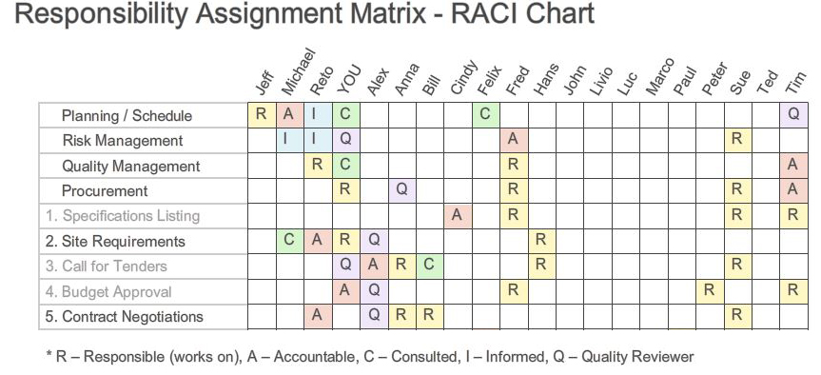
RAD | rapid application development | an approach based on the concept that products can be developed faster and of higher quality through: gathering requirements using workshops or focus groups; prototyping and early, reiterative user testing of designs; reusing software components; and using less formality in communication documents, such as reviews.
RAD | rapid application development | agile development method; enables developers to build solutions quickly by talking directly to end users to meet business requirement.
RAD Environment |  | Refers to a software tool the combines one or more programming languages with an IDE and a toolbox of modular software user interface components.
Radius | Remote Authentication Dial In User Service | - Protocol described by RFC 2865 (http://www.ietf.org/rfc/rfc2865.txt)  - Provides  - Authentication  - Authorisation  - Accounting  - TTT use FreeRADIUS Implementation  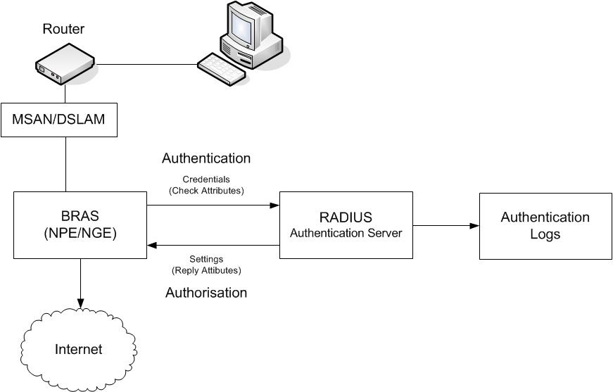
Rainbow |  | Opal business solutions, gata does into Remedy 7.6 (Service inventory)
RAN | radio access network | A radio access network (RAN) is part of a mobile telecommunication system. It implements a radio access technology. Conceptually, it resides between a device such as a mobile phone, a computer, or any remotely controlled machine and provides connection with its core network (CN). Depending on the standard, mobile phones and other wireless connected devices are varyingly known as user equipment (UE), terminal equipment, mobile station (MS), etc. RAN functionality is typically provided by a silicon chip residing in both the core network as well as the user equipment.  Examples of radio access network types are:  - GRAN: GSM radio access network  - GERAN: essentially the same as GRAN but specifying the inclusion of EDGE packet radio services  - UTRAN: UMTS radio access network  - E-UTRAN: The Long Term Evolution (LTE) high speed and low latency radio access network  It is also possible for a single handset/phone to be simultaneously connected to multiple radio access networks. Handsets capable of this are sometimes called dual-mode handsets. For instance it is common for handsets to support both GSM and UMTS (a.k.a. "3G") radio access technologies. Such devices seamlessly transfer an ongoing call between different radio access networks without the user noticing any disruption in service.  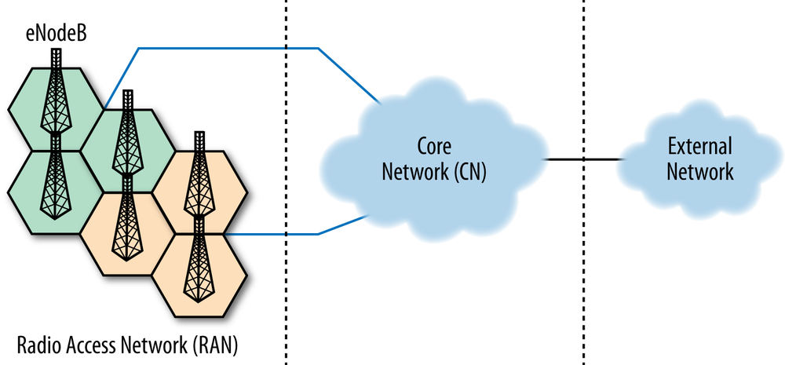
RANAP | Radio Access Network Application Part | In telecommunications networks, RANAP (an acronym for Radio Access Network Application Part) is a protocol specified by 3GPP in TS 25.413 and used in UMTS for signaling between the Core Network, which can be a MSC or SGSN, and the UTRAN. RANAP is carried over Iu-interface.  RANAP signalling protocol resides in the control plane of Radio network layer of Iu interface in the UMTS (Universal Mobile Telecommunication System) protocol stack. Iu interface is the interface between RNC (Radio Network Controller) and CN (Core Network). nb. For Iu-ps transport RANAP is carried on SCTP if IP interface used on this.  RANAP handles signaling for the Iu-PS - RNC and 3G SGSN and Iu-CS - RNC and 3G MSC . It also provides the signaling channel to transparently pass messages between the User Equipment (UE) and the CN.  In LTE, RANAP has been replaced by S1AP.
RANCID | Really Awesome New Cisco config Differ | A network management application released under a BSD-style license. RANCID uses Expect to connect to the routers, send some commands and put the results in files.
Rapid Application Development | RAD | A collection of software development techniques that focuses on user interface prototyping techniques and tools to create applications in an incremental fashion.
RARP | Dynamic IP Address Allocation – Reverse Address Resolution protocol | The Reverse Address Resolution Protocol (RARP) is an obsolete computer networking protocol used by a client computer to request its Internet Protocol (IPv4) address from a computer network, when all it has available is its link layer or hardware address, such as a MAC address. The client broadcasts the request and does not need prior knowledge of the network topology or the identities of servers capable of fulfilling its request.  RARP is described in Internet Engineering Task Force (IETF) publication RFC 903. It has been rendered obsolete by the Bootstrap Protocol (BOOTP) and the modern Dynamic Host Configuration Protocol (DHCP), which both support a much greater feature set than RARP.  RARP requires one or more server hosts to maintain a database of mappings of Link Layer addresses to their respective protocol addresses. Media Access Control (MAC) addresses need to be individually configured on the servers by an administrator. RARP is limited to serving only IP addresses.  Reverse ARP differs from the Inverse Address Resolution Protocol (InARP) described in RFC 2390, which is designed to obtain the IP address associated with a local Frame Relay data link connection identifier. InARP is not used in Ethernet.  Modern Day Uses  Although the original uses for RARP have been overcome by different protocols, some modern day protocols use RARP. Examples are:  Cisco's Overlay Transport Virtualization (OTV). RARP is used to update the layer 2 forwarding tables when a MAC address moves between data centers.
RAS | Remote Access Server | Refers to any combination of hardware and software that enable the remote access to a network; often used in dial-up networking scenarios. These devices typically use a RADIUS service.
RAS | Registration, Admission, and Status | Registration, admission, and status (RAS) is a component of a network protocol that involves the addition of (or refusal to add) new authorized users, the admission of (or refusal to admit) authorized users based on available bandwidth, and the tracking of the status of all users. Formally, RAS is part of the H.225 protocol for H.323 communications networks, designed to support multimedia bandwidths. RAS is an important signalling component in networks using voice over IP (VoIP).
RDBMS | relational database management system | A relational database management system (RDBMS) is a database management system (DBMS) based on the relational model invented by Edgar F. Codd at IBM's San Jose Research Laboratory. Most databases in widespread use today are based on his relational database model.  RDBMSs have been a common choice for the storage of information in databases used for financial records, manufacturing and logistical information, personnel data, and other applications since the 1980s. Relational databases have often replaced legacy hierarchical databases and network databases because they were easier to implement and administer. Nonetheless, relational databases received continued, unsuccessful challenges by object database management systems in the 1980s and 1990s, (which were introduced in an attempt to address the so-called object-relational impedance mismatch between relational databases and object-oriented application programs), as well as by XML database management systems in the 1990s. However, due to the expanse of technologies, such as horizontal scaling of computer clusters, NoSQL databases have recently become popular as an alternative to RDBMS databases  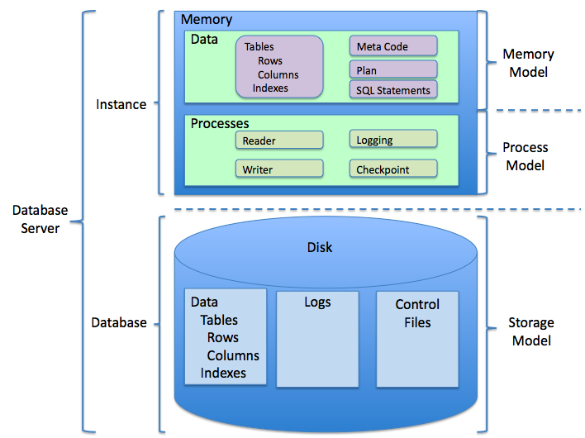
RDP | Remote Desktop Protocol | Remote Desktop Protocol (RDP) is a proprietary protocol developed by Microsoft, which provides a user with a graphical interface to connect to another computer over a network connection. The user employs RDP client software for this purpose, while the other computer must run RDP server software.  Clients exist for most versions of Microsoft Windows (including Windows Mobile), Linux, Unix, macOS, iOS, Android, and other operating systems. RDP servers are built into Windows operating systems; an RDP server for Unix and OS X also exists. By default, the server listens on TCP port 3389[1] and UDP port 3389.[2]  Microsoft currently refers to their official RDP client software as Remote Desktop Connection, formerly "Terminal Services Client".  The protocol is an extension of the ITU-T T.128 application sharing protocol.
Reading Inspection |  | An inspection in which all components of the full inspection process are done except the inspection meeting.
refactoring |  | a process that improves the internal structure of a software system without changing its external behaviour.
Refactoring |  | Refactoring consists of improving the internal structure of an existing program's source code, while preserving its external behavior.
Reference | CxRef | CxOne reference material type, see CxOneOverview for description.
regression testing |  | the process of testing changes to computer programs to make sure that the older programming still works with the new changes.
Regular expression |  | A regular expression, regex or regexp (sometimes called a rational expression) is, in theoretical computer science and formal language theory, a sequence of characters that define a search pattern. Usually this pattern is then used by string searching algorithms for "find" or "find and replace" operations on strings, or for input validation.
Relative Estimation |  | Relative estimation consists of estimating tasks or user stories by comparison or by grouping of items of equivalent difficulty.
Release |  | A software release. Providing a deployable version of a software system to a customer, e.g., test group, client, customer, etc.
Release Management |  | The identification, packaging, and delivery of the elements of the product to an external or internal customer.
Release Test |  | Test to ensure software is ready for a release.
Requirement |  | A detailed description of what the software is supposed to do
Requirements |  | are written as ‘stories’ that are collated into a prioritised list called the ‘Backlog’.
Requirements |  | Software requirements. Determining and capturing what a software system should do. Also denotes the requirements CKA. See CxStand_Requirements for more information.
Requirements Lead |  | Responsible for defining, maintaining, and tracing product requirements. Ensures proper end-user documentation is developed from the requirements.
REST | Representational State Transfer | Representational State Transfer (REST) is an architectural style that defines a set of constraints and properties based on HTTP. Web Services that conform to the REST architectural style, or RESTful web services, provide interoperability between computer systems on the Internet. REST-compliant web services allow the requesting systems to access and manipulate textual representations of web resources by using a uniform and predefined set of stateless operations. Other kinds of web services, such as SOAP web services, expose their own arbitrary sets of operations.  "Web resources" were first defined on the World Wide Web as documents or files identified by their URLs. However, today they have a much more generic and abstract definition that encompasses everything or entity that can be identified, named, addressed, or handled, in any way whatsoever, on the web. In a RESTful web service, requests made to a resource's URI will elicit a response that may be in HTML, XML, JSON, or some other format. The response may confirm that some alteration has been made to the stored resource, and the response may provide hypertext links to other related resources or collections of resources. When HTTP is used, as is most common, the operations available are GET, POST, PUT, DELETE, and other predefined CRUD HTTP methods.  By using a stateless protocol and standard operations, REST systems aim for fast performance, reliability, and the ability to grow, by re-using components that can be managed and updated without affecting the system as a whole, even while it is running.  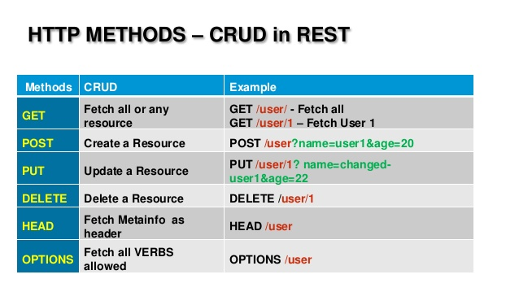
Review |  | A defined process in which people who are not the author of an artifact look over it with the intent of finding issues. Reviews range in formality from desk checks to inspections.
Reviewer |  | A person who participates in a review to identify issues in an artifact
Revision |  | An instance of a specific artifact, generally as noted by an automated system.
Revision Control | RC | The identification, storage, and management of projects artifacts and the revisions over time of those artifacts. Usually performed to artifacts stored in electronic form, through an automated system.
Rework |  | Any unforeseen or unplanned activity necessary to bring an artifact into conformance with project needs. Compare to update.
RFC | RF connector | A coaxial RF connector (radio frequency connector) is an electrical connector designed to work at radio frequencies in the multi-megahertz range. RF connectors are typically used with coaxial cables and are designed to maintain the shielding that the coaxial design offers. Better models also minimize the change in transmission line impedance at the connection in order to reduce signal reflection and power loss. As the frequency increases, transmission line effects become more important, with small impedance variations from connectors causing the signal to reflect rather than pass through. An RF connector must not allow external signals into the circuit through electromagnetic interference and capacitive pickup.  Mechanically, RF connectors may provide a fastening mechanism (thread, bayonet, braces, blind mate) and springs for a low ohmic electric contact while sparing the gold surface, thus allowing very high mating cycles and reducing the insertion force. Research activity in the area of radio-frequency (RF) circuit design has surged in the 2000s in direct response to the enormous market demand for inexpensive, high-data-rate wireless transceivers.
RFC | Request For Comment | A Request for Comments (RFC) is a formal document drafted by the Internet Engineering Task Force (IETF) that describes the specifications for a particular technology. When an RFC is ratified, it becomes a formal standards document.
RIP | Routing Information Protocol | The Routing Information Protocol (RIP) is one of the oldest distance-vector routing protocols which employ the hop count as a routing metric. RIP prevents routing loops by implementing a limit on the number of hops allowed in a path from source to destination. The largest number of hops allowed for RIP is 15, which limits the size of networks that RIP can support.  RIP implements the split horizon, route poisoning and holddown mechanisms to prevent incorrect routing information from being propagated.  In RIPv1 router broadcast updates with their routing table every 30 seconds. In the early deployments, routing tables were small enough that the traffic was not significant. As networks grew in size, however, it became evident there could be a massive traffic burst every 30 seconds, even if the routers had been initialized at random times.  In most networking environments, RIP is not the preferred choice for routing as its time to converge and scalability are poor compared to EIGRP, OSPF, or IS-IS. However, it is easy to configure, because RIP does not require any parameters unlike other protocols.  RIP uses the User Datagram Protocol (UDP) as its transport protocol, and is assigned the reserved port number 520.
Risk |  | An undesirable outcome.  Risks on projects generally refer to the captured representation of a possible future negative impact to a project’s feature, budget, schedule, or quality. Risks are a type of corrective activity management item.
Risk Analysis |  | Assesses risks for the likelihood and impact of occurrence.
Risk Identification |  | The elicitation and determination of current risks.
Risk List |  | A technique for extrinsic risk management that documents current and previous risks. Normally includes analysis information and mitigation plans.
Risk Management |  | A process or activity involving formal or informal means of identification, control, and elimination of project risk. Risk management may be explicit, or may be implicit in other activities (see intrinsic and extrinsic risk management). Managing identified risks is part of corrective activity management.
Risk Mitigation |  | The planning or steps taken to minimize either the probability or impact of a risk.
Risk Reward Matric |  | A risk-reward analysis is a very simple tool which can help you assess the risk and reward profile of completely different options. It works in the same way as a risk-return analysis which you may already be familiar with.  It can be applied at any level, for example:  - by a CEO for comparing different strategic directions for the company.  - by a program manager deciding which projects to keep within the program and which to discard.  - by a project manager deciding how to sequence tasks  - or simply by an individual team member deciding how best to spend their day.  The template works by having risk plotted along one axis and reward along the other. In the diagram below I’ve divided the template into four sections to show you how to interpret the information.  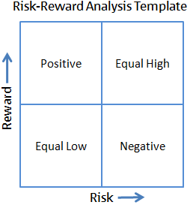  The four categories from the diagram above are as follows:  Equal Low: where risk and reward are both proportional and low.  Equal High: where risk and reward are both proportional and high.  Positive: represents a positive risk-reward balance, where a higher return can be achieved with limited risk.  Negative: represents a negative risk-reward balance, where a low return is the reward for taking on a relatively high risk.  How to Use it  First, you need to create a list of all the different options and their possible rewards. This can done quickly and roughly, or can involve serious effort (market research, scenario development etc) – the effort you put in will depend on the size of the decision you are making. Examples of some options might include: outsourcing non-core activities, stop investing in poorly performing product lines, invest in new products, or investing to move into new markets. Once you have all the options and their potential reward, they should be plotted on the risk-reward chart:  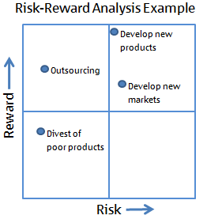  At this stage some options will appear to have a more favourable risk-reward profile than others, such as outsourcing in the above example, but it is work taking the time to investigate whether any options can have their risks mitigated, or if there are options that can have their rewards boosted, before making a final decision on which option to go with. In the above example, if the risk of developing new products could be mitigated somehow then that option would become more favourable than outsourcing.  Finally, for an even more complete picture to further aid our decision making, we can add resources to the risk-reward template. In the diagram below, the bigger the bubble the more resources are required to execute that option.  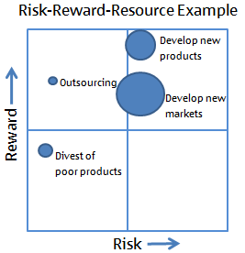  With risk, reward, and resources all plotted, we are able to trade them against one another to find the best option for us. From the diagram above you can see that outsourcing is probably the most favourable option, providing plenty of upside reward but requiring minimal resource and having little risk. Additionally, with so few resources engaged in making the outsourcing happen, perhaps some investigative work can start on the new product development option with some of the spare resource.
RNC | Radio Network Controller | The Radio Network Controller (or RNC) is a governing element in the UMTS radio access network (UTRAN) and is responsible for controlling the Node Bs that are connected to it. The RNC carries out radio resource management, some of the mobility management functions and is the point where encryption is done before user data is sent to and from the mobile. The RNC connects to the Circuit Switched Core Network through Media Gateway (MGW) and to the SGSN (Serving GPRS Support Node) in the Packet Switched Core Network.  Interfaces  RNC Interfaces  The logical connections between the network elements are known as interfaces. The interface between the RNC and the Circuit Switched Core Network (CS-CN) is called Iu-CS and between the RNC and the Packet Switched Core Network is called Iu-PS. Other interfaces include Iub (between the RNC and the Node B) and Iur (between RNCs in the same network). Iu interfaces carry user traffic (such as voice or data) as well as control information (see Protocols), and Iur interface is mainly needed for soft handovers involving 2 RNCs though not required as the absence of Iur will cause these handovers to become hard handovers.  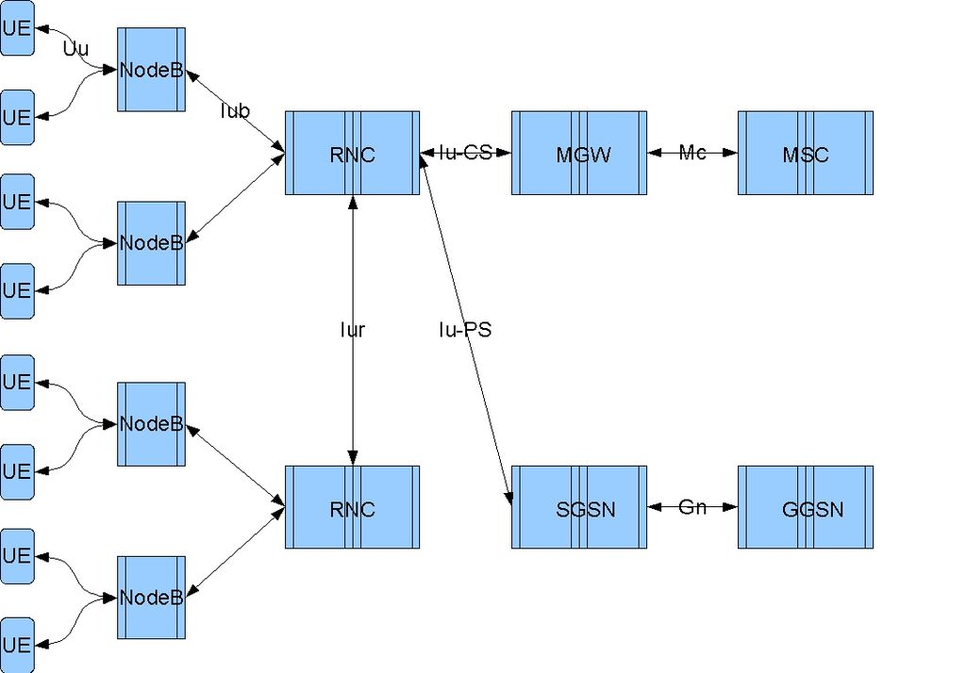  Protocols  Iub, Iu and Iur protocols all carry both user data and signalling (that is, control plane).  - Signalling protocol responsible for the control of the Node B by the RNC is called NBAP (Node-B Application Part). NBAP is subdivided into Common and Dedicated NBAP (C-NBAP and D-NBAP), where Common NBAP controls overall Node B functionality and Dedicated NBAP controls separate cells or sectors of the Node B. NBAP is carried over Iub. In order for NBAP to handle common and dedicated procedures, it is divided into: NodeB Control Port (NCP) which handles common NBAP procedures and Communication Control Port (CCP) which handles dedicated NBAP procedures.  - Control plane protocol for the transport layer is called ALCAP (Access Link Control Application Protocol). Basic functionality of ALCAP is multiplexing of different users onto one AAL2 transmission path using channel IDs (CIDs). ALCAP is carried over Iub and Iu-CS interfaces.  - Signalling protocol responsible for communication between RNC and the core network is called RANAP (Radio Access Network Application Part), and is carried over Iu interface.  - Signalling protocol responsible for communications between RNCs is called RNSAP (Radio Network Subsystem Application Part) and is carried on the Iur interface.
RNSAP | Radio Network Subsystem Application Part | RNSAP (Radio Network Subsystem Application Part) is a 3GPP signalling protocol responsible for communications between RNCs Radio Network Controllers defined in 3GPP specification TS 25.423.[1] It is carried on the lur interface and provides functionality needed for soft handovers and SRNS (Serving Radio Network Subsystem) relocation (handoff between RNCs).It defines signalling between RNCs, including SRNC(Serving RNC) and DRNC(drift RNC).  SRNC | DRNC  | IUR |  RNSAP | RNSAP  | | |  Converge protol | Converge protol  | | |  AAL 5 | AAL5  ATM | ATM  Physical links------→→→ Physical links  RNSAP Layer Architecture
Role-feature-reason |  | The "role-feature-reason" template is one of the most commonly recommended aids to write user stories: As a ... I want ... So that ...
Rolling Wave Planning |  | Planning a project, often with an iterative lifecycle, with a sliding window of visibility. Items closer to the present are planned and tracked with greater detail than items further in the future. See project headlights.
Round Robin |  | Round-robin (RR) is one of the algorithms employed by process and network schedulers in computing. As the term is generally used, time slices (also known as time quanta) are assigned to each process in equal portions and in circular order, handling all processes without priority (also known as cyclic executive). Round-robin scheduling is simple, easy to implement, and starvation-free. Round-robin scheduling can also be applied to other scheduling problems, such as data packet scheduling in computer networks. It is an operating system concept.  The name of the algorithm comes from the round-robin principle known from other fields, where each person takes an equal share of something in turn.  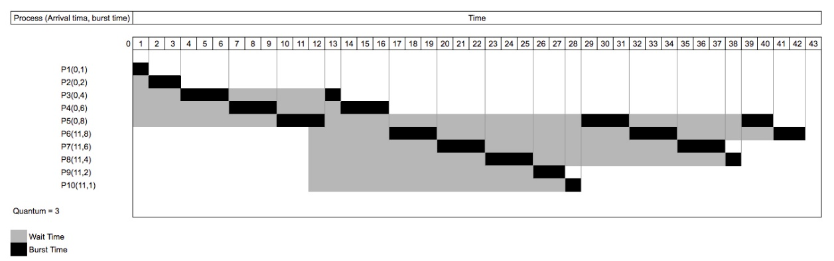
Router |  | A router is a networking device that forwards data packets between computer networks. Routers perform the traffic directing functions on the Internet. Data sent through the internet, such as a web page or email, is in the form of data packets. A packet is typically forwarded from one router to another router through the networks that constitute an internetwork until it reaches its destination node.  A router is connected to two or more data lines from different networks. When a data packet comes in on one of the lines, the router reads the network address information in the packet to determine the ultimate destination. Then, using information in its routing table or routing policy, it directs the packet to the next network on its journey.  The most familiar type of routers are home and small office routers that simply forward IP packets between the home computers and the Internet. An example of a router would be the owner's cable or DSL router, which connects to the Internet through an Internet service provider (ISP). More sophisticated routers, such as enterprise routers, connect large business or ISP networks up to the powerful core routers that forward data at high speed along the optical fiber lines of the Internet backbone. Though routers are typically dedicated hardware devices, software-based routers also exist
RPC |  | In distributed computing, a remote procedure call (RPC) is when a computer program causes a procedure (subroutine) to execute in a different address space (commonly on another computer on a shared network), which is coded as if it were a normal (local) procedure call, without the programmer explicitly coding the details for the remote interaction. That is, the programmer writes essentially the same code whether the subroutine is local to the executing program, or remote. This is a form of client–server interaction (caller is client, executor is server), typically implemented via a request–response message-passing system. In the object-oriented programming paradigm, RPC calls are represented by remote method invocation (RMI). The RPC model implies a level of location transparency, namely that calling procedures is largely the same whether it is local or remote, but usually they are not identical, so local calls can be distinguished from remote calls. Remote calls are usually orders of magnitude slower and less reliable than local calls, so distinguishing them is important.  RPCs are a form of inter-process communication (IPC), in that different processes have different address spaces: if on the same host machine, they have distinct virtual address spaces, even though the physical address space is the same; while if they are on different hosts, the physical address space is different. Many different (often incompatible) technologies have been used to implement the concept.
RRC | Radio Resource Control | The Radio Resource Control (RRC) protocol is used in UMTS and LTE on the Air interface. It is a layer that exists between UE and eNB and exists at the IP level. This protocol is specified by 3GPP in TS 25.331 for UMTS and in TS 36.331 for LTE. RRC messages are transported via the PDCP-Protocol.  The major functions of the RRC protocol include connection establishment and release functions, broadcast of system information, radio bearer establishment, reconfiguration and release, RRC connection mobility procedures, paging notification and release and outer loop power control. By means of the signalling functions the RRC configures the user and control planes according to the network status and allows for Radio Resource Management strategies to be implemented.  The operation of the RRC is guided by a state machine which defines certain specific states that a UE may be present in. The different states in this state machine have different amounts of radio resources associated with them and these are the resources that the UE may use when it is present in a given specific state. Since different amounts of resources are available at different states the quality of the service that the user experiences and the energy consumption of the UE are influenced by this state machine.  In order to comprehend the Radio Resource Control (RRC) state machine, we should study the architecture of the third generation mobile cellular system, the Universal Mobile Telecommunications System (UMTS). The UMTS is composed by two subsystems, the UTRAN (Umts Terrestrial Radio Access Network) and CN (core network) :  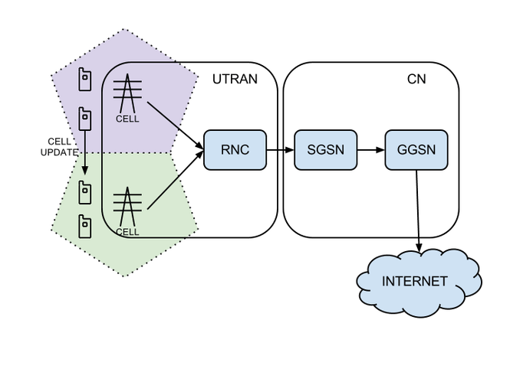  The RNC is responsible for the packet scheduling, radio resource control and handover control.  Unlike other wireless technologies like WIFI in which clients concurrently send packets and collisions occur (and backoff algorithms), in the UMTS there is a centralized entity that schedules resources to each client. In order to manage the UE access to radio resources, the UMTS introduces a radio resource control protocol (RRC) that attributes each UE a specific state machine (based on radio resource usage). This state machine is dependent on the 3G provider and can have different states and/or transitions. According to the reference paper – Characterizing Radio Resource Allocation for 3G Networks – the studied networks were composed by three states: IDLE, CELL_FACH and CELL_DCH.  In truth other states can actually be observed in some operators before going into a disconnected mode. For example the PCH states – URA_PCH and CELL_PCH – are states in which the user equipment has no transport channels allocated but has to monitor the cell/UTRAN it is currently connected to in order to send CELL_UPDATES to the RCN (just in case it actually changes). This update implies temporarily changing the state to a CELL_FACH in order to be able to send data. The change from CELL_PCH, in which the UE is known at a cell level, to URA_PCH, in which the user is known at UTRAN level, may be due to an increasing number of CELL_UPDATES (e.g. travelling fast). This is useful in order to speed up incoming connections since it might take around 0.9 seconds to establish it against the 2.5s delay if the UE is on the IDLE state.  Below is a diagram that represents the six most common states – CELL_DCH, CELL_FACH, CELL_PCH, URA_PCH, IDLE, DISCONNECT – and some of the possible transitions.  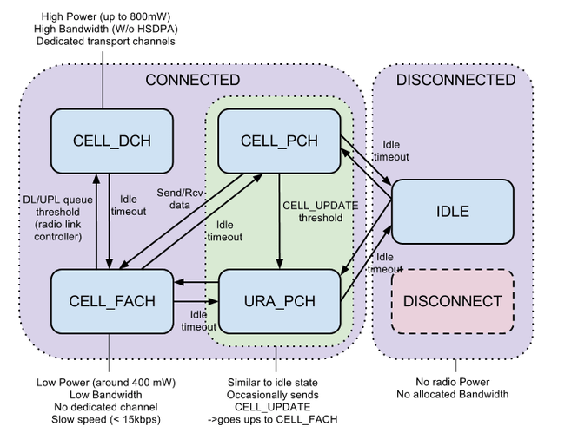
RSTP | Rapid Spanning Tree Protocol | In 2001, the IEEE introduced Rapid Spanning Tree Protocol (RSTP) as 802.1w. RSTP provides significantly faster spanning tree convergence after a topology change, introducing new convergence behaviors and bridge port roles to do this. RSTP was designed to be backwards-compatible with standard STP.  While STP can take 30 to 50 seconds to respond to a topology change, RSTP is typically able to respond to changes within 3 × Hello times (default: 3 times 2 seconds) or within a few milliseconds of a physical link failure. The Hello time is an important and configurable time interval that is used by RSTP for several purposes; its default value is 2 seconds.  Standard IEEE 802.1D-2004 incorporates RSTP and obsoletes the original STP standard.
RSVP | Resource Reservation Protocol | The Resource Reservation Protocol (RSVP) is a transport layer protocol designed to reserve resources across a network for quality of service (QoS) using the integrated services model. RSVP operates over an IPv4 or IPv6 and provides receiver-initiated setup of resource reservations for multicast or unicast data flows. It does not transport application data but is similar to a control protocol, like Internet Control Message Protocol (ICMP) or Internet Group Management Protocol (IGMP). RSVP is described in RFC 2205.  RSVP can be used by hosts and routers to request or deliver specific levels of QoS for application data streams or flows. RSVP defines how applications place reservations and how they can relinquish the reserved resources once no longer required. RSVP operation will generally result in resources being reserved in each node along a path. RSVP is not a routing protocol and was designed to interoperate with current and future routing protocols.  RSVP by itself is rarely deployed in telecommunications networks today[citation needed] but, as of February 2003, the traffic engineering extension of RSVP, or RSVP-TE, is becoming more widely accepted nowadays in many QoS-oriented networks. Next Steps in Signaling (NSIS) is a proposed replacement for RSVP.
RTCP | Real-Time Control Protocol | The RTP Control Protocol (RTCP) is a sister protocol of the Real-time Transport Protocol (RTP). Its basic functionality and packet structure is defined in RFC 3550. RTCP provides out-of-band statistics and control information for an RTP session. It partners with RTP in the delivery and packaging of multimedia data, but does not transport any media data itself.  The primary function of RTCP is to provide feedback on the quality of service (QoS) in media distribution by periodically sending statistics information such as transmitted octet and packet counts, packet loss, packet delay variation, and round-trip delay time to participants in a streaming multimedia session. An application may use this information to control quality of service parameters, perhaps by limiting flow, or using a different codec.
RTOS |  | A real-time operating system (RTOS) is an operating system (OS) intended to serve real-time applications that process data as it comes in, typically without buffer delays. Processing time requirements (including any OS delay) are measured in tenths of seconds or shorter increments of time. A real time system is a time bound system which has well defined fixed time constraints. Processing must be done within the defined constraints or the system will fail. They either are event driven or time sharing. Event driven systems switch between tasks based on their priorities while time sharing systems switch the task based on clock interrupts. Most RTOS’s use a pre-emptive scheduling algorithm.  A key characteristic of an RTOS is the level of its consistency concerning the amount of time it takes to accept and complete an application's task; the variability is jitter. A hard real-time operating system has less jitter than a soft real-time operating system. The chief design goal is not high throughput, but rather a guarantee of a soft or hard performance category. An RTOS that can usually or generally meet a deadline is a soft real-time OS, but if it can meet a deadline deterministically it is a hard real-time OS.  An RTOS has an advanced algorithm for scheduling. Scheduler flexibility enables a wider, computer-system orchestration of process priorities, but a real-time OS is more frequently dedicated to a narrow set of applications. Key factors in a real-time OS are minimal interrupt latency and minimal thread switching latency; a real-time OS is valued more for how quickly or how predictably it can respond than for the amount of work it can perform in a given period of time.
RTP | Real-time Protocol | The Real-time Transport Protocol (RTP) is a network protocol for delivering audio and video over IP networks. RTP is used extensively in communication and entertainment systems that involve streaming media, such as telephony, video teleconference applications including WebRTC, television services and web-based push-to-talk features.  RTP typically runs over User Datagram Protocol (UDP). RTP is used in conjunction with the RTP Control Protocol (RTCP). While RTP carries the media streams (e.g., audio and video), RTCP is used to monitor transmission statistics and quality of service (QoS) and aids synchronization of multiple streams. RTP is one of the technical foundations of Voice over IP and in this context is often used in conjunction with a signalling protocol such as the Session Initiation Protocol (SIP) which establishes connections across the network.
RTSP | Real Time Streaming Protocol | The Real Time Streaming Protocol (RTSP) is a network control protocol designed for use in entertainment and communications systems to control streaming media servers. The protocol is used for establishing and controlling media sessions between end points. Clients of media servers issue VCR-style commands, such as play, record and pause, to facilitate real-time control of the media streaming from the server to a client (Video On Demand) or from a client to the server (Voice Recording).  The transmission of streaming data itself is not a task of RTSP. Most RTSP servers use the Real-time Transport Protocol (RTP) in conjunction with Real-time Control Protocol (RTCP) for media stream delivery.
Ruby |  | Ruby is a dynamic, interpreted, reflective, object-oriented, general-purpose programming language. It was designed and developed in the mid-1990s by Yukihiro "Matz" Matsumoto in Japan.  According to the creator, Ruby was influenced by Perl, Smalltalk, Eiffel, Ada, and Lisp. It supports multiple programming paradigms, including functional, object-oriented, and imperative. It also has a dynamic type system and automatic memory management.
Ruby on rails |  | Ruby on Rails, or Rails, is a server-side web application framework written in Ruby under the MIT License. Rails is a model–view–controller (MVC) framework, providing default structures for a database, a web service, and web pages. It encourages and facilitates the use of web standards such as JSON or XML for data transfer, and HTML, CSS and JavaScript for display and user interfacing. In addition to MVC, Rails emphasizes the use of other well-known software engineering patterns and paradigms, including convention over configuration (CoC), don't repeat yourself (DRY), and the active record pattern.
Rule of Simplicity |  | Rules of Simplicity is a set of criteria, in priority order, proposed by Kent Beck to judge whether some source code is "simple enough."
RUP | Rational Unified Process | an object-oriented and Web-enabled program development methodology that is said to be like an online mentor that provides guidelines, templates, and examples for all aspects and stages of program development.

S
S- Tag | Service VLAN Tag | The IEEE standard 802.1ad provides for double-tagging by service providers so that they can use VLANs allocated internally together with traffic already tagged as VLANs by service provider customers.  In this double tagging, the S-Tag comes first followed by the C-Tag (customer tag). The standard 802.1ad specifies a TPID of 0x88a8 for the outer S-Tag.  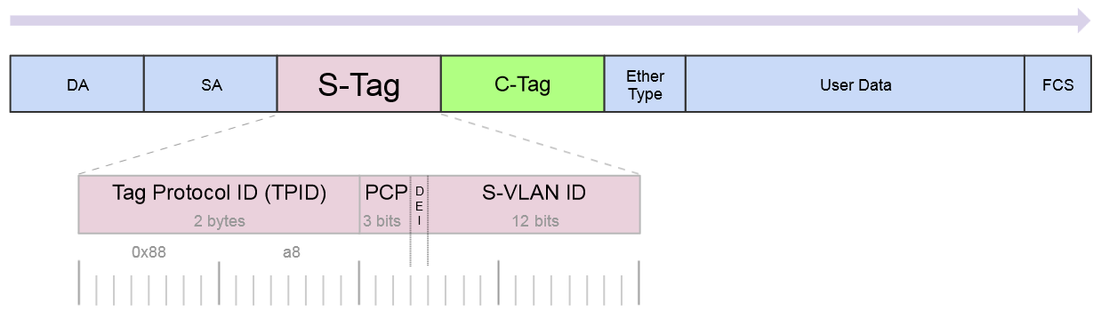
SAAL | Signalling ATM Adaptation Layer | In ATM (Asynchronous Transfer Mode), the SAAL (ATM Adaptation Layer for Signalling) provides reliable transport of signalling messages between peer entities. These signalling messages are carried over a PVC (Permanent Virtual Circuit).
SaaS | Software As A Service | Software as a service is a software licensing and delivery model in which software is licensed on a subscription basis and is centrally hosted. It is sometimes referred to as "on-demand software". SaaS is typically accessed by users using a thin client, e.g. via a web browser.  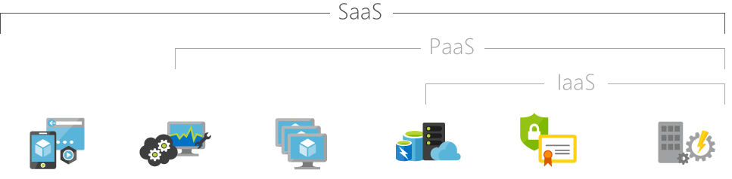  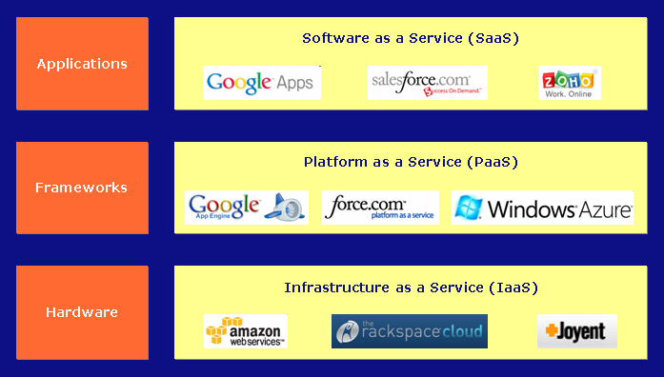
SaaS | Software as a Service | Software as a service (SaaS /sæs/) is a software licensing and delivery model in which software is licensed on a subscription basis and is centrally hosted. It is sometimes referred to as "on-demand software", and was formerly referred to as "software plus services" by Microsoft. SaaS is typically accessed by users using a thin client via a web browser. SaaS has become a common delivery model for many business applications, including office software, messaging software, payroll processing software, DBMS software, management software, CAD software, development software, gamification, virtualization, accounting, collaboration, customer relationship management (CRM), Management Information Systems (MIS), enterprise resource planning (ERP), invoicing, human resource management (HRM), talent acquisition, learning management systems, content management (CM), and service desk management. SaaS has been incorporated into the strategy of nearly all leading enterprise software companies
SAE | System Architecture Evolution | System Architecture Evolution (SAE) is the core network architecture of 3GPP's LTE wireless communication standard.  SAE is the evolution of the GPRS Core Network, with some differences:  - simplified architecture  - all-IP Network (AIPN)  - support for higher throughput and lower latency radio access networks (RANs)  - support for, and mobility between, multiple heterogeneous access networks, including E-UTRA (LTE and LTE Advanced air interface), 3GPP legacy systems (for example GERAN or UTRAN, air interfaces of GPRS and UMTS respectively), but also non-3GPP systems (for example WiFi, WiMAX or cdma2000)
SAFe | scaled agile framework enterprise | agile methodology used for software development.
Sample | CxSample | CxOne sample material type, see CxOneOverview for description.
SBC | Session Border Controller | A session border controller (SBC) is a device regularly deployed in Voice over Internet Protocol (VoIP) networks to exert control over the signalling and usually also the media streams involved in setting up, conducting, and tearing down telephone calls or other interactive media communications.  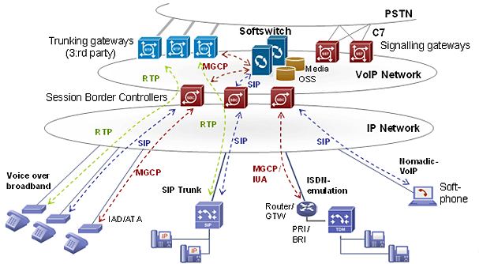
Scala |  | Scala is a general-purpose programming language providing support for functional programming and a strong static type system. Designed to be concise, many of Scala's design decisions aimed to address criticisms of Java.  Scala source code is intended to be compiled to Java bytecode, so that the resulting executable code runs on a Java virtual machine. Scala provides language interoperability with Java, so that libraries written in both languages may be referenced directly in Scala or Java code. Like Java, Scala is object-oriented, and uses a curly-brace syntax reminiscent of the C programming language. Unlike Java, Scala has many features of functional programming languages like Scheme, Standard ML and Haskell, including currying, type inference, immutability, lazy evaluation, and pattern matching. It also has an advanced type system supporting algebraic data types, covariance and contravariance, higher-order types (but not higher-rank types), and anonymous types. Other features of Scala not present in Java include operator overloading, optional parameters, named parameters, and raw strings. Conversely, a feature of Java not in Scala is checked exceptions, which have proved controversial.
Scaled Agile |  | agile scaled up to large projects or programmes, for example by having multiple sub-projects, creating tranches of projects, etc.
SCCP | Signalling Connection Control Part | The (SCCP) is a network layer protocol that provides extended routing, flow control, segmentation, connection-orientation, and error correction facilities in Signaling System 7 telecommunications networks. SCCP relies on the services of MTP for basic routing and error detection.
Scenario |  | A narrative description of an activity or activities which take the form of a story
SC-FDMA | Single-carrier FDMA | Single-carrier FDMA (SC-FDMA) is a frequency-division multiple access scheme. It is also called Linearly precoded OFDMA (LP-OFDMA). Like other multiple access schemes (TDMA, FDMA, CDMA, OFDMA), it deals with the assignment of multiple users to a shared communication resource. SC-FDMA can be interpreted as a linearly precoded OFDMA scheme, in the sense that it has an additional DFT processing step preceding the conventional OFDMA processing.  SC-FDMA has drawn great attention as an attractive alternative to OFDMA, especially in the uplink communications where lower peak-to-average power ratio (PAPR) greatly benefits the mobile terminal in terms of transmit power efficiency and reduced cost of the power amplifier. It has been adopted as the uplink multiple access scheme in 3GPP Long Term Evolution (LTE), or Evolved UTRA (E-UTRA).
Schedule |  | General term for a plan that defines calendar timing, resources, dependencies, and other details for tasks necessary to complete a project or part of a project. CxOne defines two major classes of schedules, business schedules and detailed schedules.
Scheduler |  | In computing, scheduling is the method by which work specified by some means is assigned to resources that complete the work. The work may be virtual computation elements such as threads, processes or data flows, which are in turn scheduled onto hardware resources such as processors, network links or expansion cards.  A scheduler is what carries out the scheduling activity. Schedulers are often implemented so they keep all computer resources busy (as in load balancing), allow multiple users to share system resources effectively, or to achieve a target quality of service. Scheduling is fundamental to computation itself, and an intrinsic part of the execution model of a computer system; the concept of scheduling makes it possible to have computer multitasking with a single central processing unit (CPU).  A scheduler may aim at one or more of many goals, for example: maximizing throughput (the total amount of work completed per time unit); minimizing wait time (time from work becoming enabled until the first point it begins execution on resources); minimizing latency or response time (time from work becoming enabled until it is finished in case of batch activity, or until the system responds and hands the first output to the user in case of interactive activity); or maximizing fairness (equal CPU time to each process, or more generally appropriate times according to the priority and workload of each process). In practice, these goals often conflict (e.g. throughput versus latency), thus a scheduler will implement a suitable compromise. Preference is measured by any one of the concerns mentioned above, depending upon the user's needs and objectives.  In real-time environments, such as embedded systems for automatic control in industry (for example robotics), the scheduler also must ensure that processes can meet deadlines; this is crucial for keeping the system stable. Scheduled tasks can also be distributed to remote devices across a network and managed through an administrative back end.
SCM | software configuration management | In software engineering, software configuration management (SCM or S/W CM) is the task of tracking and controlling changes in the software, part of the larger cross-disciplinary field of configuration management.[2] SCM practices include revision control and the establishment of baselines. If something goes wrong, SCM can determine what was changed and who changed it. If a configuration is working well, SCM can determine how to replicate it across many hosts.
Scratch |  | Scratch is a visual programming language and online community targeted primarily at children. Using Scratch, users can create online projects and develop them into almost anything by using a simple block-like interface. When they are ready, they then share, and also discuss their creations with each other. Developed by the Lifelong Kindergarten group at the MIT Media Lab, the service is designed to help children (ages 8 and up) learn to utilize their imaginations, practice common sense, and, most importantly, to interact with computers.
Scribe |  | Records issues during an inspection or other formal meeting.
Scrum |  | Scrum is a process framework used to manage product development and other knowledge work.
Scrum Master |  | The scrum master is responsible for ensuring the team lives agile values and principles and follows the practices that the team agreed they would use.
Scrum of Scrums |  | A technique to scale Scrum up to large groups (over a dozen people), consisting of dividing the groups into Agile teams of 5-10.
SCTP | Stream Control Transmission Protocol | The (SCTP) is a computer networking communications protocol which operates at the transport layer and serves a role similar to the popular protocols TCP and UDP. It is standardized by IETF in RFC 4960.  SCTP provides some of the features of both UDP and TCP: it is message-oriented like UDP and ensures reliable, in-sequence transport of messages with congestion control like TCP. It differs from those protocols by providing multi-homing and redundant paths to increase resilience and reliability.
SDES | Session Description protocol Security | SDES (Session Description Protocol Security Descriptions) for Media Streams is a way to negotiate the key for Secure Real-time Transport Protocol.
SDH | Synchronous Digital Hierarchy | Synchronous optical networking (SONET) and synchronous digital hierarchy (SDH) are standardized protocols that transfer multiple digital bit streams synchronously over optical fiber using lasers or highly coherent light from light-emitting diodes (LEDs). At low transmission rates data can also be transferred via an electrical interface. The method was developed to replace the plesiochronous digital hierarchy (PDH) system for transporting large amounts of telephone calls and data traffic over the same fiber without synchronization problems.  SONET and SDH, which are essentially the same, were originally designed to transport circuit mode communications (e.g., DS1, DS3) from a variety of different sources, but they were primarily designed to support real-time, uncompressed, circuit-switched voice encoded in PCM format.[1] The primary difficulty in doing this prior to SONET/SDH was that the synchronization sources of these various circuits were different. This meant that each circuit was actually operating at a slightly different rate and with different phase. SONET/SDH allowed for the simultaneous transport of many different circuits of differing origin within a single framing protocol. SONET/SDH is not a communications protocol in itself, but a transport protocol.  Due to SONET/SDH's essential protocol neutrality and transport-oriented features, SONET/SDH was the obvious choice for transporting the fixed length Asynchronous Transfer Mode (ATM) frames also known as cells. It quickly evolved mapping structures and concatenated payload containers to transport ATM connections. In other words, for ATM (and eventually other protocols such as Ethernet), the internal complex structure previously used to transport circuit-oriented connections was removed and replaced with a large and concatenated frame (such as STS-3c) into which ATM cells, IP packets, or Ethernet frames are placed.
SDK | Software Development Kit | a set of programs used by a computer programmer to write application programs.
SDLC | Synchronous Data Link Control | Synchronous Data Link Control (SDLC) is a computer communications protocol. It is the layer 2 protocol for IBM's Systems Network Architecture (SNA). SDLC supports multipoint links as well as error correction. It also runs under the assumption that an SNA header is present after the SDLC header.[1] SDLC was mainly used by IBM mainframe and midrange systems; however, implementations exist on many platforms from many vendors. The use of SDLC (and SNA) is becoming more and more rare, mostly replaced by IP-based protocols or being tunnelled through IP (using AnyNet or other technologies)
SDLC | systems development life cycle model | one of a number of structured approaches to information system development, created to guide all the processes involved, from an initial feasibility study through maintenance of the completed application. Models include the waterfall model; rapid application development (RAD); joint application development (JAD); the fountain model; the spiral model; build and fix; and synchronize-and-stabilize.
SDMA | Space-division multiple access | Space-division multiple access (SDMA) is a channel access method based on creating parallel spatial pipes[clarification needed] next to higher capacity pipes through spatial multiplexing and/or diversity, by which it is able to offer superior performance in radio multiple access communication systems.[clarification needed] In traditional mobile cellular network systems, the base station has no information on the position of the mobile units within the cell and radiates the signal in all directions within the cell in order to provide radio coverage. This results in wasting power on transmissions when there are no mobile units to reach, in addition to causing interference for adjacent cells using the same frequency, so called co-channel cells. Likewise, in reception, the antenna receives signals coming from all directions including noise and interference signals. By using smart antenna technology and differing spatial locations of mobile units within the cell, space-division multiple access techniques offer attractive performance enhancements. The radiation pattern of the base station, both in transmission and reception, is adapted to each user to obtain highest gain in the direction of that user. This is often done using phased array techniques.  In GSM cellular networks, the base station is aware of the distance (but not direction) of a mobile phone by use of a technique called "timing advance" (TA). The base transceiver station (BTS) can determine how far the mobile station (MS) is by interpreting the reported TA. This information, along with other parameters, can then be used to power down the BTS or MS, if a power control feature is implemented in the network. The power control in either BTS or MS is implemented in most modern networks, especially on the MS, as this ensures a better battery life for the MS. This is also why having a BTS close to the user results in less exposure to electromagnetic radiation.
SDN | Software Defined Network | Software-defined networking (SDN) technology is an approach to cloud computing that facilitates network management and enables programmatically efficient network configuration in order to improve network performance and monitoring. SDN is meant to address the fact that the static architecture of traditional networks is decentralized and complex while current networks require more flexibility and easy troubleshooting. SDN suggests to centralize network intelligence in one network component by disassociating the forwarding process of network packets (data plane) from the routing process (control plane). The control plane consists of one or more controllers which are considered as the brain of SDN network where the whole intelligence is incorporated. However, the intelligence centralization has its own drawbacks when it comes to security, scalability and elasticity and this is the main issue of SDN
SDP | Session Description Protocol | The Session Description Protocol (SDP) is a format for describing streaming media communications parameters. The IETF published the original specification as an IETF Proposed Standard in April 1998, and subsequently published a revised specification as an IETF Proposed Standard as RFC 4566 in July 2006.  SDP is used for describing multimedia communication sessions for the purposes of session announcement, session invitation, and parameter negotiation. SDP does not deliver any media by itself but is used between endpoints for negotiation of media type, format, and all associated properties. The set of properties and parameters are often called a session profile.  SDP is designed to be extensible to support new media types and formats. SDP started off as a component of the Session Announcement Protocol (SAP), but found other uses in conjunction with Real-time Transport Protocol (RTP), Real-time Streaming Protocol (RTSP), Session Initiation Protocol (SIP) and even as a standalone format for describing multicast sessions.
SDSL | Symmetrical Digital Subscriber Line | A symmetric digital subscriber line (SDSL) is a digital subscriber line (DSL) that transmits digital data over the copper wires of the telephone network, where the bandwidth in the downstream direction, from the network to the subscriber, is identical to the bandwidth in the upstream direction, from the subscriber to the network. This symmetric bandwidth can be considered to be the opposite of the asymmetric bandwidth offered by asymmetric digital subscriber line (ADSL) technologies, where the upstream bandwidth is lower than the downstream bandwidth. SDSL is generally marketed at business customers, while ADSL is marketed at private as well as business customers.  More specifically, SDSL can be understood as:  - in the wider sense, an umbrella term for all DSL variant which offer symmetric bandwidth, including IDSL, which offers 144 kbit/s, HDSL, HDSL2, G.SHDSL, which offers up to 22.784 Mbit/s over four pairs of copper wires, as well as the SDSL variant below  - in the narrow sense, a particular proprietary and non-standardized DSL variant for operation at 1.544 Mbit/s or 2.048 Mbit/s over a single pair of copper wires, without support for analog calls on the same line  - a term used by ETSI to refer to G.SHDSL
Sed |  | sed (stream editor) is a Unix utility that parses and transforms text, using a simple, compact programming language. sed was developed from 1973 to 1974 by Lee E. McMahon of Bell Labs, and is available today for most operating systems. sed was based on the scripting features of the interactive editor ed ("editor", 1971) and the earlier qed ("quick editor", 1965–66). sed was one of the earliest tools to support regular expressions, and remains in use for text processing, most notably with the substitution command. Popular alternative tools for plaintext string manipulation and "stream editing" include AWK and Perl.
Semaphore |  | In computer science, a semaphore is a variable or abstract data type used to control access to a common resource by multiple processes in a concurrent system such as a multitasking operating system. Semaphore is simply a variable. This variable is used to solve critical section problems and to achieve process synchronization in the multi processing environment.  A trivial semaphore is a plain variable that is changed (for example, incremented or decremented, or toggled) depending on programmer-defined conditions.  A useful way to think of a semaphore as used in the real-world systems is as a record of how many units of a particular resource are available, coupled with operations to adjust that record safely (i.e. to avoid race conditions) as units are required or become free, and, if necessary, wait until a unit of the resource becomes available.  Semaphores are a useful tool in the prevention of race conditions; however, their use is by no means a guarantee that a program is free from these problems. Semaphores which allow an arbitrary resource count are called counting semaphores, while semaphores which are restricted to the values 0 and 1 (or locked/unlocked, unavailable/available) are called binary semaphores and are used to implement locks.
Sequence Model |  | Specifies the set of object roles and their interactions by showing and describing the messages exchanged. The focus is on the timing of messages.
SF | Super Frame | In telecommunications, superframe (SF) is a T1 framing standard. In the 1970s it replaced the original T1/D1 framing scheme of the 1960s in which the framing bit simply alternated between 0 and 1.
SFTP | Secure File Transfer Protocol | In computing, the SSH File Transfer Protocol (also Secure File Transfer Protocol, or SFTP) is a network protocol that provides file access, file transfer, and file management over any reliable data stream. It was designed by the Internet Engineering Task Force (IETF) as an extension of the Secure Shell protocol (SSH) version 2.0 to provide secure file transfer capabilities. The IETF Internet Draft states that, even though this protocol is described in the context of the SSH-2 protocol, it could be used in a number of different applications, such as secure file transfer over Transport Layer Security (TLS) and transfer of management information in VPN applications.  This protocol assumes that it is run over a secure channel, such as SSH, that the server has already authenticated the client, and that the identity of the client user is available to the protocol.
SGML | Standard Generalized Markup Language | The Standard Generalized Markup Language (SGML; ISO 8879:1986) is a standard for defining generalized markup languages for documents. ISO 8879 Annex A.1 defines generalized markup:  Generalized markup is based on two postulates:  - Markup should be declarative: it should describe a document's structure and other attributes, rather than specify the processing to be performed on it. Declarative markup is less likely to conflict with unforeseen future processing needs and techniques.  Markup should be rigorous so that the techniques available for processing rigorously-defined objects like programs and databases can be used for processing documents as well.
SGSN | Serving GPRS support node | The Serving GPRS Support Node (SGSN) is the node that is serving the MS/UE. The SGSN supports GPRS and/or UMTS. The SGSN keeps track of the location of an individual MS/UE and performs security functions and access control. The SGSN is connected to the GERAN base station system through the Gb or Iu interface and/or to the UTRAN through the Iu interface. A SGSN is responsible for the delivery of data packets from and to the mobile stations within its geographical service area. Its tasks include packet routing and transfer, mobility management (attach/detach and location management), logical link management, and authentication and charging functions. The location register of the SGSN stores location information (e.g., current cell, current VLR) and user profiles (e.g., IMSI, address(es) used in the packet data network) of all GPRS users registered with it.
SGW | signalling gateway | A signalling gateway (SGW) interfaces with the signalling plane of the CS. It transforms lower layer protocols as Stream Control Transmission Protocol (SCTP, an IP protocol) into Message Transfer Part (MTP, an Signalling System 7 (SS7) protocol), to pass ISDN User Part (ISUP) from the MGCF to the CS network.
S-GW | Serving Gateway | The SGW routes and forwards user data packets, while also acting as the mobility anchor for the user plane during inter-eNodeB handovers and as the anchor for mobility between LTE and other 3GPP technologies (terminating S4 interface and relaying the traffic between 2G/3G systems and PGW). For idle state UEs, the SGW terminates the downlink data path and triggers paging when downlink data arrives for the UE. It manages and stores UE contexts, e.g. parameters of the IP bearer service, network internal routing information. It also performs replication of the user traffic in case of lawful interception.
Sh |  | The Bourne shell (sh) is a shell, or command-line interpreter, for computer operating systems.  The Bourne shell was the default shell for Version 7 Unix. Most Unix-like systems continue to have /bin/sh—which will be the Bourne shell, or a symbolic link or hard link to a compatible shell—even when other shells are used by most users.
SHA | Secure Hash Algorithm | The Secure Hash Algorithms are a family of cryptographic hash functions published by the National Institute of Standards and Technology (NIST) as a U.S. Federal Information Processing Standard (FIPS), including:  - SHA-0: A retronym applied to the original version of the 160-bit hash function published in 1993 under the name "SHA". It was withdrawn shortly after publication due to an undisclosed "significant flaw" and replaced by the slightly revised version SHA-1.  - SHA-1: A 160-bit hash function which resembles the earlier MD5 algorithm. This was designed by the National Security Agency (NSA) to be part of the Digital Signature Algorithm. Cryptographic weaknesses were discovered in SHA-1, and the standard was no longer approved for most cryptographic uses after 2010.  - SHA-2: A family of two similar hash functions, with different block sizes, known as SHA-256 and SHA-512. They differ in the word size; SHA-256 uses 32-bit words where SHA-512 uses 64-bit words. There are also truncated versions of each standard, known as SHA-224, SHA-384, SHA-512/224 and SHA-512/256. These were also designed by the NSA.  - SHA-3: A hash function formerly called Keccak, chosen in 2012 after a public competition among non-NSA designers. It supports the same hash lengths as SHA-2, and its internal structure differs significantly from the rest of the SHA family.  The corresponding standards are FIPS PUB 180 (original SHA), FIPS PUB 180-1 (SHA-1), FIPS PUB 180-2 (SHA-1, SHA-256, SHA-384, and SHA-512). NIST has updated Draft FIPS Publication 202, SHA-3 Standard separate from the Secure Hash Standard (SHS).
Shell Scripting |  | A shell script is a computer program designed to be run by the Unix shell, a command-line interpreter. The various dialects of shell scripts are considered to be scripting languages. Typical operations performed by shell scripts include file manipulation, program execution, and printing text. A script which sets up the environment, runs the program, and does any necessary cleanup, logging, etc. is called a wrapper.  The term is also used more generally to mean the automated mode of running an operating system shell; in specific operating systems they are called other things such as batch files (MSDos-Win95 stream, OS/2), command procedures (VMS), and shell scripts (Windows NT stream and third-party derivatives like 4NT—article is at cmd.exe), and mainframe operating systems are associated with a number of terms.
Sidetone |  | Sidetone is audible feedback to someone speaking when using a handset or headset as an indication of an active transmission. The term is often used in the telecommunication field.
Sign Up |  | for Tasks Members of an Agile development team normally choose which tasks to work on, rather than being assigned work by a manager. (see more
SIM | Subscriber Identity Module | A subscriber identity module or subscriber identification module (SIM), widely known as a SIM card, is an integrated circuit that is intended to securely store the international mobile subscriber identity (IMSI) number and its related key, which are used to identify and authenticate subscribers on mobile telephony devices (such as mobile phones and computers). It is also possible to store contact information on many SIM cards. SIM cards are always used on GSM phones; for CDMA phones, they are only needed for newer LTE-capable handsets. SIM cards can also be used in satellite phones, smart watches, computers, or cameras.  The SIM circuit is part of the function of a universal integrated circuit card (UICC) physical smart card, which is usually made of PVC with embedded contacts and semiconductors. SIM cards are transferable between different mobile devices. The first UICC smart cards were the size of credit and bank cards; sizes were reduced several times over the years, usually keeping electrical contacts the same, so that a larger card could be cut down to a smaller size.  A SIM card contains its unique serial number (ICCID), international mobile subscriber identity (IMSI) number, security authentication and ciphering information, temporary information related to the local network, a list of the services the user has access to, and two passwords: a personal identification number (PIN) for ordinary use, and a personal unblocking code (PUC) for PIN unlocking.  SIM cards have been made smaller over the years; functionality is independent of format. Full-size SIM were followed by mini-SIM, micro-SIM, and nano-SIM. SIM cards are also made to embed in devices.  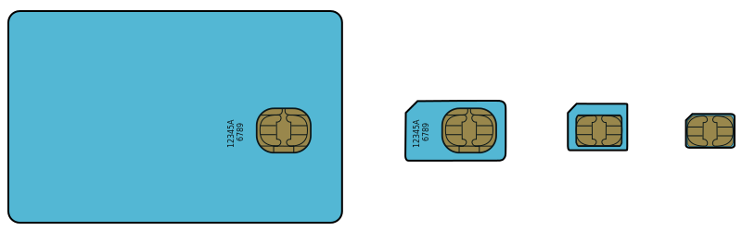  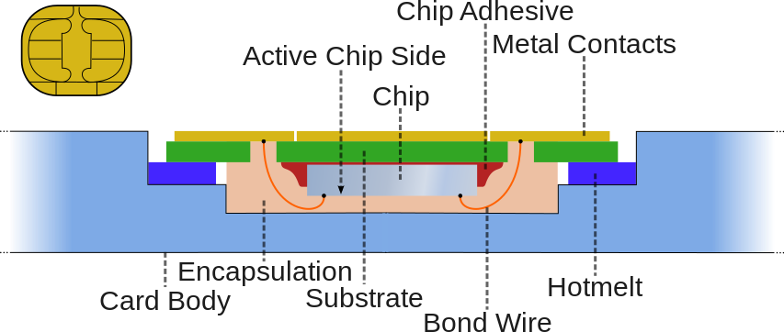
SIMPLE | Session Initiation Protocol for Instant Messaging and Presence Leveraging Extensions | SIMPLE, the Session Initiation Protocol for Instant Messaging and Presence Leveraging Extensions, is an instant messaging (IM) and presence protocol suite based on Session Initiation Protocol (SIP) managed by the Internet Engineering Task Force. Contrary to the vast majority of IM and presence protocols used by software deployed today, SIMPLE is an open standard like XMPP.
Simple Design |  | A team adopting the "simple design" practice bases its software design strategy on a set of "simple design" principles.
Simplex |  | Simplex communication is a communication channel that sends information in one direction only.  The International Telecommunication Union definition is a communications channel that operates in one direction at a time, but that may be reversible; this is termed half duplex in other contexts. A duplex communication channel requires two simplex channels operating in opposite directions.  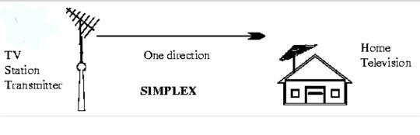
Single Step Test |  | Test conducted in a debugging environment by stepping through the source code while executing.
SIP | Session Initiation Protocol | The Session Initiation Protocol (SIP) is a communications protocol for signaling and controlling multimedia communication sessions in applications of Internet telephony for voice and video calls, in private IP telephone systems, as well as in instant messaging over Internet Protocol (IP) networks.  The protocol defines the specific format of messages exchanged and the sequence of communications for cooperation of the participants. SIP is a text-based protocol, incorporating many elements of the Hypertext Transfer Protocol (HTTP) and the Simple Mail Transfer Protocol (SMTP).[1] A call established with SIP may consist of multiple media streams, but no separate streams are required for applications, such as text messaging, that exchange data as payload in the SIP message.  SIP works in conjunction with several other protocols that specify and carry the session media. Media type and parameter negotiation and media setup is performed with the Session Description Protocol (SDP), which is carried as payload in SIP messages. SIP is designed to be independent of the underlying transport layer protocol, and can be used with the User Datagram Protocol (UDP), the Transmission Control Protocol (TCP), and the Stream Control Transmission Protocol (SCTP). For the transmission of media streams (voice, video) SIP typically employs the Real-time Transport Protocol (RTP) or the Secure Real-time Transport Protocol (SRTP). For secure transmissions of SIP messages over insecure network links, the protocol may be encrypted with Transport Layer Security (TLS)  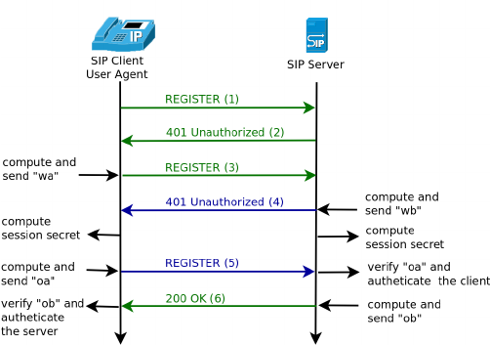  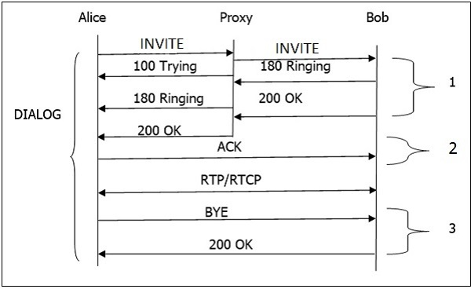
SIP Trunk |  | SIP trunking enables the end point’s PBX (Phone Exchange System) to send and receive calls via Internet. As SIP is applied for the signalling protocol for multiple real-time application, SIP trunk is able to control voice, video and messaging applications.  It is also a voice over Internet Protocol (VoIP) technology and streaming media service based on the Session Initiation Protocol (SIP) by which Internet telephony service providers (ITSPs) deliver telephone services and unified communications to customers equipped with SIP-based private branch exchange (IP-PBX) and unified communications facilities.
SISO | single-input and single-output | A single-input and single-output (SISO) system is a simple single variable control system with one input and one output. In radio it is the use of only one antenna both in the transmitter and receiver.
Skew |  | Clock skew (sometimes called timing skew) is a phenomenon in synchronous digital circuit systems (such as computer systems) in which the same sourced clock signal arrives at different components at different times i.e. the instantaneous difference between the readings of any two clocks is called their skew.
SLA | Service Level Agreement | A service-level agreement (SLA) is a commitment between a service provider and a client. Particular aspects of the service – quality, availability, responsibilities – are agreed between the service provider and the service user. The most common component of SLA is that the services should be provided to the customer as agreed upon in the contract. As an example, Internet service providers and telcos will commonly include service level agreements within the terms of their contracts with customers to define the level(s) of service being sold in plain language terms. In this case the SLA will typically have a technical definition in mean time between failures (MTBF), mean time to repair or mean time to recovery (MTTR); identifying which party is responsible for reporting faults or paying fees; responsibility for various data rates; throughput; jitter; or similar measurable details.
SLIP | Serial Line Interface Protocol | The Serial Line Internet Protocol (also SLIP) is an encapsulation of the Internet Protocol designed to work over serial ports and modem connections. It is documented in RFC 1055. On personal computers, SLIP has been largely replaced by the Point-to-Point Protocol (PPP), which is better engineered, has more features and does not require its IP address configuration to be set before it is established. On microcontrollers, however, SLIP is still the preferred way of encapsulating IP packets due to its very small overhead.
SME | Subject Matter Expert | A subject-matter expert (SME) or domain expert is a person who is an authority in a particular area or topic. The term domain expert is frequently used in expert systems software development, and there the term always refers to the domain other than the software domain. A domain expert is a person with special knowledge or skills in a particular area of endeavour (e.g. an accountant is an expert in the domain of accountancy). The development of accounting software requires knowledge in two different domains: accounting and software. Some of the development workers may be experts in one domain and not the other.
Smoke Test |  | Test conducted to prove a build.
smoke testing |  | non-exhaustive software testing, ascertaining that the most crucial functions of a prog
SMP | Symmetric Multiprocessing | Symmetric multiprocessing (SMP) involves a multiprocessor computer hardware and software architecture where two or more identical processors are connected to a single, shared main memory, have full access to all input and output devices, and are controlled by a single operating system instance that treats all processors equally, reserving none for special purposes. Most multiprocessor systems today use an SMP architecture. In the case of multi-core processors, the SMP architecture applies to the cores, treating them as separate processors.  Professor John D. Kubiatowicz considers traditionally SMP systems to contain processors without caches. Culler and Pal-Singh in their 1998 book "Parallel Computer Architecture: A Hardware/Software Approach" mention: "The term SMP is widely used but causes a bit of confusion. [...] The more precise description of what is intended by SMP is a shared memory multiprocessor where the cost of accessing a memory location is the same for all processors; that is, it has uniform access costs when the access actually is to memory. If the location is cached, the access will be faster. but cache access times and memory access times are the same on all processors."  SMP systems are tightly coupled multiprocessor systems with a pool of homogeneous processors running independently of each other. Each processor, executing different programs and working on different sets of data, has the capability of sharing common resources (memory, I/O device, interrupt system and so on) that are connected using a system bus or a crossbar.  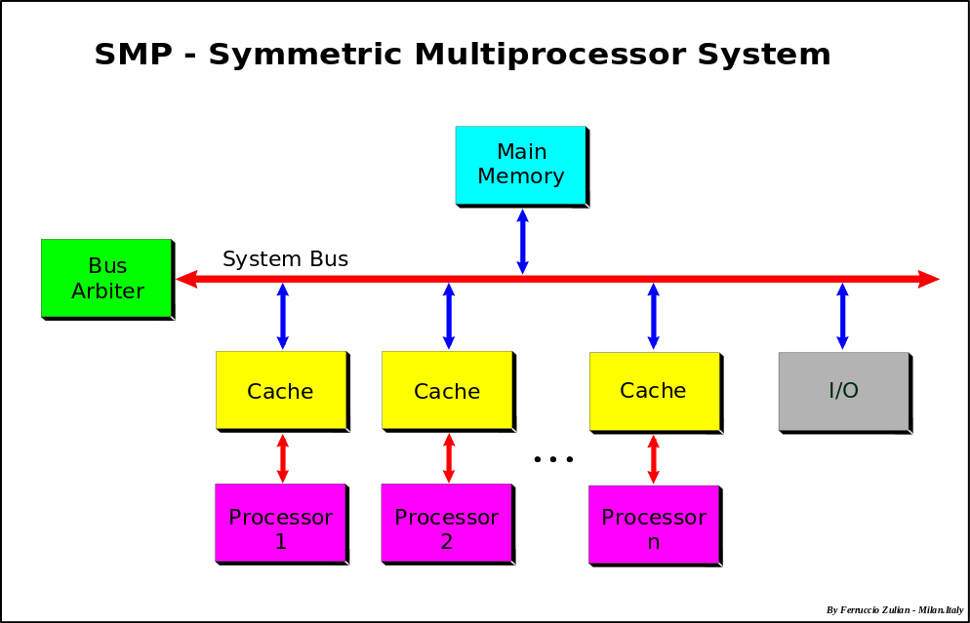
SMPF | Shared Metallic Path Facility | A copper pair to the exchange that goes to two telcos, one for telephone service and one for broadband. Normally this means telephone from BT, and can mean broadband from BT or from another provider.
SMSC | Short Message service center | A Short Message Service Center (SMSC) is a network element in the mobile telephone network. Its purpose is to store, forward, convert and deliver Short Message Service (SMS) messages.  The full designation of an SMSC according to 3GPP is Short Message Service - Service Center (SMS-SC).  Basic Trajectories of SMS are  - From mobile to another mobile - referred to as MO-MT (Mobile Originated - Mobile Terminated)  - From mobile to a content provider (also known as Large Account / ESME) - referred to as MO-AT (Mobile Originated - Application Terminated)  - From application to a mobile - referred to as AO-MT (Application Originated - Mobile Terminated)
Snake Case |  | Snake case (or snake_case) is the practice of writing compound words or phrases in which the elements are separated with one underscore character (_) and no spaces, with each element's initial letter usually lowercased within the compound and the first letter either upper- or lowercase—as in "foo_bar" and "Hello_world". It is commonly used in computer code for variable names, and function names, and sometimes computer filenames.
SNMP | Simple Network Management Protocol | Simple Network Management Protocol (SNMP) is an Internet Standard protocol for collecting and organizing information about managed devices on IP networks and for modifying that information to change device behavior. Devices that typically support SNMP include cable modems, routers, switches, servers, workstations, printers, and more.  SNMP is widely used in network management for network monitoring. SNMP exposes management data in the form of variables on the managed systems organized in a management information base (MIB) which describe the system status and configuration. These variables can then be remotely queried (and, in some circumstances, manipulated) by managing applications.  Three significant versions of SNMP have been developed and deployed. SNMPv1 is the original version of the protocol. More recent versions, SNMPv2c and SNMPv3, feature improvements in performance, flexibility and security.  SNMP is a component of the Internet Protocol Suite as defined by the Internet Engineering Task Force (IETF). It consists of a set of standards for network management, including an application layer protocol, a database schema, and a set of data objects.  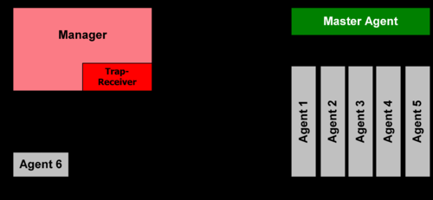
SNTP | Simple Network time Protocol | A less complex implementation of NTP, using the same protocol but without requiring the storage of state over extended periods of time, is known as the Simple Network Time Protocol (SNTP). It is used in some embedded devices and in applications where full NTP capability is not required.
SOA | Service-oriented architecture | Service-oriented architecture (SOA) is a style of software design where services are provided to the other components by application components, through a communication protocol over a network. The basic principles of service-oriented architecture are independent of vendors, products and technologies. A service is a discrete unit of functionality that can be accessed remotely and acted upon and updated independently, such as retrieving a credit card statement online.  A service has four properties according to one of many definitions of SOA:  - It logically represents a business activity with a specified outcome.  - It is self-contained.  - It is a black box for its consumers.  - It may consist of other underlying services.  Different services can be used in conjunction to provide the functionality of a large software application, a principle SOA shares with modular programming. Service-oriented architecture integrates distributed, separately-maintained and -deployed software components. It is enabled by technologies and standards that facilitate components' communication and cooperation over a network, especially over an IP network.
SOAP | Simple Object Access Protocol | SOAP (originally Simple Object Access Protocol) is a messaging protocol specification for exchanging structured information in the implementation of web services in computer networks. Its purpose is to induce extensibility, neutrality and independence. It uses XML Information Set for its message format, and relies on application layer protocols, most often Hypertext Transfer Protocol (HTTP) or Simple Mail Transfer Protocol (SMTP), for message negotiation and transmission.  SOAP allows processes running on disparate operating systems (such as Windows and Linux) to communicate using Extensible Markup Language (XML). Since Web protocols like HTTP are installed and running on all operating systems, SOAP allows clients to invoke web services and receive responses independent of language and platforms.  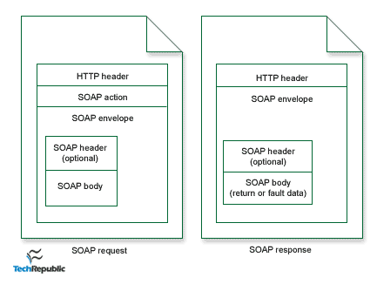
Softswitch |  | A softswitch (software switch) is a central device in a telecommunications network which connects telephone calls from one phone line to another, across a telecommunication network or the public Internet, entirely by means of software running on a general-purpose computer system. Most landline calls are routed by purpose-built electronic hardware; however, soft switches using general purpose servers and VoIP technology are becoming more popular.[1]  Many telecommunications networks now make use of combinations of softswitches and more traditional purpose-built hardware.  Although the term softswitch technically refers to any such device, it is more conventionally applied to a device that handles IP-to-IP phone calls, while the phrase "access server" or "media gateway" is used to refer to devices that either originate or terminate traditional "land line" (hard wired) phone calls. In practice, such devices can often do both. As a practical distinction, a Skype-to-Skype phone call is entirely IP (internet) based, and so uses a softswitch somewhere in the middle connecting the calling party with the called party. In contrast, access servers might take a mobile call or a call originating from a traditional phone line, convert it to IP traffic, then send it over the internet to another such device, which terminates the call by reversing the process and converting the Voice over IP call back to older circuit switched digital systems using traditional digital ISDN / PSTN protocols that transmit voice traffic using non-IP systems.  The Call Agent takes care of functions such as billing, call routing, signaling, call services and the like, supplying the functional logic to accomplish these telephony meta-tasks. A call agent may control several different media gateways in geographically dispersed areas via a TCP/IP link. It is also used to control the functions of media gateway, in order to connect with media as well as other interfaces. This procedure is utilized to keep the interfaces clear as crystal for receiving calls from any phone lines.[2]  The softswitch generally resides in a building owned by the telephone company called a telephone exchange (UK/IRL/AUS/NZ) or central office (US/CAN). The central office or telephone exchange has high capacity connections to carry calls to other offices owned by the telecommunication company and to other telecommunication companies via the PSTN.  Looking towards the end users from the switch, the softswitch may be connected to several access devices via TCP/IP network. These access devices can range from small and large Analog Telephone Adaptors (ATA) which provide from one to hundreds of Telephone Pairs to an Integrated Access Device (IAD), eMTA s (embedded Multimedia Terminal Adapters) using MGCP/NCS protocol over cable (VoCable) or PBX which may provide several hundred telephone connections  Note here that Analogue (ATA), PSTN telephone devices can only be reached by a softswitch that has embedded SS7 or SIGTRAN cards, software in terms of signalling AND Trunking Gateway for Voice traffic IP/TDM, TDM/IP, TDM/TDM functions.  Typically the larger access devices will be located in a building owned by the telecommunication company near to the customers they serve. Each end user can be connected to the IAD by a simple pair of copper wires.  The medium-sized devices and PBXs are most commonly used by business that locate them on their own premises, and single-line devices are mostly found at private residences.  At the turn of the 21st century with IP Multimedia Subsystem (or IMS), the Softswitch element is represented by the Media Gateway Controller (MGC) element, and the term "Softswitch" is rarely used in the IMS context. Rather, it is called an AGCF (Access Gateway Control Function).
Software Change Request | SCR | See change request.
Software Configuration Management | SCM | See configuration management.
Software Development Plan | SDP | Sometimes used as a synonym for project plan on software focused projects.
Software Engineering Body of Knowledge | SWEBOK | IEEE led industry effort to define a body of knowledge for software engineering. Is intended to support defining software engineering as a profession. CxOne bases its top-level organization on SWEBOK.  www.swebok.org
Software Engineering Lab | SEL | NASA lab developed to improving the software process used to develop systems at Goddard.
Software Engineering Process Group | SEPG | Provides experienced and objective technical oversight from individuals who are not directly involved in the project. Also provides process improvement input for projects and the organization.
Software Requirements Specification | SRS | A text based document that captures the requirements for a software system. Often used in conjunction with other requirements techniques such as modeling and prototyping to provide a complete view of system requirements.
SoGEA | Single Order Generic Ethernet Access | • Single order Generic Ethernet Access.  • Copper bearer to the cabinet and IP FTTC service delivered in a single order.  • No voice service services provided on copper bearer.  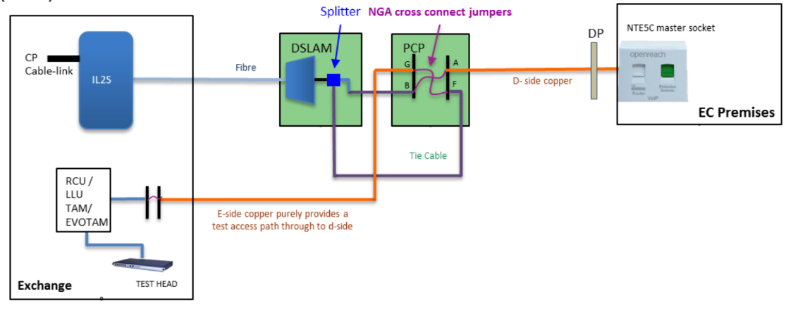  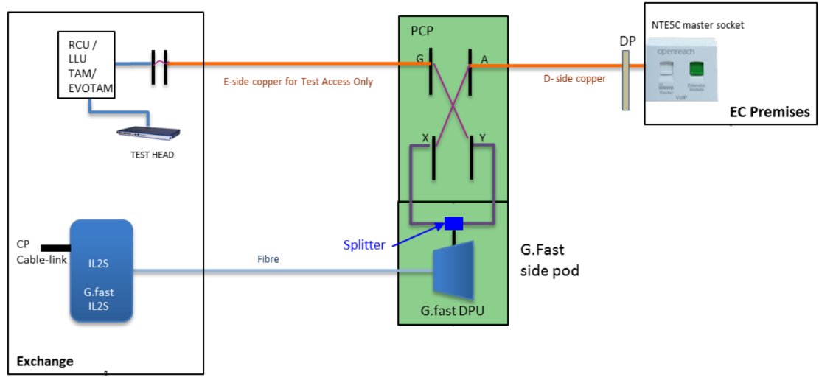
SONET | Synchronous Optical Network | Synchronous optical networking (SONET) and synchronous digital hierarchy (SDH) are standardized protocols that transfer multiple digital bit streams synchronously over optical fiber using lasers or highly coherent light from light-emitting diodes (LEDs). At low transmission rates data can also be transferred via an electrical interface. The method was developed to replace the plesiochronous digital hierarchy (PDH) system for transporting large amounts of telephone calls and data traffic over the same fiber without synchronization problems.  SONET and SDH, which are essentially the same, were originally designed to transport circuit mode communications (e.g., DS1, DS3) from a variety of different sources, but they were primarily designed to support real-time, uncompressed, circuit-switched voice encoded in PCM format.[1] The primary difficulty in doing this prior to SONET/SDH was that the synchronization sources of these various circuits were different. This meant that each circuit was actually operating at a slightly different rate and with different phase. SONET/SDH allowed for the simultaneous transport of many different circuits of differing origin within a single framing protocol. SONET/SDH is not a communications protocol in itself, but a transport protocol.  Due to SONET/SDH's essential protocol neutrality and transport-oriented features, SONET/SDH was the obvious choice for transporting the fixed length Asynchronous Transfer Mode (ATM) frames also known as cells. It quickly evolved mapping structures and concatenated payload containers to transport ATM connections. In other words, for ATM (and eventually other protocols such as Ethernet), the internal complex structure previously used to transport circuit-oriented connections was removed and replaced with a large and concatenated frame (such as STS-3c) into which ATM cells, IP packets, or Ethernet frames are placed.
Source Code |  | In computing, source code is any collection of code, possibly with comments, written using a human-readable programming language, usually as plain text. The source code of a program is specially designed to facilitate the work of computer programmers, who specify the actions to be performed by a computer mostly by writing source code. The source code is often transformed by an assembler or compiler into binary machine code understood by the computer. The machine code might then be stored for execution at a later time. Alternatively, source code may be interpreted and thus immediately executed.  Most application software is distributed in a form that includes only executable files. If the source code were included it would be useful to a user, programmer or a system administrator, any of whom might wish to study or modify the program.
SPEEX |  | Speex is an audio compression format specifically tuned for the reproduction of human speech and also a free software speech codec that may be used on VoIP applications and podcasts. It is based on the CELP speech coding algorithm. Speex claims to be free of any patent restrictions and is licensed under the revised (3-clause) BSD license. It may be used with the Ogg container format or directly transmitted over UDP/RTP. It may also be used with the FLV container format.  The Speex designers see their project as complementary to the Vorbis general-purpose audio compression project.  Speex is a lossy format, i.e. quality is permanently degraded to reduce file size.  The Speex project was created on February 13, 2002. The first development versions of Speex were released under LGPL license, but as of version 1.0 beta 1, Speex is released under Xiph's version of the (revised) BSD license. Speex 1.0 was announced on March 24, 2003, after a year of development. The last stable version of Speex encoder and decoder is 1.2.0.  Xiph.Org now considers Speex obsolete; its successor is the more modern Opus codec, which surpasses its performance in all areas.
Spiral Lifecycle |  | A set of mini-projects cumulating in final delivery. Each mini-project focuses on addressing the current major project risk(s).
Sponsor |  | Synonym for project sponsor.
Sprial Model |  | The spiral model is a risk-driven process model generator for software projects. Based on the unique risk patterns of a given project, the spiral model guides a team to adopt elements of one or more process models, such as incremental, waterfall, or evolutionary prototyping.  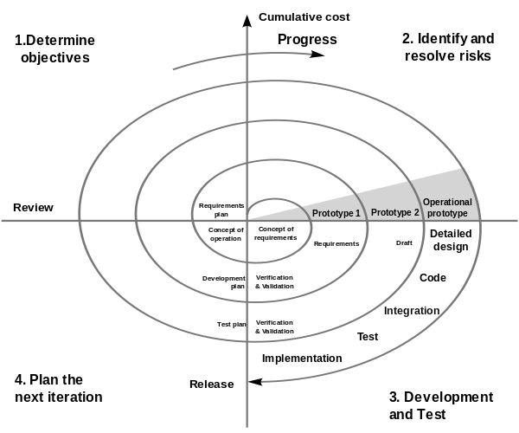
Sprint Planning |  | Sprint planning is an event that occurs at the beginning of a sprint where the team determines the product backlog items they will work on during that sprint.
Sprint retrospective |  | a review of a Sprint providing lessons learned with the aim of promoting continuous improvement.
Sprints |  | a short development phase within a larger project defined by available time (‘timeboxes’) and resources.
SQL |  | SQL is a domain-specific language used in programming and designed for managing data held in a relational database management system (RDBMS), or for stream processing in a relational data stream management system (RDSMS). It is particularly useful in handling structured data where there are relations between different entities/variables of the data. SQL offers two main advantages over older read/write APIs like ISAM or VSAM: first, it introduced the concept of accessing many records with one single command; and second, it eliminates the need to specify how to reach a record, e.g. with or without an index.  Originally based upon relational algebra and tuple relational calculus, SQL consists of many types of statements, which may be informally classed as sublanguages, commonly: a data query language (DQL), a data definition language (DDL), a data control language (DCL), and a data manipulation language (DML). The scope of SQL includes data query, data manipulation (insert, update and delete), data definition (schema creation and modification), and data access control. Although SQL is often described as, and to a great extent is, a declarative language (4GL), it also includes procedural elements.
SS7 | Signaling System 7 | Signaling System No. 7 (SS7) is a set of telephony signaling protocols developed in 1975, which is used to set up and tear down most of the world's public switched telephone network (PSTN) telephone calls. It also performs number translation, local number portability, prepaid billing, Short Message Service (SMS), and other mass market services.  In North America it is often referred to as CCSS7, abbreviated for Common Channel Signaling System 7. In the United Kingdom, it is called C7 (CCITT number 7), number 7 and CCIS7 (Common Channel Interoffice Signaling 7). In Germany, it is often called ZZK-7 (Zentraler ZeichengabeKanal Nummer 7).  The only international SS7 protocol is defined by ITU-T's Q.700-series recommendations in 1988.[1] Of the many national variants of the SS7 protocols, most are based on variants of the international protocol as standardized by ANSI and ETSI. National variants with striking characteristics are the Chinese and Japanese (TTC) national variants.  The Internet Engineering Task Force (IETF) has defined the SIGTRAN protocol suite that impinaplements levels 2, 3, and 4 protocols compatible with SS7. Sometimes also called Pseudo SS7, it is layered on the Stream Control Transmission Protocol (SCTP) transport mechanism.  SS7 protocol suite  The SS7 protocol stack may be partially mapped to the OSI Model of a packetized digital protocol stack. OSI layers 1 to 3 are provided by the Message Transfer Part (MTP) and the Signalling Connection Control Part (SCCP) of the SS7 protocol (together referred to as the Network Service Part (NSP)); for circuit related signaling, such as the BT IUP, Telephone User Part (TUP), or the ISDN User Part (ISUP), the User Part provides layer 7. Currently there are no protocol components that provide OSI layers 4 through 6.[1] The Transaction Capabilities Application Part (TCAP) is the primary SCCP User in the Core Network, using SCCP in connectionless mode. SCCP in connection oriented mode provides transport layer for air interface protocols such as BSSAP and RANAP. TCAP provides transaction capabilities to its Users (TC-Users), such as the Mobile Application Part, the Intelligent Network Application Part and the CAMEL Application Part.[citation needed]  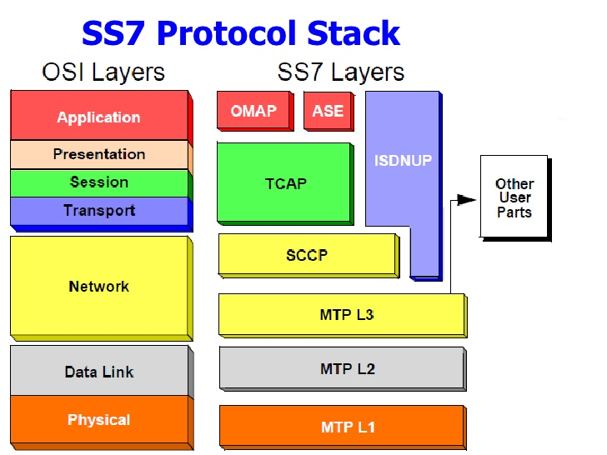  The Message Transfer Part (MTP) covers a portion of the functions of the OSI network layer including: network interface, information transfer, message handling and routing to the higher levels. Signaling Connection Control Part (SCCP) is at functional Level 4. Together with MTP Level 3 it is called the Network Service Part (NSP). SCCP completes the functions of the OSI network layer: end-to-end addressing and routing, connectionless messages (UDTs), and management services for users of the Network Service Part (NSP).[12] Telephone User Part (TUP) is a link-by-link signaling system used to connect calls. ISUP is the key user part, providing a circuit-based protocol to establish, maintain, and end the connections for calls. Transaction Capabilities Application Part (TCAP) is used to create database queries and invoke advanced network functionality, or links to Intelligent Network Application Part (INAP) for intelligent networks, or Mobile Application Part (MAP) for mobile services.
SSADM | Structured Systems Analysis & Design Method | a widely-used computer application development method in the UK that divides an application development project into modules, stages, steps, and tasks, and provides a framework for describing projects in a fashion suited to managing the project.
SSH | Secure Shell | Secure Shell (SSH) is a cryptographic network protocol for operating network services securely over an unsecured network. The best known example application is for remote login to computer systems by users.  SSH provides a secure channel over an unsecured network in a client-server architecture, connecting an SSH client application with an SSH server. Common applications include remote command-line login and remote command execution, but any network service can be secured with SSH. The protocol specification distinguishes between two major versions, referred to as SSH-1 and SSH-2.
SSID | Service Set Identifier | Logical wireless networks (including extended service sets) are identified by SSIDs, which serve as "network names" and are typically natural language labels.
SSIS | SQL Server Integration Services | SQL Server Integration Services (SSIS) is a component of the Microsoft SQL Server database software that can be used to perform a broad range of data migration tasks.  SSIS is a platform for data integration and workflow applications. It features a data warehousing tool used for data extraction, transformation, and loading (ETL). The tool may also be used to automate maintenance of SQL Server databases and updates to multidimensional cube data
SSL | Secure Sockets Layer | See TLS
Stack |  | The protocol stack or network stack is an implementation of a computer networking protocol suite or protocol family. The terms are often used interchangeably; strictly speaking, the suite is the definition of the Communications protocols, and the stack is the software implementation of them.  Individual protocols within a suite are often designed with a single purpose in mind. This modularization makes design and evaluation easier. Because each protocol module usually communicates with two others, they are commonly imagined as layers in a stack of protocols. The lowest protocol always deals with low-level interaction with the communications hardware. Every higher layer adds more features and capability. User applications usually deal only with the topmost layers (see also OSI model)  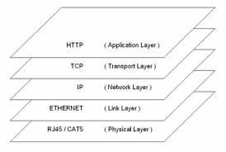
Staff Days |  | A measure of effort indicating how much work needs to take place on an activity or artifact. Is often used to differentiate from calendar days. Also applies to other units of time.
Stage |  | Often used as a synonym for phase. May be more precisely used to define groupings of milestones, in terms of a hierarchy with phases that are made up of stages.
Staged Delivery Lifecycle |  | Project development occurs in stages, where the most critical functionality is delivered first
Stakeholder |  | Individuals or entities with significant investment in the outcome of a project. Normally includes clients, customers, internal/external organizations affected by the project, etc.
Standard | CxStand | CxOne standard material type. Defined terminology, processes, policies, knowledge, and/or guidelines. See CxOneOverview for description.
Statistical Estimation |  | Estimation techniques that utilize historical data coupled with a statistically derived model to provide output estimates based on input characteristics. Most often use size as an input to predict effort and time. Works best when calibrated with relevant historical data and influence modifiers.
STB | Set Top Box | A set-top box (STB) or set-top unit (STU) (one type also colloquially known as a cable box) is an information appliance device that generally contains a TV-tuner input and displays output to a television set and an external source of signal, turning the source signal into content in a form that then be displayed on the television screen or other display device. They are used in cable television, satellite television, and over-the-air television systems, as well as other uses.
Stories |  | see Requirements.
Story Mapping |  | Story mapping consists of ordering user stories along two independent dimensions.
Story Splitting |  | Splitting consists of breaking up one user story into smaller ones, while preserving the property that each user story separately has measurable business value.
Storyboard |  | A sequence of images which depict a scenario or use case.
STP | Spanning Tree Protocol | The Spanning Tree Protocol (STP) is a network protocol that builds a loop-free logical topology for Ethernet networks. The basic function of STP is to prevent bridge loops and the broadcast radiation that results from them. Spanning tree also allows a network design to include backup links to provide fault tolerance if an active link fails.  As the name suggests, STP creates a spanning tree within a network of connected layer-2 bridges, and disables those links that are not part of the spanning tree, leaving a single active path between any two network nodes. STP is based on an algorithm that was invented by Radia Perlman while she was working for Digital Equipment Corporation.  In 2001, the IEEE introduced Rapid Spanning Tree Protocol (RSTP) as 802.1w. RSTP provides significantly faster recovery in response to network changes or failures, introducing new convergence behaviors and bridge port roles to do this. RSTP was designed to be backwards-compatible with standard STP.
Strategy |  | The way a problem or issue is approached.
STUN | Session Traversal Utilities for NAT | (STUN) is a standardized set of methods, including a network protocol, for traversal of network address translator (NAT) gateways in applications of real-time voice, video, messaging, and other interactive communications.  STUN is a tool used by other protocols, such as Interactive Connectivity Establishment (ICE), the Session Initiation Protocol (SIP), or WebRTC. It provides a tool for hosts to discover the presence of a network address translator, and to discover the mapped, usually public, Internet Protocol (IP) address and port number that the NAT has allocated for the application's User Datagram Protocol (UDP) flows to remote hosts. The protocol requires assistance from a third-party network server (STUN server) located on the opposing (public) side of the NAT, usually the public Internet.  Originally, STUN was an acronym for Simple Traversal of User Datagram Protocol (UDP) through Network Address Translators, but this title was changed in a specification of an updated set of methods published as RFC 5389, retaining the same acronym
Subversion |  | Apache Subversion (often abbreviated SVN, after its command name svn) is a software versioning and revision control system distributed as open source under the Apache License. Software developers use Subversion to maintain current and historical versions of files such as source code, web pages, and documentation. Its goal is to be a mostly compatible successor to the widely used Concurrent Versions System (CVS).
Sustainable Pace |  | The team aims for a work pace that they would be able to sustain indefinitely.
SVC | Soft Virtual Service | Switched virtual circuits (SVCs) are generally set up on a per-call basis and are disconnected when the call is terminated; however, a permanent virtual circuit (PVC) can be established as an option to provide a dedicated circuit link between two facilities. PVC configuration is usually preconfigured by the service provider. Unlike SVCs, PVC are usually very seldom broken/disconnected.  A switched virtual circuit (SVC) is a virtual circuit that is dynamically established on demand and is torn down when transmission is complete, for example after a phone call or a file download. SVCs are used in situations where data transmission is sporadic and/or not always between the same data terminal equipment (DTE) endpoints.
Swift |  | Swift is a general-purpose, multi-paradigm, compiled programming language developed by Apple Inc. for iOS, macOS, watchOS, tvOS, and Linux. Swift is designed to work with Apple's Cocoa and Cocoa Touch frameworks and the large body of existing Objective-C (ObjC) code written for Apple products. It is built with the open source LLVM compiler framework and has been included in Xcode since version 6. On platforms other than Linux, it uses the Objective-C runtime library which allows C, Objective-C, C++ and Swift code to run within one program
Switch |  | A network switch (also called switching hub, bridging hub, officially MAC bridge) is a computer networking device that connects devices together on a computer network by using packet switching to receive, process, and forward data to the destination device.  A network switch is a multiport network bridge that uses hardware addresses to process and forward data at the data link layer (layer 2) of the OSI model. Some switches can also process data at the network layer (layer 3) by additionally incorporating routing functionality. Such switches are commonly known as layer-3 switches or multilayer switches.  Switches for Ethernet are the most common form of network switch. The first Ethernet switch was introduced by Kalpana in 1990. Switches also exist for other types of networks including Fibre Channel, Asynchronous Transfer Mode, and InfiniBand.  Unlike less advanced repeater hubs, which broadcast the same data out of each of its ports and let the devices decide what data they need, a network switch forwards data only to the devices that need to receive it
System |  | A functional entity, normally composed of software, hardware, and closely related operational processes.  In CxOne, system is often used to refer to the software portions of a system.  Also used in CxOne to refer to the end output of a project, i.e., the system a project was chartered to create. This is useful when discussing attributes of a the system separate from attributes of the project.
System Test |  | Test focused on verifying operational behavior of the entire system, using a project build and the system test environment.
System Test Environment |  | Environment that simulates operational environment and conditions as closely as possible.
SystemX | 2nd national digital telephone exchange system to be used in the United Kingdom. | System X was developed by the UK Post Office (later to become British Telecom), GEC, Plessey (later to be Marconi), and Standard Telephones and Cables (STC).  System X covers three main types of telephone switching equipment. Many of these switches reside all over the United Kingdom. Concentrators are usually kept in local telephone exchanges but can be housed remotely in less populated areas. DLEs and DMSUs operate in major towns and cities and provide call routing functions.  Concentrator unit  The concentrator unit consists of four main sub-systems, line modules, digital concentrator switch, digital line termination (DLT) units and control unit. Its purpose is to convert speech from analogue signals to digital format and concentrate the traffic for onward transmission to the digital local exchange (DLE). It also receives dialled information from the subscriber and passes this to the DLE, so that the call can be routed to its destination. In normal circumstances, it does not switch signals between subscriber lines but has limited capacity to do this if the connection to the DLE is lost.  Digital local exchange  The Digital Local Exchange (DLE) connects to the concentrator and routes calls to different DLEs or DMSUs depending on the destination of the call. The heart of the DLE is the Digital Subscriber Switching Subsystem (DSSS) which consists of Time Switches and a Space Switch. Incoming traffic on the 30 channel PCM highways from the Concentrator Units is connected to Time Switches. The purpose of these is to take any incoming individual Time Slot and connect it to an outgoing Time Slot and so perform a switching and routing function.  Digital main switching unit  The Digital Main Switching Unit (DMSU) deals with calls that have been routed by DLEs or another DMSU and is a 'trunk switch', i.e. it is not connected to any concentrators. As with DLEs, DMSUs are made up of a Digital Switching Subsystem and a Processor Utility Subsystem, amongst other things. In the British PSTN network, each DMSU is connected to every other DMSU in the country, enabling almost congestion-proof connectivity for calls through the network.  Replacement system  Many of the switches installed during the 1980s are near to or over 30 years old and still in use within local exchanges, giving an idea of their reliability.  System X was scheduled for replacement with Next Generation softswitch equipment as part of the BT 21st Century Network (21CN) programme. Some other users of System X – in particular Jersey Telecom and Kingston Communications – replaced their circuit switched System X equipment with Marconi XCD5000 softswitches (which are the NGN replacement for System X) and Access Hub multiservice access nodes. However, the omission of Marconi from the BT 21CN supplier list, the lack of a suitable replacement softswitch to match System X reliability, and the shift in focus away from telephony onto broadband – all led to much of the System X estate being maintained.

T
Task |  | An atomic unit of work on a project. See activity.
Task Board |  | The most basic form of a task board is divided into three columns labeled "To Do," "In Progress," and "Done." Cards are placed in the columns to reflect the current status of that task.  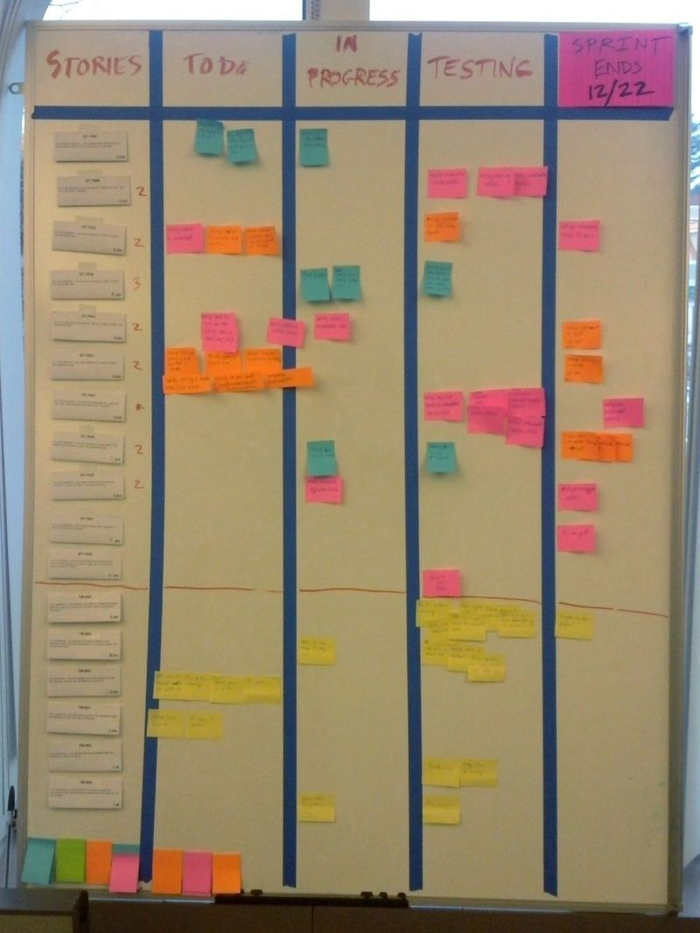
Task Estimate |  | An estimate for a particular task. Depending on purpose and formality these estimates are often created and captured as part of ongoing planning and tracking and incorporated in work plans and detailed schedules.
TCAP | Transaction Capabilities Application Part | Transaction Capabilities Application Part, from ITU-T recommendations Q.771-Q.775 or ANSI T1.114 is a protocol for Signalling System 7 networks. Its primary purpose is to facilitate multiple concurrent dialogs between the same sub-systems on the same machines, using Transaction IDs to differentiate these, similar to the way TCP ports facilitate multiplexing connections between the same IP addresses on the Internet.  TCAP uses ASN.1 BER encoding, as well as the protocols it encapsulates, namely MAP in mobile phone networks or INAP in Intelligent Networks.
Tcl/tk |  | Tk is a free and open-source, cross-platform widget toolkit that provides a library of basic elements of GUI widgets for building a graphical user interface (GUI) in many programming languages.  Tk provides a number of widgets commonly needed to develop desktop applications, such as button, menu, canvas, text, frame, label, etc. Tk has been ported to run on most flavors of Linux, Mac OS, Unix, and Microsoft Windows. Like Tcl, Tk supports Unicode within the Basic Multilingual Plane but it has not yet been extended to handle 32-bit Unicode.  Tk was designed to be extended, and a wide range of extensions are available that offer new widgets or other capabilities.  Since Tcl/Tk 8, it offers "native look and feel" (for instance, menus and buttons are displayed in the manner of "native" software for any given platform). Highlights of version 8.5 include a new theming engine, originally called Tk Tile, but now generally referred to as "themed Tk", as well as improved font rendering.
TCP | Transmission Control Protocol | The Transmission Control Protocol (TCP) is one of the main protocols of the Internet protocol suite. It originated in the initial network implementation in which it complemented the Internet Protocol (IP). Therefore, the entire suite is commonly referred to as TCP/IP. TCP provides reliable, ordered, and error-checked delivery of a stream of octets (bytes) between applications running on hosts communicating via an IP network. Major internet applications such as the World Wide Web, email, remote administration, and file transfer rely on TCP. Applications that do not require reliable data stream service may use the User Datagram Protocol (UDP), which provides a connectionless datagram service that emphasizes reduced latency over reliability.  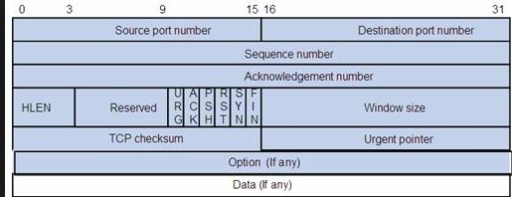
Tcsh |  | tcsh is a Unix shell based on and compatible with the C shell (csh). It is essentially the C shell with programmable command-line completion, command-line editing, and a few other features. Unlike the other common shells, functions cannot be defined in a tcsh script and the user must use aliases instead (as in csh). It is the native root shell for BSD-based systems such as FreeBSD.  tcsh added filename and command completion and command line editing concepts borrowed from the Tenex system, which is the source of the “t”. Because it only added functionality and did not change what was there, tcsh remained backward compatible with the original C shell. Though it started as a side branch from the original source tree Joy had created, tcsh is now the main branch for ongoing development. tcsh is very stable but new releases continue to appear roughly once a year, consisting mostly of minor bug fixes.
TDD | Test Driven Development | Test-driven development is a style of programming in which three activities are tightly interwoven: coding, testing (in the form of writing unit tests) and design (in the form of refactoring).
TDM | Time Division Multiplexing | Time-division multiplexing (TDM) is a method of transmitting and receiving independent signals over a common signal path by means of synchronized switches at each end of the transmission line so that each signal appears on the line only a fraction of time in an alternating pattern. It is used when the bit rate of the transmission medium exceeds that of the signal to be transmitted. This form of signal multiplexing was developed in telecommunications for telegraphy systems in the late 19th century, but found its most common application in digital telephony in the second half of the 20th century.  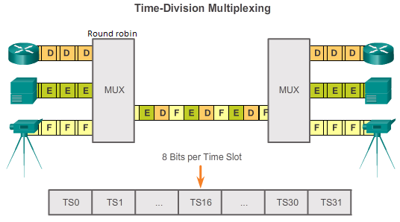
Team |  | A "team" in the Agile sense is a small group of people, assigned to the same project or effort, nearly all of them on a full-time basis.
Team Room |  | The team (ideally the whole team, including the product owner or domain expert) has the use of a dedicated space for the duration of the project, set apart from other groups' activities.
Technical Debt |  | Technical debt (also known as design debt or code debt) is a concept in software development that reflects the implied cost of additional rework caused by choosing an easy solution now instead of using a better approach that would take longer.  Technical debt can be compared to monetary debt. If technical debt is not repaid, it can accumulate 'interest', making it harder to implement changes later on. Unaddressed technical debt increases software entropy. Technical debt is not necessarily a bad thing, and sometimes (e.g., as a proof-of-concept) technical debt is required to move projects forward. On the other hand, some experts claim that the "technical debt" metaphor tends to minimize the impact, which results in insufficient prioritization of the necessary work to correct it
Template | CxTemp | CxOne template material type. Provides an outline, framework, or container for creating an artifact. See CxOneOverview for description.
Test |  | See Testing. May also be used to describe an individual test case.
Test Activity |  | A specific test procedure created by combining one or more test techniques and test types.
Test Case | TC | A description of inputs, execution instructions, and expected results, which are created for the purpose of determining whether a specific software feature works correctly or a specific requirement has been satisfied.
Test Case Specification | TCS | Documents the set of test cases needed to verify one or more product features.
Test Design |  | Provides a bridge between the test cases and the product’s requirements and design. Test design is analogous to software design, and is used when test solutions require a significant amount of analysis and defined structure.  Test design is not software design necessary to support testing (e.g., design of an automated test framework).
Test Design Specification | TDS | Documents the test design for a group of test cases.
Test Level |  | Synonym for test type.
Test Plan | TP | Documents the scope, approach, resources, test items, and schedule of the testing activities.
Test Technique |  | Strategy and approach to a test activity.
Test Type |  | Standard definitions capturing the what, how, why, and when of a test activity.
Testing |  | Software testing CKA. Dynamic execution of software to detect defects. See CxStand_Testing for more information.
Three Amigos |  | Three amigos refers to the primary perspectives to examine an increment of work before, during, and after development. Those perspectives are Business, Development, and Testing.
Three C's |  | "Card, Conversation, Confirmation" is a formula that captures the components of a User Story.
Three Questions |  | The daily meeting is structured around some variant of the following three questions: What have you completed? What will you do next? What is getting in your way?
TIA | Telecommunications Industry Association | The Telecommunications Industry Association (TIA) is accredited by the American National Standards Institute (ANSI) to develop voluntary, consensus-based industry standards for a wide variety of Information and Communication Technologies (ICT) products, and currently represents nearly 400 companies. TIA's Standards and Technology Department operates twelve engineering committees, which develop guidelines for private radio equipment, cellular towers, data terminals, satellites, telephone terminal equipment, accessibility, VoIP devices, structured cabling, data centers, mobile device communications, multimedia multicast, vehicular telematics, healthcare ICT, machine to machine communications, and smart utility networks.
Timebox |  | A timebox is a previously agreed period of time during which a person or a team works steadily towards completion of some goal.
TKIP | Temporal Key Integrity Protocol | Temporal Key Integrity Protocol or TKIP /tiːˈkɪp/ is a security protocol used in the IEEE 802.11 wireless networking standard. TKIP was designed by the IEEE 802.11i task group and the Wi-Fi Alliance as an interim solution to replace WEP without requiring the replacement of legacy hardware. This was necessary because the breaking of WEP had left Wi-Fi networks without viable link-layer security, and a solution was required for already deployed hardware. However, TKIP itself is no longer considered secure, and was deprecated in the 2012 revision of the 802.11 standard.
TLS | Transport Layer Security | Transport Layer Security (TLS) – and its predecessor, Secure Sockets Layer (SSL), which is now deprecated by the Internet Engineering Task Force (IETF) – are cryptographic protocols that provide communications security over a computer network. Several versions of the protocols find widespread use in applications such as web browsing, email, instant messaging, and voice over IP (VoIP). Websites are able to use TLS to secure all communications between their servers and web browsers.  The TLS protocol aims primarily to provide privacy and data integrity between two or more communicating computer applications. When secured by TLS, connections between a client (e.g., a web browser) and a server (e.g., wikipedia.org) have one or more of the following properties:  - The connection is private (or secure) because symmetric cryptography is used to encrypt the data transmitted. The keys for this symmetric encryption are generated uniquely for each connection and are based on a shared secret negotiated at the start of the session. The server and client negotiate the details of which encryption algorithm and cryptographic keys to use before the first byte of data is transmitted . The negotiation of a shared secret is both secure (the negotiated secret is unavailable to eavesdroppers and cannot be obtained, even by an attacker who places themselves in the middle of the connection) and reliable (no attacker can modify the communications during the negotiation without being detected).  - The identity of the communicating parties can be authenticated using public-key cryptography. This authentication can be made optional, but is generally required for at least one of the parties (typically the server).  - The connection is reliable because each message transmitted includes a message integrity check using a message authentication code to prevent undetected loss or alteration of the data during transmission.  - 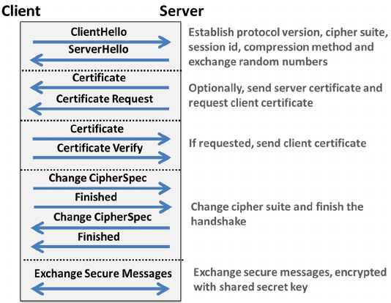
TLV | Type(Tag), Length and Value | Within data communication protocols, TLV (type-length-value or tag-length-value) is an encoding scheme used for optional information element in a certain protocol.  The type and length are fixed in size (typically 1-4 bytes), and the value field is of variable size. These fields are used as follows:  Type  A binary code, often simply alphanumeric, which indicates the kind of field that this part of the message represents;  Length  The size of the value field (typically in bytes);  Value  Variable-sized series of bytes which contains data for this part of the message.  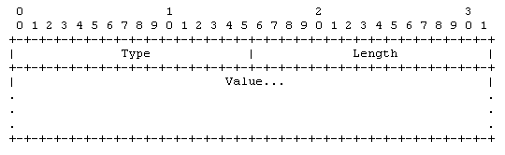
Token Ring |  | Token Ring local area network (LAN) technology is a communications protocol for local area networks. It uses a special three-byte frame called a "token" that travels around a logical "ring" of workstations or servers. This token passing is a channel access method providing fair access for all stations, and eliminating the collisions of contention-based access methods.  Introduced by IBM in 1984, it was then standardized with protocol IEEE 802.5 and was fairly successful, particularly in corporate environments, but gradually eclipsed by the later versions of Ethernet.  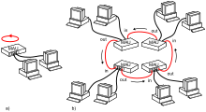
Top Level Schedule |  | See Business Schedule.
Top-Down Estimation |  | Estimating a system by deriving values for the entire system, and then splitting the total values among decomposed pieces of the system.
Triple DES |  | In cryptography, Triple DES (3DES), officially the Triple Data Encryption Algorithm (TDEA or Triple DEA), is a symmetric-key block cipher, which applies the DES cipher algorithm three times to each data block.  While the government and industry standards abbreviate the algorithm's name as TDES (Triple DES) and TDEA (Triple Data Encryption Algorithm), RFC 1851 called it 3DES from the time it first promulgated the idea, and this namesake has since come into wide use by most vendors, users, and cryptographers.
T-Shirt Sizing |  | T-shirt sizing is a way to practice relative sizing. By comparing stories, you can break them into buckets of extra-small, small, medium, large, and extra-large.  Estimating in relative buckets is more important than estimating absolute time or effort. We want to understand how things compare to each other in a rough sense, and not waste time on false precision.
TTY |  | A terminal emulator, terminal application, or term, is a program that emulates a video terminal within some other display architecture. Though typically synonymous with a shell or text terminal, the term terminal covers all remote terminals, including graphical interfaces. A terminal emulator inside a graphical user interface is often called a terminal window.  A terminal window allows the user access to a text terminal and all its applications such as command-line interfaces (CLI) and text user interface (TUI) applications. These may be running either on the same machine or on a different one via telnet, ssh, or dial-up. On Unix-like operating systems, it is common to have one or more terminal windows connected to the local machine.
TUP | Telephone User Part | Telephone User Part (TUP) provides conventional PSTN telephony services across the Signalling System No. 7 (SS7) network. TUP was the first layer 4 protocol defined by the standards bodies and as such did not provision for ISDN services. It has now largely been replaced by ISUP. However, it can still be found in operational use in some parts of the world (e.g., China).  TUP is defined in ITU-T Recommendations Q.721-725. These define the international telephone call control signalling functions for use over SS7.  Various national variants of TUP have evolved, some of which provide varying degrees of support for ISDN.
Twisted pair |  | Twisted pair cabling is a type of wiring in which two conductors of a single circuit are twisted together for the purposes of improving electromagnetic compatibility. Compared to a single conductor or an untwisted balanced pair, a twisted pair reduces electromagnetic radiation, crosstalk between neighboring pairs and improves rejection of external electromagnetic interference

U
UA | User Agent | In computing, a user agent is software (a software agent) that is acting on behalf of a user. One common use of the term refers to a web browser telling a website information about the browser and operating system. This allows the website to customize content for the capabilities of a particular device, but also raises privacy issues.  There are other uses of the term "user agent". For example, an email reader is a mail user agent. In many cases, a user agent acts as a client in a network protocol used in communications within a client–server distributed computing system. In particular, the Hypertext Transfer Protocol (HTTP) identifies the client software originating the request, using a user-agent header, even when the client is not operated by a user. The Session Initiation Protocol (SIP) protocol (based on HTTP) followed this usage. In the SIP, the term user agent refers to both end points of a communications session.
Ubiquitous Language |  | Striving to use the vocabulary of a given business domain, not only in discussions about the requirements for a software product, but in discussions of design as well and all the way into "the product's source code itself."
UDP | User Datagram Protocol | In computer networking, the User Datagram Protocol (UDP) is one of the core members of the Internet protocol suite. The protocol was designed by David P. Reed in 1980 and formally defined in RFC 768. With UDP, computer applications can send messages, in this case referred to as datagrams, to other hosts on an Internet Protocol (IP) network. Prior communications are not required in order to set up communication channels or data paths.  UDP uses a simple connectionless communication model with a minimum of protocol mechanism. UDP provides checksums for data integrity, and port numbers for addressing different functions at the source and destination of the datagram. It has no handshaking dialogues, and thus exposes the user's program to any unreliability of the underlying network; There is no guarantee of delivery, ordering, or duplicate protection. If error-correction facilities are needed at the network interface level, an application may use Transmission Control Protocol (TCP) or Stream Control Transmission Protocol (SCTP) which are designed for this purpose.  UDP is suitable for purposes where error checking and correction are either not necessary or are performed in the application; UDP avoids the overhead of such processing in the protocol stack. Time-sensitive applications often use UDP because dropping packets is preferable to waiting for packets delayed due to retransmission, which may not be an option in a real-time system.  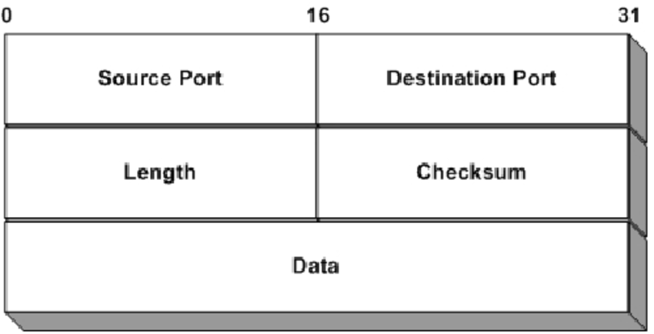
UER | Universal Edge Router | What Juniper call their BRASs.
UML |  | The Unified Modeling Language (UML) is a general-purpose, developmental, modeling language in the field of software engineering, that is intended to provide a standard way to visualize the design of a system.  The creation of UML was originally motivated by the desire to standardize the disparate notational systems and approaches to software design. It was developed by Grady Booch, Ivar Jacobson and James Rumbaugh at Rational Software in 1994–1995, with further development led by them through 1996.  In 1997 UML was adopted as a standard by the Object Management Group (OMG), and has been managed by this organization ever since. In 2005 UML was also published by the International Organization for Standardization (ISO) as an approved ISO standard.[2] Since then the standard has been periodically revised to cover the latest revision of UML.  Design  UML offers a way to visualize a system's architectural blueprints in a diagram, including elements such as:  - any activities (jobs);  - individual components of the system;  - and how they can interact with other software components;  - how the system will run;  - how entities interact with others (components and interfaces);  - external user interface.  Although originally intended for object-oriented design documentation, UML has been extended to a larger set of design documentation (as listed above),and been found useful in many contexts.  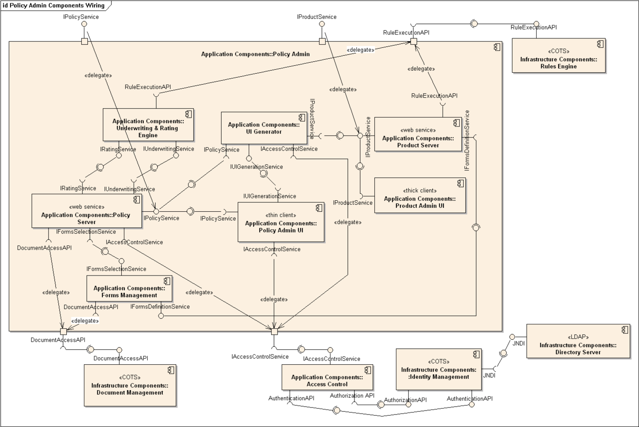  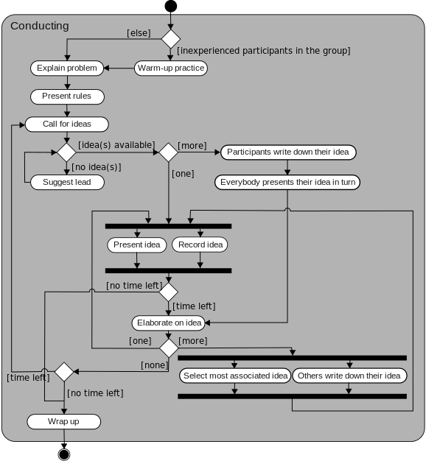  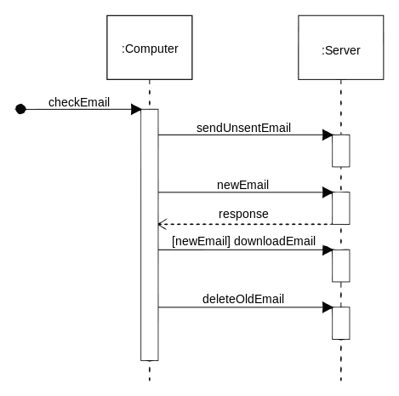
UMTS | Universal Mobile Telecommunications System | The Universal Mobile Telecommunications System (UMTS) is a third generation mobile cellular system for networks based on the GSM standard. Developed and maintained by the 3GPP (3rd Generation Partnership Project), UMTS is a component of the International Telecommunications Union IMT-2000 standard set and compares with the CDMA2000 standard set for networks based on the competing cdmaOne technology. UMTS uses wideband code division multiple access (W-CDMA) radio access technology to offer greater spectral efficiency and bandwidth to mobile network operators.  UMTS specifies a complete network system, which includes the radio access network (UMTS Terrestrial Radio Access Network, or UTRAN), the core network (Mobile Application Part, or MAP) and the authentication of users via SIM (subscriber identity module) cards.  The technology described in UMTS is sometimes also referred to as Freedom of Mobile Multimedia Access (FOMA) or 3GSM.
UNI | User–network interface | See NNI  In telecommunications, a User Network Interface (UNI) is a demarcation point between the responsibility of the service provider and the responsibility of the subscriber. This is distinct from a Network to Network Interface (NNI) that defines a similar interface between provider networks.
unicast |  | In computer networking, unicast refers to a one-to-one transmission from one point in the network to another point; that is, one sender and one receiver, each identified by a network address.  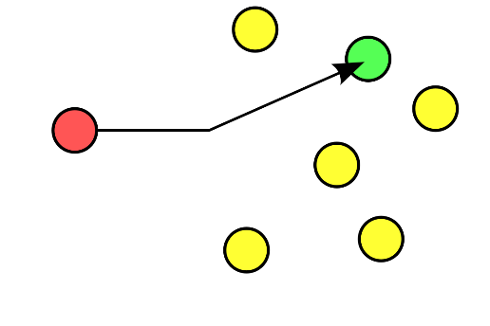
Unicode |  | Unicode is a computing industry standard for the consistent encoding, representation, and handling of text expressed in most of the world's writing systems. The standard is maintained by the Unicode Consortium, and as of June 2018 the most recent version, Unicode 11.0, contains a repertoire of 137,439 characters covering 146 modern and historic scripts, as well as multiple symbol sets and emoji. The character repertoire of the Unicode Standard is synchronized with ISO/IEC 10646, and both are code-for-code identical.  The Unicode Standard consists of a set of code charts for visual reference, an encoding method and set of standard character encodings, a set of reference data files, and a number of related items, such as character properties, rules for normalization, decomposition, collation, rendering, and bidirectional display order (for the correct display of text containing both right-to-left scripts, such as Arabic and Hebrew, and left-to-right scripts).  Unicode's success at unifying character sets has led to its widespread and predominant use in the internationalization and localization of computer software. The standard has been implemented in many recent technologies, including modern operating systems, XML, Java (and other programming languages), and the .NET Framework.  Unicode can be implemented by different character encodings. The Unicode standard defines UTF-8, UTF-16, and UTF-32, and several other encodings are in use. The most commonly used encodings are UTF-8, UTF-16 and UCS-2, a precursor of UTF-16.  UTF-8, dominantly used by websites (over 91%), uses one byte for the first 128 code points, and up to 4 bytes for other characters. The first 128 Unicode code points are the ASCII characters, which means that any ASCII text is also a UTF-8 text.  UCS-2 uses two bytes (16 bits) for each character but can only encode the first 65,536 code points, the so-called Basic Multilingual Plane (BMP). With 1,114,112 code points on 17 planes being possible, and with over 137,000 code points defined so far, many Unicode characters are beyond the reach of UCS-2. Therefore, UCS-2 is obsolete, though still widely used in software. UTF-16 extends UCS-2, by using the same 16-bit encoding as UCS-2 for the Basic Multilingual Plane, and a 4-byte encoding for the other planes. As long as it contains no code points in the reserved range U+D800–U+DFFF, a UCS-2 text is a valid UTF-16 text.  UTF-32 (also referred to as UCS-4) uses four bytes for each character. Like UCS-2, the number of bytes per character is fixed, facilitating character indexing; but unlike UCS-2, UTF-32 is able to encode all Unicode code points. However, because each character uses four bytes, UTF-32 takes significantly more space than other encodings, and is not widely used.
Unified Communications |  | Unified communications (UC) is a business and marketing concept describing the integration of enterprise communication services such as instant messaging (chat), presence information, voice (including IP telephony), mobility features (including extension mobility and single number reach), audio, web & video conferencing, fixed-mobile convergence (FMC), desktop sharing, data sharing (including web connected electronic interactive whiteboards), call control and speech recognition with non-real-time communication services such as unified messaging (integrated voicemail, e-mail, SMS and fax). UC is not necessarily a single product, but a set of products that provides a consistent unified user interface and user experience across multiple devices and media types.  In its broadest sense, the UC can encompass all forms of communications that are exchanged via a network to include other forms of communications such as Internet Protocol Television (IPTV) and digital signage Communications as they become an integrated part of the network communications deployment and may be directed as one-to-one communications or broadcast communications from one to many.  UC allows an individual to send a message on one medium and receive the same communication on another medium. For example, one can receive a voicemail message and choose to access it through e-mail or a cell phone. If the sender is online according to the presence information and currently accepts calls, the response can be sent immediately through text chat or a video call. Otherwise, it may be sent as a non-real-time message that can be accessed through a variety of media.
Unified Modeling Language | UML | A defined set of rules, concepts, and notations used to specify object-oriented systems
Unit Test |  | Lowest level component test for a system.
Unit Testing |  | A unit test is a short program fragment written and maintained by the developers on the product team, which exercises some narrow part of the product's source code and checks the results.
Unix |  | Unix is a family of multitasking, multiuser computer operating systems that derive from the original AT&T Unix, development starting in the 1970s at the Bell Labs research center by Ken Thompson, Dennis Ritchie, and others.  Initially intended for use inside the Bell System, AT&T licensed Unix to outside parties in the late 1970s, leading to a variety of both academic and commercial Unix variants from vendors including University of California, Berkeley (BSD), Microsoft (Xenix), IBM (AIX), and Sun Microsystems (Solaris). In the early 1990s, AT&T sold its rights in Unix to Novell, which then sold its Unix business to the Santa Cruz Operation (SCO) in 1995. The UNIX trademark passed to The Open Group, a neutral industry consortium, which allows the use of the mark for certified operating systems that comply with the Single UNIX Specification (SUS). As of 2014, the Unix version with the largest installed base is Apple's macOS.  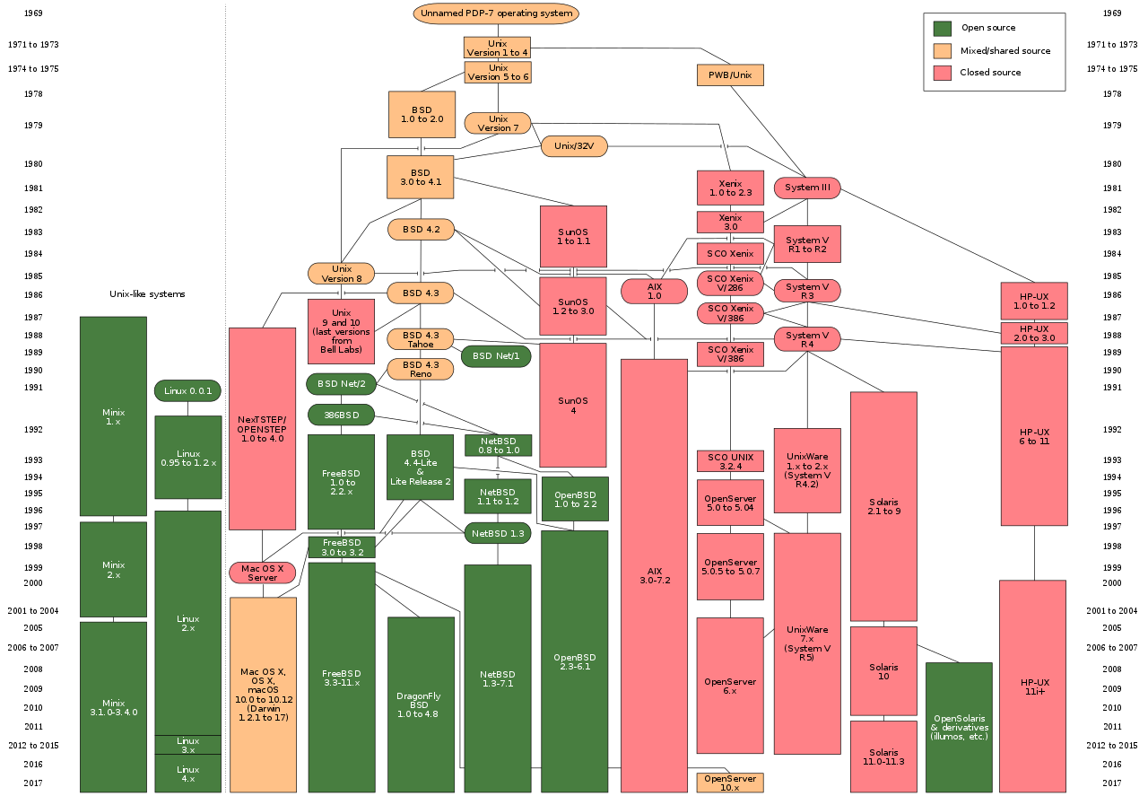
Update |  | Any foreseen or planned activity necessary to bring an artifact up to date with current project needs. Compare to rework.
Upstream |  | In computer networking, upstream refers to the direction in which data can be transferred from the client to the server (uploading). This differs greatly from downstream not only in theory and usage, but also in that upstream speeds are usually at a premium. Whereas downstream speed is important to the average home user for purposes of downloading content, uploads are used mainly for web server applications and similar processes where the sending of data is critical. Upstream speeds are also important to users of peer-to-peer software.  ADSL and cable modems are asymmetric, with the upstream data rate much lower than that of its downstream. Symmetric connections such as Symmetric Digital Subscriber Line (SDSL) and T1, however, offer identical upstream and downstream rates.  If a node A on the Internet is closer (fewer hops away) to the Internet backbone than a node B, then A is said to be upstream of B or conversely, B is downstream of A. Related to this is the idea of upstream providers. An upstream provider is usually a large ISP that provides Internet access to a local ISP. Hence, the word upstream also refers to the data connection between two ISPs
Upstream |  | Used to refer to project activities and artifacts that occur early in a project lifecycle. Includes chartering, planning, defining scope and requirements, architecture and high level design, and any other activities that occur to some extent before significant construction begins. See downstream.
URI | Uniform Resource Identifier | URIs encompasses both URLs, URNs, and other ways to indicate a resource.  An example of a URI that is neither a URL nor a URN would be a data URI such as data:,Hello%20World. It is not a URL or URN because the URI contains the data. It neither names it, nor tells you how to locate it over the network.  There are also uniform resource citations (URCs) that point to meta data about a document rather than to the document itself. An example of a URC would be an indicator for viewing the source code of a web page: view-source:http://example.com/. A URC is another type of URI that is neither URL nor URN.  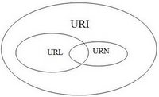
URL | Universal (or Uniform) Resource Locator | Contains information about how to fetch a resource from its location. For example:  - http://example.com/mypage.html  - ftp://example.com/download.zip  - mailto:user@example.com  - file:///home/user/file.txt  - http://example.com/resource?foo=bar#fragment  - /other/link.html (A relative URL, only useful in the context of another URL)  URLs always start with a protocol (http) and usually contain information such as the network host name (example.com) and often a document path (/foo/mypage.html). URLs may have query parameters and fragment identifiers.
URN | Uniform Resource | Identifies a resource by name. It always starts with the prefix urn: For example:  - urn:isbn:0451450523 to identify a book by its ISBN number.  - urn:uuid:6e8bc430-9c3a-11d9-9669-0800200c9a66 a globally unique identifier  - urn:publishing:book - An XML namespace that identifies the document as a type of book.  URNs can identify ideas and concepts. They are not restricted to identifying documents. When a URN does represent a document, it can be translated into a URL by a "resolver". The document can then be downloaded from the URL.
Usability Testing |  | Usability testing is an empirical, exploratory technique to answer questions such as "how would an end user respond to our software under realistic conditions?"
Use Case |  | A single use of the system depicted as an interaction between the user and the system.
Use Case Model |  | An external view of the system used to describe the dialog between the users of the system and the system.
Use Case Specification |  | The documentation required to capture a use case.
User Experience | UX | Describes the total experience of human-machine interface. Includes user interface and aesthetic issues that may not normally be considered as part of user interface design.
User Interface | UI | The interface between a system and its external users. Normally used to describe interaction of the system with human operators.
User Interface Design |  | Design issues specific to human-machine interfaces. See CxStand_Design for more information.
User Interface Prototype |  | A prototype created to explore the user interface functionality or look and feel.
User Plane |  | In routing, the forwarding plane, sometimes called the data plane or user plane, defines the part of the router architecture that decides what to do with packets arriving on an inbound interface. Most commonly, it refers to a table in which the router looks up the destination address of the incoming packet and retrieves the information necessary to determine the path from the receiving element, through the internal forwarding fabric of the router, and to the proper outgoing interface(s). The IP Multimedia Subsystem architecture uses the term transport plane to describe a function roughly equivalent to the routing control plane.
User Stories |  | In consultation with the customer or product owner, the team divides up the work to be done into functional increments called "user stories."
UTC | Coordinated Universal Time | Coordinated Universal Time or Universal Time Coordinated (abbreviated to UTC) is the primary time standard by which the world regulates clocks and time. It is within about 1 second of mean solar time at 0° longitude, and does not observe daylight saving time. For most purposes, UTC is considered interchangeable with Greenwich Mean Time (GMT), but GMT is no longer precisely defined by the scientific community.
UTF-16 |  | UTF-32 stands for Unicode Transformation Format in 32 bits. It is a protocol to encode Unicode code points that uses exactly 32 bits per Unicode code point (but a number of leading bits must be zero as there are fewer than 221 Unicode code points). UTF-32 is a fixed-length encoding, in contrast to all other Unicode transformation formats, which are variable-length encodings. Each 32-bit value in UTF-32 represents one Unicode code point and is exactly equal to that code point's numerical value.  The main advantage of UTF-32 is that the Unicode code points are directly indexed. Finding the Nth code point in a sequence of code points is a constant time operation. In contrast, a variable-length code requires sequential access to find the Nth code point in a sequence. This makes UTF-32 a simple replacement in code that uses integers that are incremented by one to examine each location in a string, as was commonly done for ASCII.  The main disadvantage of UTF-32 is that it is space-inefficient, using four bytes per code point. Characters beyond the BMP are relatively rare in most texts, and can typically be ignored for sizing estimates. This makes UTF-32 close to twice the size of UTF-16. It can be up to four times the size of UTF-8 depending on how many of the characters are in the ASCII subset.
UTF-8 |  | UTF-8 is a variable width character encoding capable of encoding all 1,112,064 valid code points in Unicode using one to four 8-bit bytes. The encoding is defined by the Unicode standard, and was originally designed by Ken Thompson and Rob Pike. The name is derived from Unicode (or Universal Coded Character Set) Transformation Format – 8-bit.  It was designed for backward compatibility with ASCII. Code points with lower numerical values, which tend to occur more frequently, are encoded using fewer bytes. The first 128 characters of Unicode, which correspond one-to-one with ASCII, are encoded using a single octet with the same binary value as ASCII, so that valid ASCII text is valid UTF-8-encoded Unicode as well. Since ASCII bytes do not occur when encoding non-ASCII code points into UTF-8, UTF-8 is safe to use within most programming and document languages that interpret certain ASCII characters in a special way, such as "/" in filenames, "\" in escape sequences, and "%" in printf.  UTF-8 has been the dominant character encoding for the World Wide Web since 2009, as it is most popular in every country, and as of July 2018 accounts for 91.9% of all web pages and 95.5% of the top 1,000 highest ranked web pages (some of which are simply ASCII, a subset of UTF-8). The next-most popular multibyte encodings, Shift JIS and GB 2312, have 0.5% and 0.5% respectively. The Internet Mail Consortium (IMC) recommended that all e-mail programs be able to display and create mail using UTF-8,and the W3C recommends UTF-8 as the default encoding in XML and HTML.
UTRAN | Universal Terrestrial Radio Access Network | UTRAN (short for "Universal Terrestrial Radio Access Network") is a collective term for the network and equipment that connects mobile handsets to the public telephone network or the Internet. It contains the base stations, which are called Node B's and Radio Network Controllers (RNCs) which make up the UMTS radio access network. This communications network, commonly referred to as 3G (for 3rd Generation Wireless Mobile Communication Technology), can carry many traffic types from real-time Circuit Switched to IP based Packet Switched. The UTRAN allows connectivity between the UE (user equipment) and the core network.  The RNC provides control functionalities for one or more Node Bs. A Node B and an RNC can be the same device, although typical implementations have a separate RNC located in a central office serving multiple Node Bs. Despite the fact that they do not have to be physically separated, there is a logical interface between them known as the Iub. The RNC and its corresponding Node Bs are called the Radio Network Subsystem (RNS). There can be more than one RNS present in a UTRAN.  There are four interfaces connecting the UTRAN internally or externally to other functional entities: Iu, Uu, Iub and Iur. The Iu interface is an external interface that connects the RNC to the Core Network (CN). The Uu is also external, connecting the Node B with the User Equipment (UE). The Iub is an internal interface connecting the RNC with the Node B. And at last there is the Iur interface which is an internal interface most of the time, but can, exceptionally be an external interface too for some network architectures. The Iur connects two RNCs with each other.  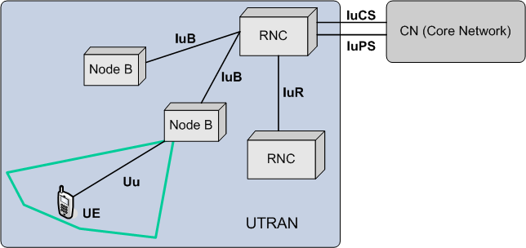  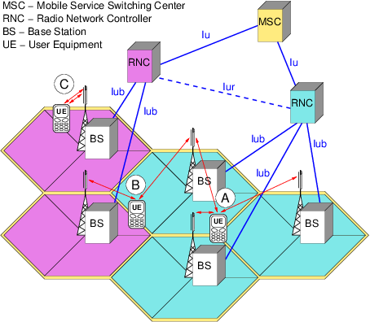

V
V Model |  | In software development, the V-model represents a development process that may be considered an extension of the waterfall model, and is an example of the more general V-model. Instead of moving down in a linear way, the process steps are bent upwards after the coding phase, to form the typical V shape. The V-Model demonstrates the relationships between each phase of the development life cycle and its associated phase of testing. The horizontal and vertical axes represents time or project completeness (left-to-right) and level of abstraction (coarsest-grain abstraction uppermost), respectively.  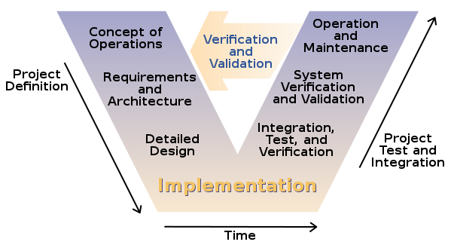
V.90 |  | V.90 is an ITU-T recommendation for a modem, allowing 56 kbit/s digital download and 33.6 kbit/s analog upload. It replaced two vendor standards (K56flex and X2) and was designed to allow modems from both prior standards to be flash upgraded to support it. It was developed between March 1998 and February 1999. It is also known as V.Last as it was anticipated to be the last standard for modems operating near the channel capacity of POTS lines to be developed. V.90 is generally used in concert with the V.42bis compression standard. A follow-on standard, V.92, was developed later in 1999 to replace V.90.
V.92 |  | V.92 is an ITU-T recommendation, titled Enhancements to Recommendation V.90, that establishes a modem standard allowing near 56 kb/s download and 48 kb/s upload rates. With V.92 PCM is used for both the upstream and downstream connections; previously 56K modems only used PCM for downstream data.
VAD | Voice Activity Detection | Voice activity detection (VAD), also known as speech activity detection or speech detection, is a technique used in speech processing in which the presence or absence of human speech is detected. The main uses of VAD are in speech coding and speech recognition. It can facilitate speech processing, and can also be used to deactivate some processes during non-speech section of an audio session: it can avoid unnecessary coding/transmission of silence packets in Voice over Internet Protocol applications, saving on computation and on network bandwidth.  VAD is an important enabling technology for a variety of speech-based applications. Therefore, various VAD algorithms have been developed that provide varying features and compromises between latency, sensitivity, accuracy and computational cost. Some VAD algorithms also provide further analysis, for example whether the speech is voiced, unvoiced or sustained. Voice activity detection is usually language independent.
VB | Visual Basic | Visual Basic is a third-generation event-driven programming language and integrated development environment (IDE) from Microsoft for its Component Object Model (COM) programming model first released in 1991 and declared legacy during 2008. Microsoft intended Visual Basic to be relatively easy to learn and use. Visual Basic was derived from BASIC and enables the rapid application development (RAD) of graphical user interface (GUI) applications, access to databases using Data Access Objects, Remote Data Objects, or ActiveX Data Objects, and creation of ActiveX controls and objects.  A programmer can create an application using the components provided by the Visual Basic program itself. Over time the community of programmers developed third-party components. Programs written in Visual Basic can also use the Windows API, which requires external function declarations.
VBS | VB Script | VBScript ("Microsoft Visual Basic Scripting Edition") is an Active Scripting language developed by Microsoft that is modeled on Visual Basic. It allows Microsoft Windows system administrators to generate powerful tools for managing computers with error handling, subroutines, and other advanced programming constructs. It can give the user complete control over many aspects of their computing environment.  VBScript uses the Component Object Model to access elements of the environment within which it is running; for example, the FileSystemObject (FSO) is used to create, read, update and delete files. VBScript has been installed by default in every desktop release of Microsoft Windows since Windows 98; in Windows Server since Windows NT 4.0 Option Pack; and optionally with Windows CE (depending on the device it is installed on).
VC | Virtual Circuit | A virtual circuit (VC) is a means of transporting data over a packet switched computer network in such a way that it appears as though there is a dedicated physical layer link between the source and destination end systems of this data. The term virtual circuit is synonymous with virtual connection and virtual channel. Before a connection or virtual circuit may be used, it has to be established, between two or more nodes or software applications, by configuring the relevant parts of the interconnecting network. After that, a bit stream or byte stream may be delivered between the nodes; hence, a virtual circuit protocol allows higher level protocols to avoid dealing with the division of data into segments, packets, or frames.  Virtual circuit communication resembles circuit switching, since both are connection oriented, meaning that in both cases data is delivered in correct order, and signalling overhead is required during a connection establishment phase. However, circuit switching provides a constant bit rate and latency, while these may vary in a virtual circuit service due to factors such as:  - varying packet queue lengths in the network nodes,  - varying bit rate generated by the application,  - varying load from other users sharing the same network resources by means of statistical multiplexing, etc.  Many virtual circuit protocols, but not all, provide reliable communication service through the use of data retransmissions because of error detection and automatic repeat request (ARQ).  An alternate network configuration to virtual circuit is datagram.
VCI | Virtual Channel Identifier | The VCI, used in conjunction with the VPI (virtual path indicator), indicates where an ATM cell is to travel over a network. ATM, or asynchronous transfer mode, is a method that many ISPs (Internet Service Providers) use to transfer data to client computers. Because ATM sends packets over fixed channels, the data is easier to track than information sent over the standard TCP/IP protocol.  The VCI within each ATM cell defines the fixed channel on which the packet of information should be sent. It is a 16-bit field, compared to the VPI, which is only 8 bits. Since this numerical tag specifies the virtual channel that each packet belongs to, it prevents interference with other data being sent across the network.
VCID | Virtual Circuit/Channel ID | 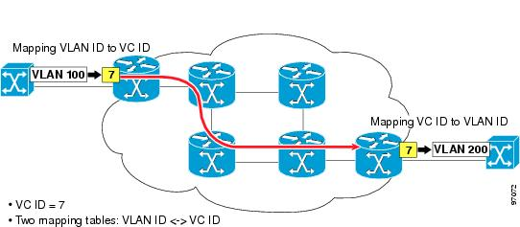
VDSL | Very-high-bit-rate digital subscriber line | Very-high-bit-rate digital subscriber line (VDSL) and very-high-bit-rate digital subscriber line 2 (VDSL2)[2] are digital subscriber line (DSL) technologies providing data transmission faster than asymmetric digital subscriber line (ADSL).  VDSL offers speeds of up to 52 Mbit/s downstream and 16 Mbit/s upstream, over a single flat untwisted or twisted pair of copper wires using the frequency band from 25 kHz to 12 MHz. These rates mean that VDSL is capable of supporting applications such as high-definition television, as well as telephone services (voice over IP) and general Internet access, over a single connection. VDSL is deployed over existing wiring used for analog telephone service and lower-speed DSL connections. This standard was approved by the International Telecommunication Union (ITU) in November 2001.  Second-generation systems (VDSL2; ITU-T G.993.2 approved in February 2006) use frequencies of up to 30 MHz to provide data rates exceeding 100 Mbit/s simultaneously in both the upstream and downstream directions. The maximum available bit rate is achieved at a range of about 300 meters; performance degrades as the local loop attenuation increases.
Velocity |  | At the end of each iteration, the team adds up effort estimates associated with user stories that were completed during that iteration. This total is called velocity.
Verifier |  | Verifies any rework for inspections.
Version |  | A formally released revision of an artifact, recognized by the configuration management process that oversees the artifact.
Version Control |  | Version control is not strictly an Agile "practice" insofar as it is now widespread in the industry as a whole. But it is mentioned here for several reasons.
VISP | Virtual ISP | A Virtual ISP (VISP), also known as an Affinity ISP, is an Internet Service Provider (ISP) that resells the resources of existing ISPs under another brand name.
VLAN | Virtual LAN | A virtual LAN (VLAN) is any broadcast domain that is partitioned and isolated in a computer network at the data link layer (OSI layer 2).[1][2] LAN is the abbreviation for local area network and in this context virtual refers to a physical object recreated and altered by additional logic. VLANs work by applying tags to network packets and handling these tags in networking systems – creating the appearance and functionality of network traffic that is physically on a single network but acts as if it is split between separate networks. In this way, VLANs can keep network applications separate despite being connected to the same physical network, and without requiring multiple sets of cabling and networking devices to be deployed.  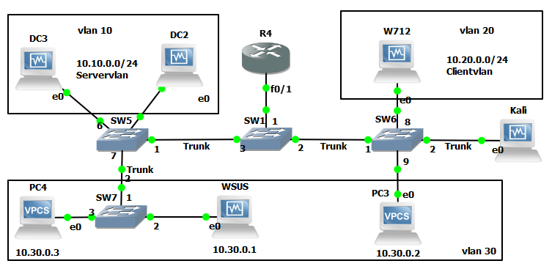
VLR | Visitor Location Register | The Visitor Location Register (VLR) is a database of the MSs (Mobile stations) that have roamed into the jurisdiction of the MSC (Mobile Switching Center) which it serves. Each main base station in the network is served by exactly one VLR (one BTS may be served by many MSCs in case of MSC in pool), hence a subscriber cannot be present in more than one VLR at a time.  The data stored in the VLR has either been received from the Home Location Register (HLR), or collected from the MS. In practice, for performance reasons, most vendors integrate the VLR directly to the V-MSC and, where this is not done, the VLR is very tightly linked with the MSC via a proprietary interface. Whenever an MSC detects a new MS in its network, in addition to creating a new record in the VLR, it also updates the HLR of the mobile subscriber, apprising it of the new location of that MS. If VLR data is corrupted it can lead to serious issues with text messaging and call services.  Data stored include:  - IMSI (the subscriber's identity number).  - Authentication data.  - MSISDN (the subscriber's phone number).  - GSM services that the subscriber is allowed to access.  - access point (GPRS) subscribed.  - The HLR address of the subscriber.  - SCP Address(For Prepaid Subscriber).
VM | Virtual Machine | In computing, a virtual machine (VM) is an emulation of a computer system. Virtual machines are based on computer architectures and provide functionality of a physical computer. Their implementations may involve specialized hardware, software, or a combination.
VOD | Video On Demand | Video on demand is a programming system which allows users to select and watch/listen to video or audio content such as movies and TV shows whenever they choose, rather than at a scheduled broadcast time, the method that prevailed with over-the-air programming during the 20th century. IPTV technology is commonly used to bring VOD to televisions and personal computers.  Television VOD systems can stream content through either a set-top box, a computer or other device, allowing viewing in real time, or download it to a device such as a computer, digital video recorder (also called a personal video recorder) or portable media player for viewing at any time. The majority of cable- and telephone company-based television providers offer:  - VOD streaming, whereby a user selects a video program and it begins to play immediately on the television set, or  - downloading to a digital video recorder (DVR) rented or purchased from the provider, or downloading onto a PC or to a portable device, for viewing in the future.  - Internet television, using the Internet, is an increasingly popular form of video on demand. VOD can also be accessed via desktop client applications such as the Apple iTunes online content store.  Some airlines offer VOD as in-flight entertainment to passengers through individually controlled video screens embedded in seatback or armrests or offered via portable media players. Some video on demand services, such as Netflix, use a subscription model that requires users to pay a monthly fee to access a bundled set of content, which is mainly movies and TV shows. Other services use an advertising-based model, where access is free.
VoIP | Voice over IP | Voice over Internet Protocol (also voice over IP, VoIP or IP telephony) is a methodology and group of technologies for the delivery of voice communications and multimedia sessions over Internet Protocol (IP) networks, such as the Internet. The terms Internet telephony, broadband telephony, and broadband phone service specifically refer to the provisioning of communications services (voice, fax, SMS, voice-messaging) over the public Internet, rather than via the public switched telephone network (PSTN).  Voice over IP has been implemented in various ways using both proprietary protocols and protocols based on open standards. These protocols can be used by a VoIP phone, special-purpose software, a mobile application or integrated into a web page. VoIP protocols include:  - Session Initiation Protocol (SIP), connection management protocol developed by the IETF  - H.323, one of the first VoIP call signaling and control protocols that found widespread implementation. Since the development of newer, less complex protocols such as MGCP and SIP, H.323 deployments are increasingly limited to carrying existing long-haul network traffic.[citation needed]  - Media Gateway Control Protocol (MGCP), connection management for media gateways  - H.248, control protocol for media gateways across a converged internetwork consisting of the traditional public switched telephone network (PSTN) and modern packet networks  - Real-time Transport Protocol (RTP), transport protocol for real-time audio and video data  - Real-time Transport Control Protocol (RTCP), sister protocol for RTP providing stream statistics and status information  - Secure Real-time Transport Protocol (SRTP), encrypted version of RTP  - Session Description Protocol (SDP), file format used principally by SIP to describe VoIP connections  - Inter-Asterisk eXchange (IAX), protocol used between VoIP servers  - Extensible Messaging and Presence Protocol (XMPP), instant messaging, presence information, and contact list maintenance  - Jingle, adds peer-to-peer session control to XMPP  - Skype protocol, proprietary Internet telephony protocol suite based on peer-to-peer architecture  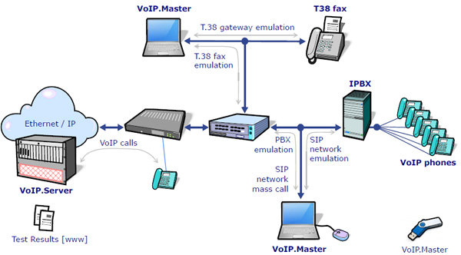
VoLTE | Voice over Long-Term Evolution | Voice over Long-Term Evolution (VoLTE) is a standard for high-speed wireless communication for mobile phones and data terminals - including IoT devices and wearables. It is based on the IP Multimedia Subsystem (IMS) network, with specific profiles for control and media planes of voice service on LTE defined by GSMA in PRD IR.92. This approach results in the voice service (control and media planes) being delivered as data flows within the LTE data bearer. This means that there is no dependency on (or ultimately, requirement for) the legacy circuit-switched voice network to be maintained. VoLTE has up to three times more voice and data capacity than 3G UMTS and up to six times more than 2G GSM. Furthermore, it frees up bandwidth because VoLTE’s packets headers are smaller than those of unoptimized VoIP/LTE.
Vorbis |  | Vorbis is a free and open-source software project headed by the Xiph.Org Foundation. The project produces an audio coding format and software reference encoder/decoder (codec) for lossy audio compression. Vorbis is most commonly used in conjunction with the Ogg container format and it is therefore often referred to as Ogg Vorbis.
VPI | Virtual Path Identifier | See VCI
VPLS | Virtual Private LAN Service | Virtual Private LAN Service (VPLS) is a way to provide Ethernet-based multipoint to multipoint communication over IP or MPLS networks. It allows geographically dispersed sites to share an Ethernet broadcast domain by connecting sites through pseudowires. The term 'sites' includes multiplicities of both servers and clients. The technologies that can be used as pseudo-wire can be Ethernet over MPLS, L2TPv3 or even GRE. There are two IETF standards track RFCs (RFC 4761 and RFC 4762) describing VPLS establishment.  VPLS is a virtual private network (VPN) technology. In contrast to L2TPv3, which allows only point-to-point layer 2 tunnels, VPLS allows any-to-any (multipoint) connectivity.  In a VPLS, the local area network (LAN) at each site is extended to the edge of the provider network. The provider network then emulates a switch or bridge to connect all of the customer LANs to create a single bridged LAN.  VPLS is designed for applications that require multipoint or broadcast access.  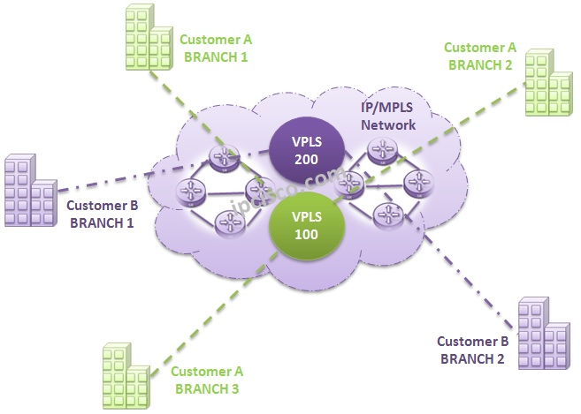
VPN | Virtual Private Network | A virtual private network (VPN) extends a private network across a public network, and enables users to send and receive data across shared or public networks as if their computing devices were directly connected to the private network. Applications running across a VPN may therefore benefit from the functionality, security, and management of the private network.  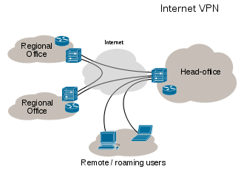
VPWS | Virtual Private Wire Service | Virtual Leased Lines (VLL) is a way to provide Ethernet-based point to point communication over IP/MPLS networks.  The term Virtual Leased Line is also used to describe a point to point bonded connection using the Broadband Bonding technology. This implementation is bonded in layer 4.  In the industry, the technology is also referred to as Virtual Private Wire Service (VPWS) or EoMPLS (Ethernet over MPLS).  VLL uses the pseudo-wire encapsulation for transporting Ethernet traffic over an MPLS tunnel across an IP/MPLS backbone.
VRF | Virtual (VPN) Routing and Forwarding | In IP-based computer networks, (VRF) is a technology that allows multiple instances of a routing table to co-exist within the same router at the same time. Because the routing instances are independent, the same or overlapping IP addresses can be used without conflicting with each other. Network functionality is improved because network paths can be segmented without requiring multiple routers.  Cisco implementation - VPN routing and forwarding, the key element in the Cisco MPLS VPN technology  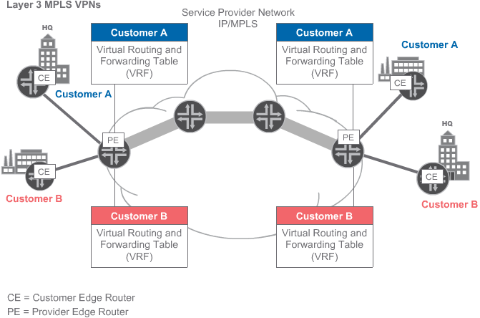

W
W3C | World Wide Web Consortium | The World Wide Web Consortium (W3C) is the main international standards organization for the World Wide Web (abbreviated WWW or W3).  Founded and currently led by Tim Berners-Lee, the consortium is made up of member organizations which maintain full-time staff for the purpose of working together in the development of standards for the World Wide Web. As of 24 September 2017, the World Wide Web Consortium (W3C) has 474 members.
Walkthrough |  | An informal review in which the author and one or more people meet to review an artifact with the intent of finding defects.
WAN | Wide Area Network | A wide area network (WAN) is a telecommunications network or computer network that extends over a large geographical distance/place. Wide area networks are often established with leased telecommunication circuits.  Business, education and government entities use wide area networks to relay data to staff, students, clients, buyers, and suppliers from various locations across the world. In essence, this mode of telecommunication allows a business to effectively carry out its daily function regardless of location. The Internet may be considered a WAN.  Related terms for other types of networks are personal area networks (PANs), local area networks (LANs), campus area networks (CANs), or metropolitan area networks (MANs) which are usually limited to a room, building, campus or specific metropolitan area respectively.  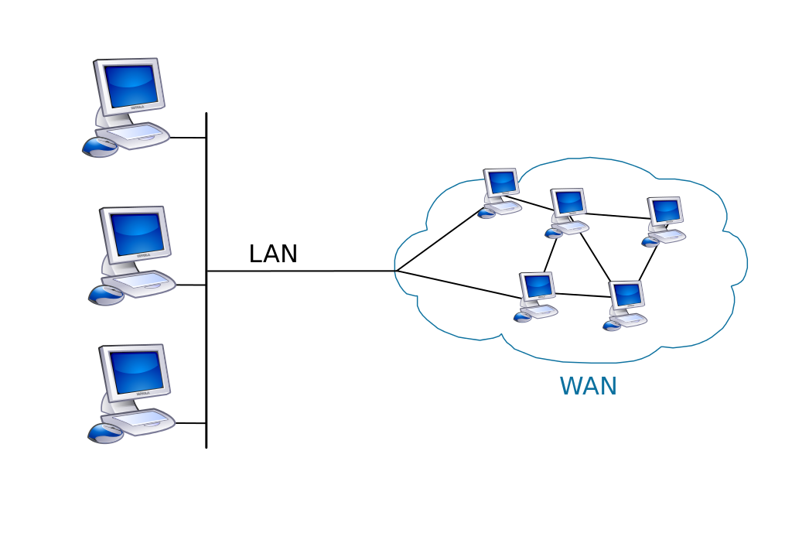
WANET | Wireless ad hoc network | A wireless ad hoc network (WANET) or MANET (Mobile ad hoc network) is a decentralised type of wireless network. The network is ad hoc because it does not rely on a pre-existing infrastructure, such as routers in wired networks or access points in managed (infrastructure) wireless networks. Instead, each node participates in routing by forwarding data for other nodes, so the determination of which nodes forward data is made dynamically on the basis of network connectivity and the routing algorithm in use.  In the Windows operating system, ad-hoc is a communication mode (setting) that allows computers to directly communicate with each other without a router.  Wireless mobile ad hoc networks are self-configuring, dynamic networks in which nodes are free to move. Wireless networks lack the complexities of infrastructure setup and administration, enabling devices to create and join networks "on the fly" – anywhere, anytime.
WAP | Wireless Access Point | In computer networking, a wireless access point (WAP), or more generally just access point (AP), is a networking hardware device that allows a Wi-Fi device to connect to a wired network. The AP usually connects to a router (via a wired network) as a standalone device, but it can also be an integral component of the router itself. An AP is differentiated from a hotspot, which is the physical location where Wi-Fi access to a WLAN is available.
Waterfall |  | The waterfall model is a relatively linear sequential design approach for certain areas of engineering design. In software development, it tends to be among the less iterative and flexible approaches, as progress flows in largely one direction ("downwards" like a waterfall) through the phases of conception, initiation, analysis, design, construction, testing, deployment and maintenance.  The waterfall development model originated in the manufacturing and construction industries; where the highly structured physical environments meant that design changes became prohibitively expensive much sooner in the development process. When first adopted for software development, there were no recognized alternatives for knowledge-based creative work  The Waterfall methodology came about by mistake due to a misunderstanding a 1970 paper which gave it as an example of a methodology along with a comment that states this is a risky method and invites failure. A US Department of Defense standard was published in 1985 with a methodology based on the 1970 paper and it then became widespread.  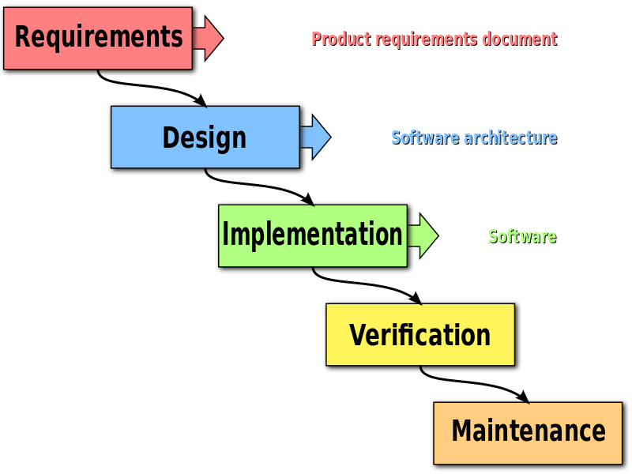
Waterfall Lifecycle |  | An orderly sequence of phases from system concept to delivery with a review at the end of each phase.
WBC | Wholesale Broadband Managed | The vanilla WBC product is the most flexible of the three. Crudely speaking, it is not that dissimilar to DataStream. But rather than having to rent capacity at every exchange from BT, the ISP has to install equipment ("have presence") at BT's WBC Aggregation Points (APs). There are twenty of these dotted around the country, and these are the same as the Core nodes discussed on the 21CN overview. One aggregation point will cover a region of the country, so an ISP would need to have presence at all twenty to cover the entire of the UK.  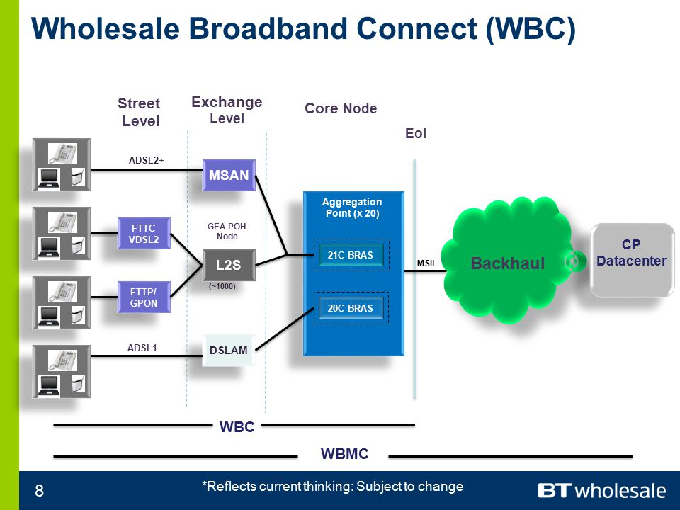
WBCC | Wholesale Broadband Connect Converge | There is relatively little public information available about this product. It is known to roll the voice and broadband products in to a package, with BT providing the ISP a single bill for both. Given that this product will again be based on WBC, one can only assume that the same product options and QoS would also be available.
WBMC | Wholesale Broadband Managed Connect | The IPSC replacement  In the same way that the vanilla WBC product could be seen as a replacement for DataStream, WBMC can be seen as a replacement for IPStream. This product is an end-to-end product, encompassing the EUA (End User Access), presence at the APs (Aggregation Points), EPs (Extension Paths) and an MSIL (Although the MSIL is purchased separately by the ISP). Ultimately this saves the ISP having to manage and maintain presence at the 20 WBC nodes (APs), which would involve considerable initial outlay and ongoing investment. The backhaul is also managed by BT entirely. On the other side of the coin this means the ISP is locked in to a BT platform - which may not necessarily be the cheapest - and it certainly does not offer all of the flexibility that an ISP using WBC would receive. That said, all of the same products and QoS options are available on WBMC as on WBC.
W-CDMA | Wideband Code-division multiple access | W-CDMA or WCDMA (Wideband Code Division Multiple Access), along with UMTS-FDD, UTRA-FDD, or IMT-2000 CDMA Direct Spread is an air interface standard found in 3G mobile telecommunications networks. It supports conventional cellular voice, text and MMS services, but can also carry data at high speeds, allowing mobile operators to deliver higher bandwidth applications including streaming and broadband Internet access.[5]  W-CDMA uses the DS-CDMA channel access method with a pair of 5 MHz wide channels. In contrast, the competing CDMA2000 system uses one or more available 1.25 MHz channels for each direction of communication. W-CDMA systems are widely criticized for their large spectrum usage, which delayed deployment in countries that acted relatively slowly in allocating new frequencies specifically for 3G services (such as the United States).
Weekly Individual Plan |  | A mechanism for individuals to create miniature milestone plan on a weekly basis. See CxGuide_WeeklyIndividualPlan.
WEP | Wired Equivalent Privacy | Wired Equivalent Privacy (WEP) is a security algorithm for IEEE 802.11 wireless networks. Introduced as part of the original 802.11 standard ratified in 1997, its intention was to provide data confidentiality comparable to that of a traditional wired network. WEP, recognizable by its key of 10 or 26 hexadecimal digits (40 or 104 bits), was at one time widely in use and was often the first security choice presented to users by router configuration tools.  In 2003 the Wi-Fi Alliance announced that WEP had been superseded by Wi-Fi Protected Access (WPA). In 2004, with the ratification of the full 802.11i standard (i.e. WPA2), the IEEE declared that both WEP-40 and WEP-104 have been deprecated.  WEP was the only encryption protocol available to 802.11a and 802.11b devices built before the WPA standard, which was available for 802.11g devices.
What Requirement |  | Synonym for Functional Requirement
Why Requirement |  | Synonym for Business Requirement
Wi-Fi |  | Wi-Fi or WiFi is technology for radio wireless local area networking of devices based on the IEEE 802.11 standards. Wi-Fi is a trademark of the Wi-Fi Alliance, which restricts the use of the term Wi-Fi Certified to products that successfully complete interoperability certification testing.  Devices that can use Wi-Fi technology include desktops and laptops, video game consoles, smartphones and tablets, smart TVs, digital audio players and modern printers. Wi-Fi compatible devices can connect to the Internet via a WLAN and a wireless access point. Such an access point (or hotspot) has a range of about 20 meters (66 feet) indoors and a greater range outdoors. Hotspot coverage can be as small as a single room with walls that block radio waves, or as large as many square kilometres achieved by using multiple overlapping access points.  Depiction of a device sending information wirelessly to another device, both connected to the local network, in order to print a document  Wi-Fi most commonly uses the 2.4 gigahertz (12 cm) UHF and 5.8 gigahertz (5 cm) SHF ISM radio bands, these bands are subdivided into multiple channels. Each channel can be time-shared by multiple networks. These wavelengths work best for line-of-sight. Many common materials absorb or reflect them, which further restricts range, but can tend to help minimise interference between different networks in crowded environments. At close range, some versions of Wi-Fi, running on suitable hardware[disambiguation needed] can achieve speeds of over 1 Gbps.  Anyone within range with a wireless network interface controller can attempt to access a network; because of this, Wi-Fi is more vulnerable to attack (called eavesdropping) than wired networks. Wi-Fi Protected Access is a family of technologies created to protect information moving across Wi-Fi networks and includes solutions for personal and enterprise networks. Security features of Wi-Fi Protected Access have included stronger protections and new security practices as the security landscape has changed over time.
Wiki |  | A wiki is a website on which users collaboratively modify content and structure directly from the web browser. In a typical wiki, text is written using a simplified markup language and often edited with the help of a rich-text editor.  A wiki is run using wiki software, otherwise known as a wiki engine. A wiki engine is a type of content management system, but it differs from most other such systems, including blog software, in that the content is created without any defined owner or leader, and wikis have little inherent structure, allowing structure to emerge according to the needs of the users. There are dozens of different wiki engines in use, both standalone and part of other software, such as bug tracking systems. Some wiki engines are open source, whereas others are proprietary. Some permit control over different functions (levels of access); for example, editing rights may permit changing, adding, or removing material. Others may permit access without enforcing access control. Other rules may be imposed to organize content.
WiMAX | Worldwide Interoperability for Microwave Access | WiMAX (Worldwide Interoperability for Microwave Access) is a family of wireless communication standards based on the IEEE 802.16 set of standards, which provide multiple physical layer (PHY) and Media Access Control (MAC) options.  The name "WiMAX" was created by the WiMAX Forum, which was formed in June 2001 to promote conformity and interoperability of the standard, including the definition of predefined system profiles for commercial vendors. The forum describes WiMAX as "a standards-based technology enabling the delivery of last mile wireless broadband access as an alternative to cable and DSL". IEEE 802.16m or WirelessMAN-Advanced was a candidate for the 4G, in competition with the LTE Advanced standard.  WiMAX was initially designed to provide 30 to 40 megabit-per-second data rates, with the 2011 update providing up to 1 Gbit/s for fixed stations
WIN-T | Warfighter Information Network - Tactical | WIN-T is the U.S. Army’s tactical network backbone, providing secure voice and data communications for soldiers on the battlefield without the need for fixed infrastructure. By connecting soldiers with their commanders, WIN-T is changing the way the U.S. Army fights by providing life-saving information on-the-move, anywhere in the world. WIN-T enables soldiers to:  - Stream real-time video over the network  - View a topographical map of friendly forces  - Send texts requesting medical assistance  - Digitally call for artillery support  - Access mission command apps like CPOF and TIGR  WIN-T INCREMENT 1: COMMUNICATIONS AT-THE-HALT  Originally known as the Joint Network Node Network (JNN-N) program, WIN-T Increment 1 (Inc. 1) began fielding in 2004 to support combat missions during Operation Enduring Freedom and Operation Iraqi Freedom.  With WIN-T Inc. 1, for the first time in history, the soldiers on the battlefield had a high-speed, interoperable voice and data communications network at the battalion level.  WIN-T INCREMENT 2: COMMUNICATIONS ON-THE-MOVE  The Army's 10th Mountain Division was the first to field WIN-T Inc. 2 new capabilities when they deployed for Afghanistan in July 2013. WIN-T Inc. 2's unique value was immediately recognized, as it provided soldiers with communications even as fixed infrastructure was removed.  The Tactical Communication Nodes in Inc. 2 took the first step in providing a mobile infrastructure on the battlefield. This includes mobile Point Of Presence systems (installed on select vehicles at battalion levels and above, which include four companies of up to 200 soldiers and about 10 to 30 vehicles each), vehicle wireless packages, and the Soldier Network Extension (for Company-level connectivity).  Increment 2 enables mission command from brigade to division to company through a completely ad-hoc, self-forming network. Commanders and select staff now have the ability to maneuver anywhere on the battlefield and maintain connectivity to the network, without the need to stop and set up communications, making them vulnerable to attack.  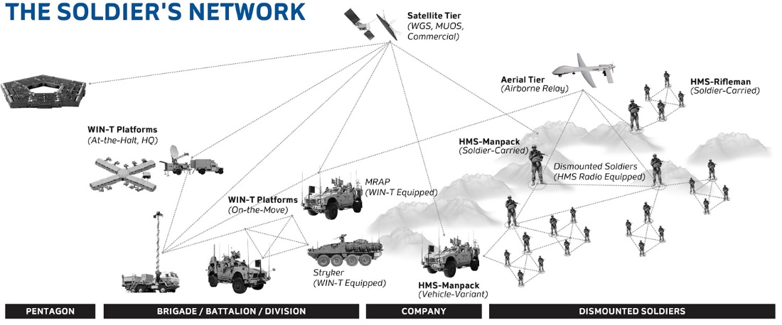
Wireless Mesh Network |  | 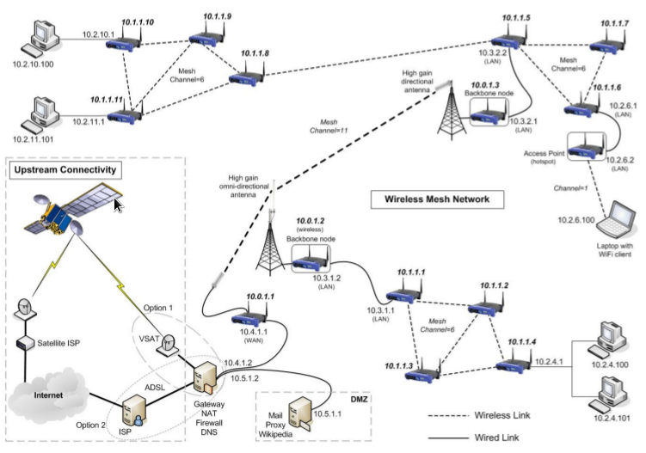  A wireless mesh network (WMN) is a communications network made up of radio nodes organized in a mesh topology. It is also a form of wireless ad hoc network.  A mesh refers to rich interconnection among devices or nodes. Wireless mesh networks often consist of mesh clients, mesh routers and gateways. Mobility of nodes is less frequent. If nodes were to constantly or frequently move, the mesh will spend more time updating routes than delivering data. In a wireless mesh network, topology tends to be more static, so that routes computation can converge and delivery of data to their destinations can occur. Hence, this is a low-mobility centralized form of wireless ad hoc network. Also, because it sometimes relies on static nodes to act as gateways, it is not a truly all-wireless ad hoc network.  The mesh clients are often laptops, cell phones and other wireless devices while the mesh routers forward traffic to and from the gateways which may, but need not, be connected to the Internet. The coverage area of the radio nodes working as a single network is sometimes called a mesh cloud. Access to this mesh cloud is dependent on the radio nodes working in harmony with each other to create a radio network. A mesh network is reliable and offers redundancy. When one node can no longer operate, the rest of the nodes can still communicate with each other, directly or through one or more intermediate nodes. Wireless mesh networks can self form and self heal. Wireless mesh networks work with different wireless technologies including 802.11, 802.15, 802.16, cellular technologies and need not be restricted to any one technology or protocol.
Wireless Repeater |  | A wireless repeater (also called wireless range extender) takes an existing signal from a wireless router or wireless access point and rebroadcasts it to create a second network. When two or more hosts have to be connected with one another over the IEEE 802.11 protocol and the distance is too long for a direct connection to be established, a wireless repeater is used to bridge the gap. It can be a specialized stand alone computer networking device. Also, some Wireless network interface controllers (WNIC)s optionally support operating in such a mode. Those outside of the primary network will be able to connect through the new "repeated" network. However, as far as the original router or access point is concerned, only the repeater MAC is connected, making it necessary to enable safety features on the wireless repeater. Wireless repeaters are commonly used to improve signal range and strength within homes and small offices.
Wireshark |  | Wireshark is a free and open source packet analyzer. It is used for network troubleshooting, analysis, software and communications protocol development, and education. Originally named Ethereal, the project was renamed Wireshark in May 2006 due to trademark issues.  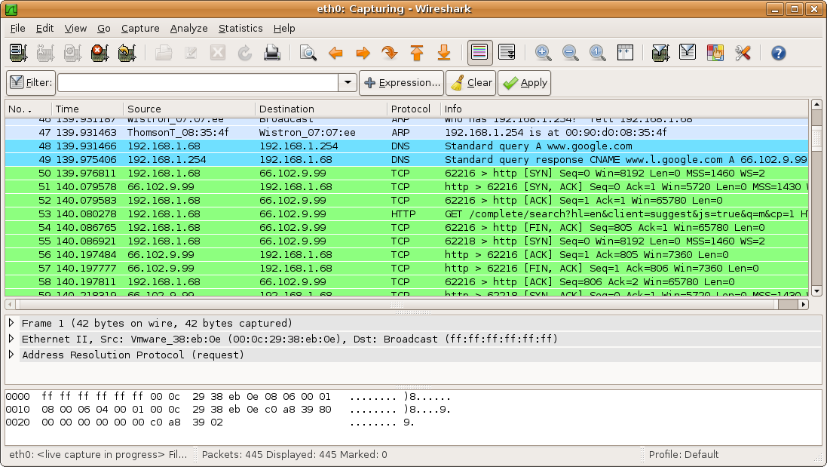
WISP | Wireless ISP | A wireless Internet service provider (WISP) is an Internet service provider with a network based on wireless networking. Technology may include commonplace Wi-Fi wireless mesh networking, or proprietary equipment designed to operate over open 900 MHz, 2.4 GHz, 4.9, 5, 24, and 60 GHz bands or licensed frequencies in the UHF band (including the MMDS frequency band), LMDS, and other bands from 6Ghz to 80Ghz.  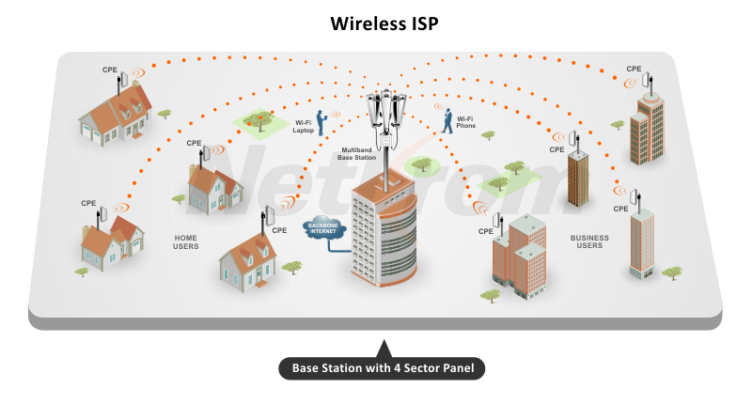
WLR | Wholesale Line Rental | Wholesale line rental (WLR) is a service in which a telecommunications operator takes control of all the connections made through a telephone line from the native operator and collects the subscription fee from the subscribers.  With WLR the alternative telecoms provider buys a wholesale product from the incumbent (usually in conjunction with a wholesale call product such as CPS) and is then able to produce a single bill for the end user covering calls and line rental. Broadband services can also be provided by the WLR operator (and included in a single bill) if a separate wholesale DSL product is purchased from the incumbent, but this is optional.
WMA | Windows Media Audio | Windows Media Audio (WMA) is the name of a series of audio codecs and their corresponding audio coding formats developed by Microsoft. It is a proprietary technology that forms part of the Windows Media framework. WMA consists of four distinct codecs. The original WMA codec, known simply as WMA, was conceived as a competitor to the popular MP3 and RealAudio codecs. WMA Pro, a newer and more advanced codec, supports multichannel and high resolution audio. A lossless codec, WMA Lossless, compresses audio data without loss of audio fidelity (the regular WMA format is lossy).[3] WMA Voice, targeted at voice content, applies compression using a range of low bit rates.
Work Breakdown Structure | WBS | A representation of all work (activities and tasks) on a project, decomposed into work packages. The WBS provides the fundamental project management view of a project. Smaller projects may capture their WBS implicitly in work plans or detailed schedules. Larger projects will often define the WBS as a separate artifact.
Work Item |  | Synonym for artifact.
Work Package | WP | A leaf element of a WBS, often defined as a tangible deliverable. Bottom-up project estimation and planning is driven by work packages and is often captured in a work plan. Work packages are normally broken down into activities and tasks for task estimation and detailed scheduling.
Work Plan |  | A key project artifact that captures work packages along with their task estimates. Used to plan, track, and control detailed execution. See CxGuide_EarnedValueWorkPlan.
Work Product |  | Synonym for artifact.
WPA2 | Wi-Fi Protected Access | Wi-Fi Protected Access (WPA) and Wi-Fi Protected Access II (WPA2) are two security protocols and security certification programs developed by the Wi-Fi Alliance to secure wireless computer networks. The Alliance defined these in response to serious weaknesses researchers had found in the previous system, Wired Equivalent Privacy (WEP).  WPA (sometimes referred to as the draft IEEE 802.11i standard) became available in 2003. The Wi-Fi Alliance intended it as an intermediate measure in anticipation of the availability of the more secure and complex WPA2, which became available in 2004 and is a common shorthand for the full IEEE 802.11i (or IEEE 802.11i-2004) standard.
WPS | Wi-Fi Protected Setup | Wi-Fi Protected Setup (WPS; originally, Wi-Fi Simple Config) is a network security standard to create a secure wireless home network.  Created by the Wi-Fi Alliance and introduced in 2006, the goal of the protocol is to allow home users who know little of wireless security and may be intimidated by the available security options to set up Wi-Fi Protected Access, as well as making it easy to add new devices to an existing network without entering long passphrases. Prior to the standard, several competing solutions were developed by different vendors to address the same need.
write-only code |  | code that is hard to read.
WS-BPEL | Web Services Business Process Execution Language | BPEL was developed to address the differences between programming in the large and programming in the small. This term is also known as Web Services Business Process Execution Language (WS-BPEL), and is sometimes written as business process execution language for Web Services.
WSDL | Web Services Description Language | The Web Services Description Language is an XML-based interface definition language that is used for describing the functionality offered by a web service. The acronym is also used for any specific WSDL description of a web service (also referred to as a WSDL file), which provides a machine-readable description of how the service can be called, what parameters it expects, and what data structures it returns. Therefore, its purpose is roughly similar to that of a type signature in a programming language.  The current version of WSDL is WSDL 2.0. The meaning of the acronym has changed from version 1.1 where the "D" stood for "Definition".  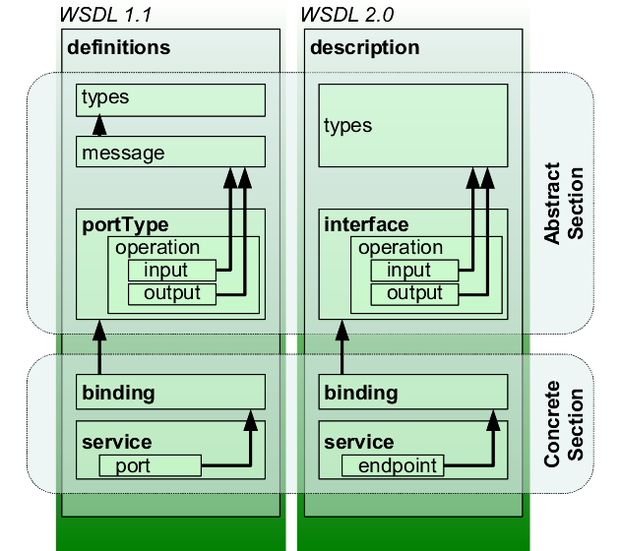  <?xml version="1.0" encoding="UTF-8"?>  <description xmlns="http://www.w3.org/ns/wsdl"  xmlns:tns="http://www.tmsws.com/wsdl20sample"  xmlns:whttp="http://schemas.xmlsoap.org/wsdl/http/"  xmlns:wsoap="http://schemas.xmlsoap.org/wsdl/soap/"  targetNamespace="http://www.tmsws.com/wsdl20sample">  <documentation>  This is a sample WSDL 2.0 document.  </documentation>  <!-- Abstract type -->  <types>  <xs:schema xmlns:xs="http://www.w3.org/2001/XMLSchema"  xmlns="http://www.tmsws.com/wsdl20sample"  targetNamespace="http://www.example.com/wsdl20sample">  <xs:element name="request"> ... </xs:element>  <xs:element name="response"> ... </xs:element>  </xs:schema>  </types>  <!-- Abstract interfaces -->  <interface name="Interface1">  <fault name="Error1" element="tns:response"/>  <operation name="Get" pattern="http://www.w3.org/ns/wsdl/in-out">  <input messageLabel="In" element="tns:request"/>  <output messageLabel="Out" element="tns:response"/>  </operation>  </interface>  <!-- Concrete Binding Over HTTP -->  <binding name="HttpBinding" interface="tns:Interface1"  type="http://www.w3.org/ns/wsdl/http">  <operation ref="tns:Get" whttp:method="GET"/>  </binding>  <!-- Concrete Binding with SOAP-->  <binding name="SoapBinding" interface="tns:Interface1"  type="http://www.w3.org/ns/wsdl/soap"  wsoap:protocol="http://www.w3.org/2003/05/soap/bindings/HTTP/"  wsoap:mepDefault="http://www.w3.org/2003/05/soap/mep/request-response">  <operation ref="tns:Get" />  </binding>  <!-- Web Service offering endpoints for both bindings-->  <service name="Service1" interface="tns:Interface1">  <endpoint name="HttpEndpoint"  binding="tns:HttpBinding"  address="http://www.example.com/rest/"/>  <endpoint name="SoapEndpoint"  binding="tns:SoapBinding"  address="http://www.example.com/soap/"/>  </service>  </description>

X
X.25 |  | X.25 is an ITU-T standard protocol suite for packet switched wide area network (WAN) communication. An X.25 WAN consists of packet-switching exchange (PSE) nodes as the networking hardware, and leased lines, plain old telephone service connections, or ISDN connections as physical links.  X.25 was originally defined by the International Telegraph and Telephone Consultative Committee (CCITT, now ITU-T) in a series of drafts and finalized in a publication known as The Orange Book in 1976.  X.25 networks were popular during the 1980s with telecommunications companies and in financial transaction systems such as automated teller machines. However, most uses have moved to internet protocol (IP) systems instead. X.25 is still used (e.g., as of 2012 in the credit card payment industry) and available in niche applications.  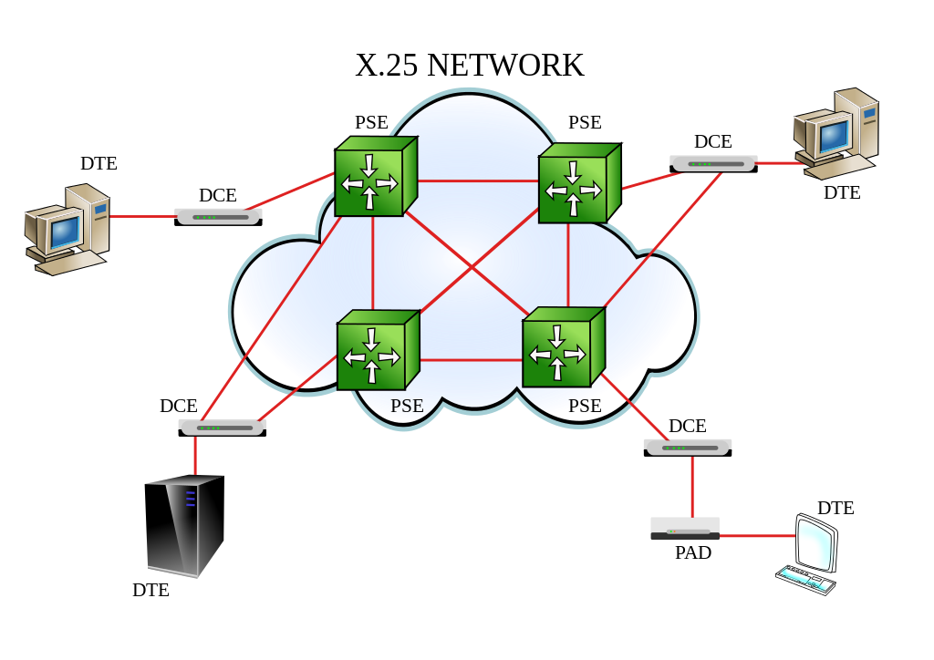
XML | Extensible Markup Language | In computing, Extensible Markup Language (XML) is a markup language that defines a set of rules for encoding documents in a format that is both human-readable and machine-readable. The W3C's XML 1.0 Specification and several other related specifications—all of them free open standards—define XML.  The design goals of XML emphasize simplicity, generality, and usability across the Internet.[5] It is a textual data format with strong support via Unicode for different human languages. Although the design of XML focuses on documents, the language is widely used for the representation of arbitrary data structures such as those used in web services.  Several schema systems exist to aid in the definition of XML-based languages, while programmers have developed many application programming interfaces (APIs) to aid the processing of XML data.  <note>  <to>Tove</to>  <from>Jani</from>  <heading>Reminder</heading>  <body>Don't forget me this weekend!</body>  </note>
XML Schema |  | An XML schema is a description of a type of XML document, typically expressed in terms of constraints on the structure and content of documents of that type, above and beyond the basic syntactical constraints imposed by XML itself. These constraints are generally expressed using some combination of grammatical rules governing the order of elements, Boolean predicates that the content must satisfy, data types governing the content of elements and attributes, and more specialized rules such as uniqueness and referential integrity constraints.  There are languages developed specifically to express XML schemas. The Document Type Definition (DTD) language, which is native to the XML specification, is a schema language that is of relatively limited capability, but that also has other uses in XML aside from the expression of schemas. Two more expressive XML schema languages in widespread use are XML Schema (with a capital S) and RELAX NG.  The mechanism for associating an XML document with a schema varies according to the schema language. The association may be achieved via markup within the XML document itself, or via some external means.  <?xml version="1.0" encoding="UTF-8"?>  <shiporder orderid="889923"  xmlns:xsi="http://www.w3.org/2001/XMLSchema-instance"  xsi:noNamespaceSchemaLocation="shiporder.xsd">  <orderperson>John Smith</orderperson>  <shipto>  <name>Ola Nordmann</name>  <address>Langgt 23</address>  <city>4000 Stavanger</city>  <country>Norway</country>  </shipto>  <item>  <title>Empire Burlesque</title>  <note>Special Edition</note>  <quantity>1</quantity>  <price>10.90</price>  </item>  <item>  <title>Hide your heart</title>  <quantity>1</quantity>  <price>9.90</price>  </item>  </shiporder>
XML-RPC |  | XML-RPC is a remote procedure call (RPC) protocol which uses XML to encode its calls and HTTP as a transport mechanism. "XML-RPC" also refers generically to the use of XML for remote procedure call, independently of the specific protocol. This article is about the protocol named "XML-RPC".
XMPP | Extensible Messaging and Presence Protocols | Extensible Messaging and Presence Protocol (XMPP) is a communication protocol for message-oriented middleware based on XML (Extensible Markup Language). It enables the near-real-time exchange of structured yet extensible data between any two or more network entities. Originally named Jabber, the protocol was developed by the Jabber open-source community in 1999 for near real-time instant messaging (IM), presence information, and contact list maintenance. Designed to be extensible, the protocol has been used also for publish-subscribe systems, signalling for VoIP, video, file transfer, gaming, the Internet of Things (IoT) applications such as the smart grid, and social networking services.  Unlike most instant messaging protocols, XMPP is defined in an open standard and uses an open systems approach of development and application, by which anyone may implement an XMPP service and interoperate with other organizations' implementations. Because XMPP is an open protocol, implementations can be developed using any software license and many server, client, and library implementations are distributed as free and open-source software, numerous freeware and commercial software implementations also exist.  The Internet Engineering Task Force (IETF) formed an XMPP working group in 2002 to formalize the core protocols as an IETF instant messaging and presence technology. The XMPP Working group produced four specifications (RFC 3920, RFC 3921, RFC 3922, RFC 3923), which were approved as Proposed Standards in 2004. In 2011, RFC 3920 and RFC 3921 were superseded by RFC 6120 and RFC 6121 respectively, with RFC 6122 specifying the XMPP address format. In 2015, RFC 6122 was superseded by RFC 7622. In addition to these core protocols standardized at the IETF, the XMPP Standards Foundation (formerly the Jabber Software Foundation) is active in developing open XMPP extensions.
XP | eXtreme Programming | Programming Extreme Programming (XP) is an agile software development framework that aims to produce higher quality software, and higher quality of life for the development team. XP is the most specific of the agile frameworks regarding appropriate engineering practices for software development.
xsd |  | XSD (XML Schema Definition), a recommendation of the World Wide Web Consortium (W3C), specifies how to formally describe the elements in an Extensible Markup Language (XML) document. It can be used by programmers to verify each piece of item content in a document. They can check if it adheres to the description of the element it is placed in.  Like all XML schema languages, XSD can be used to express a set of rules to which an XML document must conform in order to be considered "valid" according to that schema. However, unlike most other schema languages, XSD was also designed with the intent that determination of a document's validity would produce a collection of information adhering to specific data types. Such a post-validation infoset can be useful in the development of XML document processing software.
XSS | Cross Site Scripting | Cross-site scripting (XSS) is a type of computer security vulnerability typically found in web applications. XSS enables attackers to inject client-side scripts into web pages viewed by other users. A cross-site scripting vulnerability may be used by attackers to bypass access controls such as the same-origin policy. Cross-site scripting carried out on websites accounted for roughly 84% of all security vulnerabilities documented by Symantec as of 2007. Bug bounty company HackerOne in 2017 reported that XSS is still a major threat vector. XSS effects vary in range from petty nuisance to significant security risk, depending on the sensitivity of the data handled by the vulnerable site and the nature of any security mitigation implemented by the site's owner.

Z
ZigBee |  | Zigbee is an IEEE 802.15.4-based specification for a suite of high-level communication protocols used to create personal area networks with small, low-power digital radios, such as for home automation, medical device data collection, and other low-power low-bandwidth needs, designed for small scale projects which need wireless connection. Hence, Zigbee is a low-power, low data rate, and close proximity (i.e., personal area) wireless ad hoc network.  The technology defined by the Zigbee specification is intended to be simpler and less expensive than other wireless personal area networks (WPANs), such as Bluetooth or more general wireless networking such as Wi-Fi. Applications include wireless light switches, home energy monitors, traffic management systems, and other consumer and industrial equipment that requires short-range low-rate wireless data transfer.  Its low power consumption limits transmission distances to 10–100 meters line-of-sight, depending on power output and environmental characteristics. Zigbee devices can transmit data over long distances by passing data through a mesh network of intermediate devices to reach more distant ones. Zigbee is typically used in low data rate applications that require long battery life and secure networking (Zigbee networks are secured by 128 bit symmetric encryption keys.) Zigbee has a defined rate of 250 kbit/s, best suited for intermittent data transmissions from a sensor or input device.

μ-law |  | The µ-law algorithm (sometimes written "mu-law", often approximated as "u-law") is a companding algorithm, primarily used in 8-bit PCM digital telecommunication systems in North America and Japan. It is one of two versions of the G.711 standard from ITU-T, the other version being the similar A-law, used in regions where digital telecommunication signals are carried on E-1 circuits, e.g. Europe.  Companding algorithms reduce the dynamic range of an audio signal. In analog systems, this can increase the signal-to-noise ratio (SNR) achieved during transmission; in the digital domain, it can reduce the quantization error (hence increasing signal to quantization noise ratio). These SNR increases can be traded instead for reduced bandwidth for equivalent SNR.

